**27.2**

**Explain the following in brief by using the below datasets and their uses**

Creating table customers and loading the data

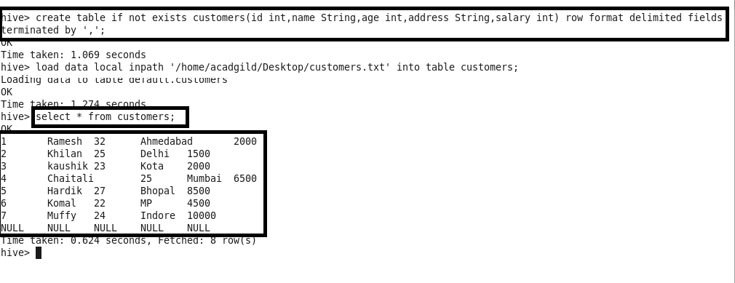

Creating table orders and loading the data

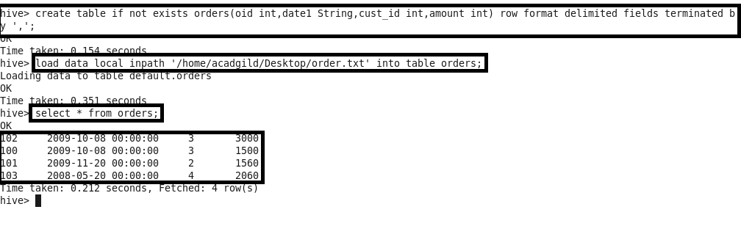

* Join

JOIN clause is used to combine and retrieve the records from multiple tables. JOIN is same as OUTER JOIN in SQL.

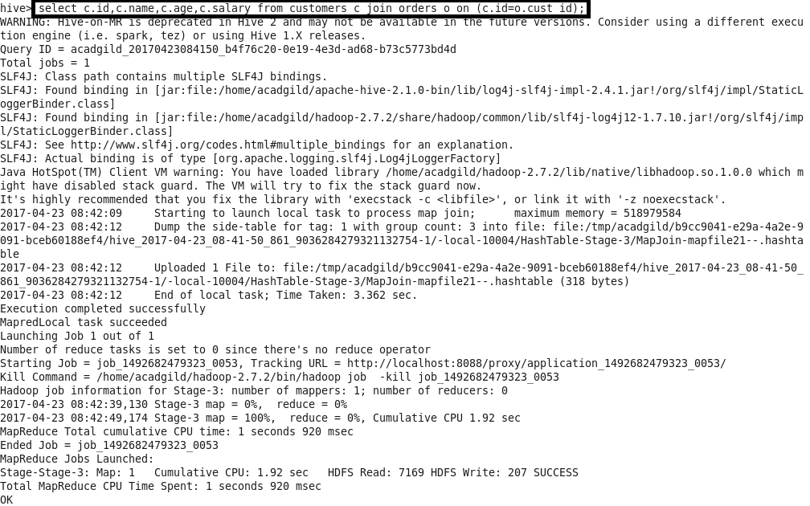

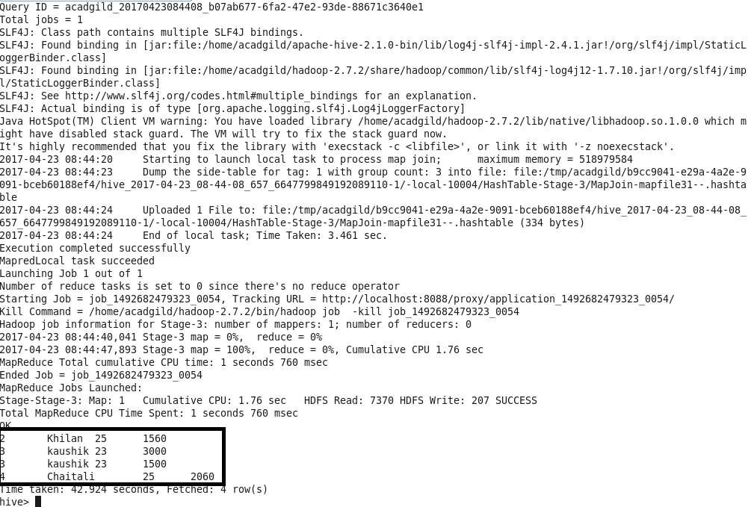

* Left Outer Join

The HiveQL LEFT OUTER JOIN returns all the rows from the left table, even if there are no matches in the right table. This means, if the ON clause matches 0 (zero) records in the right table, the JOIN still returns a row in the result, but with NULL in each column from the right table.

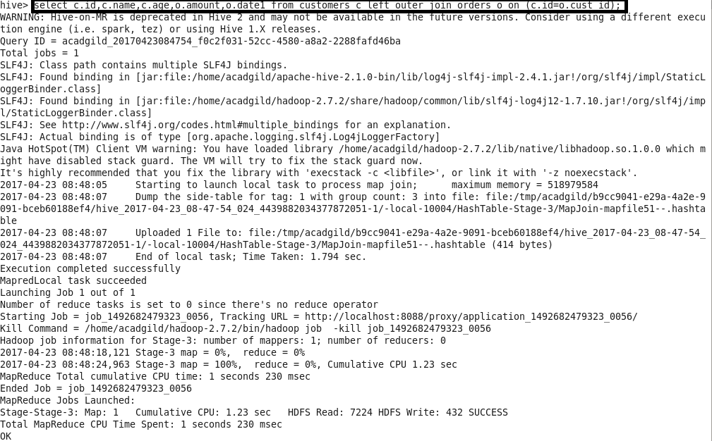

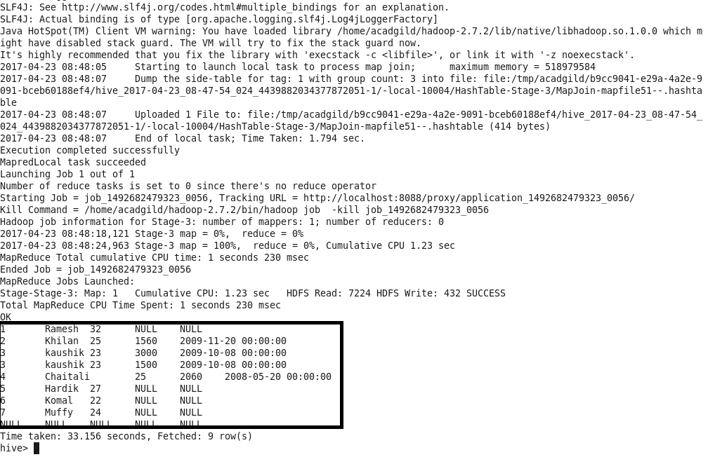

* Right Outer Join

The HiveQL RIGHT OUTER JOIN returns all the rows from the right table, even if there are no matches in the left table. If the ON clause matches 0 (zero) records in the left table, the JOIN still returns a row in the result, but with NULL in each column from the left table.

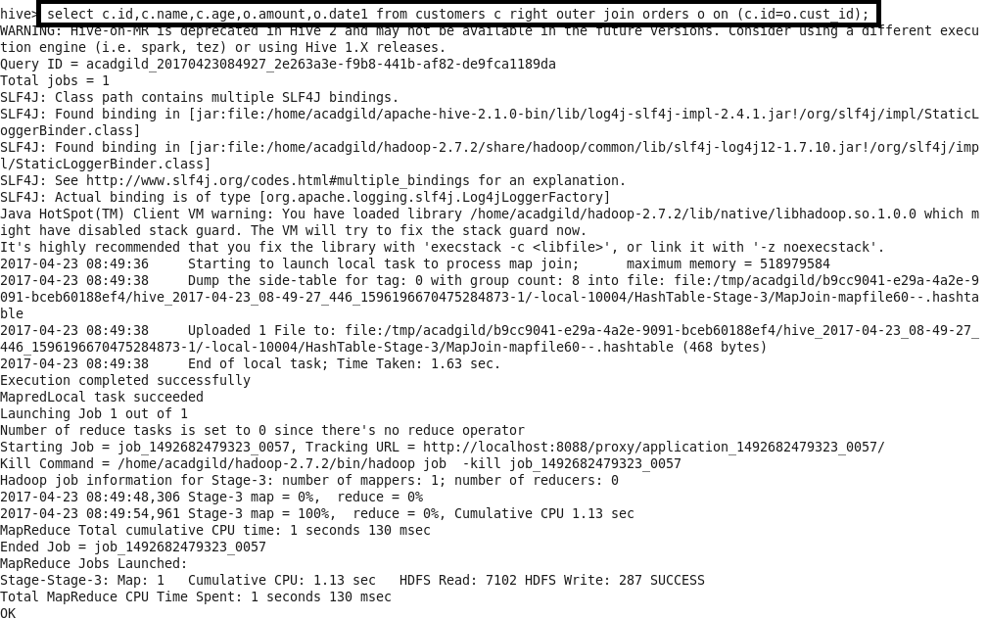

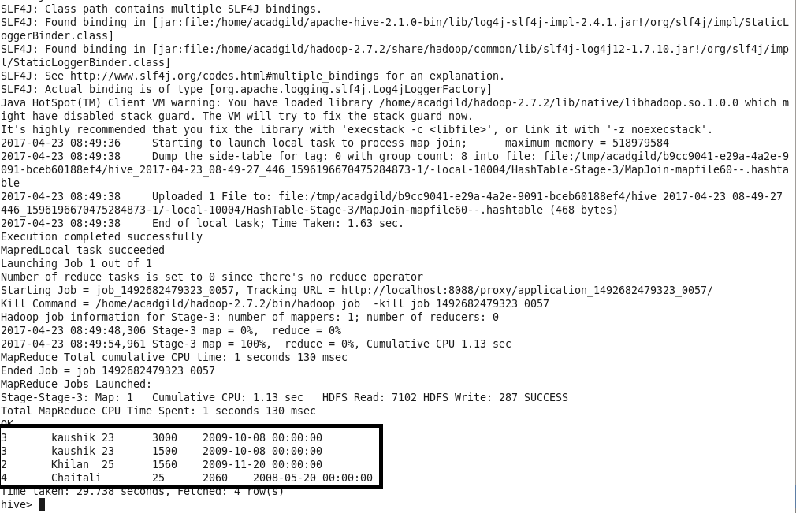

* Full Outer Join

The HiveQL FULL OUTER JOIN combines the records of both the left and the right outer tables that fulfil the JOIN condition.

