**27.4**

**Run parallel jobs in hive by following the steps in the below blog link.**

**Hive can converts a query into one or more stages and to save time executes multiple jobs parallely.**

**RUNNING NON-PARALLEL JOB:**

**STEP 1: creating 4 tables for performing joins** 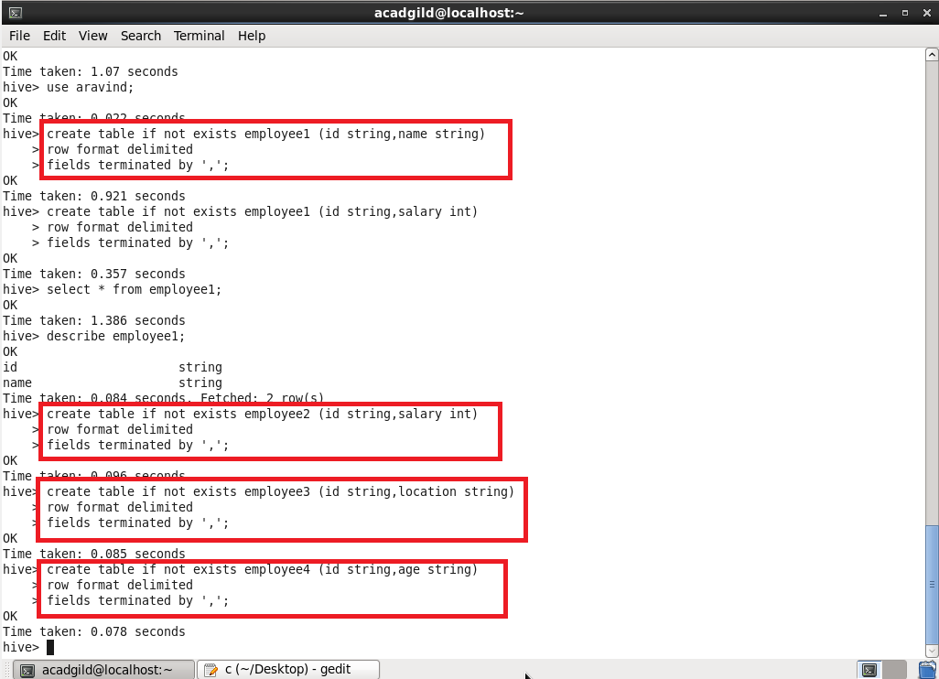

**Step 2: and loading data into the tables.**

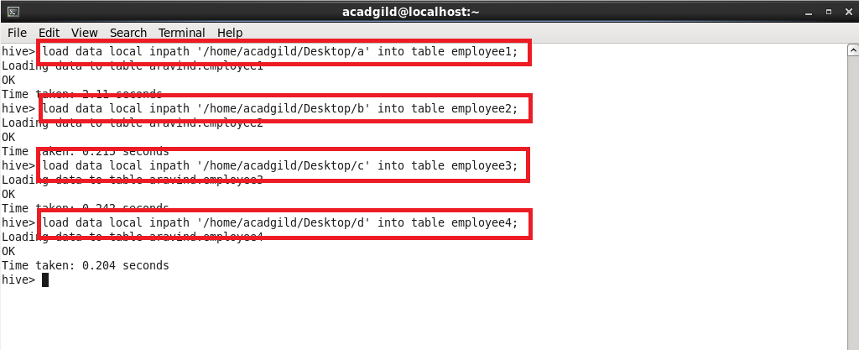

**Step 3: dumping all the contents of the tables that I’ve created**

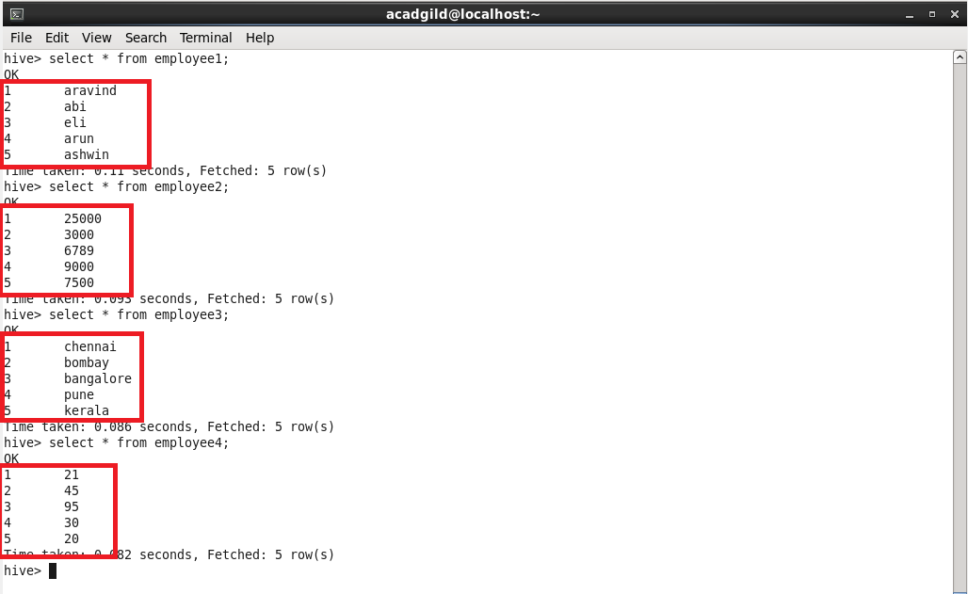

**Step 4: performing 4 joins at a time**

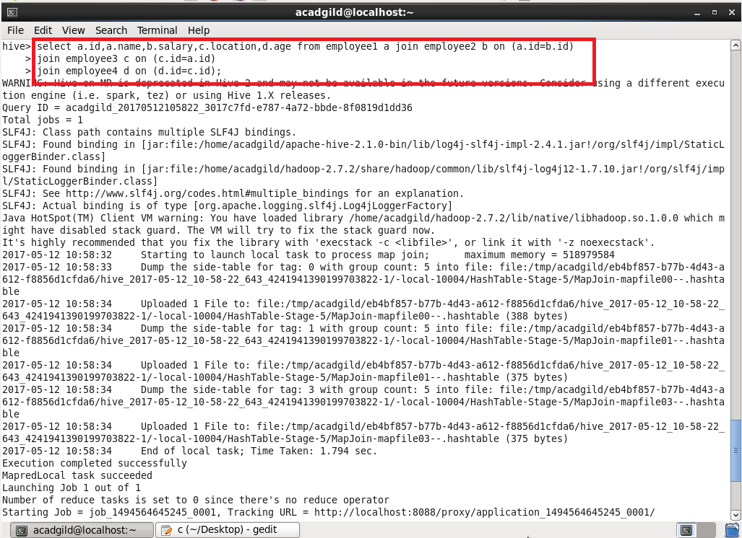

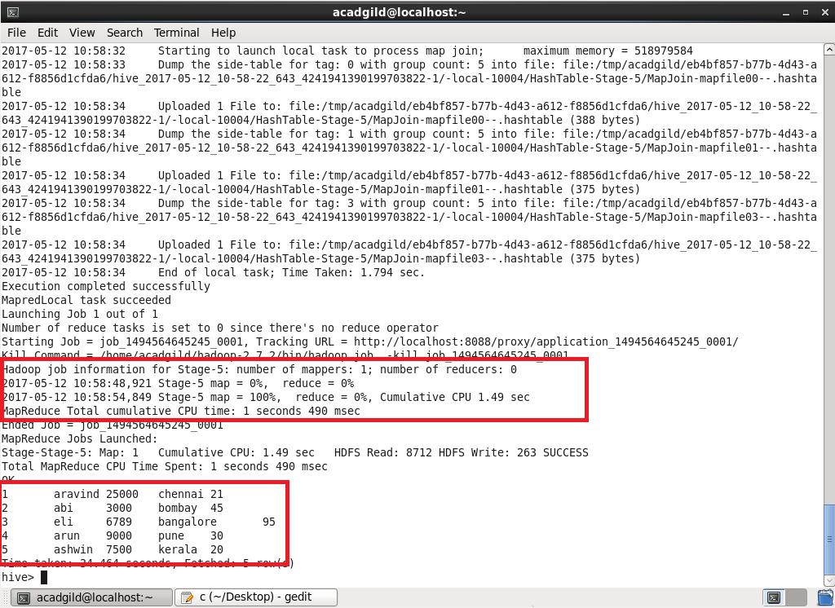

**RUNNING PARALLEL JOB:**

**Before running parallel jobs you should set**

**Set hive.exec.parallel=true;**

**QUERYING:**

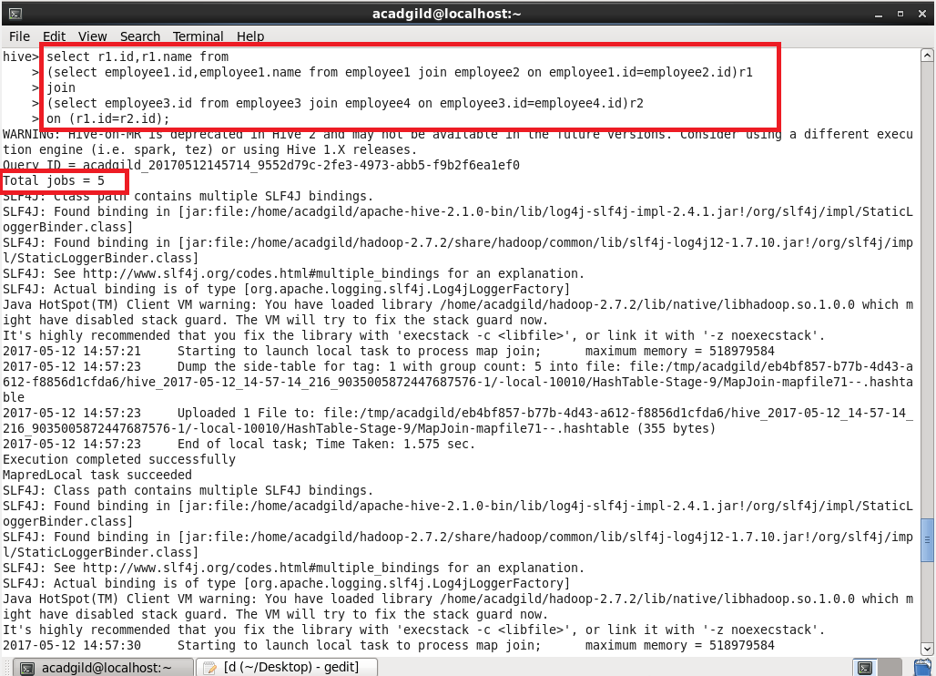

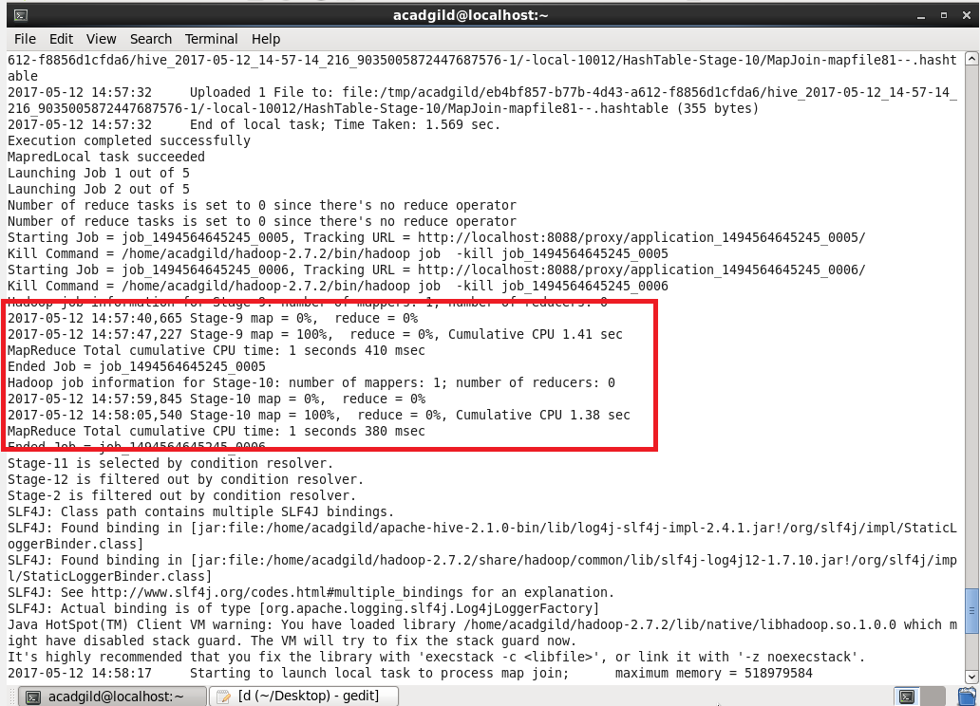

**OUTPUT:**

