ASSIGNMENT 32.3

Write a Java client API to perform following operations:

● Use HBaseAdmin class and create the table named company with one column family name details.

● Create the method name insert and use put class to insert records to company table.

STEP 1: WRITING JAVA CODE TO CREATE A TABLE IN HBASE

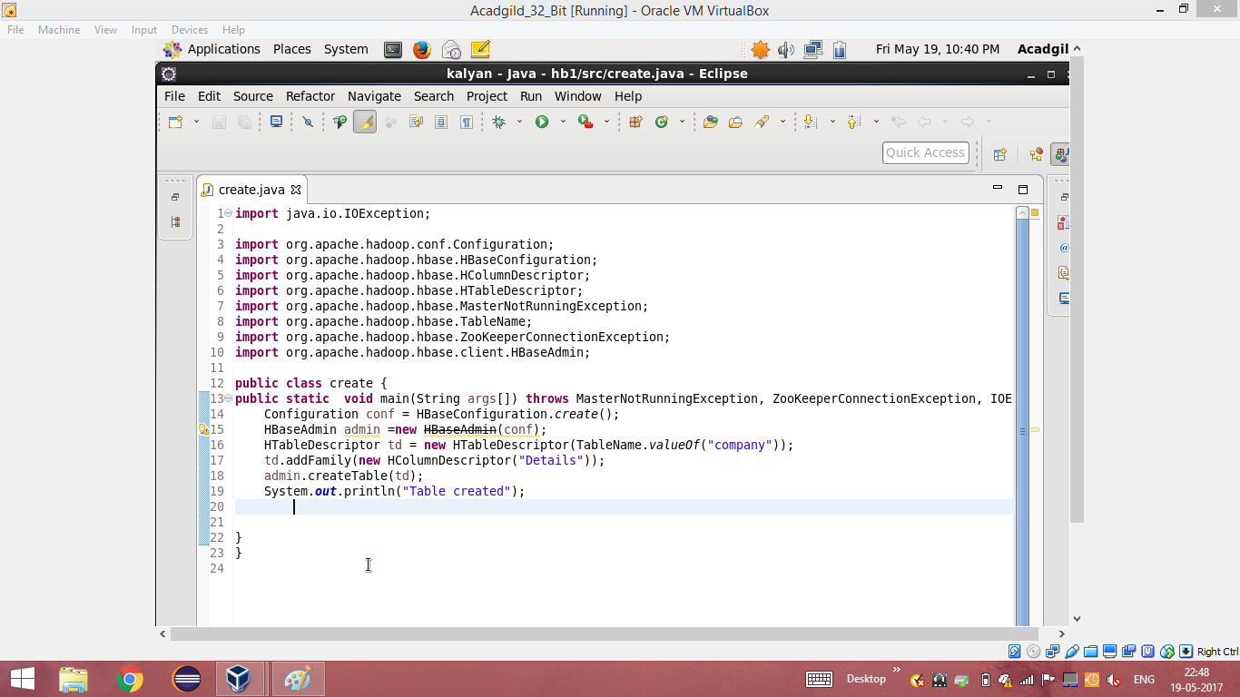

STEP 2: TABLE CREATED IN HBASE BY RUNNING THE JAVA CODE (RUN AS APPLICATION) IN ECLIPSE

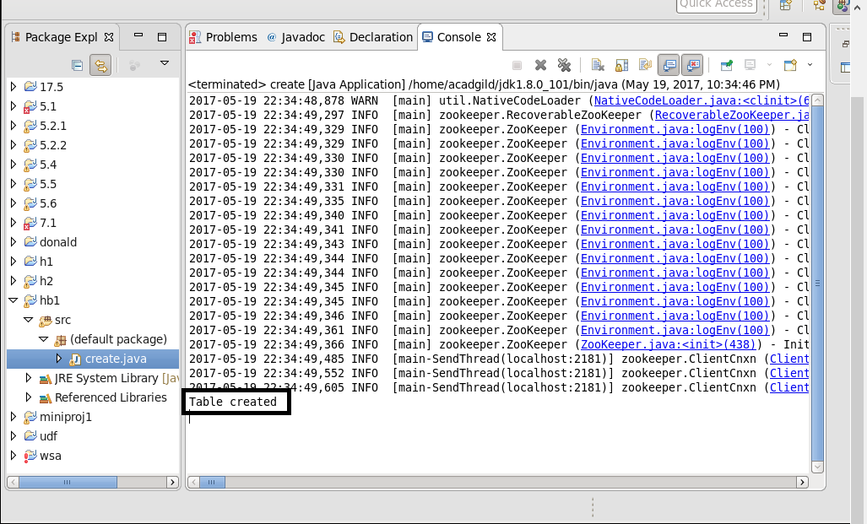

STEP 3: USING ‘LIST’ COMMAND , SHOWING THE TABLES IN HBASE

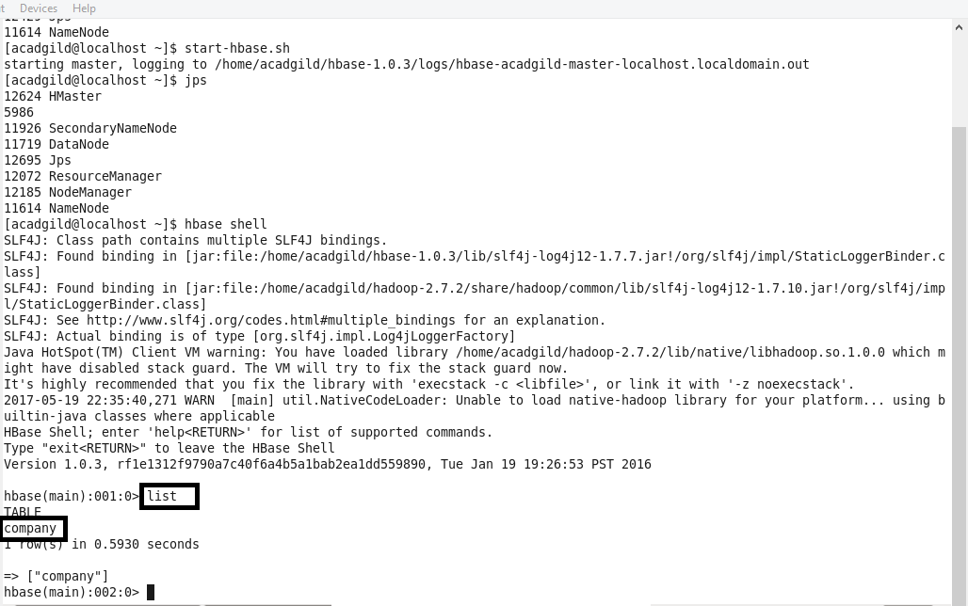

STEP 4: WRITING JAVA CODE TO INSERT DATA INTO THE TABLE “COMPANY” THAT WAS CREATED

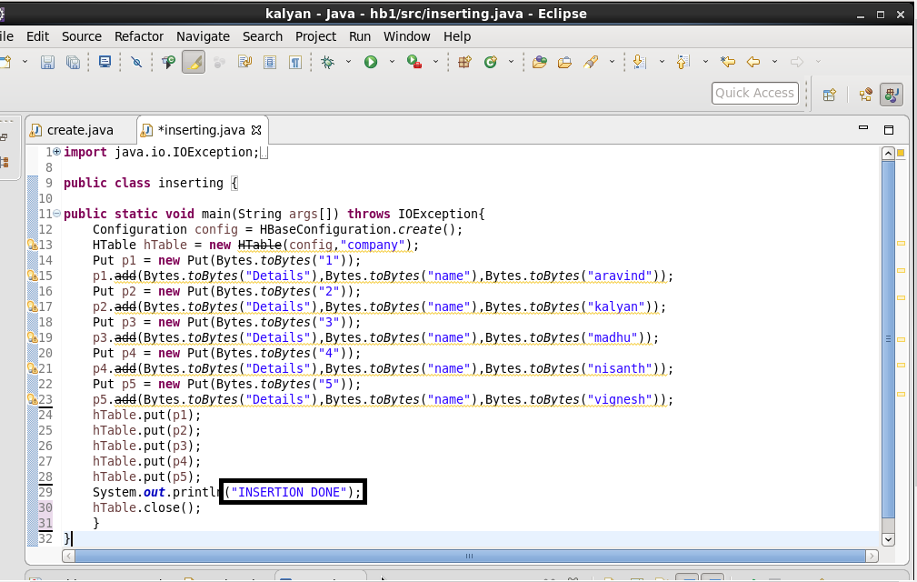

STEP 5: RUNNING THE JAVA CODE IN ECLIPSE (RUN AS APPLICATION)

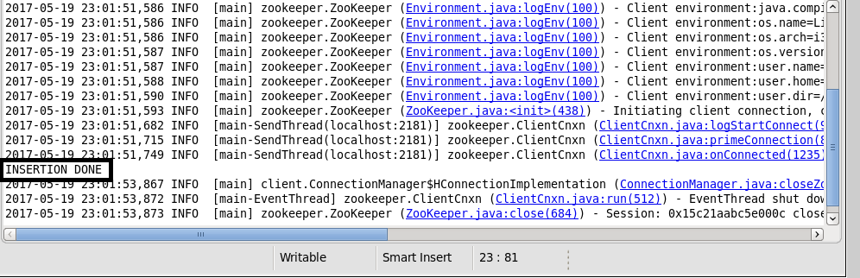

STEP 6: INSERTION WAS SUCCESSFUL AND TO CHECK IT, SCAN COMMAND IS USED.

