33.1

Write Java client API to perform following operations:

● Create the method name get record and use get class to retrieve one record at a time record from company table.

● Create the method name display and use scan class to display all records from company table.

Step 1: writing java code to get only names from the table ‘customer’

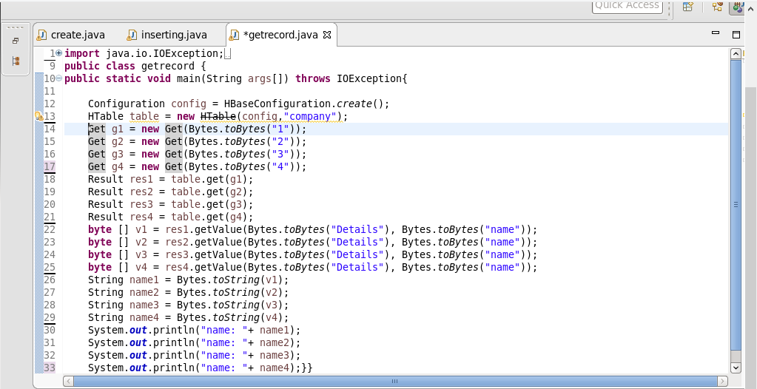

Step 2: list of names from the table ‘customer’

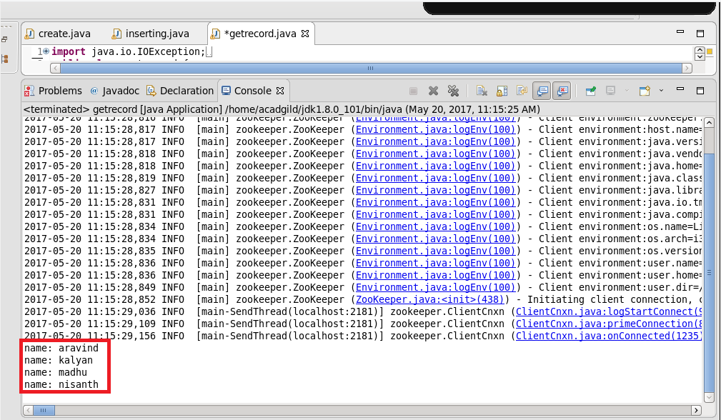

Step 3: checking the contents of the table “company” using scan command

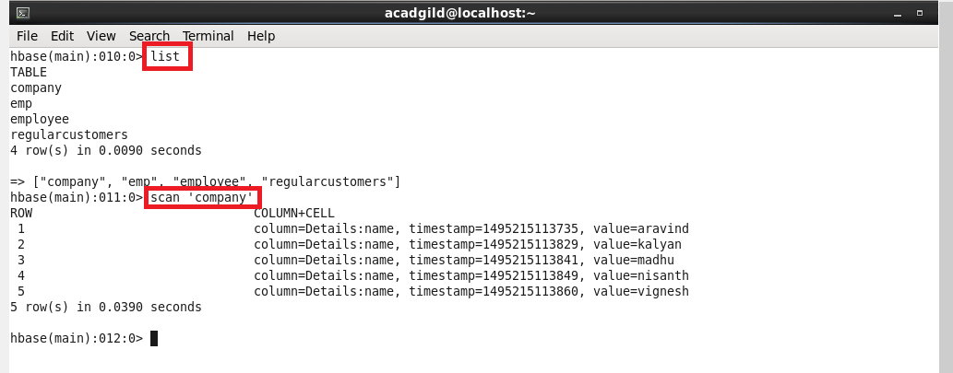

-------------------------------------------------------------------------------------------------------------

* Create the method name display and use scan class to display all records from company table.

Step 1:

writing java code by using scan class to display all records from company table.

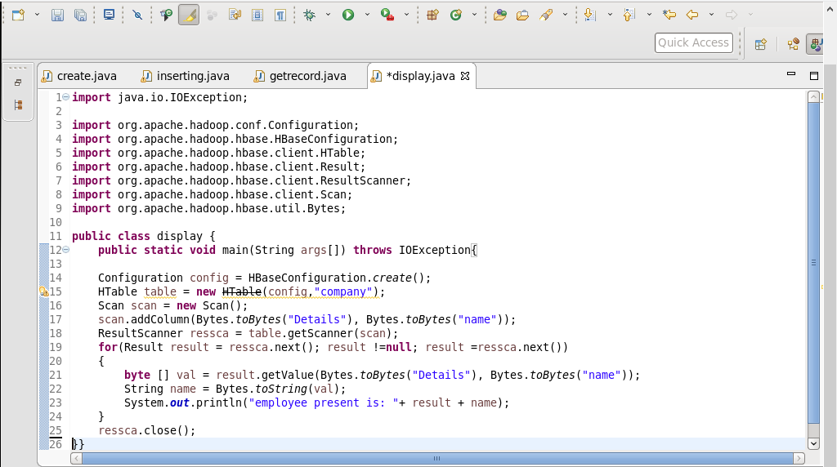

Step 2: running java code(run as application) in eclipse

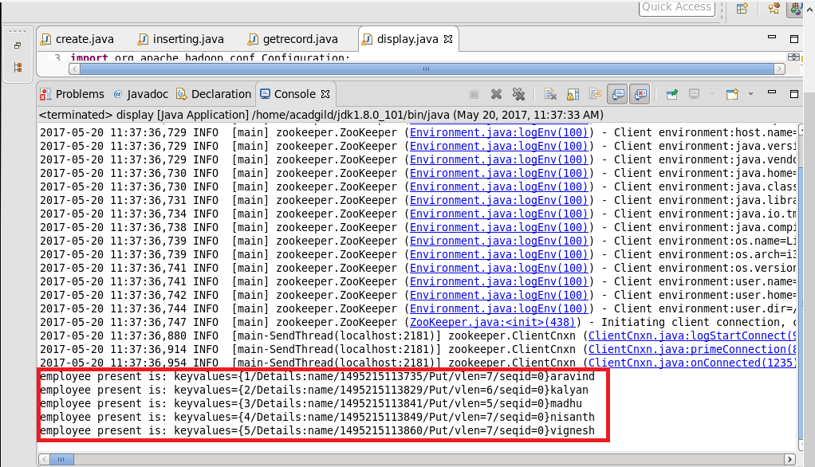

Step 3: checking the contents of the table “company” using get command

