33.3

● Integrate Hbase with Pig

● Load Data (Bulk Load) from HDFS to Hbase Table using Pig.

● Explain the procedures and code implemented with screenshots.

● Note: Candidates should Load their own data into Hbase table.

LOADING DATA INTO THE PIG USING LOAD COMMAND AND DUMPING USING DUMP COMMAND

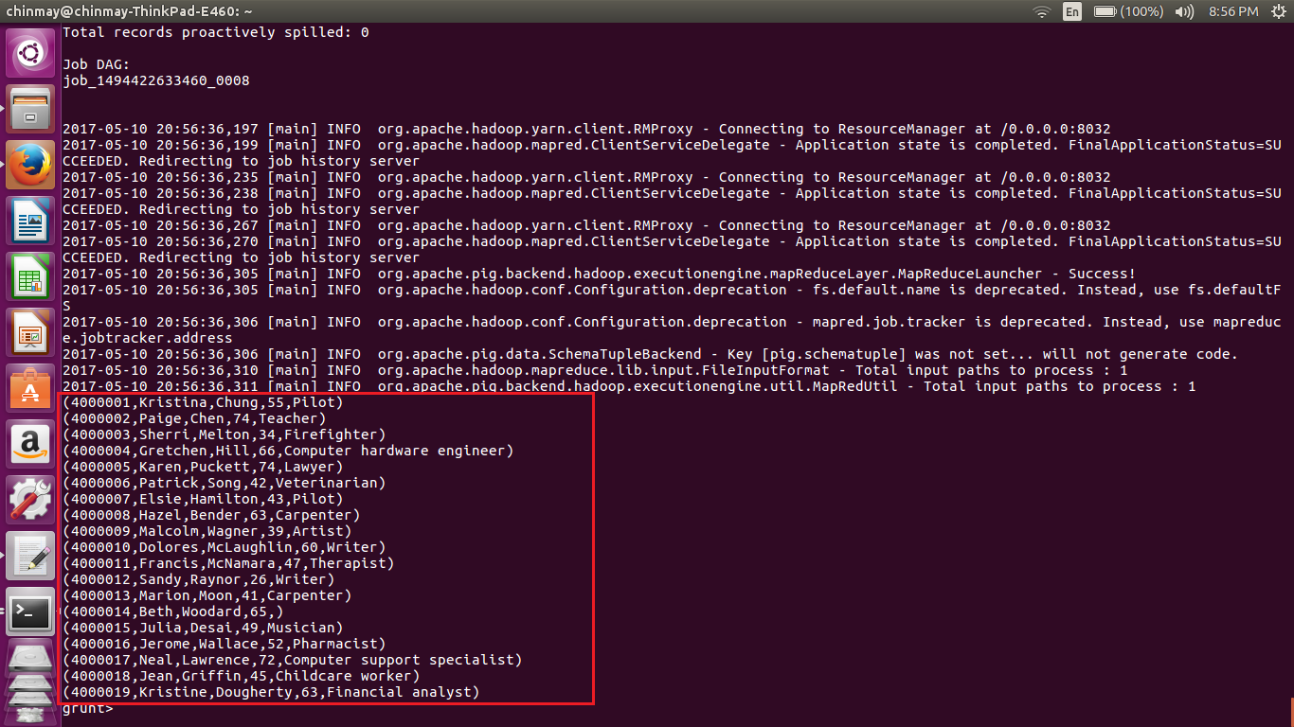

STORING THE LOADED DATA INTO THE HBASE USING STORE COMMAND IN PIG

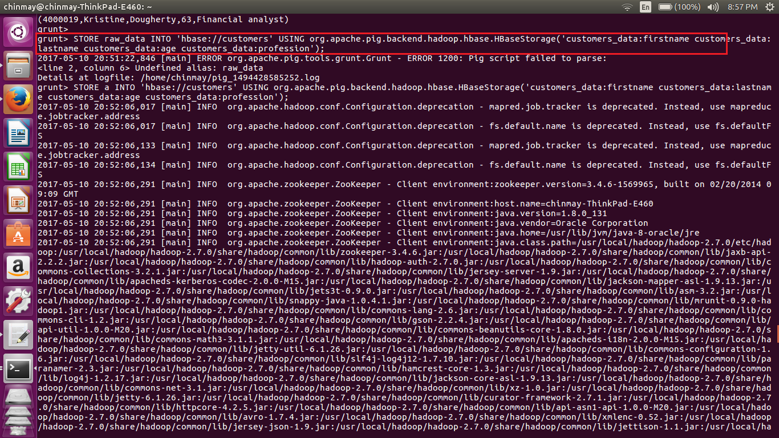

DATA SUCCESSFULLY LOADED FROM HDFS TO HBASE USING PIG

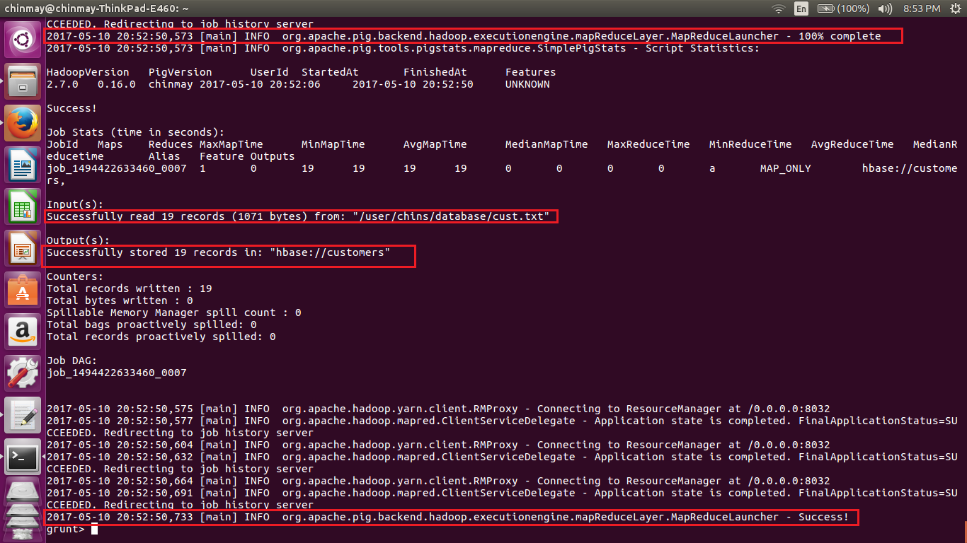

USING SCAN COMMAND TO CHECK THE CONTENTS OF THE TABLE THAT HAS BEEN LOADED INTO HBASE FROM HDFS USING PIG

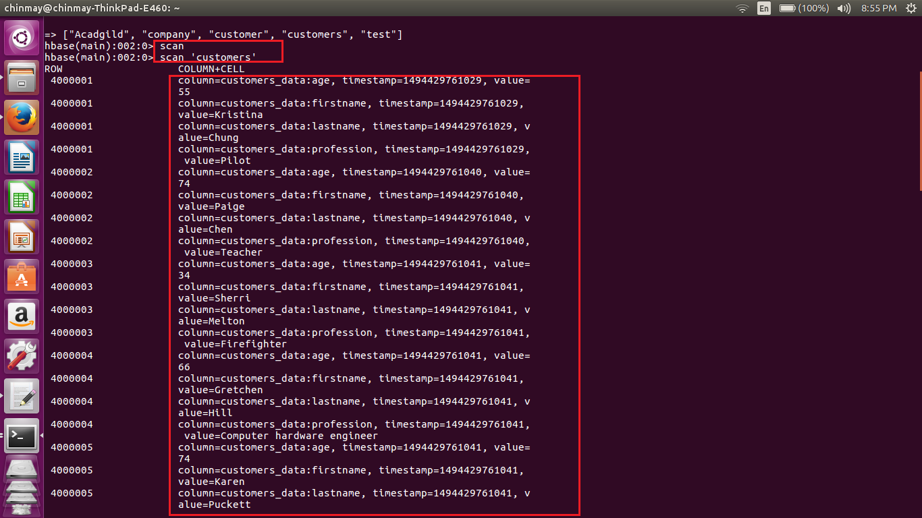

DATA HAS BEEN LOADED SUCCESSFULLY FROM HDFS TO HBASE USING PIG