35.3

Problem Statement:

● Explain and perform Importing table contents from Mysql to Hive using Sqoop.

● Explain and perform Importing table contents from Mysql to HBase using Sqoop.

Explain the procedures performed, Share the screenshots of commands and results for the same.

Solution:

* Importing table contents from Mysql to Hive using Sqoop:

Step 1: Creating table ‘emp’ in MYSQL:

First we have to login to your MySQL shell.

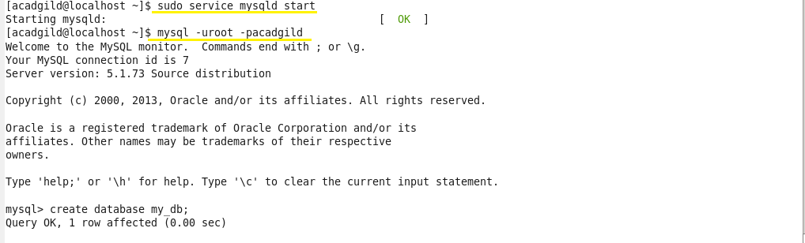

Creating a database by using the ‘create’ command and to work in the created database, we use ‘use’ command.

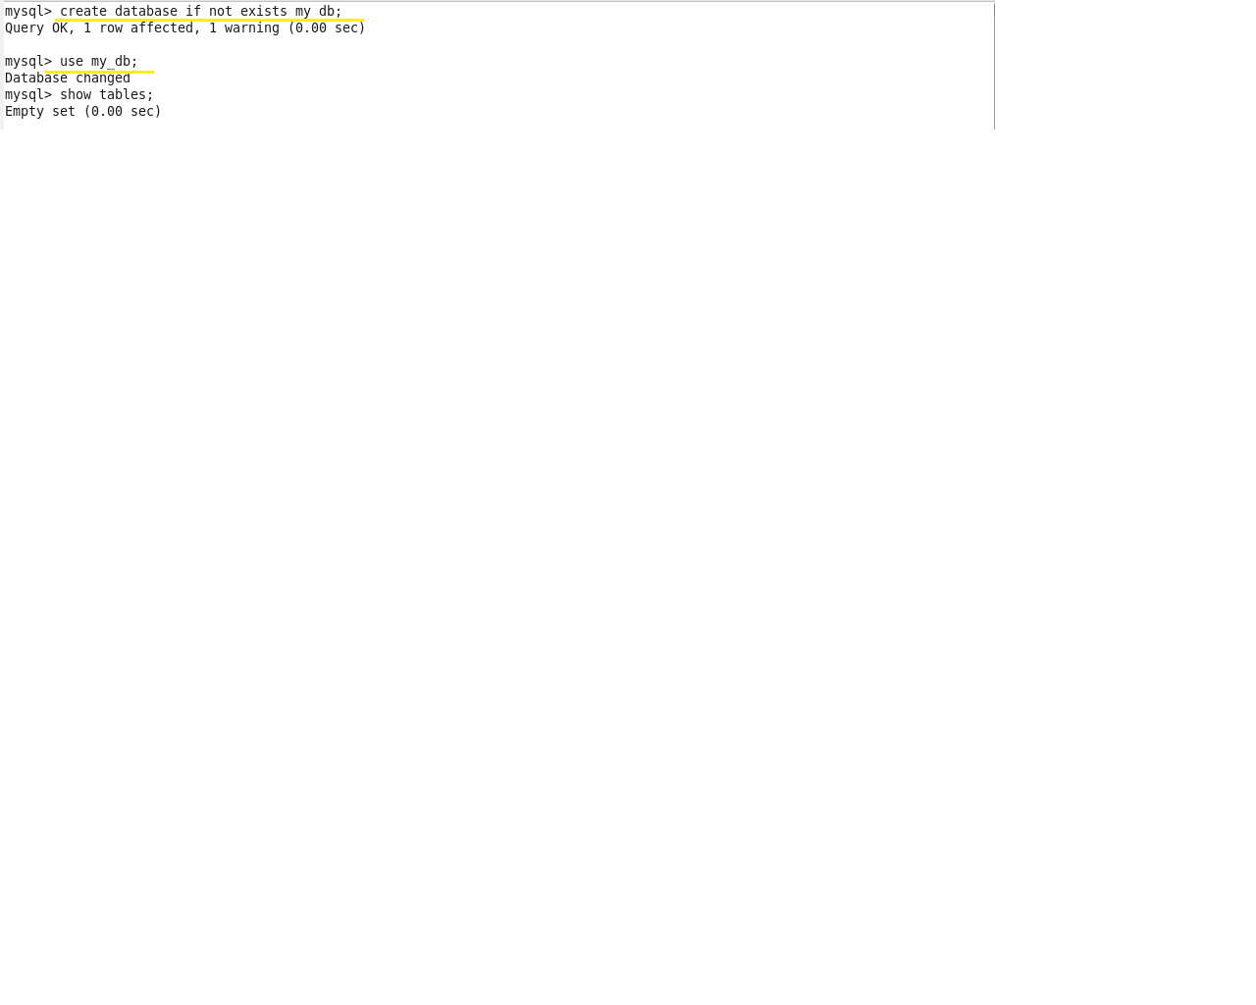

Creating a table emp by using the ‘create’ command:

After a table has been created with name emp and with the columns id, name, dept, sal. The scheme of this table can be checked using the ‘describe’ command:

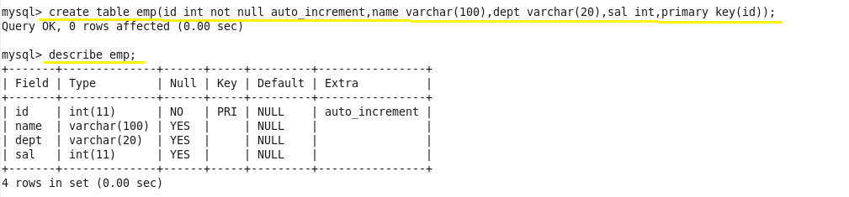

 Inserting some sample data into the created table by using ‘insert’ command:

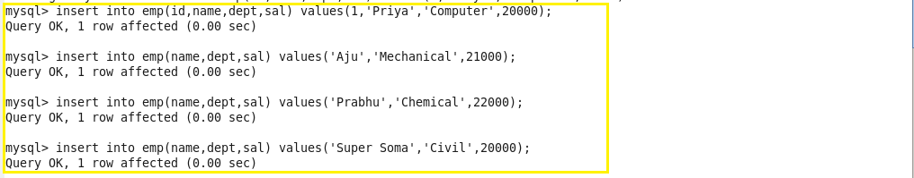

We can check the inserted using this command:

select * from employee;

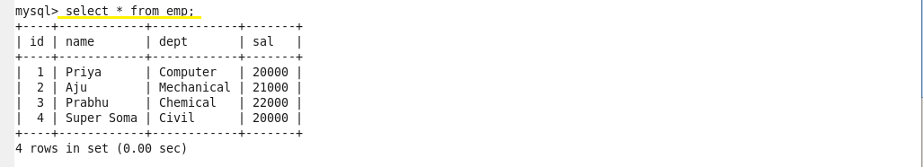

We have successfully created a table in MySQL, and we will now import the same into Hive by using Sqoop.

Step 2: Importing table contents from MySQL to Hive using Sqoop

Below is the command used to import table from MySQL to hive:

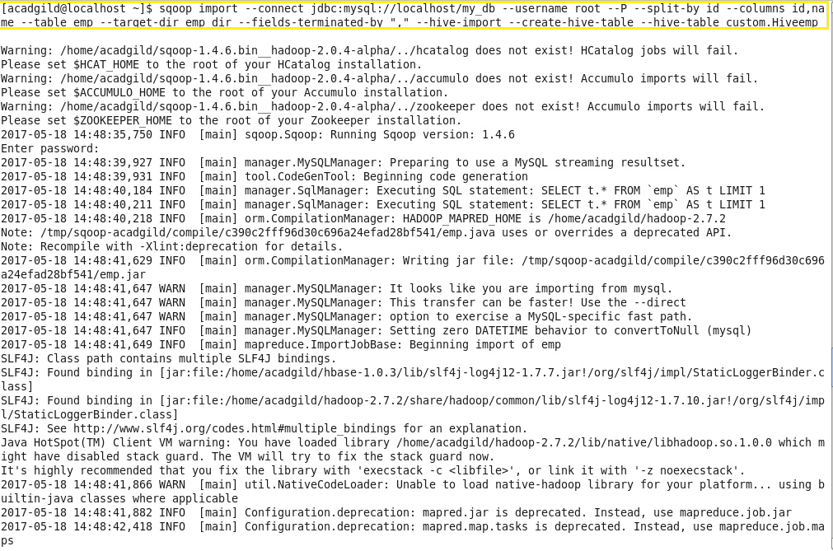

Here’s what each individual Sqoop command option means:

* connect – Provides jdbc string
* username – Database username
* -P – Will ask for the password in console. Alternatively you can use –password but this is not a good practice as its visible in your job execution logs and asking for trouble. One way to deal with this is store database passwords in a file in HDFS and provide at runtime.
* table– Tells the computer which table you want to import from MySQL. Here, it's customer.
* split-by – Specifies your splitting column. I am specifying id here.
* target-dir – HDFS destination directory.
* fields-terminated-by – I have specified comma (as by default it will import data into HDFS with comma-separated values)
* hive-import – Import table into Hive (Uses Hive’s default delimiters if none are set.)
* create-hive-table – Determines if set job will fail if a Hive table already exists. It works in this case.
* hive-table – Specifies <db_name>.<table_name>. Here it's sqoop_workspace.customers, where sqoop_workspace is my database and customers is the table name.

As we can see in the image below, all 6 records have been retrieved and the import is now complete.

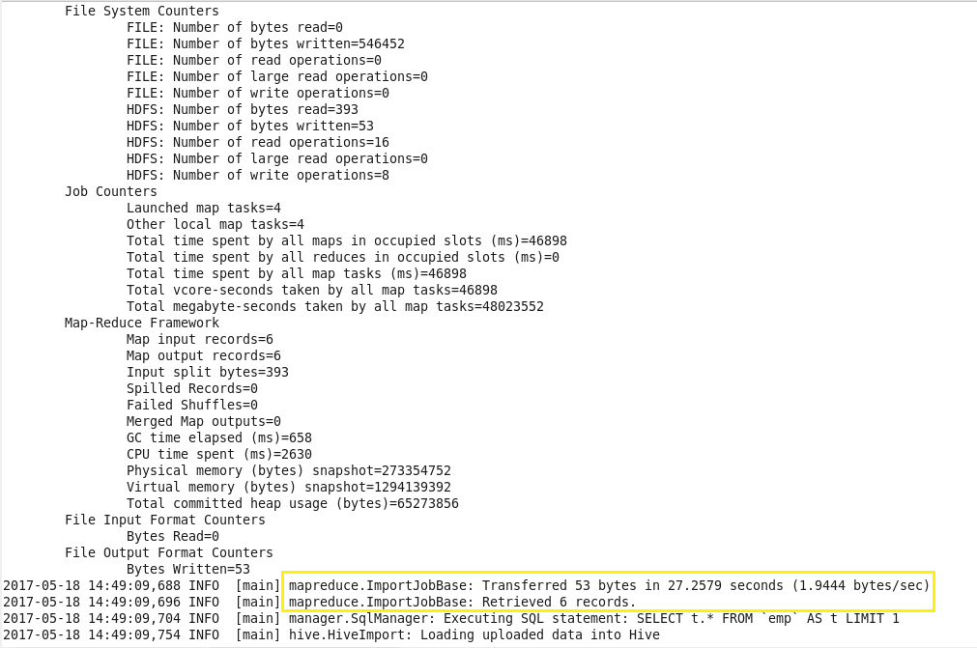

We start hive using ‘hive’ command.

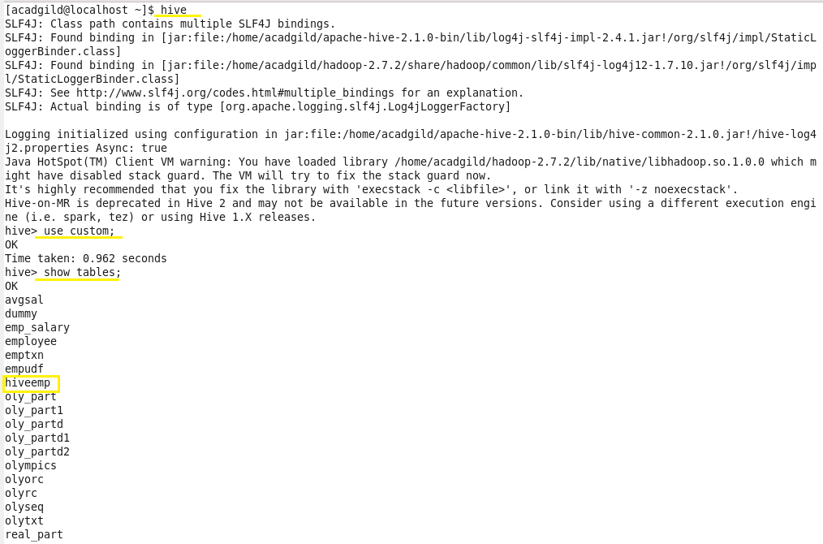

We can see the tables in the database using ‘show tables’ command.

We can see table ‘hiveemp’ is created in the database ‘custom’.We can see the contents of table using ‘select’ command.

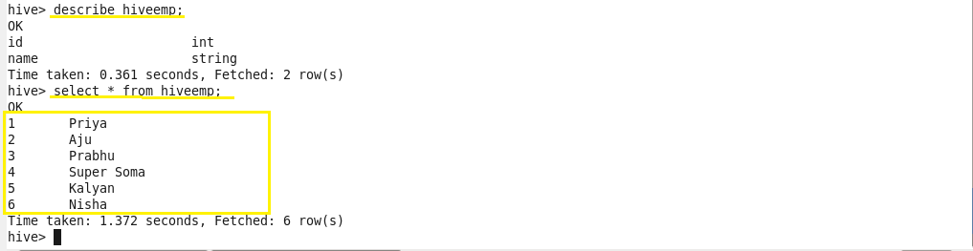

* Importing table contents from Mysql to HBase using Sqoop:

Step 1: Creating table ‘emp’ in MYSQL:

First we have to login to your MySQL shell.



Creating a database by using the ‘create’ command and to work in the created database, we use ‘use’ command.



Creating a table emp by using the ‘create’ command:

After a table has been created with name emp and with the columns id, name, dept, sal. The scheme of this table can be checked using the ‘describe’ command:



 Inserting some sample data into the created table by using ‘insert’ command:



We can check the inserted using this command: select * from employee;



We have successfully created a table in MySQL, and we will now import the same into Hive by using Sqoop.

Step 2: Creating table in HBase

First we start the HBase shell using following commands.

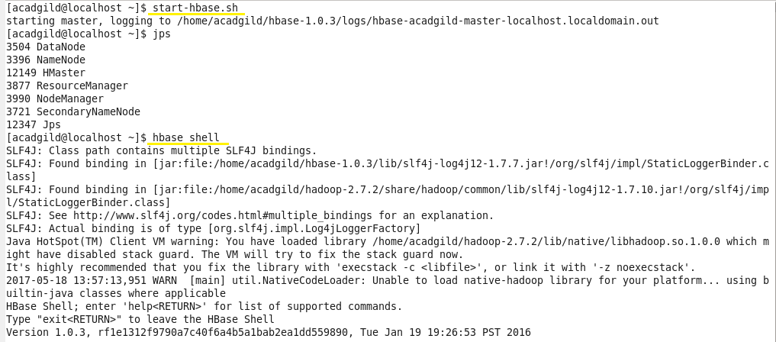

Creating a table in HBase using following syntax. We can see all the contents of the table using ‘scan’ command. Initially the table is empty as no records are inserted.

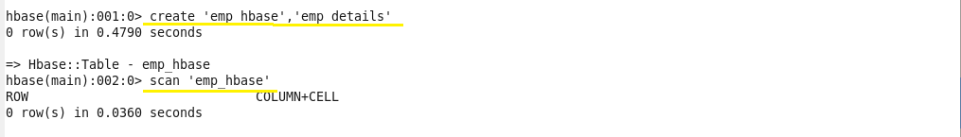

Step 3: Importing table contents from Mysql to HBase using Sqoop

Below is the command used to import table from MySQL to HBase:

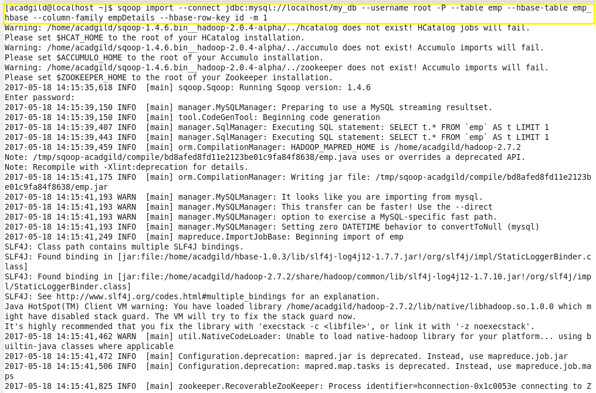

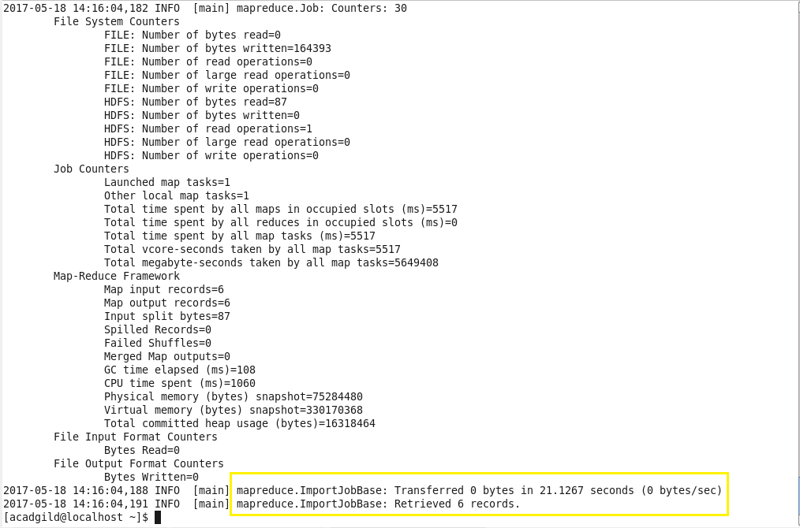

As we can see in above image, all 6 records have been retrieved and the import is now complete.

We can see the contents of imported MySQL table in HBase using ‘scan’ command as below:

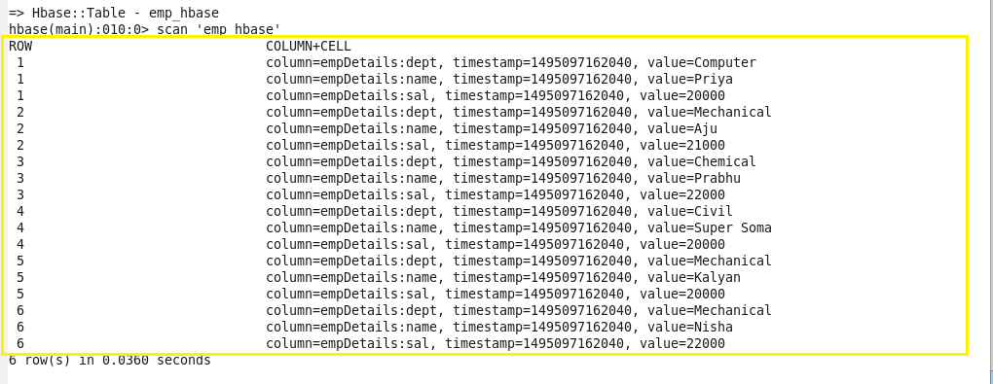

Thus, we successfully imported the contents of MySQL table to HBase using Sqoop.