**Q1-We have a dataset of sales of different TV sets across different locations. Records look like: Samsung|Optima|14|Madhya Pradesh|132401|14200**

**The fields are arranged like:**

**Company Name|Product Name|Size in inches|State|Pin Code|Price sales_differentTV : https://github.com/prateekATacadgild/DatasetsForCognizant/blob/master/sales_differentTV.txt**

**There are some invalid records which contain 'NA' in either Company Name or Product Name.**

**Sales of different TV Task 1:**

**Write a MapReduce program to filter out the invalid records. The output of this program will act as input for subsequent tasks. Map only job will fit for this context.**

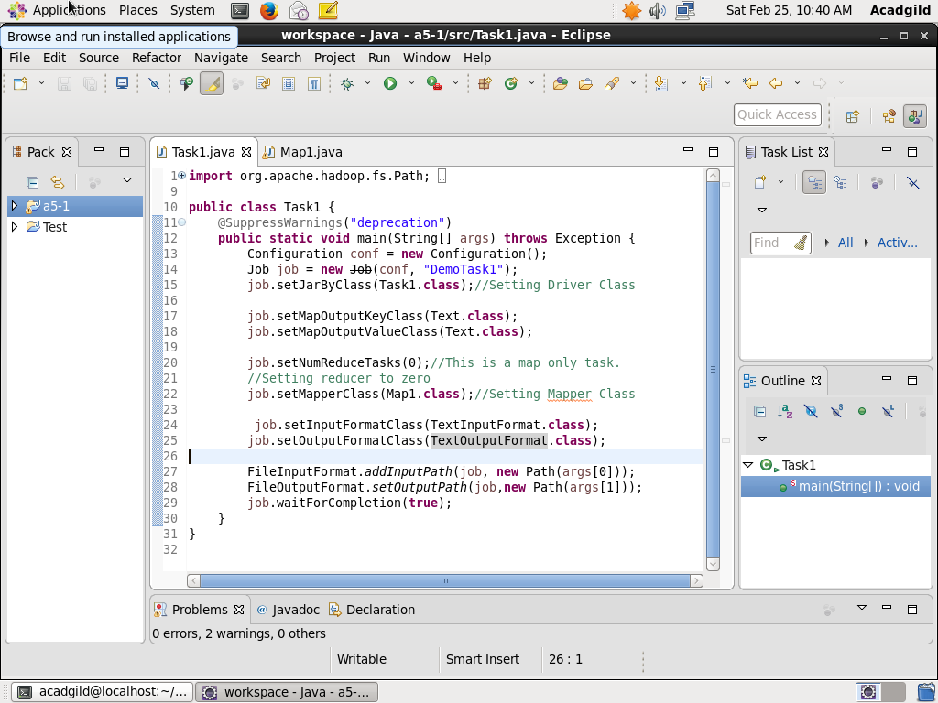

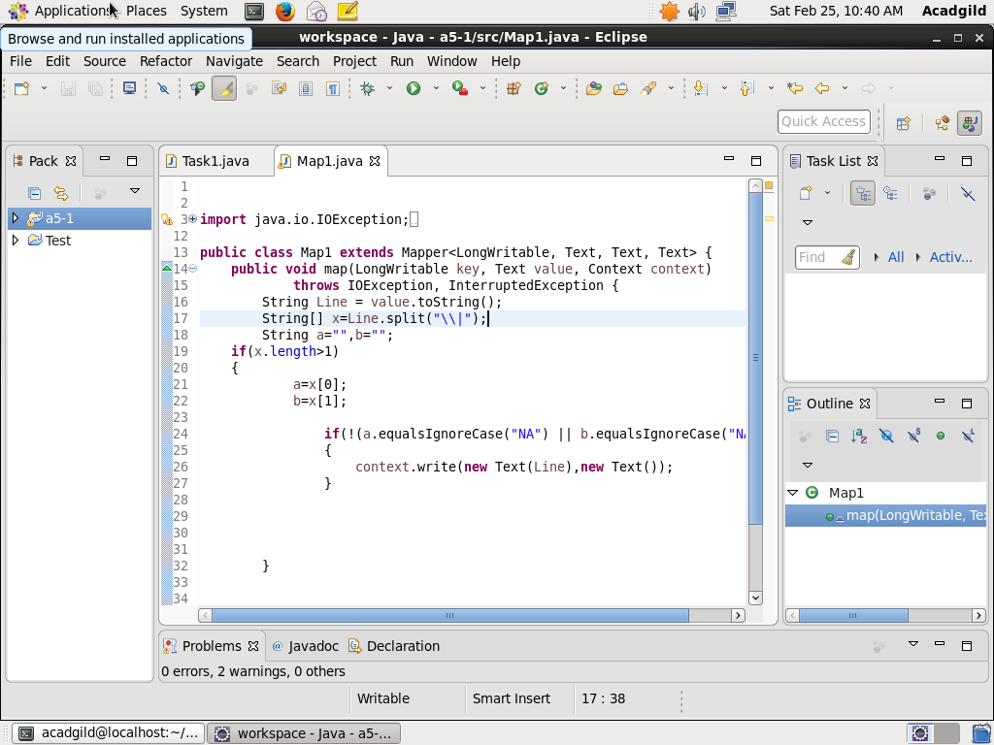

**OUTPUT:**



