**6.3**

**Problem 1:**

Find the number of GoogleKnowlege_Occupation people who were guests in the show, in a particular time period. Take the time period as 1/11/99 to 6/11/99 i.e., 6 months .

**Program:**

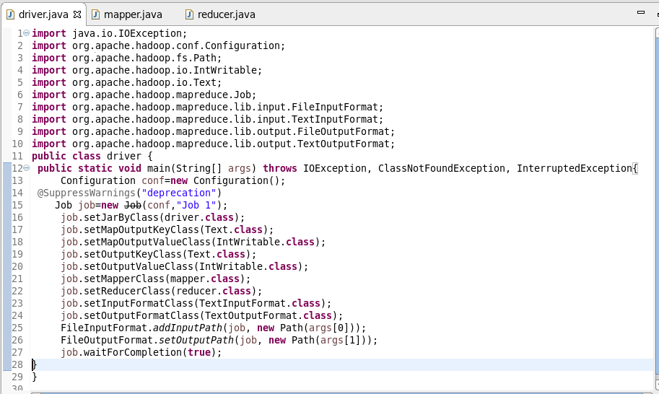

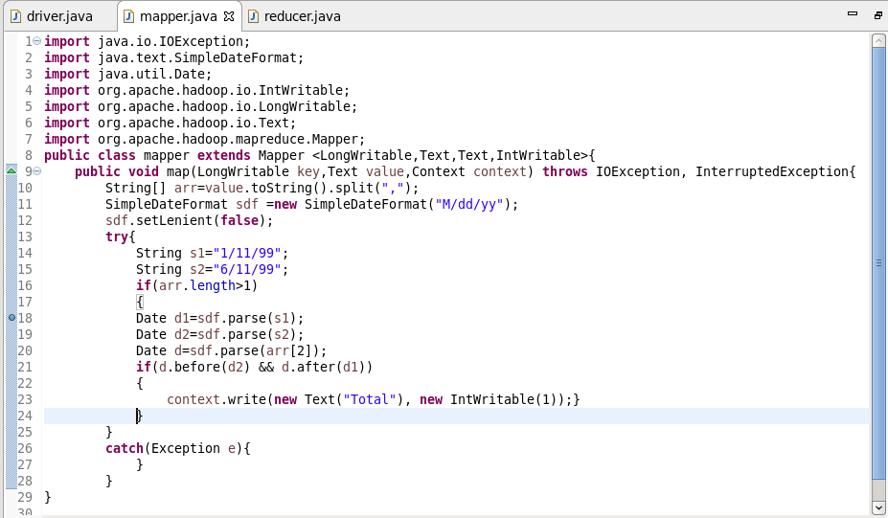

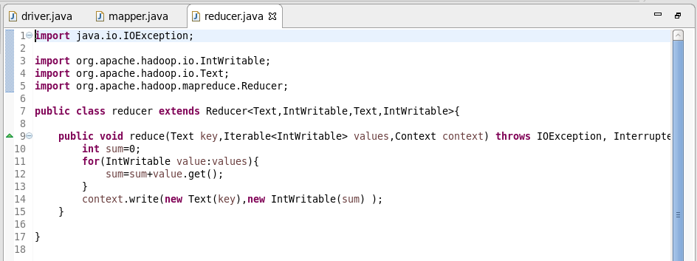

**Output:**

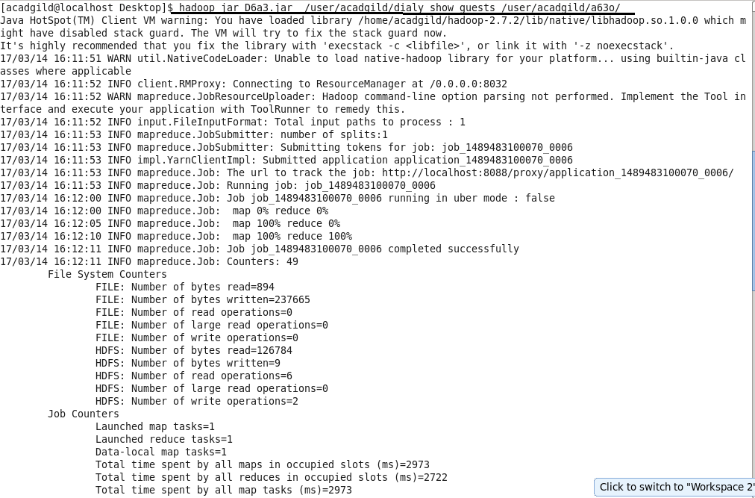

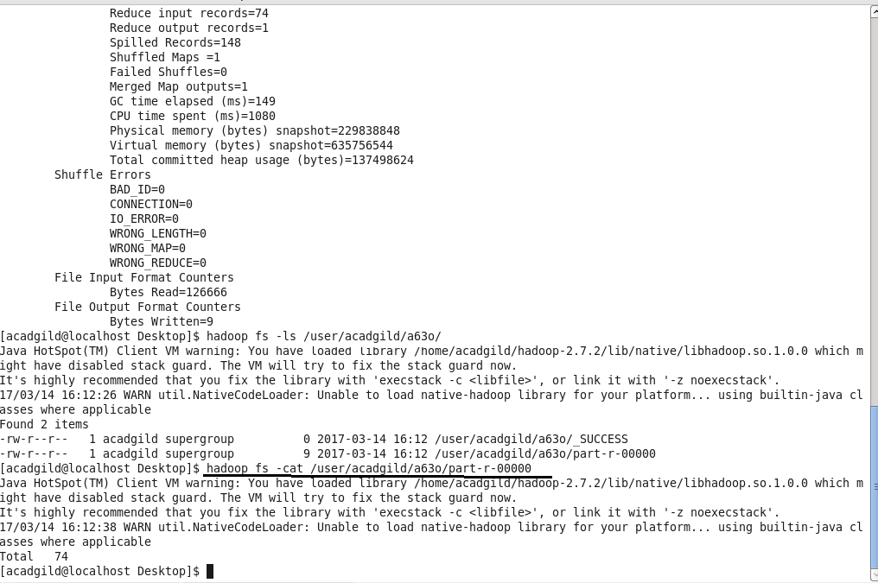

**Problem 2:**

Find the number of GoogleKnowledge occupation types in each group, who have been guests on the show.

**Program:**

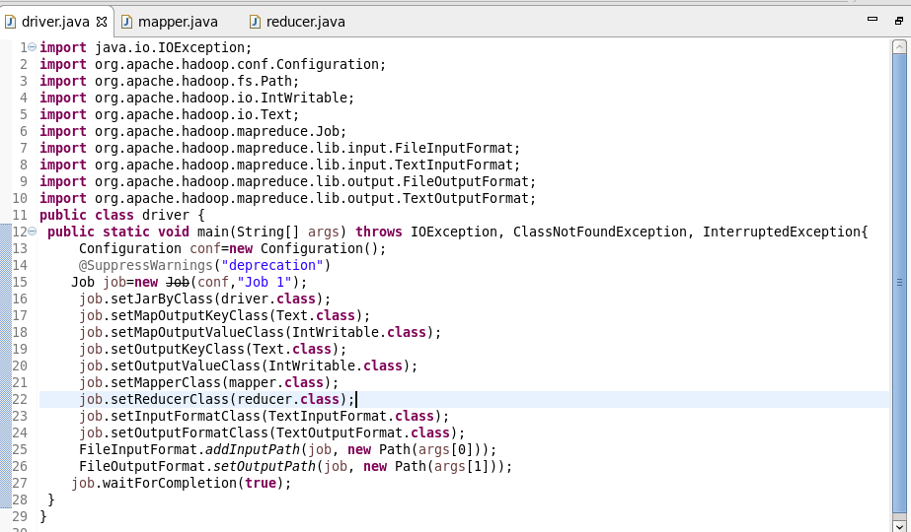

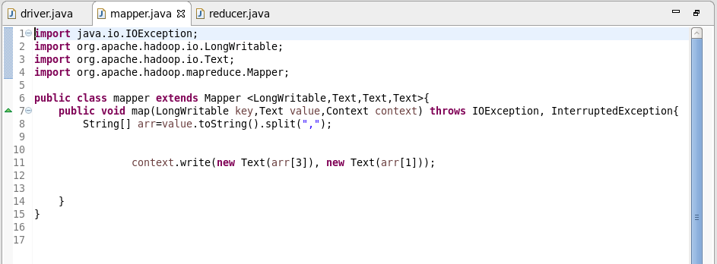

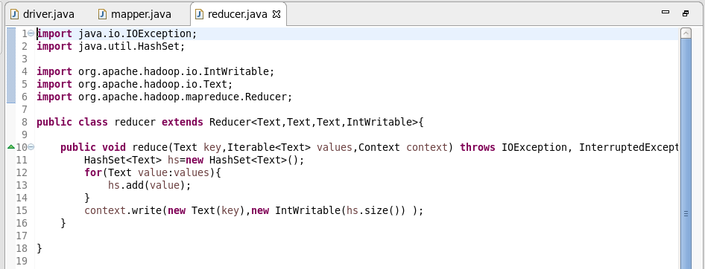

**Output:**

