**6.6:**

**Problem Statement:**

Write a map reduce program to use Sequence file as input and save the output in key value output format.

**Program:**

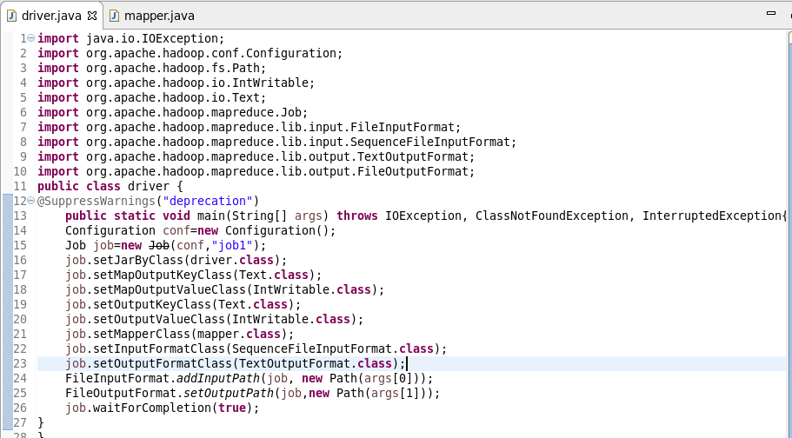

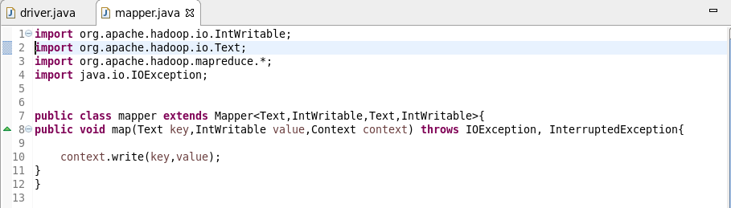

**Output:**

