**Assignment 7.4**

**Problem:**

**Write a word count program using partitioner and implement the following logic in the partitioner words with length 5 should go into reducer 1 and words with length 6 should go into reducer 2 and the rest of the words should go into reducer 3.**

**Program:**

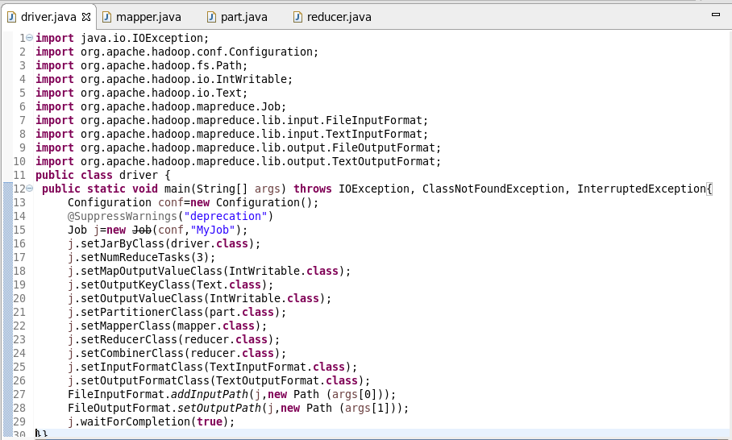

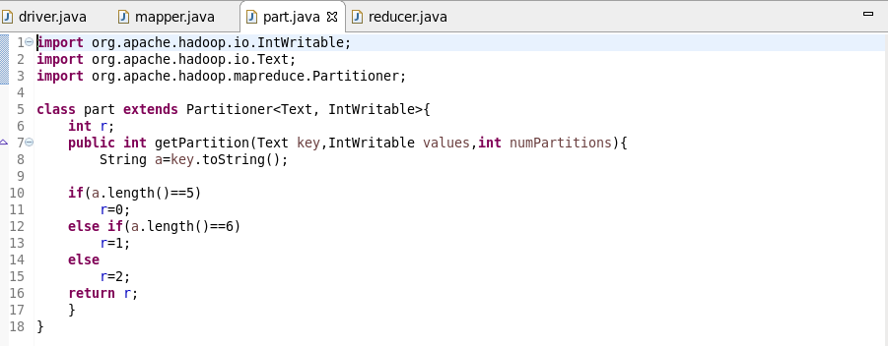

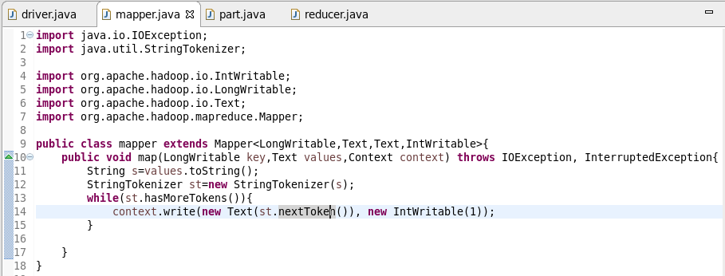

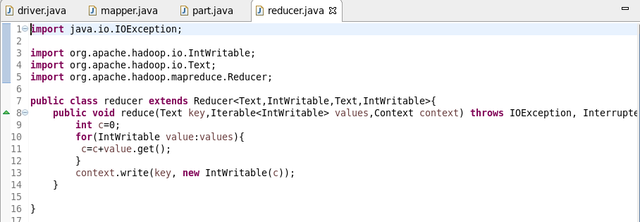

Output:

