Problem Statement 1:

Write a mapreduce program to find the total amount of petrol in volume sold by every distributor.

Problem Statement 2:

Write a mapreduce program to find which are the top 10 distributors ID's for selling petrol and also display the amount of petrol sold in volume.

Task:

: 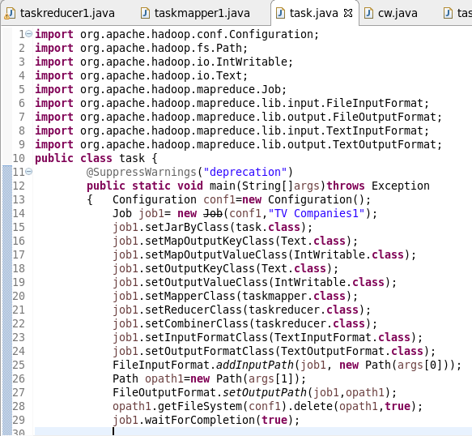

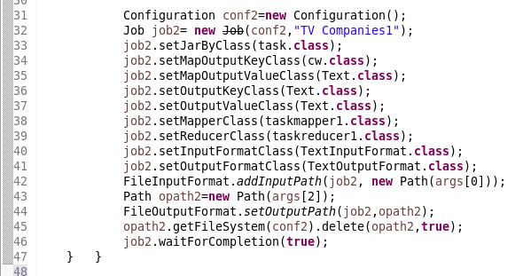

Mapper problem 1:

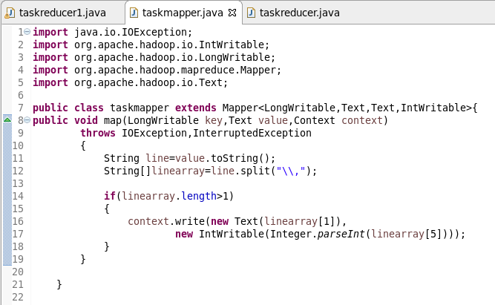

Mapper for problem 2:

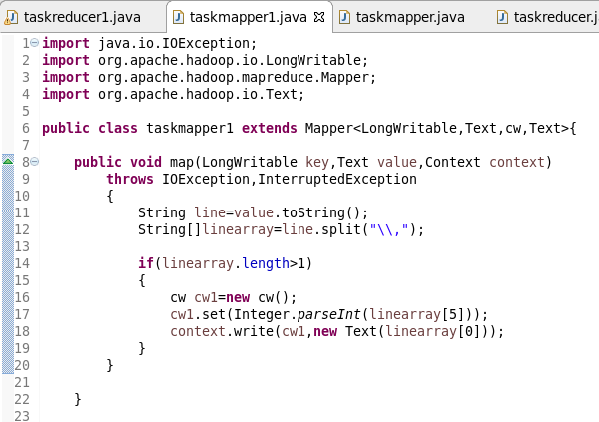

Reducer for problem 1:

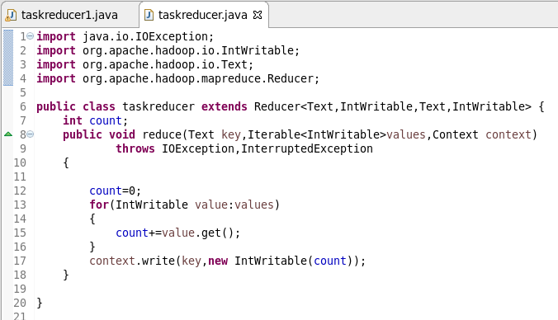

Reducer problem 2:

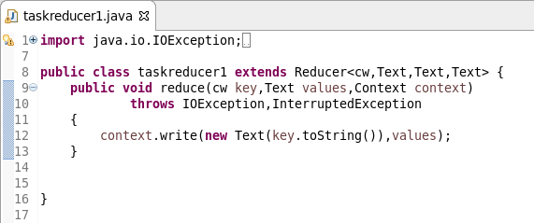

Composite key:

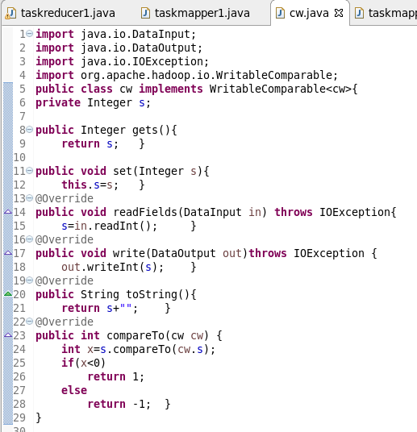

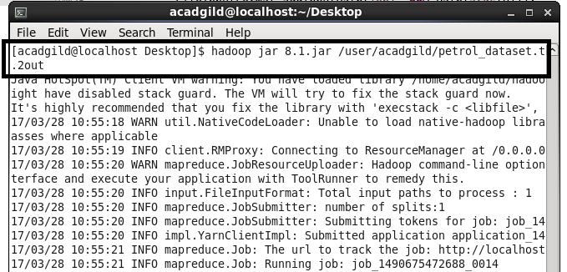

Output 1:

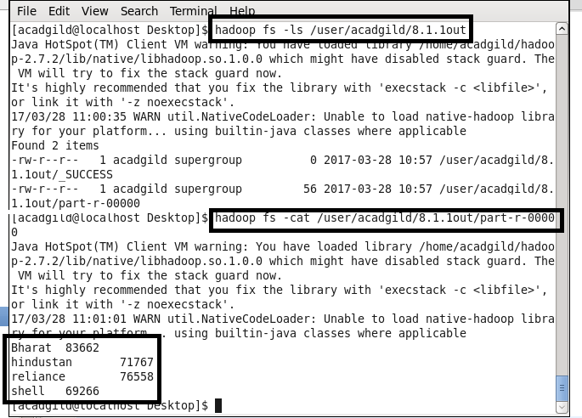

Output 2:

