Assignment 8.3:

* **Explain in brief the architecture of Apache Hadoop Yarn**

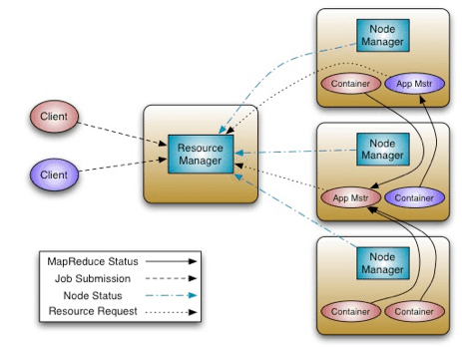

* **Explain in brief the architecture of Apache Hadoop Yarn**

The fundamental idea of YARN is to split up the two major responsibilities of the JobTracker i.e. resource management and job scheduling/monitoring, into separate daemons: a global ResourceManager and per-application ApplicationMaster (AM).

The ResourceManager and per-node slave, the NodeManager (NM), form the new, and generic, system for managing applications in a distributed manner.

The ResourceManager is the ultimate authority that arbitrates resources among all the applications in the system. The per-application ApplicationMaster is, in effect, a framework specific entity and is tasked with negotiating resources from the ResourceManager and working with the NodeManager(s) to execute and monitor the component tasks.

The Scheduler is responsible for allocating resources to the various running applications. Scheduler is pure scheduler in the sense that it performs no monitoring or tracking of status for the application.

It offers no guarantees about restarting failed tasks either due to application failure or hardware failures. The Scheduler performs its scheduling function based on the resource requirements of the applications; it does so based on the abstract notion of a resource Container which incorporates elements such as memory, CPU, disk, network etc.

The per-application ApplicationMaster has the responsibility of negotiating appropriate resource containers from the Scheduler, tracking their status and monitoring for progress. From the system perspective, the ApplicationMaster itself runs as a normal container.