**Assignment 9.4**

1. **LOAD**

Load data from the file system.

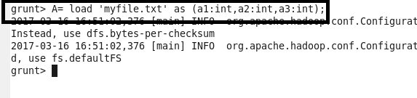

1. **LIMIT**

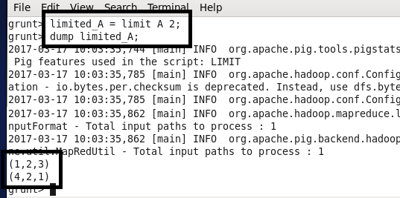

1. **ORDER BY**

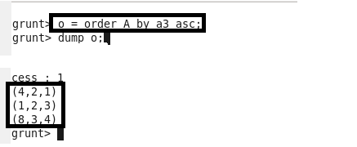

1. **GROUP BY**

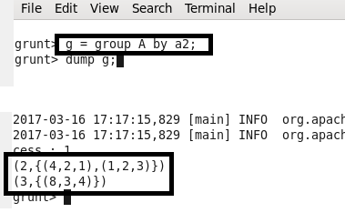

1. **FOREACH**

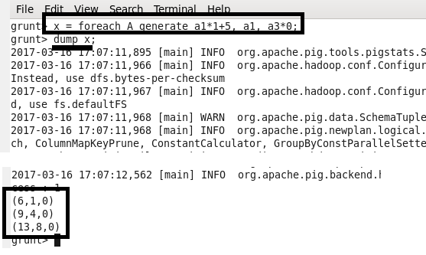

1. **FILTER**

Group the data in one or more relations.

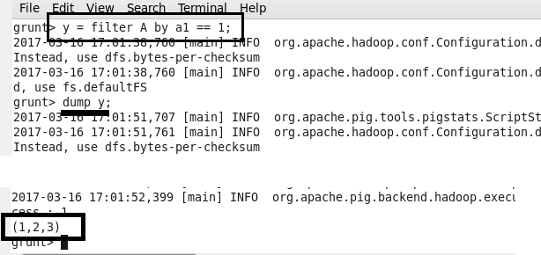

1. **STORE**

Store data in the file system.

