GIS-Integrated Machine Learning Framework for Urban Flood Prediction and Real-Time Alert System
Under the guidance of: Ms. Pathan Tasneem Farhana, Assistant Professor, Department of CSE, Presidency University
Sagar. P  20221COM0119  Department of CSE,  Presidency University | Duddukuri Sri Aditya  20221COM0087  Department of CSE,  Presidency University

Abstract—Urban flooding is a recurring hazard in fast-growing cities such as Bengaluru, where short-duration, high-intensity rainfall combined with encroached lakes, reduced natural drainage and increasing paved surface causes waterlogging that city-wide rainfall alerts cannot localise. This paper presents a GIS-integrated machine learning framework that predicts urban flood risk at 250 m spatial resolution for the BBMP region of Bengaluru and issues automated alerts. Weather data is obtained periodically from live providers (Open-Meteo, with OpenWeatherMap and an IMD adapter configurable where credentials are available), validated, and combined with static GIS features — elevation, slope, distance to drainage and waterbodies, road density and land-use/imperviousness indicators — computed on a 250 m grid. Logistic Regression and Random Forest serve as baselines and XGBoost is the primary classifier, validated using a chronological (TimeSeriesSplit) split to avoid training on future data. Predicted probabilities are mapped to LOW, MODERATE, HIGH and CRITICAL risk classes using system-configured thresholds, and SHAP/tree-based feature contributions explain individual predictions. A rule-based alert engine applies threshold, persistence, deduplication and cooldown checks before dispatching SMS notifications through Twilio, and a web dashboard renders the live risk map, rainfall charts, model performance and alert history. At the time of writing, backend and frontend components have been implemented and are undergoing structured testing; quantitative model metrics are therefore reported as planned evaluations rather than final results, with real-data validation identified as the next stage of the project.
Keywords—urban flood prediction, GIS, machine learning, XGBoost, explainable AI, SHAP, real-time alert system, geospatial risk mapping

I. Introduction
Bengaluru is an inland city built around an interconnected network of lakes and stormwater drains (rajakaluves). Rapid urbanisation has increased impervious surface and altered natural drainage paths, so that heavy rainfall over a short period can flood low-lying localities even when total rainfall over the day is not extreme. Contamination-free but volume-heavy runoff, encroachment of drains and lake edges, and uneven terrain jointly determine which parts of the city flood first.
Conventional flood warning is largely reactive and city-wide: rainfall alerts and news reports typically confirm waterlogging only after it has already begun, and they rarely indicate which specific neighbourhood is at risk. Given the increasing availability of live weather APIs, open geospatial data and machine learning tools, it is now feasible to move from reactive, city-wide alerts toward proactive, location-aware flood-risk prediction.
This paper presents a GIS-integrated machine learning framework that combines live weather ingestion, a 250 m geospatial grid, an XGBoost-based classifier with explainability, and an automated SMS alert pipeline for the Bengaluru BBMP region. The system is intended as a decision-support and early-warning tool; it does not model flood inundation depth or replace official hydrological assessment. The remainder of this paper is organised as follows: Section II reviews related work on machine-learning and GIS based flood prediction; Section III describes the proposed methodology and system architecture; Section IV presents the testing status and planned evaluation; and Section V concludes the paper and outlines future work.
II. Related Work
Ensemble tree-based models are widely reported to perform well on structured environmental and terrain features for flood-susceptibility prediction. Random Forest has been established as a robust ensemble learning method that averages many decision trees to reduce variance [1], and gradient-boosted tree methods such as XGBoost extend this idea with a scalable, regularised boosting procedure that consistently performs well on structured tabular prediction tasks [3]. Prior GIS-based flood-susceptibility studies have combined terrain and drainage criteria, in some cases weighted using the Analytic Hierarchy Process, with machine-learning ensembles such as Random Forest to produce spatial susceptibility maps [13], indicating that combining geospatial layers with tree-based classifiers is an established approach for this problem.
Model calibration and imbalance-aware evaluation are also relevant to flood prediction, since flood events are comparatively rare relative to non-flood observations. The Brier score is a standard measure of the calibration of predicted probabilities [2], and precision-recall analysis has been shown to be more informative than ROC analysis when evaluating classifiers on imbalanced datasets [12], which motivates reporting both ROC-AUC and PR-AUC for the proposed system. For model interpretability, SHAP (SHapley Additive exPlanations) provides a unified, game-theoretic framework for attributing a prediction to its input features [5], and has been extended to tree-based models specifically so that feature contributions can be computed efficiently for ensembles such as Random Forest and XGBoost [6].
On the geospatial and infrastructure side, open geospatial data from OpenStreetMap [9] and spatial-database support from PostGIS [11] are commonly used to build the terrain, drainage and road layers required for grid-based environmental prediction, and open weather-forecast APIs such as Open-Meteo [8] provide the live rainfall data needed for real-time pipelines. Collectively, this body of work indicates that (i) XGBoost and Random Forest are well suited to structured, terrain-and-rainfall driven prediction problems, (ii) SHAP-based explanation is an established way to make such predictions interpretable, and (iii) open GIS and weather data sources make a deployable, city-scale prototype feasible. The present work builds on these threads by combining a chronologically validated XGBoost classifier with a 250 m GIS grid and an automated, explainable alert pipeline for Bengaluru.
III. Methodology
A. Problem Statement
The goal of the system is to estimate, at 250 m spatial resolution across the Bengaluru BBMP region, the probability that a given grid cell will experience flood-level waterlogging in the near term, using live rainfall together with static terrain and drainage characteristics of that cell, and to notify configured recipients automatically when predicted risk becomes high. Four data categories — live, historical, demo/replay and test/mock — are distinguished throughout the system so that simulated data is never presented as real-time (Table I).
B. System Architecture
Fig. 1 shows the overall architecture. Weather data is fetched by a scheduled backend pipeline (Python, FastAPI, SQLAlchemy, APScheduler), validated, and combined with GIS layers (250 m grid, ward boundaries, lakes, drains, roads, elevation, land use) stored in PostgreSQL/PostGIS in production or SQLite with GeoJSON/Shapely for local development. The XGBoost model produces a flood-risk score per cell, which feeds both the GIS map on the Next.js/TypeScript frontend and the alert engine, which dispatches SMS notifications through Twilio.

TABLE I. DATA CATEGORIES USED IN THE PROJECT

Category | Source | Usage / Labelling
Live (real-time) | Open-Meteo API; OpenWeatherMap and IMD adapter where credentials are configured | Fetched periodically by the pipeline; shown as live
Historical | Historical rainfall/event records used for training and evaluation | Used offline for model training and validation
Demo / replay | Past events replayed through the pipeline in the Demo page | Always labelled DEMO / HISTORICAL REPLAY
Test / mock | Mock weather provider and test SMS | Only for automated testing; never shown as real data

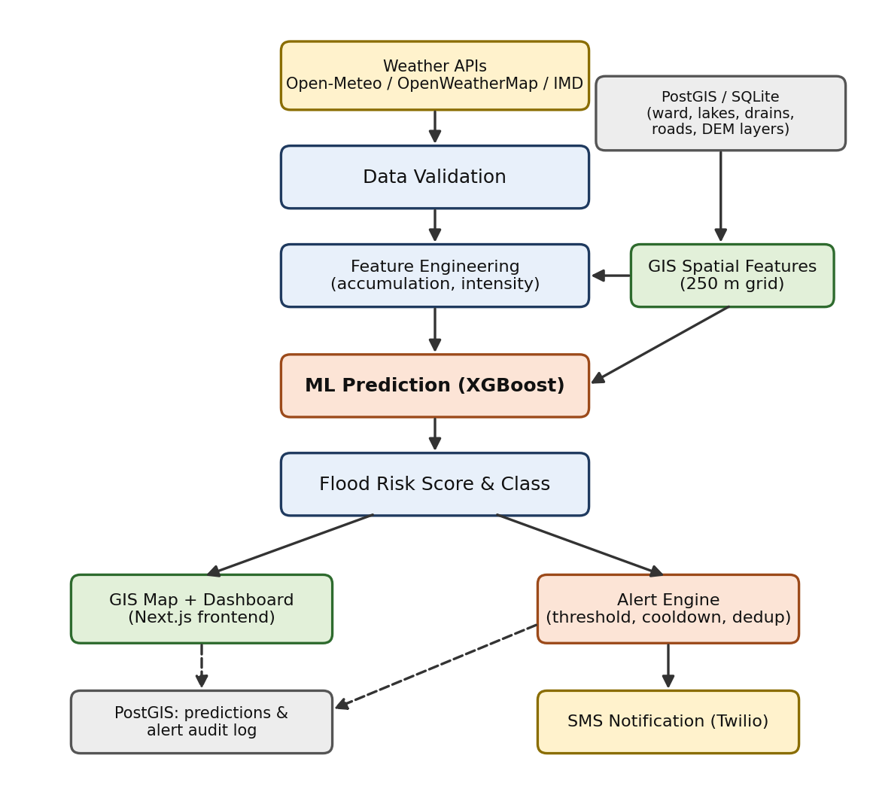
Fig. 1. Overall system architecture: weather ingestion, GIS feature grid, ML prediction, GIS map and alert engine.

C. GIS Design
Each 250 m grid cell over the BBMP region is described by seven static features: elevation, slope, distance to the nearest waterbody, distance to the nearest stormwater drain, road density, an imperviousness proxy derived from land-use information, and a land-use category. These features are combined with time-varying rainfall accumulation and intensity to form the model input for that cell.
D. Machine Learning Methodology
Fig. 2 shows the machine-learning workflow. Historical rainfall/event data is cleaned and joined with the GIS features described in Section III-C. A chronological split (TimeSeriesSplit) is used for training, validation and testing so that the model is never evaluated on data that precedes its training window. Logistic Regression and Random Forest are trained as baselines, and XGBoost is trained as the primary classifier. The model outputs a flood probability for each cell, which is mapped to a risk class using the system-configured thresholds in Table II; these thresholds are to be validated against historical observations rather than treated as pre-calibrated
TABLE II. FLOOD-RISK CLASSES (SYSTEM-CONFIGURED)
Risk Level | Probability
LOW | < 0.30
MODERATE | 0.30–0.59
HIGH | 0.60–0.79
CRITICAL | ≥ 0.80*

E. Explainable AI
SHAP and tree-based feature contributions [5], [6] are used to explain individual predictions, for example by showing that a HIGH-risk classification for a given cell was driven primarily by high short-duration rainfall accumulation and short distance to a drain. Feature contribution explains the model prediction and should not be interpreted as proof of causation.

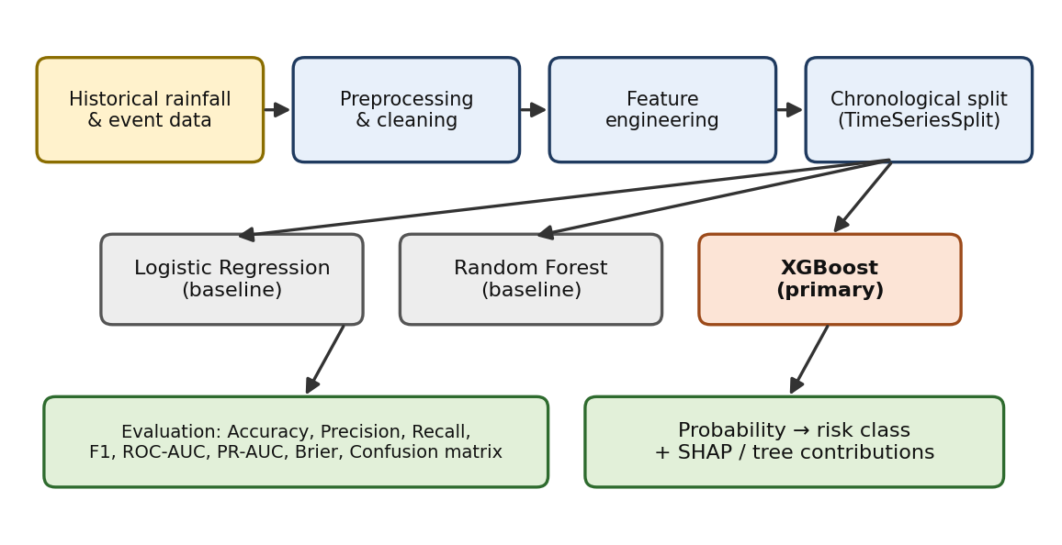
Fig. 2. Machine learning prediction workflow: preprocessing, chronological split, baseline and primary models, evaluation and explanation.

F. Real-Time Prediction Pipeline
A scheduler runs the prediction pipeline at a configurable interval (default 10 minutes): obtain weather data, validate it, compute rainfall accumulation and temporal features, attach GIS spatial features, run inference for all grid cells, store predictions, evaluate alert thresholds, trigger configured alerts, and log system status. If the live provider fails or returns invalid data, the failure is logged and stale or mock values are not presented as live.
G. Alert Generation
Fig. 3 shows the alert workflow. A predicted risk class that exceeds the configured threshold must also satisfy a persistence check across consecutive cycles before an alert is raised, which reduces false alerts from single noisy readings. Deduplication prevents repeated alerts for the same area and level, and a cooldown period limits alert frequency. Alerts that pass all checks are dispatched by SMS through Twilio to configured recipients, and every decision — including suppressed alerts — is written to an audit log.

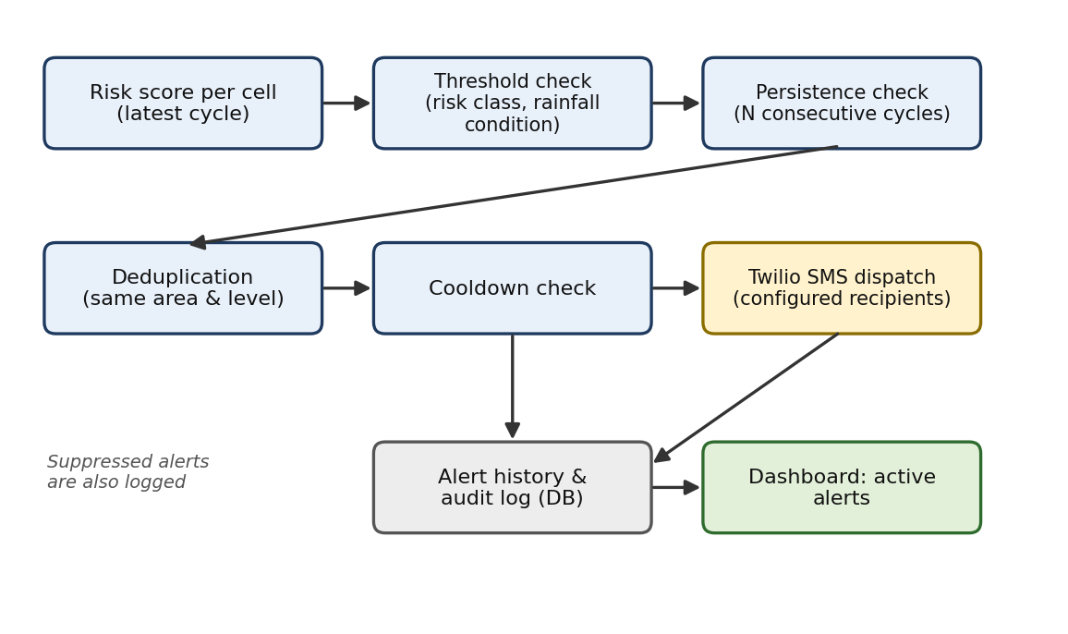
Fig. 3. Real-time alert workflow: threshold, persistence, deduplication, cooldown and SMS dispatch.

IV. Results and Discussion
A. Implementation and Testing Status
At the time of writing, the backend pipeline, GIS feature layers, model-training code and frontend dashboard have been implemented, and the project is in structured testing: backend syntax verification, API tests, weather-provider tests, feature-engineering tests, ML-inference tests, alert-engine tests and end-to-end tests are planned or in progress, alongside frontend build verification and page-level checks for the map, dashboard, model/XAI, historical-replay and alert-settings pages. No test in this list is reported as passed unless it has actually been executed and verified.

B. Model Evaluation (Planned)
The models are to be evaluated on the chronologically held-out test set using Accuracy, Precision, Recall, F1-score, ROC-AUC, PR-AUC and Brier score [2], with PR-AUC reported in addition to ROC-AUC because flood events are expected to be a minority class [12]. Table III lists the planned comparison; no experimental values are reported yet, and entries are marked accordingly to avoid presenting fabricated results.

C. GIS Risk Visualisation
The risk class predicted for each 250 m cell is rendered on a MapLibre/Leaflet-based map, coloured by LOW/MODERATE/HIGH/CRITICAL level, alongside KPI cards, rainfall charts and an active-alerts panel. This converts a per-cell tabular prediction into a spatial view that can be interpreted at a glance, consistent with prior work showing that GIS-based visualisation is an effective way to translate model output into an actionable format for responders [13].
D. Scope, Assumptions and Constraints
Results at this stage are architectural and procedural rather than quantitative: the pipeline, GIS grid and alerting logic have been designed and implemented, but model accuracy and threshold suitability have not yet been measured on held-out data. The system predicts flood-risk probability and classification; it does not model inundation depth or extent. Prediction quality on real data will depend on the completeness of the historical rainfall and GIS layers used for training.

TABLE III. PLANNED MODEL COMPARISON
Model | Role | F1-score | ROC-AUC | PR-AUC
Logistic Regression | Baseline | To be measured | To be measured | To be measured
Random Forest | Baseline | To be measured | To be measured | To be measured
XGBoost | Primary | To be measured | To be measured | To be measured

V. Conclusion
This paper presented a GIS-integrated machine learning framework for predicting urban flood risk at 250 m resolution over the Bengaluru BBMP region and for issuing automated, explainable alerts. The framework combines live weather ingestion, a static GIS feature grid (elevation, slope, drainage and waterbody proximity, road density, land use), a chronologically validated XGBoost classifier with Logistic Regression and Random Forest baselines, SHAP-based explanation, and a threshold/persistence/cooldown-based alert engine with SMS dispatch. The backend and frontend components have been implemented and are undergoing structured testing; quantitative model metrics are therefore reported as planned evaluations. Future work will focus on completing the test suite, validating model performance and risk thresholds on real historical flood observations and official rainfall data, and extending the system with additional rainfall stations, a finer digital elevation model and a mobile application.
References
[1] L. Breiman, "Random forests," Machine Learning, vol. 45, no. 1, pp. 5–32, 2001.
[2] G. W. Brier, "Verification of forecasts expressed in terms of probability," Monthly Weather Review, vol. 78, no. 1, pp. 1–3, 1950.
[3] T. Chen and C. Guestrin, "XGBoost: A scalable tree boosting system," in Proc. 22nd ACM SIGKDD Int. Conf. Knowledge Discovery and Data Mining, 2016, pp. 785–794.
[4] India Meteorological Department (IMD), Ministry of Earth Sciences, Government of India, official website and rainfall data services.
[5] S. M. Lundberg and S.-I. Lee, "A unified approach to interpreting model predictions," in Advances in Neural Information Processing Systems (NeurIPS), vol. 30, 2017.

[6] S. M. Lundberg et al., "From local explanations to global understanding with explainable AI for trees," Nature Machine Intelligence, vol. 2, no. 1, pp. 56–67, 2020.
[7] A. Mosavi, P. Ozturk, and K. Chau, "Flood prediction using machine learning models: Literature review," Water, vol. 10, no. 11, 2018.
[8] Open-Meteo, Weather Forecast API documentation, open-meteo.com.
[9] OpenStreetMap contributors, OpenStreetMap, openstreetmap.org.
[10] F. Pedregosa et al., "Scikit-learn: Machine learning in Python," Journal of Machine Learning Research, vol. 12, pp. 2825–2830, 2011.
[11] PostGIS Project, PostGIS documentation, postgis.net.
[12] T. Saito and M. Rehmsmeier, "The precision-recall plot is more informative than the ROC plot when evaluating binary classifiers on imbalanced datasets," PLoS ONE, vol. 10, no. 3, 2015.
[13] M. S. Tehrany, B. Pradhan, and M. N. Jebur, "Flood susceptibility mapping using a novel ensemble weights-of-evidence and support vector machine models in GIS," Journal of Hydrology, vol. 512, pp. 332–343, 2014.

