Lab 6 Password Policy Coverage Analysis
Final Laboratory Report
This report analyzes the assigned L6 L7 39 password policy checker. The completed suites raise the starter result from 52% combined coverage to 91% statement coverage and then to 100% statement and branch coverage.
Student Name: ____________________________
Student ID: ____________________________
Course: ____________________________
Instructor: ____________________________
Submission Date: 1 November 2026

Objective
The lab objective was to measure the assigned module with coverage.py, identify untested statements and decision outcomes, and write targeted pytest cases that exceed 90% code coverage and 90% branch coverage.

Assigned Repository
Source project: https://github.com/SETAPESU26/L6_L7_39_password_policy

Application Under Test
Function | Responsibility | Important decisions
check_password | Returns policy violations | Length, common password, and four character classes
strength | Rates the password | Strong, good, weak, or very weak
suggest_fix | Suggests the first repair | No issue, short, common, missing class, or fallback

Initial Coverage Analysis
The assigned starter file contains two valid-password tests. With branch tracking enabled, both pass, but the module reaches only 52% combined coverage: 21 of 47 statements are missed and nine branches are partial. The untested behavior includes length failures, common passwords, missing character classes, alternative strength ratings, and every suggestion outcome.
Run | Tests | Statements missed | Branch status | Coverage
Starter tests | 2 passed | 21 of 47 | 9 partial | 52%
Code suite | 6 passed | 4 of 47 | Not required | 91% line
Branch suite | 17 passed | 0 of 47 | 36 of 36 | 100%

Test Design
- Exercise valid, short, common, and missing-character-class passwords for the code-coverage milestone.
- Add the over-64-character boundary and every strength return for complete decision coverage.
- Exercise all five suggest_fix outcomes, including the empty list and fallback branch.
- Use pytest parameterization so related branch cases remain compact and readable.

Code Coverage Analysis
The code-focused suite contains six tests covering valid passwords, the short and common rules, all four character-class checks, weak and very weak ratings, and a missing-class suggestion. It exceeds the lab threshold with 91% statement coverage.

Commands
coverage erase
coverage run --source=password_policy -m pytest -q CodeCoverageTest_39_password_policy.py
coverage report -m
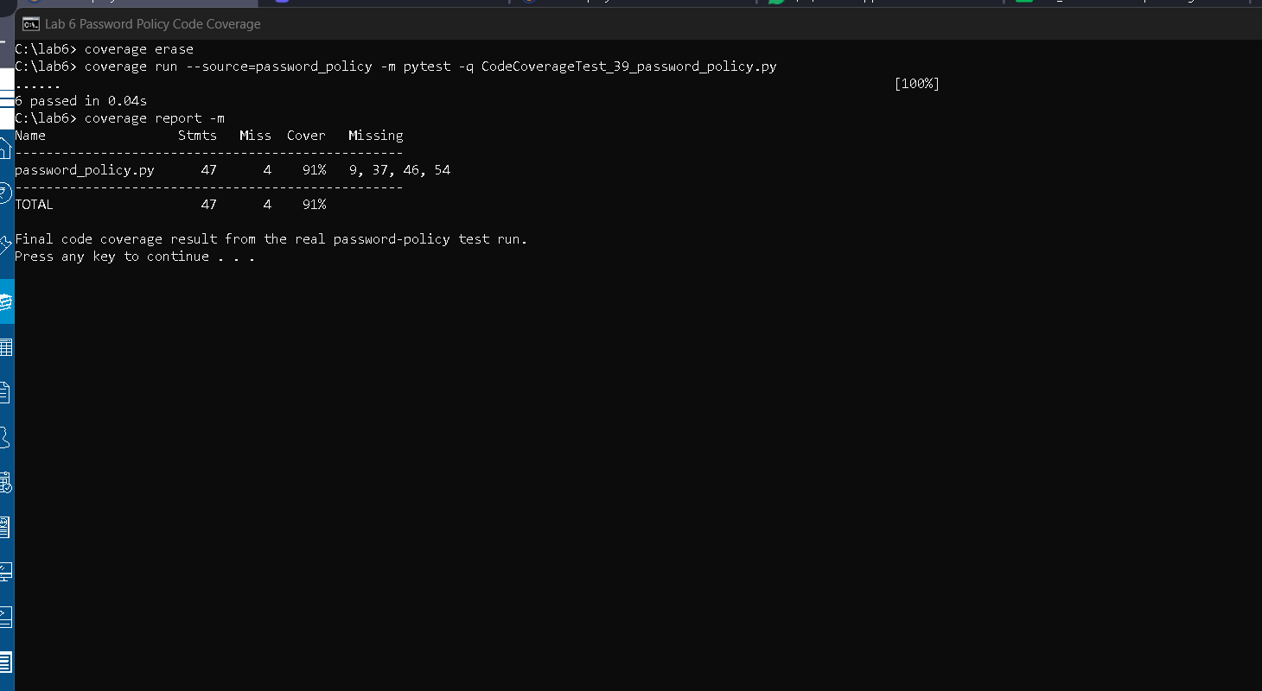
Figure 1 Genuine terminal screenshot showing 6 passing tests and 91% code coverage
The report identifies lines 9, 37, 46, and 54 as unexecuted. These correspond to the too-long rule, the strong rating, the no-fix-needed return, and the fallback suggestion. Those remaining outcomes guided the branch-focused additions.

Branch Coverage Analysis
The branch suite expands the coverage set to 17 parameterized cases. It evaluates both outcomes of the length and common-password conditions, every character classification path, all four strength results, and all five suggestion paths.
Area | Cases included | Outcome
Password issues | Short, long, common, valid, and each missing class | All policy decisions
Strength | Strong, good, weak, and very weak | All four returns
Suggestions | None, short, common, missing class, and fallback | All five returns

Commands
coverage erase
coverage run --branch --source=password_policy -m pytest -q BranchCoverageTest_39_password_policy.py
coverage report -m
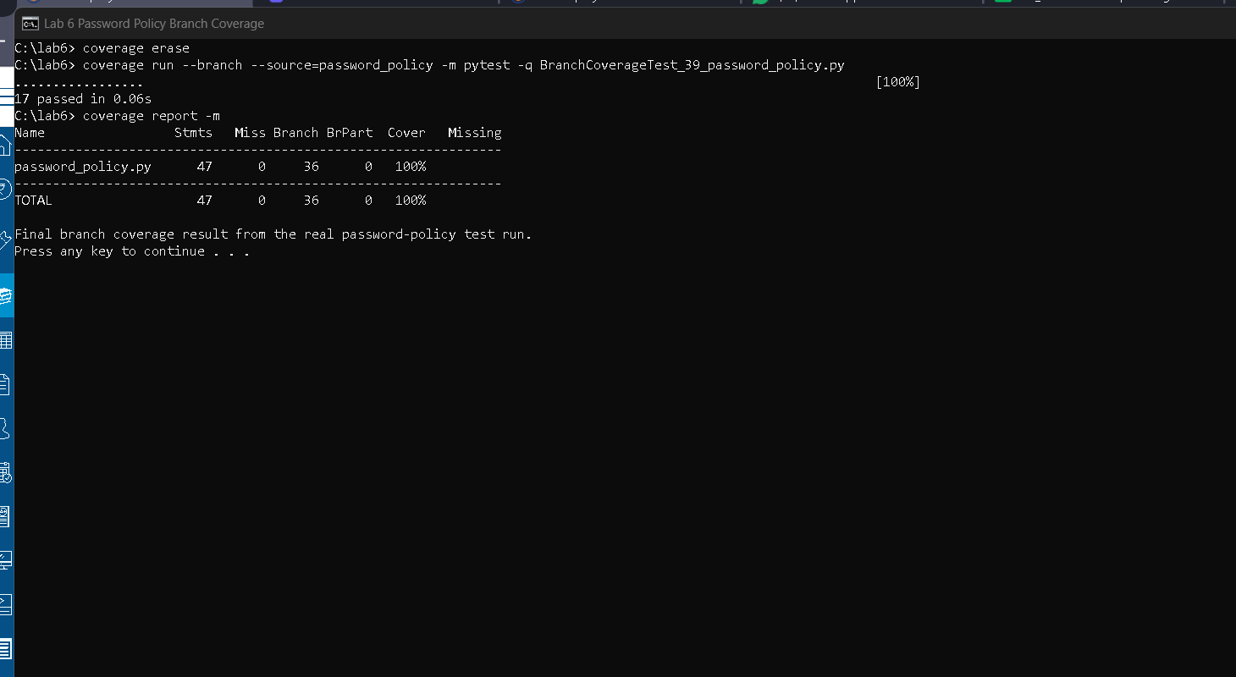
Figure 2 Genuine terminal screenshot showing 17 passing tests and 100% branch coverage
The final report records 47 statements with no misses and 36 branches with no partial branches. The result is 100% combined coverage, which exceeds the required branch-coverage threshold.

Results and Interpretation
Coverage improved in two deliberate stages. The starter tests established that the main valid-password path worked, while the 91% suite covered most executable behavior. The final suite closed every remaining branch by targeting the specific outcomes reported as missing.
Metric | Starter | Code milestone | Final branch milestone
Tests passed | 2 | 6 | 17
Statements | 26 of 47 | 43 of 47 | 47 of 47
Branches | 9 partial | Not measured | 36 of 36
Coverage | 52% combined | 91% line | 100% combined

Repository and Commit Evidence
Completed repository: https://github.com/Adi-2936/lab-6-code-branch-coverage
Commit | Purpose | Coverage evidence
80a8724 | Replace sample with assigned password-policy code and code tests | 91% line
86840d5 | Add complete branch tests and genuine terminal screenshot | 100% branch

Conclusion
The assigned password-policy module now satisfies every Lab 6 deliverable. The repository contains separate code-coverage and branch-coverage test files, genuine terminal screenshots, and distinct commits for the two milestones. Final branch analysis confirms that every statement and all 36 recorded branch outcomes execute successfully.

