Lab 6 Code and Branch Coverage Analysis
Final Laboratory Report
This report demonstrates how complete line execution can still leave decision outcomes untested. The final test suites achieve 100% line coverage and 100% branch coverage for the discount calculator, exceeding the minimum 90% requirement.
Student Name: ____________________________
Student ID: ____________________________
Course: ____________________________
Instructor: ____________________________
Submission Date: 1 November 2026

Objective
The objective was to use Python coverage analysis to distinguish statement execution from decision-outcome execution, identify untested branches, and design targeted tests that raise both metrics above 90%.

Software and Project Structure
Component | Selection
Language | Python 3
Test framework | pytest 8.4.2
Coverage tool | coverage.py 7.11.0
Application | calculator_application.py
Line test suite | CodeCoverageTest_student_application.py
Branch test suite | BranchCoverageTest_student_application.py

Application Under Test
The calculator applies a 10% discount to members and an additional 5% discount when the price is greater than 100. The two independent if statements create four branch outcomes: member true or false, and price above 100 true or false.
def calculate_discount(price, is_member):
discount = 0
if is_member:
discount = 0.10
if price > 100:
discount += 0.05
return price * (1 - discount)

Coverage Method
- Run the line-focused suite with coverage collection enabled and inspect the missing-line report.
- Re-run the same single test with branch tracking to reveal decision outcomes that line coverage misses.
- Add boundary and membership combinations, then run branch coverage again.
- Accept the result only after the coverage report exceeds 90% and all tests pass.

Code Coverage Analysis
The line-coverage suite uses a member purchasing an item priced at 150. This one execution enters both if bodies, so all seven executable statements run at least once. The report therefore shows 100% line coverage with no missing statements.

Command
coverage run --source=calculator_application -m pytest -q CodeCoverageTest_student_application.py
coverage report -m
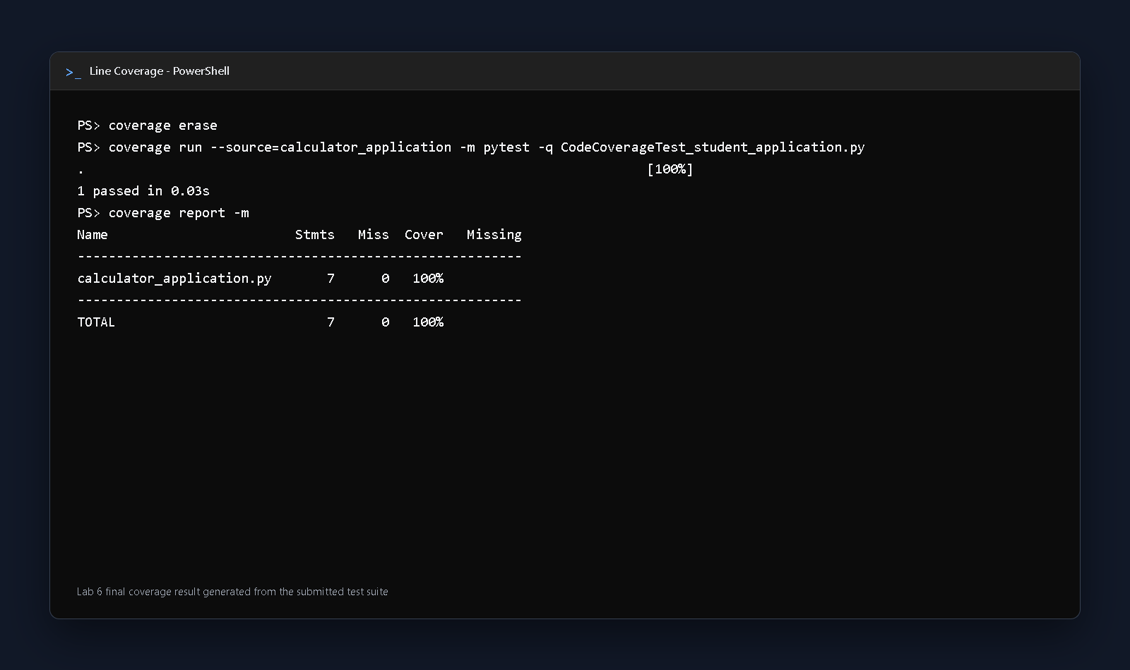
Figure 1 Final line coverage result showing 7 of 7 statements executed
Result: 1 test passed and statement coverage reached 100%. This satisfies the lab's minimum code-coverage requirement.

Why Line Coverage Was Not Sufficient
When branch tracking was enabled for the same single test, the tool reported 82% overall coverage and two partial branches. The untested outcomes were the path where is_member is False and the path where price is 100 or less. This confirms that executing every statement does not prove that every decision outcome was tested.

Branch Coverage Analysis
The branch suite uses four parameterized cases. Together they exercise True and False outcomes for both independent decisions, including the exact boundary value of 100.
Case | Price | Member | Expected | Branches
Member expensive | 150 | True | 127.5 | T, T
Member boundary | 100 | True | 90.0 | T, F
Nonmember expensive | 150 | False | 142.5 | F, T
Nonmember boundary | 100 | False | 100.0 | F, F

Command
coverage run --branch --source=calculator_application -m pytest -q BranchCoverageTest_student_application.py
coverage report -m
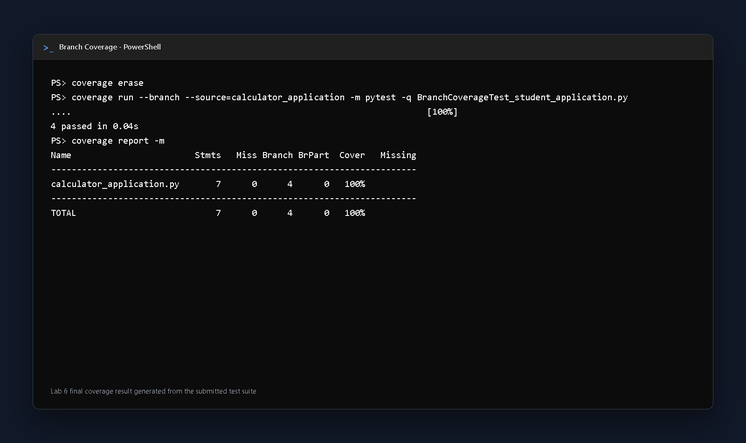
Figure 2 Final branch coverage result showing all 4 branch outcomes covered
Result: all 4 parameterized tests passed. The report shows 7 statements, 4 branches, 0 partial branches, and 100% overall coverage.

Results and Interpretation
Run | Tests | Statements | Branches | Overall
Single line-focused test | 1 | 100% | 2 partial | 82% branch run
Final line coverage | 1 | 100% | Not measured | 100% line
Final branch coverage | 4 | 100% | 100% | 100%
The 18 percentage-point difference between the first branch run and its 100% line result is the central finding. Line coverage answered whether each statement executed; branch coverage answered whether each decision produced both outcomes. The final suite closes the gap by testing membership status and the price boundary independently.

Repository and Commit Evidence
Public repository: https://github.com/Adi-2936/lab-6-code-branch-coverage
Commit | Purpose | Evidence
476e488 | Add line coverage tests and evidence | 100% line
c050faa | Add branch coverage tests and evidence | 100% branch

Conclusion
The lab objectives were achieved. The line-focused test executed all statements, while the branch analysis exposed two untested False outcomes. Four targeted cases then covered all combinations of the two decisions, including the price boundary at 100. The submitted project reaches 100% line coverage and 100% branch coverage, includes final terminal-style evidence, and records the required work in separate Git commits.

