# VPN IMPLEMENTION

## A PROJECT REPORT

***Submitted by***

# K Sonali-220301120200

**Abhilipsa Sahoo-220301120206 Padmabati Routray-220301120211 Nirbikar Kr. Mohanty-220301120194**

***In partial fulfillment for the award of the***

***degree of***

# BACHELOR OF TECHNOLOGY

***in***

# COMPUTER SCIENCE AND ENGINEERING



## SCHOOL OF ENGINEERING AND TECHNOLOGY BHUBANESWAR CAMPUS

**CENTURION UNIVERSITY IF TECHNILOGY AND MANAGEMENT ODISHA**



**DEPARTMENT OF COMPUTER SCIENCE AND ENGINEERING SCHOOL OF ENGINEERING AND TECHNOLOGY BHUBANESWAR CAMPUS**

**BONAFIDE CERTIFICATE**

Certified that this project report on **“VPN IMPLEMENTION”** is the bonafide work of “K Sonali (220301120200), Abhilipsa Sahoo (220301120206), Padmabati Routray (220301120211), Nirbikar Kr. Mohanty (220301120194)” **who** carried out the project work under the supervision of **Ms. Adyasha Swain** This is to certify to the best of our knowledge, that this project has not been carried out in this institute and the university.

**SIGNATURE**

**Ms. Adyasha Swain Asst. Professor**

**Department of Computer Science and Engineering**

*Certified that the above-mentioned project has been duly carried out as per the norms of the college and statutes of the university.*

**SIGNATURE**

**Prof. Raj Kumar Mohanta (HEAD OF THE DEPARTMENT)**

**Computer Science and Engineering**

## DECLARATION

I hereby declare that the project entitled **“VPN IMPLEMENTION”** submitted for the **“IT IFRASTUCTURE MANAGEMENT”** of 6th Semester B. Tech in Computer Science and Engineering is our original work and the project was not formed on the basis for the reward of any Degree / Diploma or any other similar titles in any other Universities / Institutes.

**Name of the Student: Signature of the Student:**

**Registration no: Place:**

**Date:**

## ACKNOWLEDGEMENTS

I wish to express my profound and sincere gratitude to **Ms. Adyasha Swain,** Department of Computer Science and Engineering, SoET, Bhubaneswar Campus, who guided us into the intricacies of this project nonchalantly with matchless magnanimity.

I thank **Prof. Raj Kumar Mohanta**, Head of the Dept. of Department of Computer Science and Engineering, SoET, Bhubaneswar Campus and **Dr. Sujata Chakravarty**, Dean, School of Engineering and Technology, Bhubaneswar Campus for extending their support during Course of this investigation.

I express my sincere gratitude to the faculty members and staff of the Department of Computer Science Engineering at CUTM, Jatani, for their invaluable support in completing this project. Their commitment to academic excellence greatly enriched my learning experience.

I also extend thanks to my teammates for their collaborative efforts, dedication, and valuable contributions, which played a crucial role in enhancing the overall quality and success of our project. Together, with the support of both the faculty and my teammates, we have achieved a project outcome that I am proud to present.

**Name of the Student: Signature of the Student:**

**Registration no: Place:**

**Date:**

# ABSTRACT

In today's digital landscape, secure communication and data privacy are paramount, making Virtual Private Networks (VPNs) an essential technology for individuals and organizations. This report explores the implementation of VPNs using Cisco Packet Tracer, highlighting the core concepts, configuration process, software and hardware requirements, and security implications of VPN deployment. VPNs provide a secure, encrypted tunnel for data transmission, enabling remote access to networks while protecting sensitive information from cyber threats.

The study also examines the different types of VPNs, including Site-to-Site VPNs, Remote Access VPNs, and IPSec VPNs, detailing their applications and benefits in corporate, government, and personal networking environments. Additionally, the report discusses the challenges and limitations of VPN technology, such as performance bottlenecks, encryption overhead, and compliance with cybersecurity regulations.

Future trends in VPN development, including AI-driven security enhancements, quantum- resistant encryption, Zero Trust Network Access (ZTNA), and cloud-based VPN solutions, are also analysed to understand how VPN technology will evolve to meet growing security demands. By providing a comprehensive guide to VPN implementation, this report serves as a valuable resource for IT professionals, students, and cybersecurity enthusiasts looking to enhance their knowledge of secure networking.

## TABLE OF CONTENTS

**CHAPTER NO. PAGE NO.**

CHAPTER -1: INTRODUCTION 01-03

* 1. Key Highlights 01-02
  2. Purpose 02
  3. Key Objectives 02-03
  4. Intended Audience and Reading Suggestions 03

CHAPTER -2: PRODUCT SCOPE 04-06

* 1. Core Objectives 04
  2. Key Features 05
  3. Business and Industry Relevance 05-06

CHAPTER -3: SOCTWARE AND HARDWARE REQUIREMENTS 07-08

* 1. Operating environment 07
  2. Design and Implementation Constraint 08

CHAPTER-4: OVERAL DESCRIPTION 09-14

* 1. Overall Description 09
  2. Network Topology 09-10
  3. Project configuration Process 10-13
  4. Observations from the Ping Results 14

CHAPTER NO. PAGE NO.

CHAPTER-5: INTERFACE REQUIREMENTS 15-16

* 1. Output Section 15-16

CHAPTER-6 : FUTURE SCOPE 17

CHAPTER-7: CONCLUSION 18

CHAPTER-8: REFERENCES 19

## CHAPTER – 1

1. **INTRODUCTION**

In today’s digital era, the security of data transmission over networks is a critical concern. Virtual Private Networks (VPNs) play a crucial role in ensuring secure communication by encrypting data and providing a secure pathway between remote networks or users. This report focuses on the **implementation of VPN using Cisco Packet Tracer**, a network simulation tool that allows users to configure, analyse, and troubleshoot networking devices. The project demonstrates the configuration of **IPSec VPN tunnels**, **secure data transmission**, and **network security best practices**. By implementing a VPN in a simulated environment, this project provides insights into **real-world network security challenges and solutions**, making it an essential learning tool for networking professionals and students.

* 1. **Key Highlights:**

Virtual Private Networks (VPNs) enable secure communication over the internet by encrypting data, ensuring confidentiality, integrity, and secure remote access for users and organizations. VPNs are essential in today's digital landscape, where cyber threats are prevalent, and businesses require secure data transmission. They allow employees to work remotely, ensuring that sensitive corporate data is protected from unauthorized access.In this project, we implement VPNs using Cisco Packet Tracer, a widely used network simulation tool. This report covers the entire process, from setup and configuration to testing and troubleshooting. By using Cisco Packet Tracer, we can visualize how VPNs function, understand network behaviour, and explore security mechanisms in a controlled environment. This knowledge is critical for network administrators, IT professionals, and students learning about secure networking practices.

The key highlights of this project include:

* **Implementation of VPN Technology** – Configuring a secure **IPSec VPN** in Cisco Packet Tracer.
* **Encryption and Security Measures** – Using encryption protocols like **AES, 3DES, and SHA- 256** for data protection.
* **Network Segmentation and Secure Communication** – Establishing a **secure tunnel** between remote locations.
* **Configuration of Cisco Devices** – Setting up **routers, switches, and client devices** for VPN connectivity.
* **Use of Authentication Mechanisms** – Implementing **pre-shared keys (PSK)** and **certificate- based authentication**.
* **Simulation of Corporate VPN Deployment** – Replicating a **real-world enterprise network**

setup.

* **Analysis and Troubleshooting** – Performing **packet analysis, ping tests, and network debugging**.
* **Performance Optimization** – Examining **latency, bandwidth utilization, and VPN stability**.
* **Security Threat Prevention** – Understanding potential **VPN vulnerabilities** and mitigation strategies.
* **Implementation of Routing Protocols** – Configuring **Static Routing, RIP, OSPF, or EIGRP**

alongside VPN tunnels.

* 1. **Purpose**

The primary purpose of this project is to **design, implement, and test a secure VPN connection** using Cisco Packet Tracer. In today’s IT infrastructure, VPNs are widely used by organizations to ensure **secure remote access, inter-branch connectivity, and encrypted communication** over the internet.

This project serves the following purposes:

* + - **Understanding VPN Concepts** – Learning about **different types of VPNs** (Site-to-Site, Remote Access, SSL, and IPSec).
    - **Enhancing Network Security** – Implementing **secure tunnelling and encryption** to protect transmitted data.
    - **Providing a Hands-on Learning Experience** – Configuring VPNs practically instead of just learning theoretical concepts.
    - **Simulating a Secure IT Environment** – Designing a VPN network **similar to corporate infrastructures**.
    - **Reducing Security Risks** – Understanding how VPNs **prevent data breaches and unauthorized access**.
    - **Analysing Real-World Applications** – Exploring the **practical use of VPNs in businesses, remote work, and cloud networking**.
    - Establish a **secure communication channel** between two or more networks.
    - Implement **IPSec VPN** for encryption and authentication of transmitted data.
    - Provide **hands-on experience** in configuring VPNs in a simulated environment.
    - Enhance knowledge of **network security concepts** related to VPNs.

### Key Objectives

The main objectives of this project include:

* + - Understanding VPN Architecture – Learn about VPN types (Site-to-Site, Remote Access).
    - Implementing Secure Tunnels – Configure encrypted tunnels between networks.
    - Configuring VPN in Cisco Packet Tracer – Set up and troubleshoot VPN connections.
    - Ensuring Data Integrity and Security – Apply security measures such as authentication and encryption.
    - Simulating a Real-World Scenario – Create a secure communication setup similar to corporate environments.

### Intended Audience and Reading Suggestions

This report is intended for:

* + - **Networking students** learning about VPN implementation.
    - **IT professionals** interested in network security solutions.
    - **Researchers** exploring VPN technologies and their applications.
    - **Organizations** looking for a VPN setup guide using Cisco Packet Tracer.

**Reading Suggestions:**

* + - Readers should have **basic knowledge of networking concepts** (IP addressing, routing).
    - Familiarity with **Cisco Packet Tracer** will be beneficial.
    - Chapters are structured **progressively**, starting from theoretical concepts to practical implementation.

## CHAPTER 2

1. **PRODUCT SCOPE**

With the rise in cyber threats and increasing reliance on remote access solutions, Virtual Private Networks (VPNs) have become an essential component of modern networking. VPNs provide secure, encrypted communication between remote users and networks, ensuring data confidentiality, integrity, and availability. This project focuses on the implementation of VPN using Cisco Packet Tracer to simulate a real-world secure networking environment. The goal is to demonstrate how VPNs enhance security, support business operations, and provide a scalable solution for remote connectivity.

This chapter explores the core objectives of the project, key features of the VPN implementation, and its business and industry relevance in today's digital landscape.

### Core Objectives

**The primary objectives of this project are:**

* + - * **Understanding VPN Technology**
* Define Virtual Private Networks (VPNs) and their importance.
* Explain the working mechanism of VPNs, including encryption and tunneling.
* Differentiate between Site-to-Site VPN and Remote Access VPN.
  + **Implementing a Secure VPN Network**
* Configure a fully functional VPN in Cisco Packet Tracer.
* Establish a secure tunnel between remote sites using IPSec protocols.
* Implement encryption standards like AES, 3DES, and SHA-256 to secure communication.
  + **Configuring VPN Components**
* Set up Cisco routers, switches, and client devices in a simulated environment.
* Define IP addressing schemes and routing configurations to support VPN connectivity.
* Implement firewall rules and access control lists (ACLs) for security enforcement.
  + **Testing and Troubleshooting VPN Connections**
* Validate VPN functionality using ping tests, traceroute, and packet analysis.
* Diagnose common VPN issues such as latency, misconfiguration, and connectivity failures.
* Utilize debugging tools in Cisco Packet Tracer to monitor VPN traffic.

### Key Features

The VPN implementation in Cisco Packet Tracer includes the following key features:

* + **Secure Communication & Encryption**

✔ End-to-End Encryption – Data transmitted through the VPN is encrypted using IPSec protocols.

✔ Authentication Mechanisms – Users and devices authenticate using pre-shared keys (PSK) or digital certificates.

✔ Data Integrity Protection – Hashing algorithms like SHA-256 ensure data integrity during transmission.

* + **Network Architecture & Configuration**

✔ Site-to-Site VPN Setup – Establishes a secure tunnel between two remote networks.

✔ Routing Protocol Integration – Supports Static Routing, OSPF, and EIGRP for efficient data flow.

✔ Access Control Lists (ACLs) – Configures firewall rules to allow or deny specific traffic.

* + **Scalability & Performance Optimization**

✔ Load Balancing – Optimizes network performance by distributing traffic evenly.

✔ Multiple VPN Connections – Simulates multiple remote users accessing the corporate network securely.

✔ Minimal Latency Configuration – Ensures efficient routing for high-speed data transfer.

### Business and Industry Relevance

VPNs play a crucial role in various industries by providing secure, private, and reliable network connectivity. This project highlights the real-world significance of VPNs in different sectors:

* **Corporate and Enterprise Networks**
* Large organizations use VPNs to connect branch offices securely.
* Employees can remotely access company resources without compromising security.
* Protects sensitive business data from cyber threats and unauthorized access.
  + **Cybersecurity and IT Infrastructure**
* VPNs are essential for protecting corporate networks from cyberattacks.
* They ensure secure data transmission over public Wi-Fi and untrusted networks.
* Used in combination with firewalls, intrusion detection systems (IDS), and endpoint security solutions.
  + **Remote Work and Telecommuting**
* VPNs enable secure remote work environments for employees worldwide.
* They allow businesses to implement Bring Your Own Device (BYOD) policies securely.
* Provide access to internal systems without exposing them to external threats.
  + **Banking and Financial Institutions**
* Ensures secure online transactions and protects customer data.
* Prevents phishing, identity theft, and data interception in online banking.
* Used by stock markets and financial analysts for encrypted data exchange.

.

## CHAPTER 3

1. **SOFTWARE AND HARDWARE REQUIREMENTS**

The successful implementation of a Virtual Private Network (VPN) in Cisco Packet Tracer requires a well-defined software and hardware environment to ensure optimal performance and security. Selecting the right components is crucial for network simulation, secure tunneling, and efficient data transmission.This chapter discusses the operating environment, hardware specifications, and software requirements necessary to configure and run the VPN network in Cisco Packet Tracer. Additionally, it outlines the constraints that may affect the design and implementation of the VPN setup.

### Operating Environment

The VPN implementation requires a combination of software tools, hardware resources, and networking components to create a realistic simulation. The following are the key elements of the operating environment:

### Software Requirements

The software tools required for setting up the VPN include:

✔ **Cisco Packet Tracer** – A network simulation tool used to configure and test VPN implementation.

✔ **Operating System (OS)** – Windows 10/11, macOS, or Linux to run Cisco Packet Tracer.

✔ **Wireshark (Optional)** – A packet analysis tool for monitoring and troubleshooting network traffic.

### Hardware Requirements

✔ **Processor:** Intel Core i5 or higher / AMD Ryzen 5 or higher.

✔ **RAM:** Minimum 4GB (Recommended: 8GB or more for smooth performance).

✔ **Storage:** At least 2GB of free disk space for Cisco Packet Tracer installation.

✔ **Network Interface Card (NIC):** Ethernet or Wi-Fi adapter for internet connectivity.

### Networking Components in Cisco Packet Tracer

To implement VPN, the following networking devices will be configured in the simulation:

✔ **Cisco Routers (2811, 2911, or higher)** – Used for VPN configuration and tunneling.

✔ **Cisco Switches (2960 or 3560 series)** – To connect and manage network devices.

✔ **End Devices (PCs, Laptops, and Servers)** – Simulating employees accessing the VPN remotely.

✔ **Cloud Module (Internet Simulation)** – Represents the public internet through which VPN traffic is transmitted.

✔ **Firewall Device (ASA 5505 or 5510)** – Provides additional security for VPN traffic.

### Design and Implementation Constraints

The implementation of VPN in Cisco Packet Tracer is subject to several **design and technical constraints** that can impact the efficiency and security of the system.

### Technical Constraints

* **Simulation Limitations:** Cisco Packet Tracer does not support all real-world VPN configurations like dynamic VPN protocols.
* **Processing Power:** Running complex simulations with multiple routers and encryption layers may slow down performance on low-end systems.
* **Limited Cryptographic Algorithms:** Some advanced encryption methods, like AES-256-GCM, may not be available in Cisco Packet Tracer.
* **Network Latency Issues:** Packet Tracer does not simulate real-world latency and bandwidth limitations accurately.

### Security Constraints

* **No Real-World Threat Simulation:** Cisco Packet Tracer does not include real- world attack simulations like brute force or DDoS attacks.
* **Firewall Limitations:** The firewall in Packet Tracer has limited security rule configurations compared to real Cisco ASA firewalls.

## CHAPTER 4

## OVERALL DESCRIPTION

The implementation of a Virtual Private Network (VPN) using Cisco Packet Tracer provides an efficient and secure method for remote communication and data transmission. This chapter outlines the overall architecture, workflow, and functional aspects of the VPN system. The VPN simulation in Cisco Packet Tracer involves creating a secure tunnel between remote users and a private network, ensuring data encryption, authentication, and confidentiality. It also integrates multiple network devices, including routers, switches, firewalls, and end devices, to simulate a real-world VPN setup.

A VPN (Virtual Private Network) allows secure communication over the internet by establishing an encrypted tunnel between a client and a network.

* 1. **Network Topology Network Components**

1. Routers (4 total)
   * Router0 (Connected to LAN 10.0.0.0/24)
   * Router1 (Intermediate router)
   * Router2 (Intermediate router)
   * Router4 (Connected to LAN 20.0.0.0/24)
2. Switches (2 total)
   * Switch0 (Connected to Router0, PC0, and PC1)
   * Switch1 (Connected to Router3, PC2, and PC3)
3. PCs (4 total)
   * PC0 (10.0.0.1)
   * PC1 (10.0.0.2)
   * PC2 (20.0.0.1)
   * PC3 (20.0.0.2)

Network Connections

* Router0 → Switch0 → PC0, PC1
* Router4 → Switch1 → PC2, PC3
* Router0 ↔ Router1 (Serial 60.0.0.0/30)
* Router1 ↔ Router2 (Serial 70.0.0.0/30)
* Router2 ↔ Router4 (Serial 80.0.0.0/30)

### Project configuration Process

To configure the VPN implementation in Cisco Packet Tracer based on the given topology, follow these steps:

**Step 1: Configure Basic IP Addressing**

Assign IP addresses to each router and PC as per the diagram.

**Router 0 - : enable**

configure terminal

interface FastEthernet0/0

ip address 10.0.0.3 255.255.255.0 no shutdown

**exit**

interface Serial0/0/0

ip address 60.0.0.1 255.255.255.252

no shutdown

**exit**

### Router 1 -: enable

configure terminal interface Serial0/0/0

ip address 60.0.0.2 255.255.255.252

no shutdown

### exit

interface Serial0/0/1

ip address 70.0.0.1 255.255.255.252

no shutdown

**exit**

**Router 2 -:**

**enable**

configure terminal interface Serial0/0/0

ip address 70.0.0.2 255.255.255.252

no shutdown

### exit

interface Serial0/0/1

ip address 80.0.0.1 255.255.255.252

no shutdown

### exit Router 4-:

**enable**

configure terminal interface Serial0/0/0

ip address 80.0.0.2 255.255.255.252

no shutdown

### exit

interface FastEthernet0/0

ip address 20.0.0.3 255.255.255.0 no shutdown

### exit

**Step 2: Configure Routing (Static or Dynamic)** To ensure all routers can reach each other. **Static Routing Example;**

On **Router 0**:

ip route 20.0.0.0 255.255.255.0 60.0.0.2

On **Router 4**:

ip route 10.0.0.0 255.255.255.0 80.0.0.1

Or use **RIP Routing** on all routers: enable

configure terminal router rip

version 2

network 10.0.0.0

network 20.0.0.0

network 60.0.0.0

network 70.0.0.0

network 80.0.0.0 no auto-summary exit

### Step 3: Configure VPN (IPSec VPN)

**On Router 0**

crypto isakmp policy 10 encryption aes

hash sha

authentication pre-share group 2

exit

crypto isakmp key MYKEY address 80.0.0.2

crypto ipsec transform-set MYSET esp-aes esp-sha-hmac crypto map VPNMAP 10 ipsec-isakmp

set peer 80.0.0.2

set transform-set MYSET match address 100

exit

interface Serial0/0/0 crypto map VPNMAP exit

access-list 100 permit ip 10.0.0.0 0.0.0.255 20.0.0.0 0.0.0.255

**On Router 4**

crypto isakmp policy 10 encryption aes

hash sha

authentication pre-share group 2

exit

crypto isakmp key MYKEY address 60.0.0.1

crypto ipsec transform-set MYSET esp-aes esp-sha-hmac crypto map VPNMAP 10 ipsec-isakmp

set peer 60.0.0.1

set transform-set MYSET match address 100

exit

interface Serial0/0/0 crypto map VPNMAP exit

access-list 100 permit ip 20.0.0.0 0.0.0.255 10.0.0.0 0.0.0.255

**Step 4: Verify the VPN Connection**

* Use the **ping** command to check connectivity: ping 20.0.0.1
* Check if the VPN is active: show crypto isakmp sa show crypto ipsec sa

**After this configuration ;**

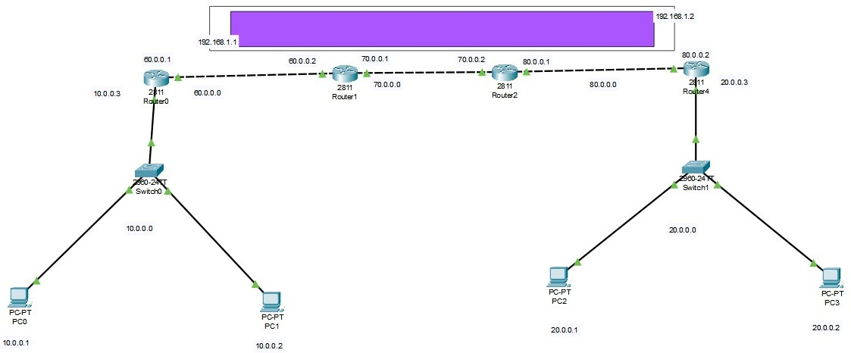

### Observations from the Ping Results

* + 1. **PC0 to PC2 - Initial Failure**
       - The first attempt from **PC0 to PC2 failed**.
       - This indicates that the VPN tunnel or routing was not properly established at that point.
    2. **PC1 to PC2 - Successful**
       - This means connectivity exists between **PC1 and PC2**, likely due to proper routing or an established VPN.
    3. **PC0 to PC2 - Later Success**
       - This suggests that after some adjustments, connectivity was restored for PC0.
    4. **PC0 to Routers (Router0, Router1, Router2) - Successful**
       - PC0 was able to communicate successfully with intermediate routers.
       - This indicates that routing is working properly up to a certain point.

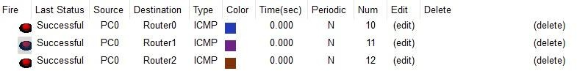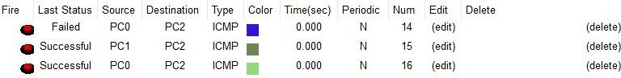

## CHAPTER – 5

### Results & Interpretation

### 5.1 Output Section

The following are the expected output results after successful configuration:

1. Ping Test: Devices from LAN 1 should communicate with devices from LAN 2.

PC1– PC2

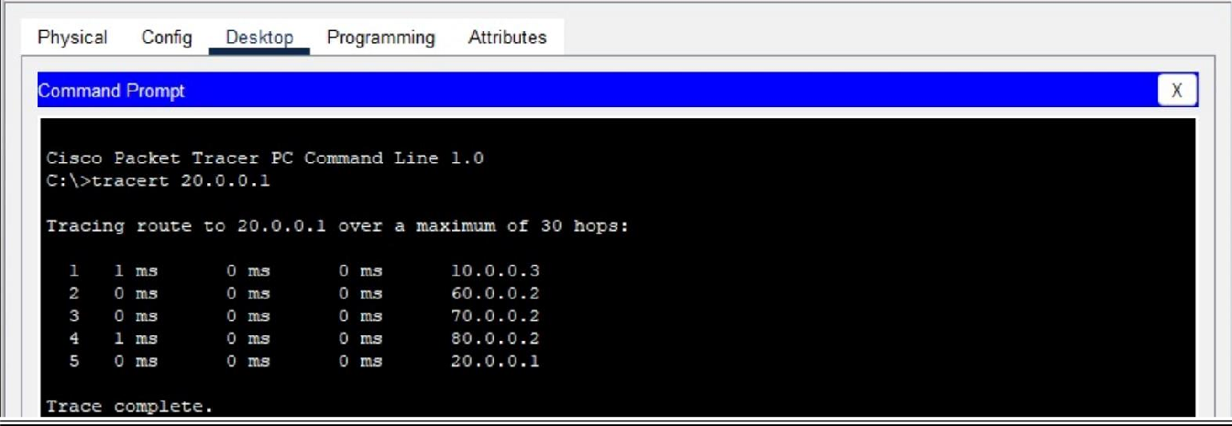

PC1– router-4

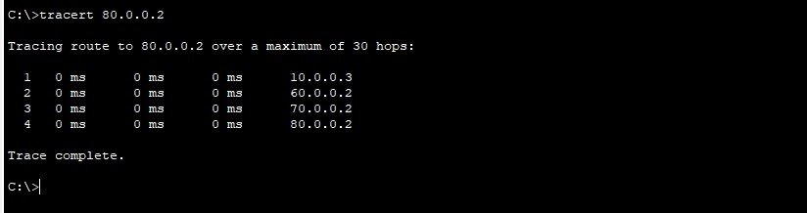

3. Traceroute Test : The traceroute should show a successful packet path from source to destination .

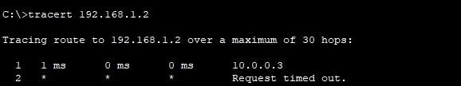

4. Interface Status: Interfaces on the router should display an "up" status.

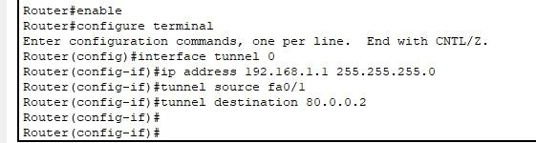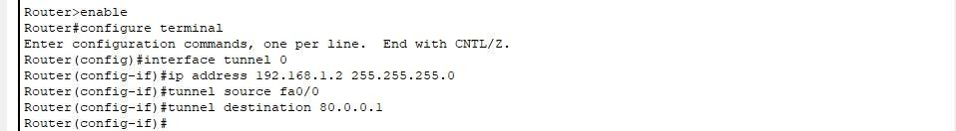

## CHAPTER-6

**FUTURE SCOPE**

With the rapid evolution of networking and cybersecurity, the role of Virtual Private Networks (VPNs) is expected to expand significantly in the coming years. As organizations continue to embrace remote work, cloud computing, and IoT technologies, VPNs will play a crucial role in ensuring secure and seamless connectivity. Future advancements will focus on enhancing security, improving performance, and integrating with emerging technologies. One of the major transformations will be the adoption of AI and machine learning for real-time threat detection and automated security responses, making VPNs more adaptive to cyber threats. Additionally, the integration of quantum- resistant encryption algorithms will ensure that VPN security remains intact even against the potential risks posed by quantum computing. As 5G and edge computing become mainstream, VPN technology will evolve to provide faster speeds, lower latency, and enhanced scalability, making it more efficient for businesses and end-users. Moreover, the implementation of Zero Trust Network Access (ZTNA) will replace traditional VPN authentication models, ensuring that every access request is verified dynamically. Cloud-based VPN solutions will also gain momentum, allowing businesses to scale their security infrastructure without relying on physical hardware. Furthermore, VPNs will become more critical in securing IoT devices, smart city applications, and blockchain transactions, preventing unauthorized access and data breaches. Despite these advancements, VPNs will face ongoing challenges such as government regulations, cybersecurity threats, and the need for balancing speed with security. Organizations will need to continuously adapt to new compliance requirements, adopt multi-layered security approaches, and leverage AI-driven optimizations to maintain secure and efficient network access. In conclusion, the future of VPNs lies in their ability to integrate with advanced security frameworks, optimize performance, and adapt to the ever-changing landscape of digital communication and cybersecurity threats.

### Chapter – 7

**Conclusion**

The implementation of Virtual Private Networks (VPNs) using Cisco Packet Tracer highlights the critical role of secure communication in today’s digital landscape. VPNs provide a reliable and encrypted connection that ensures data confidentiality, integrity, and availability, making them an essential component of modern networking. This report has explored the key aspects of VPN technology, including its purpose, objectives, system architecture, software and hardware requirements, and future scope. As cyber threats continue to evolve, the demand for robust security solutions will grow, reinforcing the need for advancements in VPN technology. Emerging innovations such as AI-driven security, quantum-resistant encryption, Zero Trust Network Access (ZTNA), and cloud-based VPN solutions will redefine how organizations secure their networks. Additionally, the integration of 5G, IoT, and blockchain security will further enhance VPN applications beyond traditional enterprise usage. While VPNs offer numerous advantages, challenges such as performance limitations, regulatory compliance, and cybersecurity threats must be addressed to ensure their long-term effectiveness. Overall, VPNs will remain a cornerstone of secure remote access and enterprise security, continuously evolving to meet the dynamic needs of the digital world. This report provides a comprehensive foundation for understanding VPN implementation, offering valuable insights into its current capabilities and future potential.

## CHAPTER-8

1. <https://devdocs.io/bash/>
2. <https://youtu.be/LlL2DkFkACo?si=ij2MH6ggYbkdAvDy>
3. [https://www.vpnhaus.com/2024/emerging-trends-and-innovations-in-the-vpn-](https://www.vpnhaus.com/2024/emerging-trends-and-innovations-in-the-vpn-landscape?utm_source=chatgpt.com) [landscape?utm_source=chatgpt.com](https://www.vpnhaus.com/2024/emerging-trends-and-innovations-in-the-vpn-landscape?utm_source=chatgpt.com)
4. <https://www.redhat.com/en/blog/document-code-scripts>





