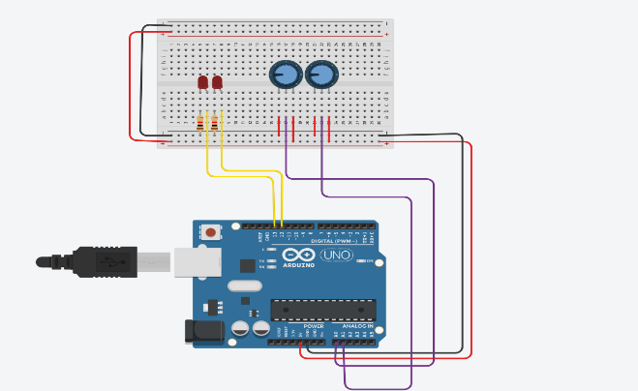

int sensorValue = 0;
const int potPin = A0;
const int led1 = 13;
const int led2 = 12;
void setup() {
pinMode(potPin, INPUT);
pinMode(led1, OUTPUT);
pinMode(led2, OUTPUT);
}
void loop() {
sensorValue = analogRead(potPin);
int delayTime = map(sensorValue, 0, 1023, 100, 1000);
digitalWrite(led1, HIGH);
digitalWrite(led2, HIGH);
delay(delayTime);
digitalWrite(led1, LOW);
digitalWrite(led2, LOW)
digitalWrite(led1, HIGH);
digitalWrite(led2, LOW);
delay(delayTime);
digitalWrite(led1, LOW);
digitalWrite(led2, HIGH);
delay(delayTime);
}

