Practical 1.1.1
Algorithm:
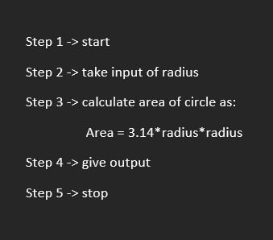
Flowchart:

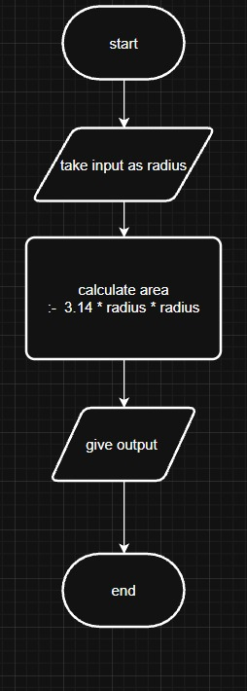
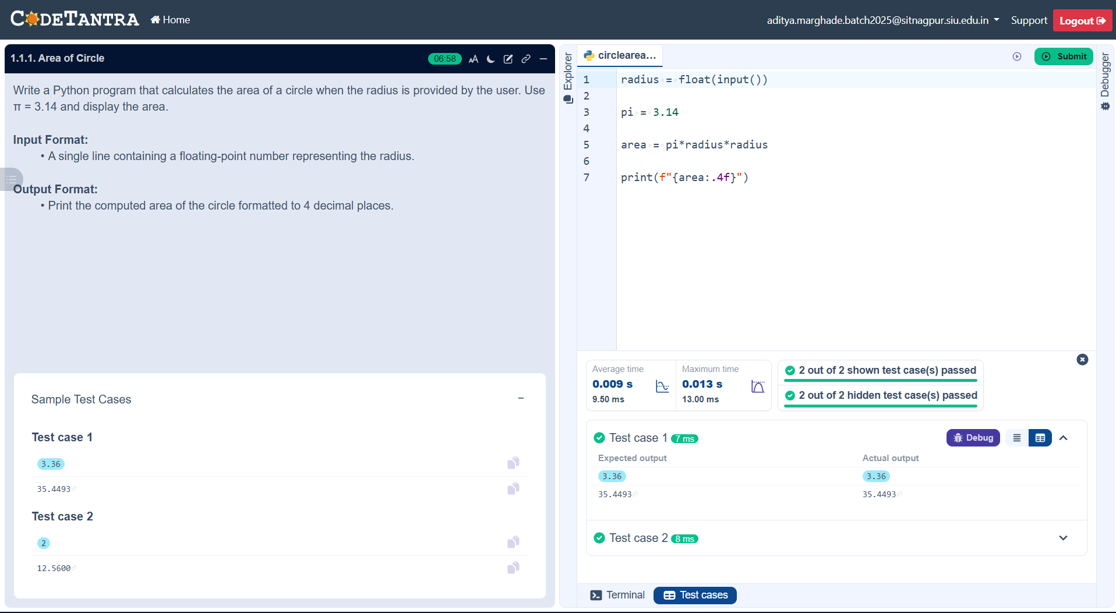

Practical 1.1.2
Algorithm:
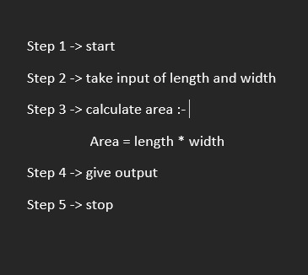
Flowchart:
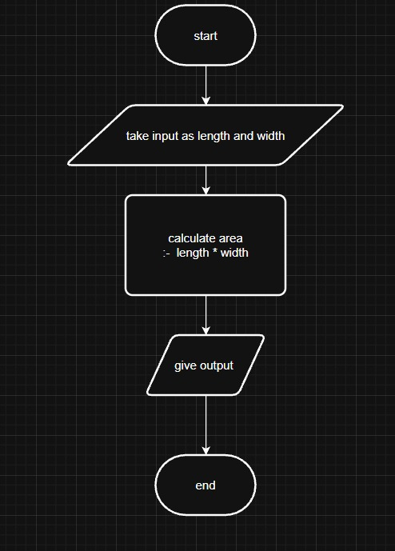
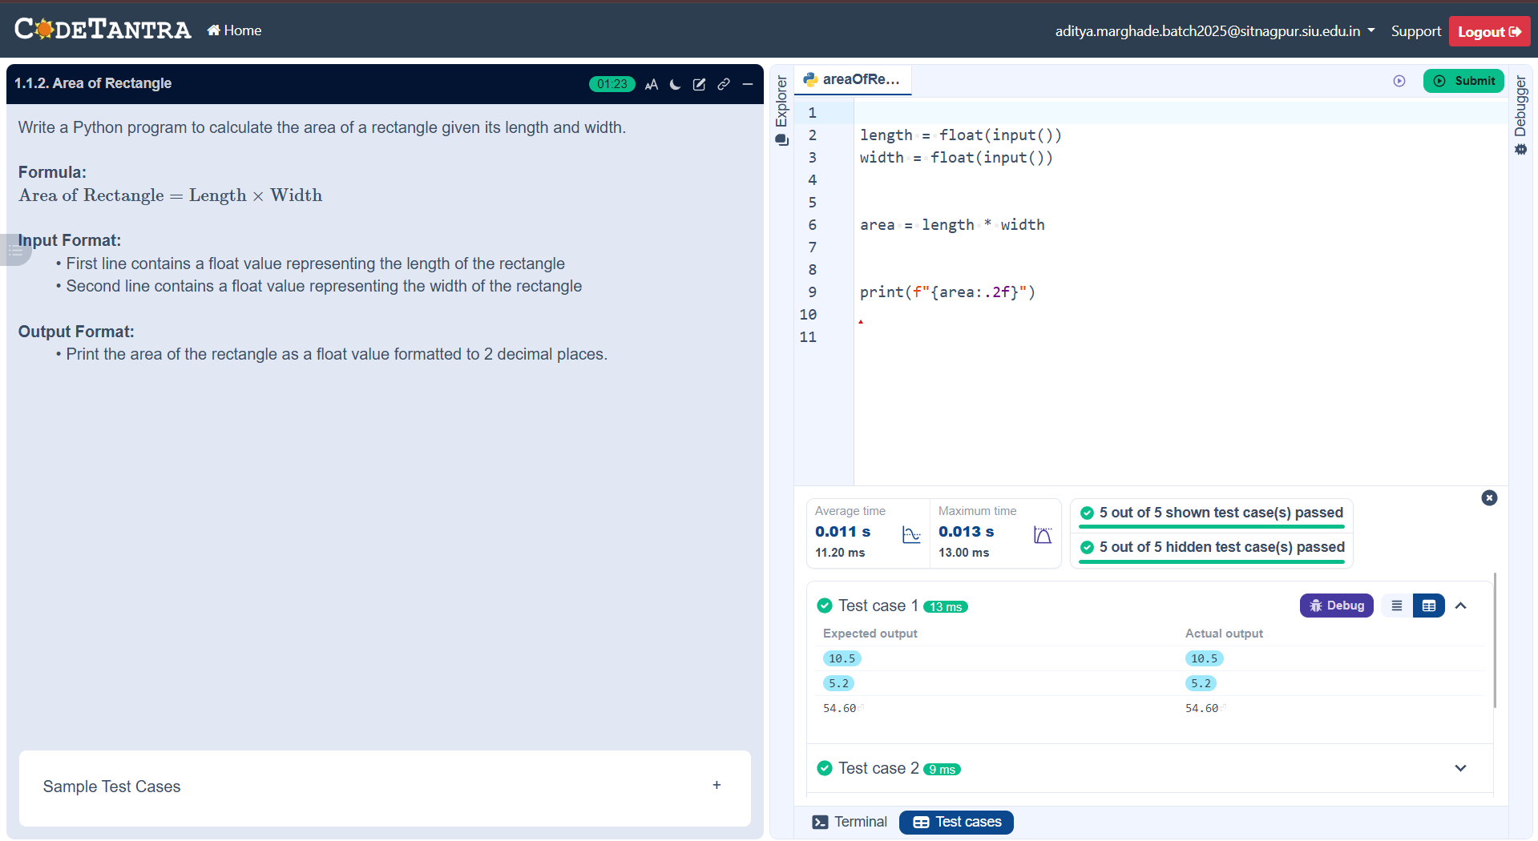

Practical 1.1.3
Algorithm:

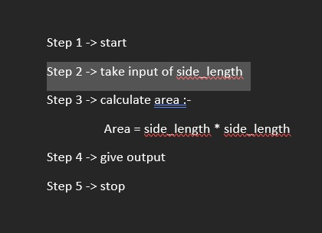
Flowchart:
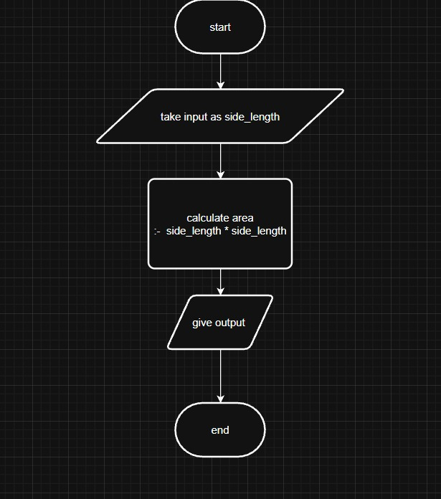
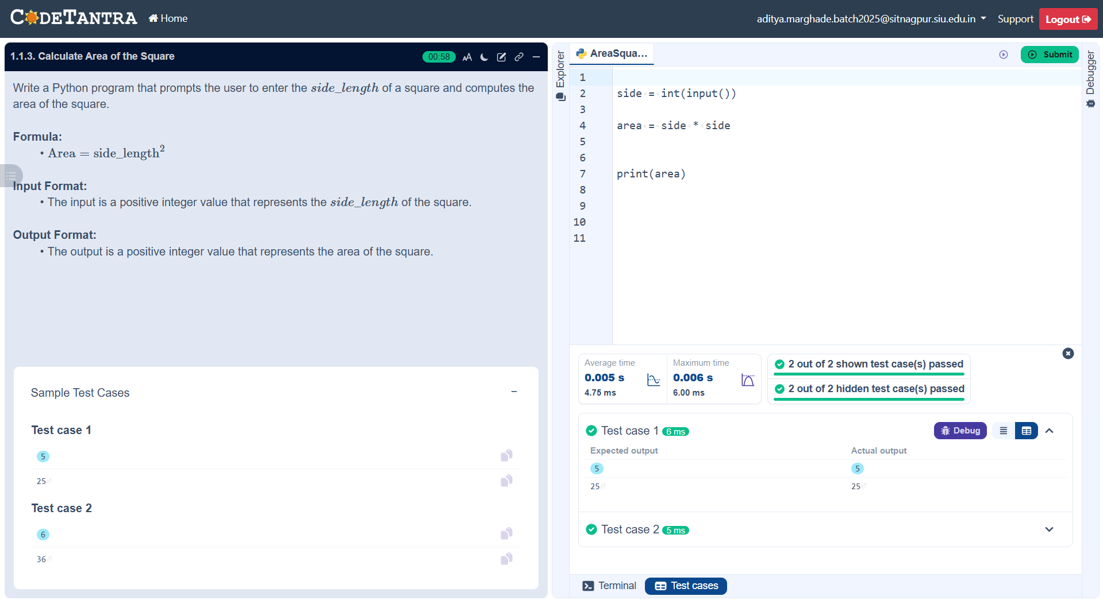

Practical 1.1.4
Algorithm:
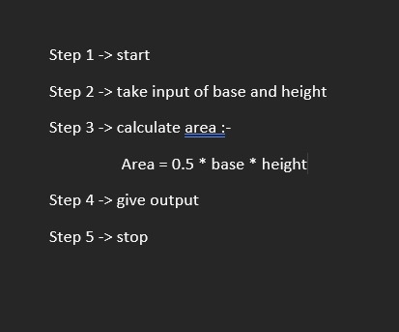
Flowchart:
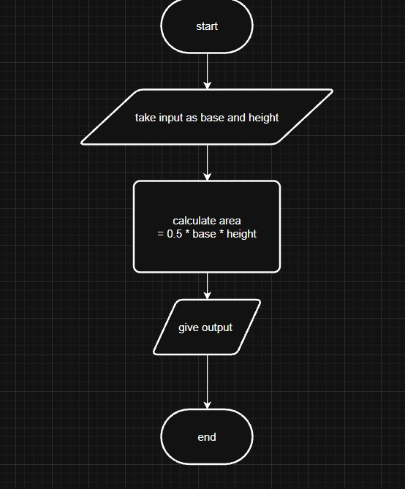
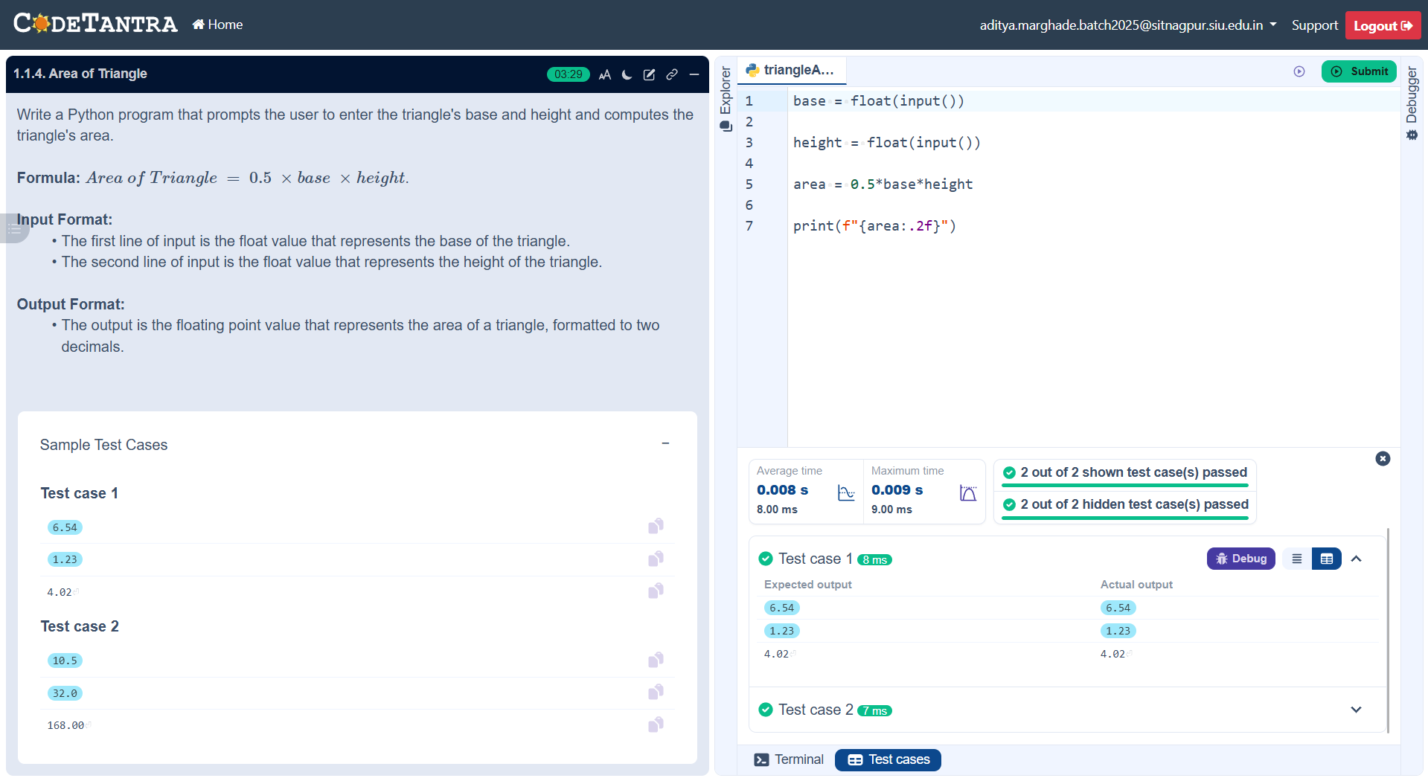

Practical 1.1.5
Algorithm:
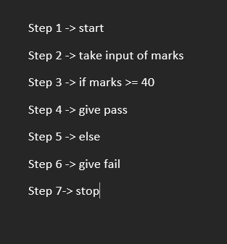
Flowchart:
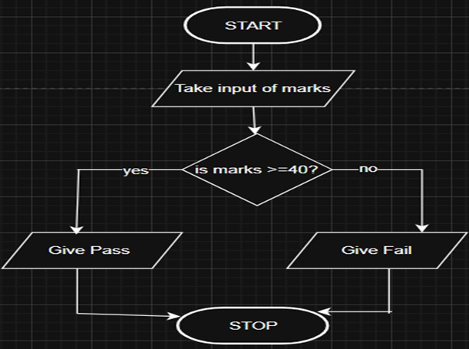
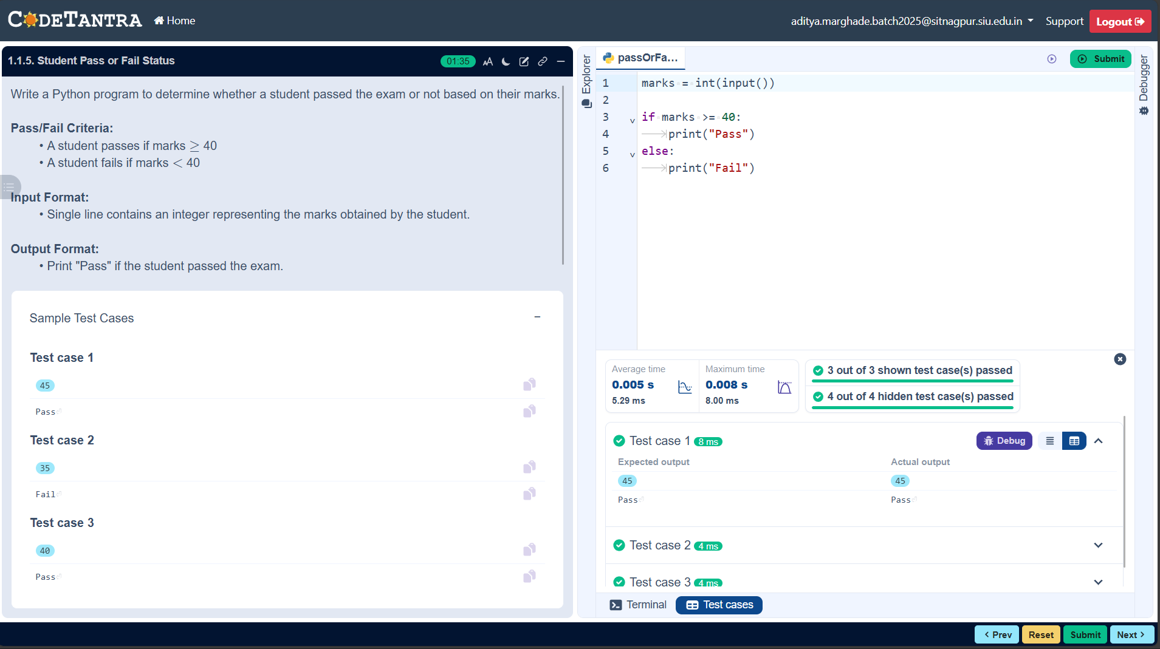

Practical 2.1.1
Algorithm:
Step 1 → Start
Step 2 → Input coefficients a, b, and c
Step 3 → Calculate the discriminant
D = b² − 4ac
Step 4 → If D > 0
→ Calculate
root1 = (-b + √D) / (2a)
root2 = (-b − √D) / (2a)
→ Print roots as real and different (to two decimal places)
Step 5 → Else if D == 0
→ Calculate
root = -b / (2a)
→ Print roots as real and same (to two decimal places)
Step 6 → Else (D < 0)
→ Calculate
realPart = -b / (2a)
imaginaryPart = √(-D) / (2a)
→ Print roots as imaginary
root1 = realPart + imaginaryPart i
root2 = realPart − imaginaryPart i
(formatted to two decimal places)
Step 7 → Stop

Flowchart:
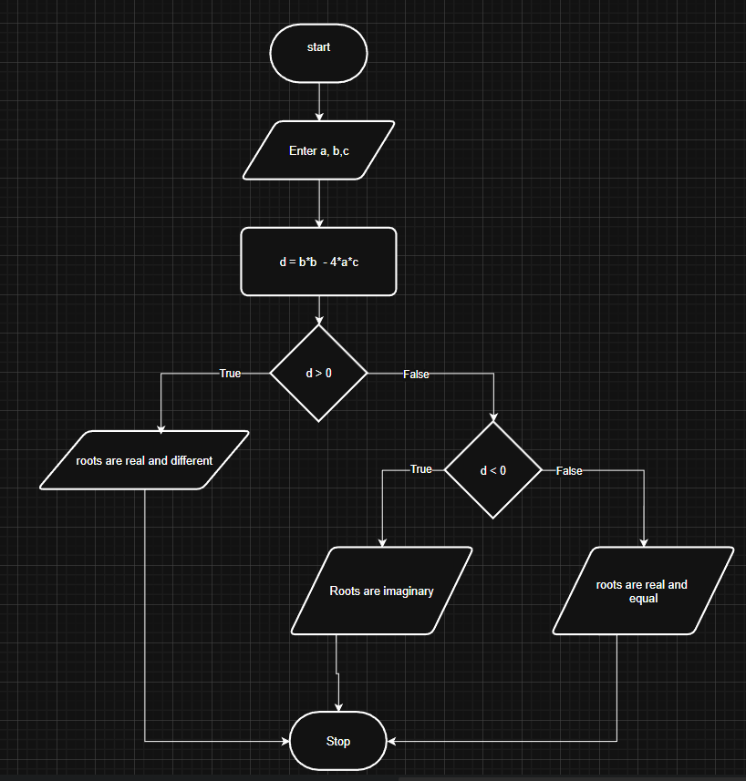
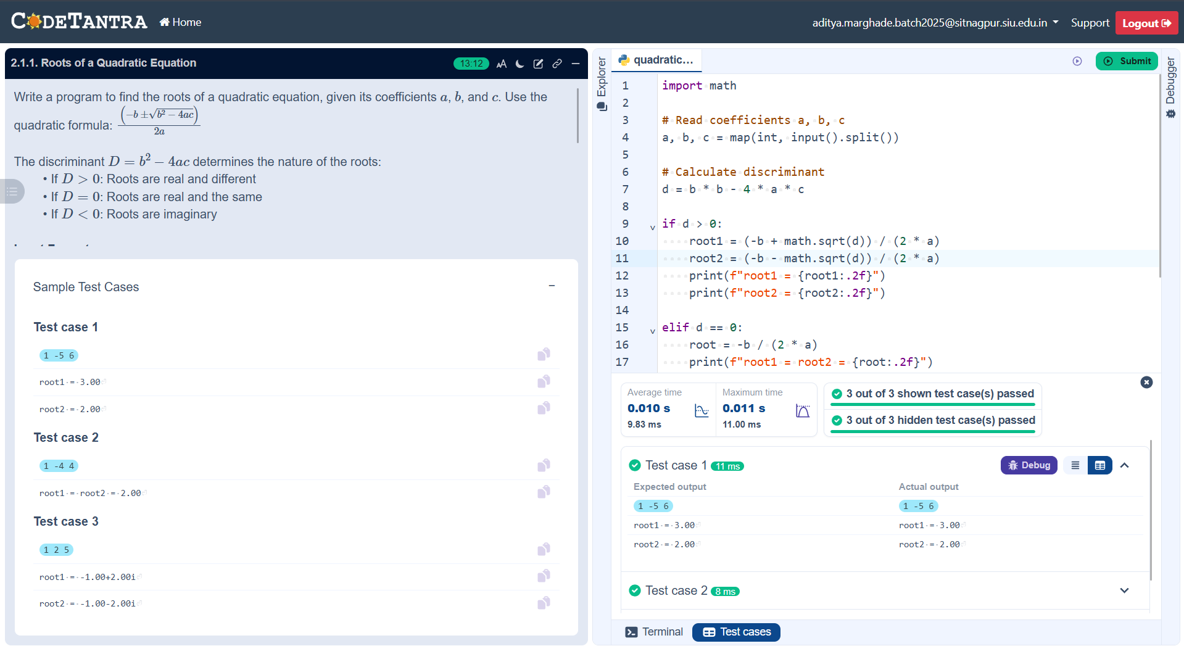

Practical 3.1.1
Algorithm:
Step 1 → Start
Step 2 → Input three integers a, b, and c
Step 3 → If a ≥ b and a ≥ c
→ Print a as the largest number
Step 4 → Else if b ≥ a and b ≥ c
→ Print b as the largest number
Step 5 → Else
→ Print c as the largest number
Step 6 → Stop

Flowchart:
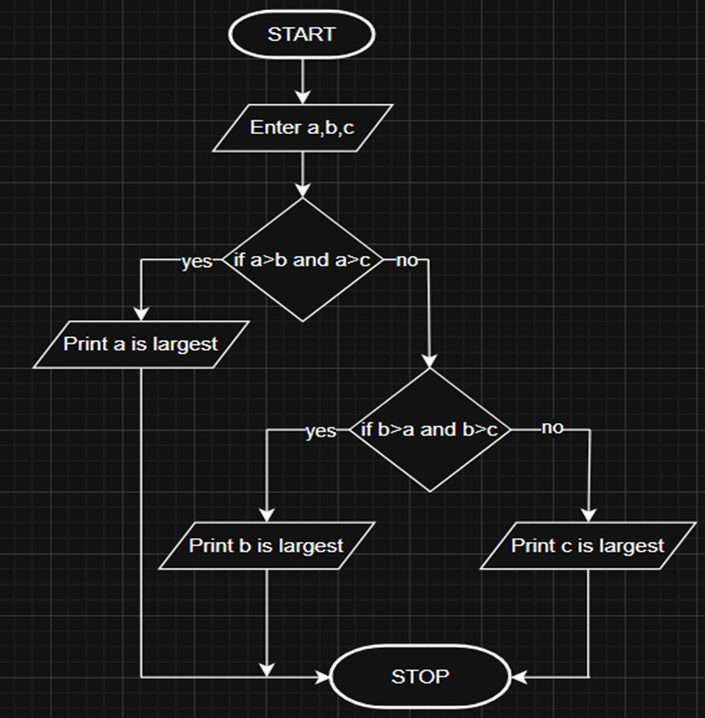
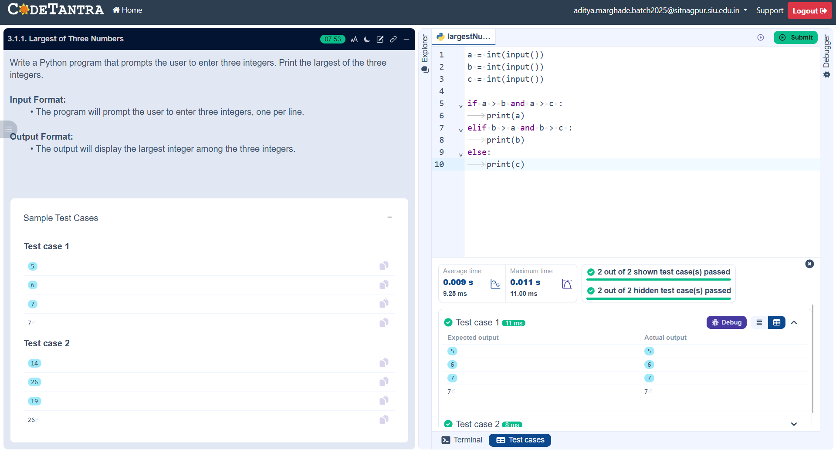
Practical 3.1.2
Algorithm:
Step 1 → Start
Step 2 → Input temperature in Celsius C
Step 3 → Calculate temperature in Fahrenheit using the formula
F = (C × 9/5) + 32
Step 4 → Print F formatted to two decimal places
Step 5 → Stop

Flowchart:
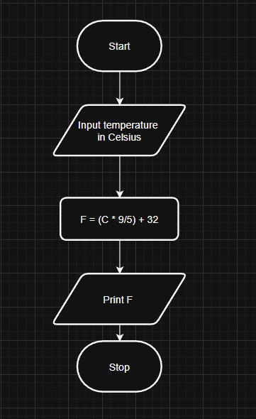
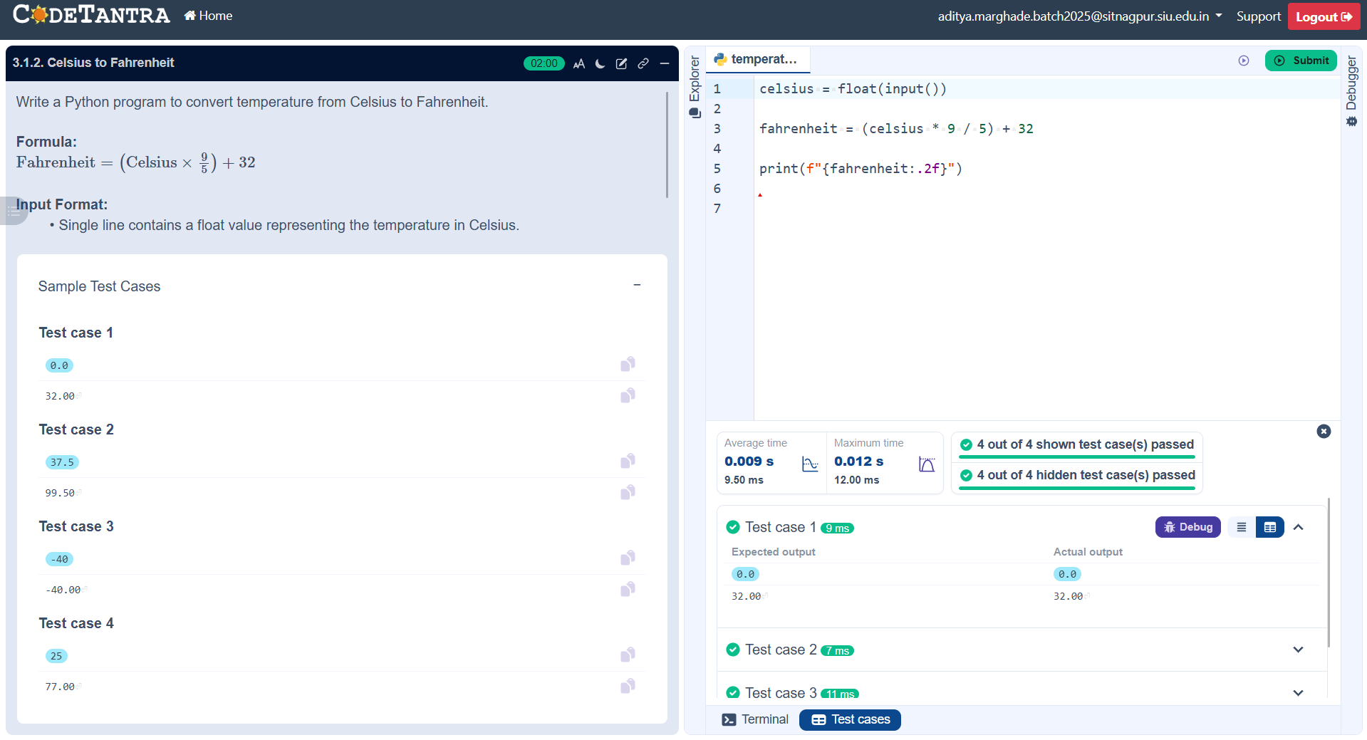

Practical 4.1.1
Algorithm:
Step 1 → Start
Step 2 → Input elements of Set A as space-separated integers
Step 3 → Input elements of Set B as space-separated integers
Step 4 → Convert the input lists into sets A and B
Step 5 → Find the union of the sets
→ Union = A ∪ B
Step 6 → Find the intersection of the sets
→ Intersection = A ∩ B
Step 7 → Find the difference of the sets
→ Difference = A − B
Step 8 → Print
→ "Union: " followed by the union set
→ "Intersection: " followed by the intersection set
→ "Difference: " followed by the difference set
Step 9 → Stop

Flowchart:
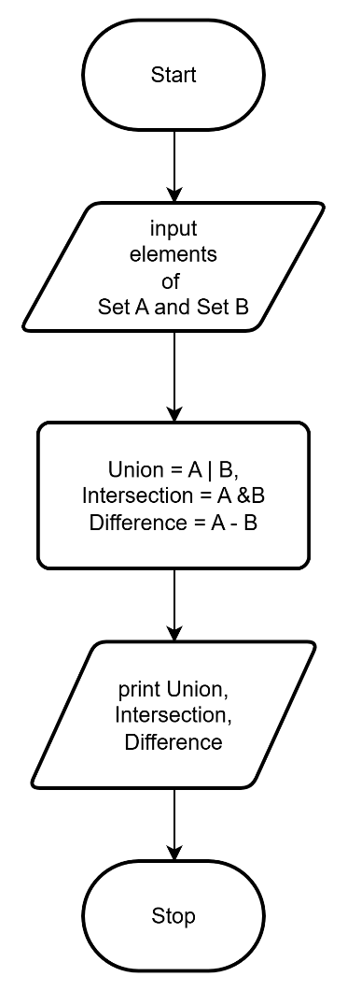
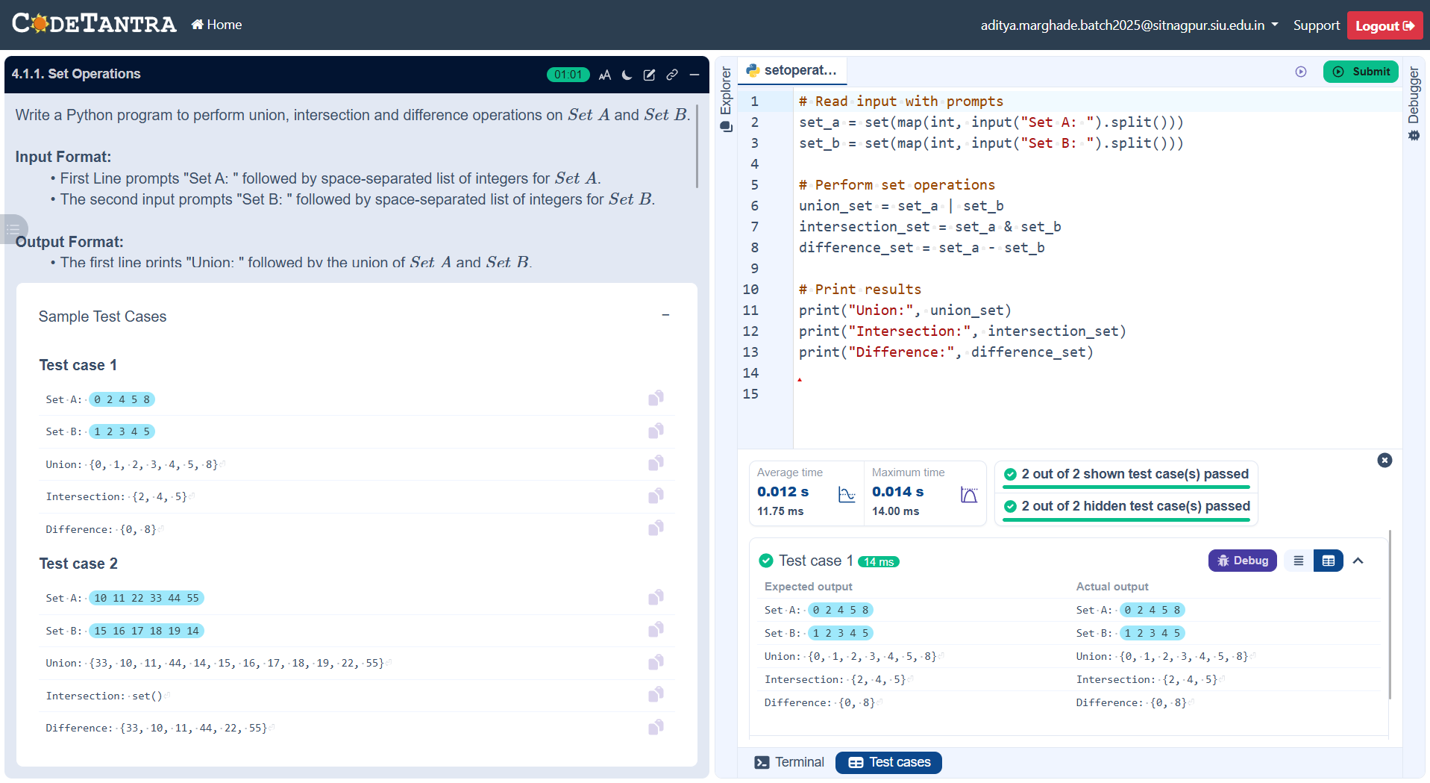
Practical 5.1.1
ALGORITHM:
Step 1 : Start
Step 2 : Input year y
Step 3 : Check if y % 4 == 0
Step 4 : If yes
Print "Leap year"
Step 5 : Else
Print "Not a leap year"
Step 6 : Stop

FLOWCHART:
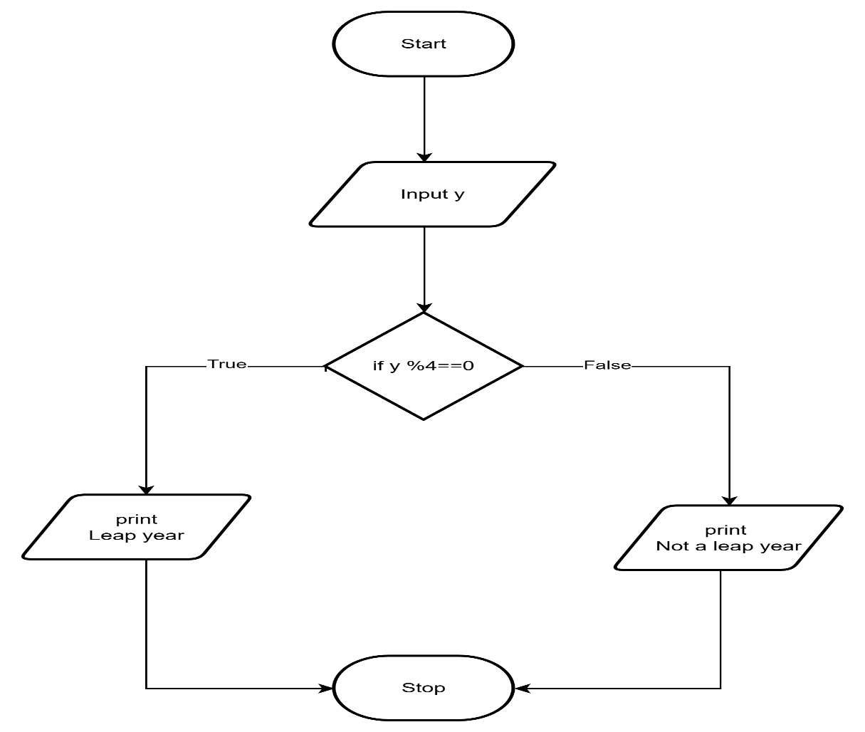
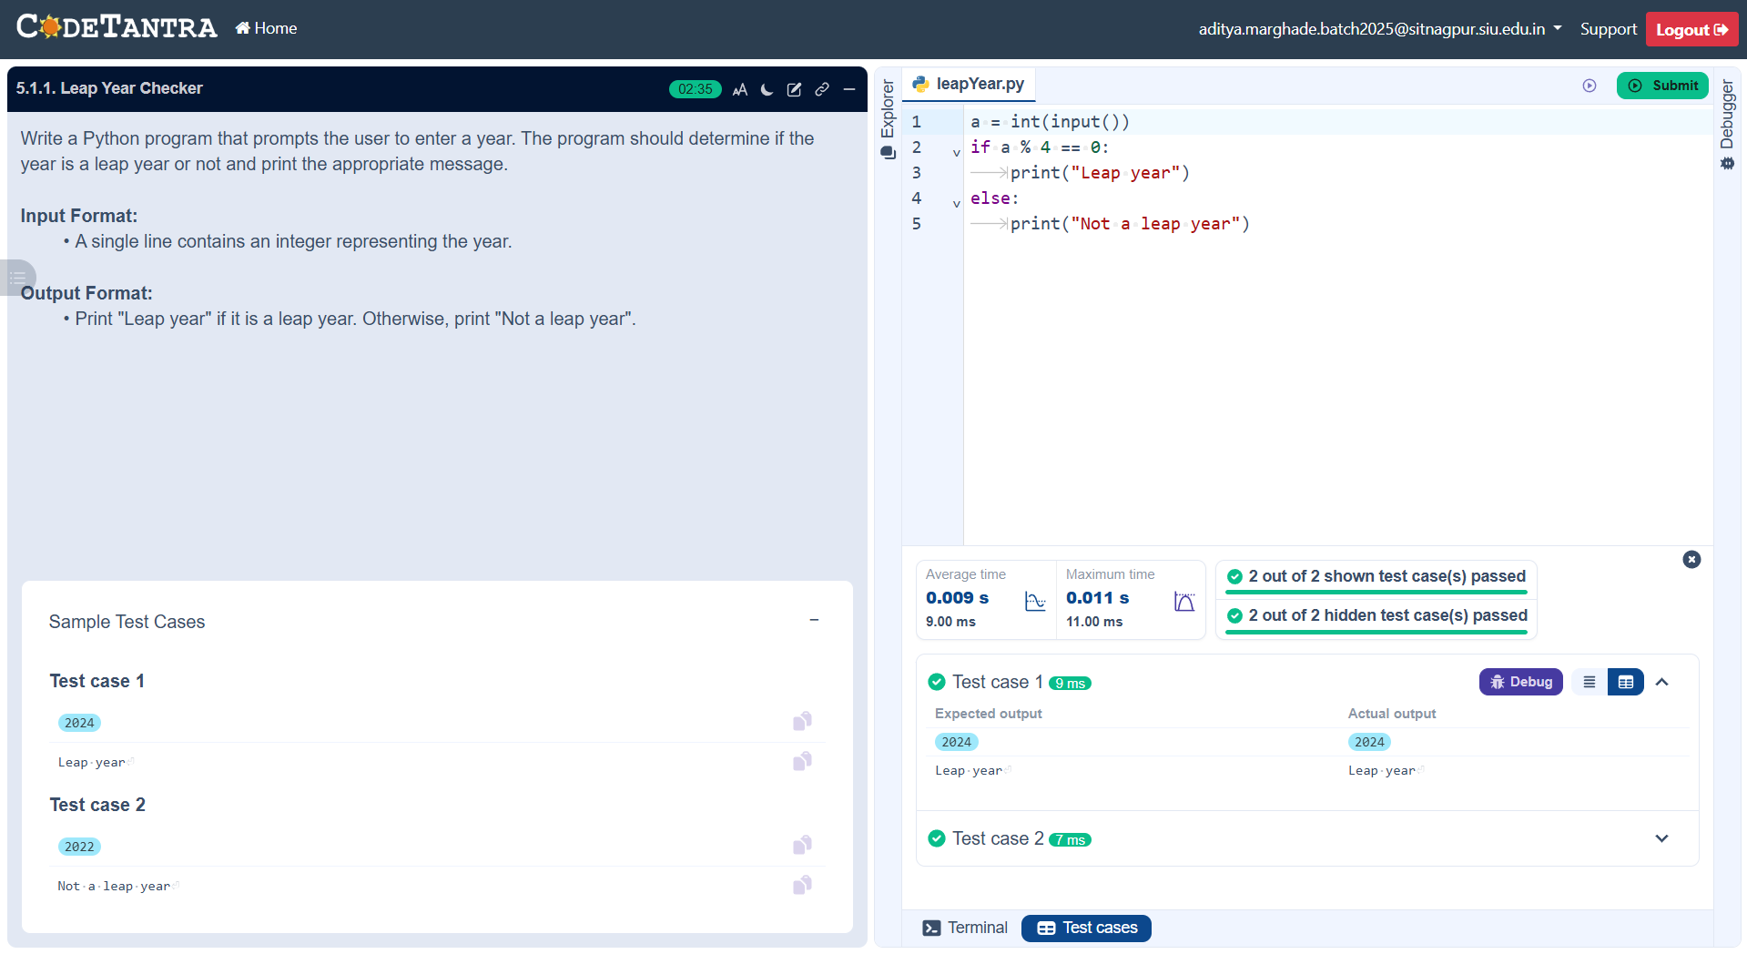

Practical 5.1.2
ALOGORITHM
Step 1: Start
Step 2: Input four marks: a, b, c, d
Step 3: Compute total
total = a + b + c + d
Step 4: Compute percentage
percent = (total / 400) × 100
Step 5: Print total
Step 6: Print percent (up to 2 decimal places)
Step 7: Check conditions:
- If percent > 75
Print Distinction
- Else if percent ≥ 60
Print First Division
- Else if percent ≥ 50
Print Second Division
- Else if percent ≥ 40
Print Third Division
- Else
Print Fail
Step 8: Stop

FLOWCHART:
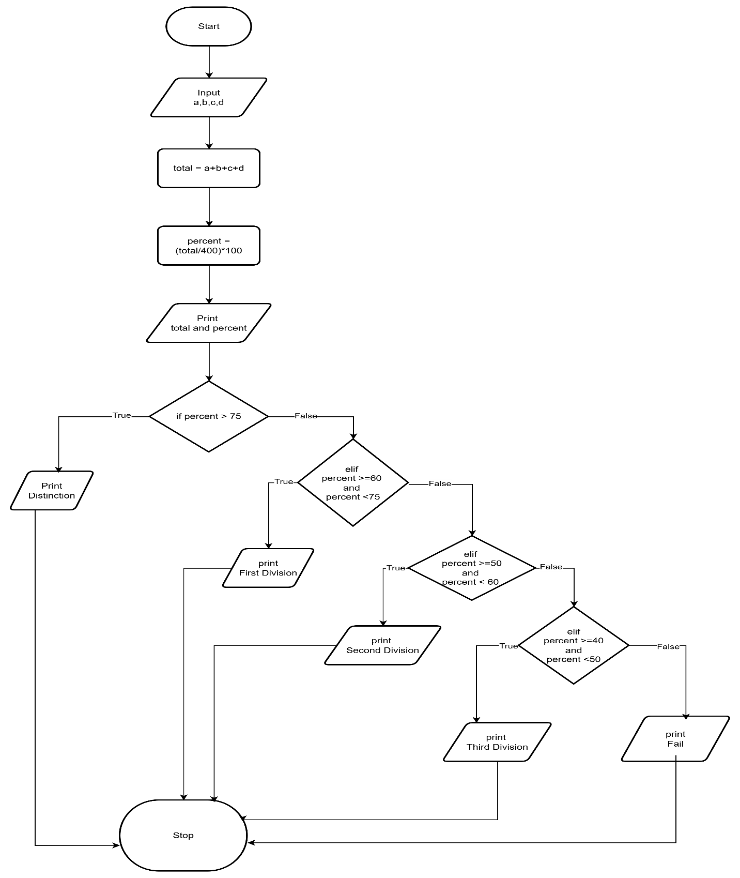
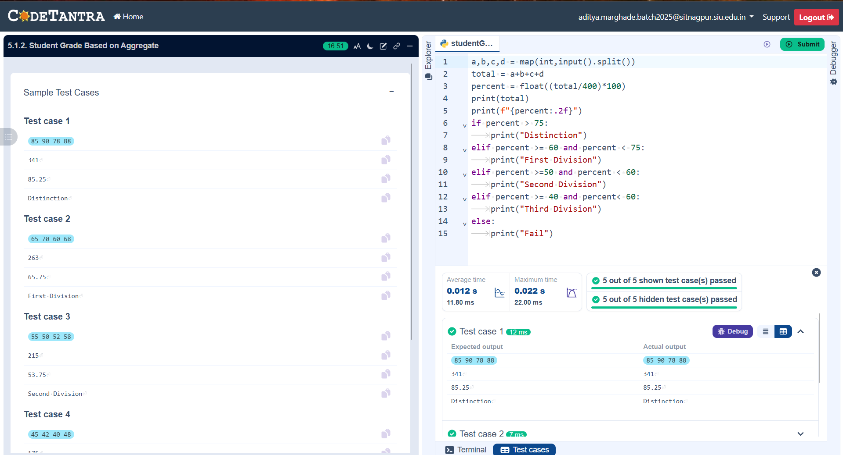

Practical 6.1.1
ALOGORITHM
Step 1 Start
Step 2 Input d, m, y
Step 3 Set flag ← 1
Step 4 If y < 0 OR m < 1 OR m > 12, set flag ← 0
Step 5 Determine maxdays:
- If m in {1,3,5,7,8,10,12} → 31
- If m in {4,6,9,11} → 30
- Else (February):
  - If y % 2 == 0 → 29
  - Else → 28
Step 6 If d < 1 OR d > maxdays, set flag ← 0
Step 7 If flag == 1:
- d ← d + 1
- If d > maxdays:
  - d ← 1, m ← m + 1
- If m > 12:
  - m ← 1, y ← y + 1
- Print date in dd-mm-yyyy format
Step 8 Else print "Invalid Date"
Step 9 End

FLOWCHART:

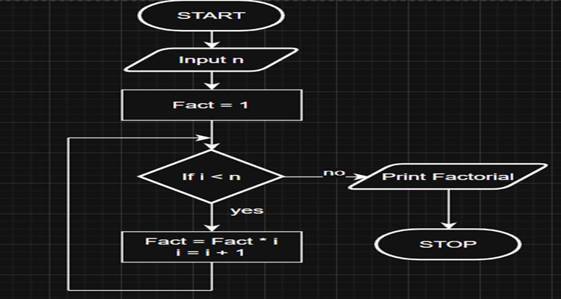

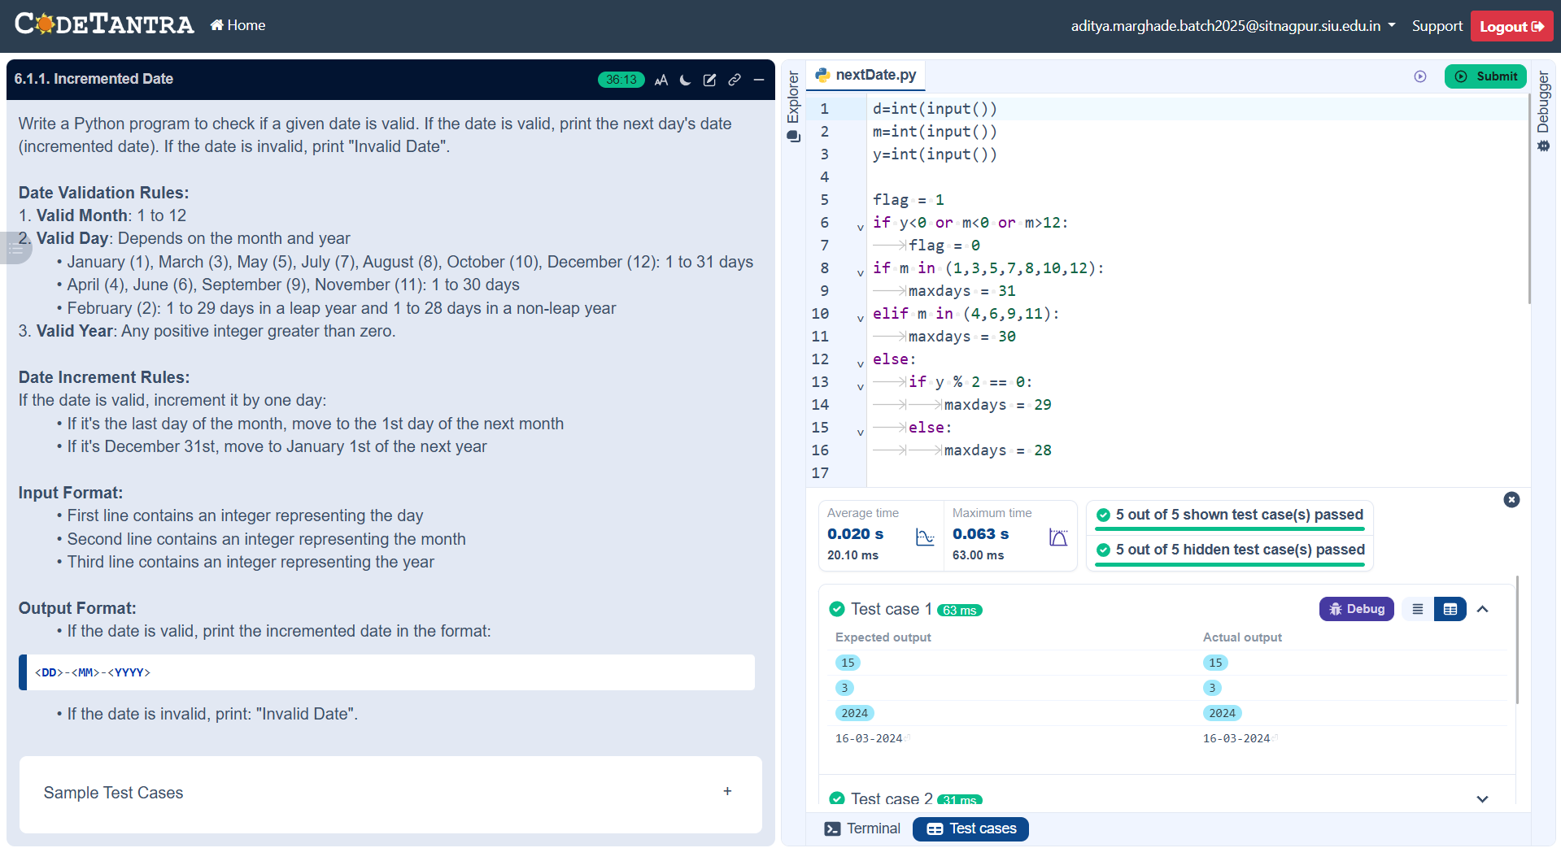

Practical 6.1.2
ALOGORITHM:
Step 1: Input integer a
Step 2: • Set fact ← 1
Step 3: For i from 1 to a do:
fact ← fact × i
Step 4: Print fact
Step 5: End

FLOWCHART:


