In their simplest form, **mechanical springs** such as coil springs, leaf springs, volute springs and compression springs are elastic devices that store mechanical potential energy when deformed by compression, extension or torsion

[What are Mechanical Springs and their types (engineeringproductdesign.com)](https://engineeringproductdesign.com/knowledge-base/springs/)

[Types of Springs and their Applications: An Overview | Fictiv](https://www.fictiv.com/articles/types-of-springs-and-their-applications-an-overview)

Helical Spring Calculations- [Conical Helical Compression Spring Design Equations and Calculator (engineersedge.com)](https://www.engineersedge.com/calculators/conical_helical_compression_spring_14934.htm)

Cantilever Beam spring calculations- [Cantilever Beam Spring Design Formula and Calculator (engineersedge.com)](https://www.engineersedge.com/calculators/cantilever_beam_spring_16109.htm)

[Tapered Flat spring cantilevered Design equations and calculator (engineersedge.com)](https://www.engineersedge.com/calculators/tapered_flat_spring_cantilevered__14617.htm)

Terms- [Spring Terminology and Definitions (engineersedge.com)](https://www.engineersedge.com/spring_terms.htm)

Tapered springs terms- [Tapered Spring Terms Compression Springs, Extension Springs, Torsion Springs and Conical Springs in Stock (stockspringscatalog.com)](https://www.stockspringscatalog.com/tapered-spring-terms.html)

[Theory of Vibration (engineersedge.com)](https://www.engineersedge.com/vibration/theory_of_vibration__15271.htm)

Welding- [Weld Process and Joint Design and Engineering Formula Menu - Engineers Edge](https://www.engineersedge.com/weld_design_menu.shtml)

There is a simple concept to determine whether a spring will buckle or bend, it is called the [slenderness ratio](https://www.acxesspring.com/coil-spring-slenderness-ratio.html). The spring slenderness ratio is the proportion of the spring’s mean diameter to its length. If a spring’s mean diameter is more than 3 times its length, it will tend to buckle.

[The Advantages of Using Conical Springs Over 70 Trillion Custom & Stock springs (thespringstore.com)](https://www.thespringstore.com/advantage-of-using-conical-springs.html)

The second type of compression spring is the conical compression spring. Conical compression springs have a pyramid shape. The pyramid shape of the helical coil spring makes it possible to supply forces in a limited space (axial space). This is because all windings are folded together at full compression.

[Blog - Helical coil springs, which spring do you need? Tevema](https://webshop.tevema.com/gb/blog/five-types-of-helical-coil-springs/)

[The Uses and Benefits of Conical Compression Springs - KB Delta](https://kbdelta.com/blog/uses-benefits-conical-compression-springs/)

[Custom Conical Extension Springs | Diamond Wire Spring Company](https://www.diamondwire.com/springs/coned-extension-springs.html#:~:text=Conical%20extension%20springs%20are%20designed,the%20hooks%2C%20thus%20avoiding%20breakage.)

Determing Conical spring loads- [20210315-Conical-spring.pdf (tokaibane.com)](https://www.tokaibane.com/en/cms/wp-content/uploads/2021/03/20210315-Conical-spring.pdf)

Conical spring rates and stress- [How to Select a Torsion Spring - Spring Rate, Design, Etc. | MW… (mwcomponents.com)](https://www.mwcomponents.com/select-tapered-spring?srsltid=AfmBOorW1eLfpzcJkHFgXJhfmGmexC0iOoZQl_m4VqejPu7UNdSO_fnz)

[Changing the Conical Compression Spring Industry Custom and Stock Springs - Quality Spring, Affordable Prices (acxesspring.com)](https://www.acxesspring.com/english/blog/changing-the-conical-compression-spring-industry.html)

[Spring Creator](https://springcreator.com/)

[How to Select a Torsion Spring - Spring Rate, Design, Etc. | MW… (mwcomponents.com)](https://www.mwcomponents.com/select-tapered-spring?srsltid=AfmBOopXda7FbqpUGPAbRRhERr8p0TGZNVG6Dlufo0h3Z3JGa1-OYfgT)

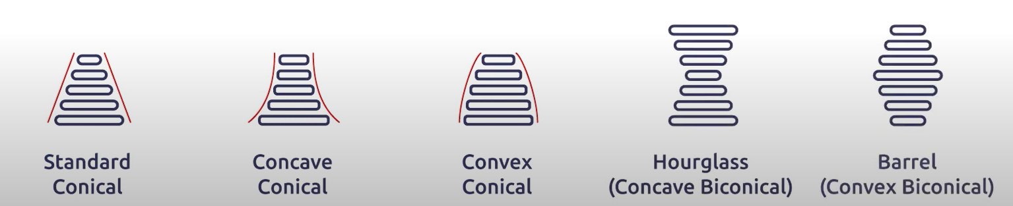

[Overview of The Different Types of Compression Springs (lesjoforssprings.com)](https://lesjoforssprings.com/insights/types-of-compression-springs/)

Hourglass shaped springs are used in applications requiring a low solid height, increased lateral stability or resistance to surging. Hourglass springs can be designed so that each coil nests wholly or partly into an adjacent coil. Solid height can be as low as one wire diameter.

Rate for hourglass springs usually increases with deflection because the number of active coils decreases progressively as the spring approaches solid. By varying the pitch, hourglass springs can be designed to have a uniform rate. Rate for conical springs is calculated, as indicated previously, by considering the spring as many springs in series.

Helical Compression Springs are used to resist applied compression forces or to store energy in the push mode. They have the most common spring configuration and are found in many applications such as automotive, aerospace and consumer goods. While the most prevalent form of a Compression Spring is a straight hourglass spring made from round wire, many other forms are produced. Hourglass forms are available, with or without variable spacing between coils. Such configurations are used to reduce solid height, buckling and surging, or to produce nonlinear load deflection characteristics

[The Pros and Cons of Different Spring Materials](https://www.tevema.com/the-pros-and-cons-of-different-spring-materials/#:~:text=In%20conclusion%2C%20selecting%20the%20appropriate,strong%20but%20susceptible%20to%20corrosion.)

[The Different Compression Spring End Types Compression Springs, Extension Springs, Torsion Springs and Conical Springs in Stock](https://www.stockspringscatalog.com/different-compression-spring-end-types.html#:~:text=Definition%3AClosed%20and%20ground%20ends,stand%20vertically%20on%20a%20surface.)

Clevis Pin and Cotter Pin Combination

U-Shaped Bracket with Loose Mount

Spring Clip

[Calculator for conical springs (tribology-abc.com)](https://www.tribology-abc.com/calculators/t14_3.htm)

[Conical Helical Spring | Online Calculator (calcdevice.com)](https://calcdevice.com/conical-helical-spring-id10.html)

[Compression Spring Calculator (tokaibane.com)](https://www.tokaibane.com/en/cl/compression-spring-calculator/)

[How to calculate the number of active coils in a spring? | Century…](https://www.centuryspring.com/faqs/how-to-calculate-the-number-of-active-coils-in-a-spring?srsltid=AfmBOoon-JGE441LaTG1coKZcmG-DYFQoBl30rnW9Soxv3qo-4yOeTrh)

[Spring Finder Over 70 Trillion Custom & Stock springs (thespringstore.com)](https://www.thespringstore.com/catalogsearch/advanced/?search=stock-conical-springs)

[Conical Spring Custom and Stock Springs - Quality Spring, Affordable Prices (acxesspring.com)](https://www.acxesspring.com/cone-springs.html)

[Tapered Springs Wholesale Over 70 Trillion spring designs (compressionspring.com)](https://www.compressionspring.com/tapered-springs-wholesale.html)

[Shop Tapered Springs - Buy Online | MW Components](https://www.mwcomponents.com/shop/tapered-springs?range%5BlargeOutsideDiameter_metric%5D%5Bmin%5D=20.22&range%5BfreeLength_metric%5D%5Bmin%5D=20.57&range%5BavgRate_metric%5D%5Bmin%5D=4.01&range%5BavgRate_metric%5D%5Bmax%5D=8.77)

[Tokai Spring industries, Inc. (tokaibane.com)](https://www.tokaibane.com/en/)

Indian Manufacturers

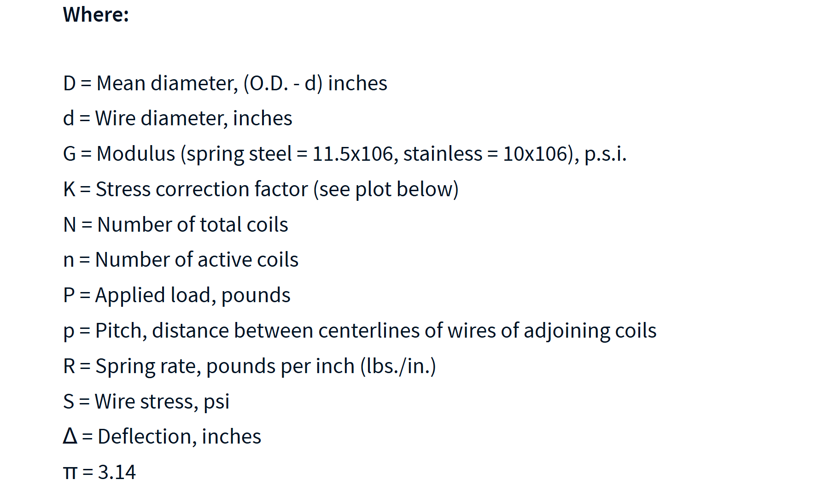

No. Of Coils- 6 – 12.5

Wire Dia.- 1.65 mm – 4.75mm

Small OD- 21.34mm – 48.41mm

Large OD- 28.58mm – 61.93mm

ID- 18.03mm - 39.7mm

Free Length- 39.62mm – 90mm

Spring Rate- 1.07N/mm - 8.35N/mm

Dear Sir / Madam,

                  Our concern is that we want a spring to freely hang an object using a spring that can move longitudinally and laterally as well (random motion).

The concern we face here is we are not quite sure as to what type of spring can represent vibrations accurately and make sure we get as much lateral movement of the object attached to the spring which is restricted to a **maximum of 8.8 cm laterally** only.

The **object can be anywhere from 2 to 3 cm** itself so the load applied on the spring will be anywhere from **0.6N to 2.5N** itself, not more than that but the spring on the other end would be connected to a highly vibrating device and we hope the spring will also vibrate due to that too.

We feel that a **conical spring**would be the best choice here as it tends to buckle less and still allows for enough lateral motion for us to be able to detect it. I would like to know what your solution would be as to what type of spring to use here and its right dimensions or if you could provide an accurate spring that you think would get the job done, then please do let me know what that will be.

Thank you so much in advance for your help.

Yours sincerely,

              Sai Tharun