

OBJECT ORIENTED PROGRAMMING USING C++
MINI PROJECT REPORT
Project Title: MediShield — Healthcare Management System

Submitted by
Group ID: [Enter Group ID]

PROJECT TEAM MEMBERS
Sr. No. | PRN Number | Student Name
1 | 1262253387 | Aditya Mohite
2 | 1262253545 | Aarna Kale
3 | 1262253557 | Parth Lohate
4 | 1262253957 | Anurag Chavan
5 | 1262252216 | Jahnav Vyas

Under the Guidance of
Dr. Vinayak Musale

Department of Computer Engineering and Technology
Dr. Vishwanath Karad MIT World Peace University, Pune – 411 038
Maharashtra, India
Academic Year 2026–2027
DEPARTMENT OF COMPUTER ENGINEERING AND TECHNOLOGY

CERTIFICATE

This is to certify that
1262253387 | Aditya Mohite
1262253545 | Aarna Kale
1262253557 | Parth Lohate
1262253557 | Anurag Chavan
1272262216 | Jahnav Vyas

students of Second Year B. Tech. Computer Science and Engineering (Cybersecurity and Forensics), have completed the mini project entitled “MediShield — Healthcare Management System” and submitted this report as part of the requirements for the course CSF20210: Object Oriented Programming Laboratory during the academic year 2026–2027.

Date: 29-10-2026
Place: Pune

Dr. Vinayak Musale
Course Teacher
Department of Computer Engg. and Tech.
MIT WPU, Pune

ACKNOWLEDGEMENT

We express our sincere gratitude to our course teacher and project guide, Dr. Vinayak Musale, for his guidance and valuable feedback throughout the development of this mini project. We thank the Department of Computer Engineering and Technology and Dr. Vishwanath Karad MIT World Peace University, Pune, for providing the academic environment and resources required to complete this work. We are also grateful to the creators and maintainers of the software tools and documentation consulted during development. Finally, we thank our teammates for their cooperation in planning, implementation, testing, and preparation of this report.

Student Name(s)
[Enter student names]
Group ID: [Enter group ID]
Date: [DD/MM/YYYY]

ABSTRACT

Provide a self-contained summary of the project in no more than 200 words. Briefly state the problem, objectives, approach, key features or modules, and outcome. Avoid citations, figures, and unexplained abbreviations in the abstract.
MediShield is a healthcare management mini project that demonstrates how patient information, appointment scheduling, clinical records, and access permissions can be organised in a single interface. The project contains a browser-based dashboard with patient search and registration, appointment booking, a medical-records area, and a security centre. It also includes a C++17 object-oriented backend model that illustrates classes, constructors, encapsulation, role checks, patient-data validation, password transformation, and audit logging. Three staff roles are represented: Administrator, Doctor, and Receptionist, each with different permissions. The website is a front-end simulation and does not connect to a live database or process real patient data. The project is intended for learning and demonstration rather than clinical deployment. It shows how object-oriented programming and basic security principles can support the design of a healthcare workflow.

Keywords: Healthcare management, C++17, object-oriented programming, role-based access control, patient records, audit logging

TABLE OF CONTENTS
Certificate
Acknowledgement
Abstract
List of Figures
List of Tables (if applicable)
List of Abbreviations (if applicable)

Sr. No. Chapter Page No.
1. Introduction
1.1 Motivation . . . . . . . . . . . . . . . . . . . . . . . . . . . . . . . . .
1.2 Objectives . . . . . . . . . . . . . . . . . . . . . . . . . . . . . . . . .
2. Problem Definition and Objectives
3. Requirements, Tools and Technologies
4. System Design and Architecture
5. Implementation and User Interface
6. Methodology
7. Algorithms and Testing
8. Conclusion and Future Scope
References
Appendices

Figure No. | Figure Caption | Page No.
Figure X.X | [Enter figure caption] | [Page]
Figure X.X | [Enter figure caption] | [Page]
Figure X.X | [Enter figure caption] | [Page]
Figure X.X | [Enter figure caption] | [Page]

LIST OF TABLES
Table No. | Table Caption | Page No.
Table X.X | [Enter table caption] | [Page]
Table X.X | [Enter table caption] | [Page]
Table X.X | [Enter table caption] | [Page]

CHAPTER 1
INTRODUCTION
Explain the context, need, and motivation for selecting the project.
Healthcare facilities handle patient registration, appointment coordination, and access to sensitive clinical information. When these activities are tracked separately, staff may have difficulty finding current information and enforcing consistent access rules. MediShield was selected as a learning project because it brings these workflows together and provides a practical setting to demonstrate classes, objects, validation, and role-based permissions in C++.
State the specific problem the project addresses, clearly and concisely.
The project addresses the need for a simple prototype through which authorised staff can view or manage patient and appointment information while restricting access to clinical records according to their role. It also demonstrates recording security-relevant actions so that allowed and denied operations can be reviewed.
List measurable and achievable objectives using action verbs.
1. Provide a dashboard that summarises patient and appointment activity. 2. Demonstrate patient registration and searching. 3. Provide an appointment-booking workflow. 4. Restrict clinical-record functions according to staff role. 5. Validate basic patient fields before accepting data. 6. Record important access decisions in an audit log. 7. Apply C++ object-oriented concepts through classes, constructors, encapsulation, and member functions.
Define the features included, intended users, assumptions, and known limitations.
The prototype is intended for demonstration and coursework. It includes a browser interface, sample records, patient registration/search, appointment booking, clinical-note interactions, role-aware navigation, and an audit-log display. The C++ backend models users, patients, permissions, and audit logging. The project does not use a live database; browser-side changes are session/local-browser demonstrations. Password handling is educational and is not suitable for production healthcare deployment. It is not a medical diagnosis or treatment system.
Briefly describe what each subsequent chapter contains.
Chapter 2 defines the problem and requirements. Chapter 3 describes hardware, software, and technologies. Chapter 4 presents architecture and object-oriented design. Chapter 5 explains the implementation and interface modules. Chapter 6 outlines the development workflow and integration. Chapter 7 presents algorithms and representative test cases. Chapter 8 summarises outcomes, limitations, and future improvements. References and appendices provide supporting resources.

CHAPTER 2
PROBLEM DEFINITION AND OBJECTIVES

2.1 Problem Definition
Healthcare administration involves maintaining patient profiles, coordinating appointments, and ensuring that sensitive records are accessed only by appropriate staff. The project models these tasks in a compact application. The central problem is to demonstrate a coherent workflow while making role permissions visible and testable.

2.2 Existing System and Its Limitations
A manual or disconnected workflow can lead to duplicated entries, slow searching, difficulty tracking appointment status, and unclear responsibility for accessing sensitive records. A prototype without persistent storage also cannot reliably preserve information across sessions. MediShield addresses the workflow and permission-demonstration aspects, but it does not claim to replace a deployed hospital information system.

2.3 Proposed Solution
MediShield combines a dashboard, patient directory, appointment scheduler, medical-record workspace, and security centre. The interface represents Administrator, Doctor, and Receptionist roles. A separate C++17 model defines User, Patient, HealthcareSystem, and AuditLogger classes and demonstrates permission checks, input validation, and audit events. The browser implementation is a simulation; the C++ program is compiled separately and demonstrates the core OOP model.

2.4 Functional and Non-Functional Requirements
Functional requirements: staff sign-in; role-specific navigation; patient search and registration; appointment booking; clinical-record access checks; adding clinical notes in the interface; and recording allow/deny events. Non-functional requirements: clear navigation, responsive layout, basic input validation, modular code, readable audit events, and maintainable class structure. Security requirements are demonstrative only: production use would require server-side enforcement, secure password hashing, HTTPS, access controls, and a protected database.

CHAPTER 3
REQUIREMENTS, TOOLS AND TECHNOLOGIES

3.1 Hardware Requirements
A computer capable of running a modern web browser and a C++ compiler is sufficient. Suggested minimum: dual-core processor, 4 GB RAM, and approximately 200 MB of free disk space for source files and tools. These are practical recommendations rather than measured requirements.

3.2 Software Requirements
Operating system: Windows, macOS, or Linux. Browser: a current version of Chrome, Edge, Firefox, or Safari. C++ compiler: g++ with C++17 support. Editor/IDE: any text editor or IDE such as Visual Studio Code. The website uses HTML, CSS, and JavaScript and can be opened locally in a browser. No database server or additional JavaScript package installation is required for the documented browser workflow.

3.3 Programming Language and Technologies
C++17 is used for the backend model. Classes represent users, patients, the healthcare system, and audit logging. HTML structures the web interface, CSS styles the dashboard and sign-in view, and JavaScript implements navigation, role-dependent controls, patient search, forms, appointment updates, and audit-log display. The browser interface is a client-side simulation and is not connected to the C++ program through an API.

3.4 Development Environment
Place index.html and its related CSS/JavaScript files together, preserving the repository structure. Open index.html in a browser to use the interface. To compile the C++ model from the repository root, run: g++ -std=c++17 backend/main.cpp -o medishield. Then run ./medishield on Linux/macOS or medishield.exe on Windows. A compiler must be installed and available on the system PATH.

CHAPTER 4
SYSTEM DESIGN AND ARCHITECTURE

4.1 System Architecture
The system has two related parts: (1) a browser-based presentation layer and (2) a standalone C++17 model. In the browser, index.html defines the dashboard and sections; style.css, roles.css, and signin.css define the presentation; script.js handles interactions. The C++ model defines the core domain classes and prints audit decisions. The website and C++ model demonstrate similar role rules but are not connected to each other at runtime.

4.2 Use-Case / Flowchart / Data-Flow Diagram
A typical interface flow is: open the website → sign in with a staff role → view the dashboard → search/register a patient or book an appointment if permitted → verify access before viewing clinical records → review the security centre and audit events → sign out. Role checks determine which sections and actions are available. Attempts to open restricted areas are denied and recorded in the browser audit display.
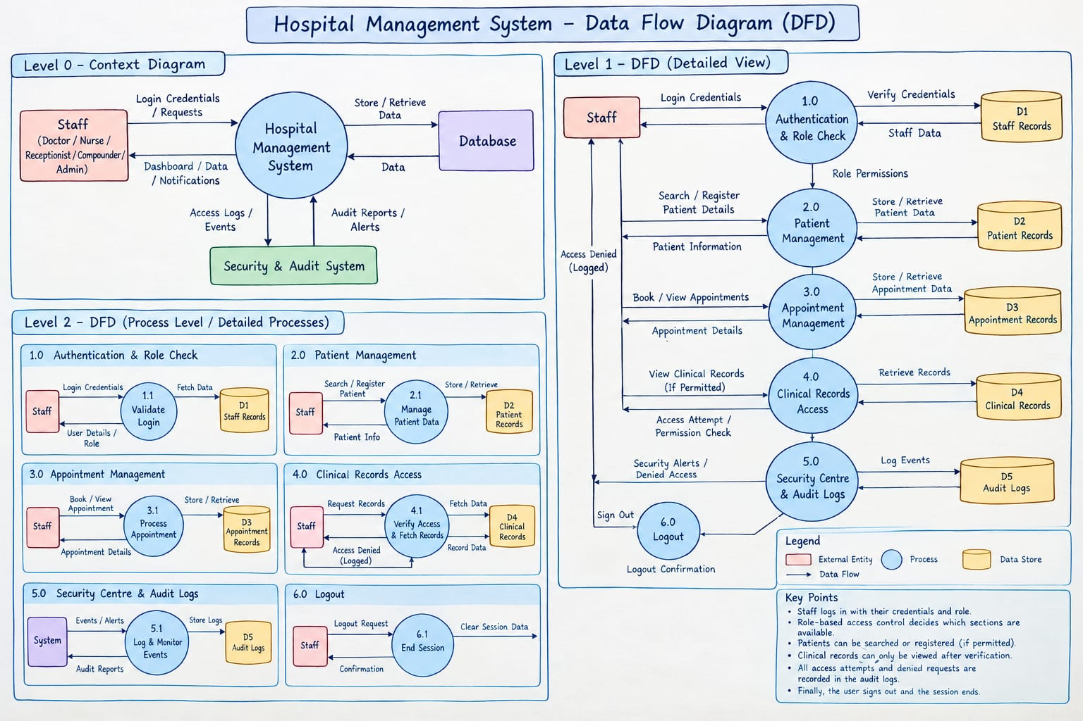

4.3 Class Diagram and Object-Oriented Design
User stores a staff ID, password hash, and role, and exposes verification and permission methods. Patient stores an ID, name, email, and age and validates its data. AuditLogger records allowed or denied actions. HealthcareSystem holds a vector of Patient objects and coordinates sign-in, registration, record-update permission checks, and summary output. The design demonstrates encapsulation by keeping data members private and exposing selected public methods. Role is represented by an enum class.
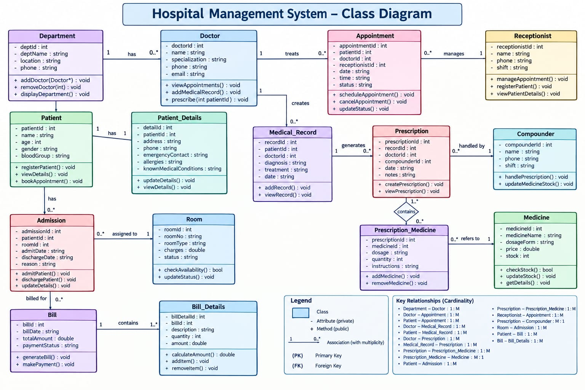

4.4 Data Design (if applicable)
The C++ model stores patient objects in an in-memory vector and uses strings for identifiers and contact details. The web interface uses HTML forms and tables and keeps demonstration data in JavaScript arrays and the DOM; the selected role and sign-in state are stored in browser localStorage. No SQL database, server-side persistence, or real patient dataset is included. Data entered in the interface should be treated as sample data only.

CHAPTER 5
IMPLEMENTATION AND USER INTERFACE

5.1 Module Description
The main modules are: Dashboard for overview statistics and recent activity; Patient Directory for searching and registering profiles; Appointments for viewing the schedule and booking a slot; Medical Records for role-checked access and clinical-note demonstration; Security Centre for role-based access, password-hashing explanation, validation, and audit events; Sign-in for selecting an authorised staff role; and the C++ backend model for core OOP and permission logic.

5.2 Key Implementation Details
In the C++ code, User verifies a password transformation and exposes role-based permission methods. Patient::isValid checks name length/characters, age range, and presence of an '@' in the email. HealthcareSystem::registerPatient checks permission and validity before adding a patient to its vector. updateClinicalRecord logs whether the user is authorised. In JavaScript, renderRole updates navigation and controls; changeView blocks unavailable sections; form handlers validate and update the demonstration interface; audit inserts allow/deny events. The current code is educational: std::hash is not a production password-storage algorithm, and browser-side checks alone are not a security boundary.

5.3 User Interface / Console Screenshots
The interface includes a dashboard, patient directory, appointment schedule, medical-record workspace, and security centre. Insert screenshots captured from the running repository at this point before submission: (1) Dashboard, (2) Patient Directory/search, (3) Appointment booking, and (4) Security Centre/audit log. Use captions Figure 5.1–Figure 5.4 and ensure that screenshots show only sample data. Screenshots are not embedded in this generated report.

5.4 Object-Oriented Programming Concepts Used
Classes and objects: User, Patient, HealthcareSystem, and AuditLogger are defined in C++. Encapsulation: data members in User and Patient are private. Constructors initialise user and patient objects. Abstraction: permission and validation methods expose a simple interface while hiding implementation details. Enum class Role represents the three staff categories. The browser code uses functions and structured objects to centralise role permissions. Inheritance and runtime polymorphism are not materially used in the current implementation and should not be claimed as implemented.

5.5 Sample Input and Output
Illustrative C++ execution: the program prints the MediShield heading, signs in the administrator, registers a valid sample patient, logs a doctor’s permitted clinical-record action, logs a receptionist’s denied clinical-record action, and prints the patient count. The browser demo uses the supplied sample staff accounts and sample patient/appointment data. Exact screen content may vary with the current repository version. Example backend command: g++ -std=c++17 backend/main.cpp -o medishield; ./medishield.

CHAPTER 6
METHODOLOGY

6.1 Development Approach
An iterative, module-based approach was followed: review the healthcare workflow, identify roles and core use cases, design the interface and C++ classes, implement each module, integrate navigation and role checks, then review the expected behaviour using representative scenarios. The project prioritises demonstrating OOP and introductory security concepts over production deployment.

6.2 Workflow / Process
1. Identify users and use cases. 2. Design the dashboard and module navigation. 3. Define roles and permission rules. 4. Implement the HTML structure and CSS styling. 5. Add JavaScript event handlers for sign-in, patient search/registration, appointments, clinical notes, and audit events. 6. Implement C++ classes and validation. 7. Compile and run the C++ program. 8. Check permitted and denied actions with each role. 9. Document limitations and future improvements.

6.3 Module Integration
The frontend modules share role definitions and permission checks in script.js. Navigation and action buttons are updated by renderRole(), while changeView() denies access to views unavailable to the current role. Form handlers update the patient table, appointment schedule, and audit log. The C++ classes form a separate model with equivalent permission concepts; because no API or database is present, frontend data is not transferred to the C++ program.

CHAPTER 7
ALGORITHMS AND TESTING

7.1 Algorithms / Pseudocode
Algorithm 1 — Sign-in: read staff ID and password; find the matching configured account; if credentials match, set the active role, update role-specific navigation, log an ALLOW event, and show the workspace; otherwise display an error. Algorithm 2 — Patient registration: check whether the role can manage patients; validate name, email, and age; if checks pass, create an identifier and add the patient to the in-memory collection/table; log the result. Algorithm 3 — Clinical-record access: check whether the role is Doctor or Administrator; if allowed, permit the action and log ALLOW; otherwise block it and log DENY. Algorithm 4 — Appointment booking: check booking permission, validate the form fields, append the appointment to the schedule, update the count, and log the action.

7.2 Test Plan and Test Cases
Representative test cases (run these scenarios and update the actual-result/status fields before submission):
TC-01 — Valid administrator sign-in | Input: admin001 / Admin@123 | Expected: dashboard opens with administrator permissions | Actual/Status: To be verified.
TC-02 — Invalid sign-in | Input: incorrect staff ID or password | Expected: error message; workspace remains unavailable | Actual/Status: To be verified.
TC-03 — Patient registration by receptionist | Input: valid name, email, age and gender | Expected: patient appears in the directory and an ALLOW event is recorded | Actual/Status: To be verified.
TC-04 — Clinical record access by doctor | Input: sign in as doctor001 and verify access | Expected: clinical-record section is available and access is logged | Actual/Status: To be verified.
TC-05 — Clinical record access by receptionist | Input: sign in as desk001 and attempt to open records | Expected: access is denied and a DENY event is recorded | Actual/Status: To be verified.
TC-06 — Patient search | Input: enter a known sample name or patient ID | Expected: matching rows remain visible | Actual/Status: To be verified.
TC-07 — Appointment booking | Input: valid patient name, doctor and time | Expected: appointment is added to the displayed schedule and logged | Actual/Status: To be verified.
Note: The cases above are a proposed test plan, not a claim that formal testing has already been completed.

7.3 Results and Discussion
The design demonstrates the main intended workflows: role-specific navigation, patient management, appointment booking, clinical-record permission checks, and audit logging. The C++ model illustrates the same permission concepts using encapsulated classes and an in-memory patient collection. The project is suitable as an OOP and interface prototype. It is not a deployed healthcare solution because the browser data is simulated, persistence is absent, and security controls are not production-grade.

CHAPTER 8
CONCLUSION AND FUTURE SCOPE

8.1 Conclusion
MediShield combines common healthcare-administration workflows with a clear demonstration of object-oriented programming and basic access-control ideas. Its interface is organised into understandable modules, and the C++ backend model uses classes, constructors, private data members, validation, permission checks, and audit logging. The project meets its educational goal of showing how these concepts can be applied to a healthcare-management scenario, subject to verification through execution and demonstration.

8.2 Limitations
The application does not use a live database, and browser-side data changes are not reliably persisted as clinical records. The frontend and C++ backend are separate demonstrations rather than an integrated full-stack application. The password transformation uses std::hash for classroom explanation and is not suitable for secure production storage. Server-side authorization, encrypted transport, robust validation, backup, privacy controls, and formal testing are not implemented as a production system.

8.3 Future Scope
Future work could add a secure backend API and relational database, robust authentication with salted Argon2id/bcrypt/scrypt hashes, HTTPS, server-enforced role-based access control, stronger validation, audit records stored securely with timestamps and immutable history, automated unit/integration tests, appointment conflict checking, patient-record export with consent, backups, accessibility improvements, and a privacy/compliance review before any real-world use.

REFERENCES
[1] Jahnav009, “Healthcare_management_miniproject: MediShield — Healthcare Management System,” GitHub repository. Available: https://github.com/Jahnav009/Healthcare_management_miniproject/tree/main. Accessed: 28 October 2026.
[2] ISO C++ Foundation, “C++ documentation,” Available: https://isocpp.org/.
[3] MDN Web Docs, “HTML, CSS, and JavaScript documentation,” Available: https://developer.mozilla.org/.

APPENDICES (IF APPLICABLE)
Appendix A — Build and run instructions
1. Open the repository folder in a terminal.
2. Open index.html in a browser to run the web interface.
3. Compile the C++ model with: g++ -std=c++17 backend/main.cpp -o medishield
4. Run the executable (./medishield on Linux/macOS; medishield.exe on Windows).
Appendix B — Implementation notes
The project is a learning prototype. It does not connect to a live database, and the frontend simulation and C++ backend are separate. Do not enter real patient or confidential health information.

