### The Meal-Dash

#### A PROJECT REPORT

##### *Submitted by*

**Aditya Vishwakarma ( 201500042 )**

***in partial fulfillment for the award of the degree of***

#### BACHELOR OF ENGINEERING

**IN**

Computer Engineering and Application

**GLA University, Mathura**

##### APRIL 2023

#### BONAFIDE CERTIFICATE

Certified that this project report **“THE MEAL-DASH ”** is the bonafide work of “**ADITYA VISHWAKARMA”** who carried out the project work under my/our

|  |  |
| --- | --- |
| supervision. |  |
| **SIGNATURE**  Rohit Agrawal  **HEAD OF THE DEPARTMENT**  Computer Engineering and Application | **SIGNATURE**  findMr. Bhanu Kapoor  **SUPERVISOR**  Technical Trainer  Training and Development |

Submitted for the project viva-voce examination held on

**INTERNAL EXAMINER EXTERNAL EXAMINER**

#### ACKNOWLEDGEMENT

It gives us a great sense of pleasure to present the synopsis of the B.Tech mini project undertaken during B.Tech III Year. This project is going to be an acknowledgement to the inspiration, drive and technical assistance will be contributed to it by many individuals. We owe special debt of gratitude to Mr. Bhanu Kapoor, for providing us with an encouraging platform to develop this project, which thus helped us in shaping our abilities towards a constructive goal and for his constant support and guidance to our work. His sincerity, thoroughness and perseverance has been a constant source of inspiration for us. We believe that he will shower us with all his extensively experienced ideas and insightful comments at different stages of the project & also taught us about the latest industry-oriented technologies. We also do not like miss the opportunity to acknowledge the contribution of all faculty members of the department for their kind guidance and co-operation.

Aditya Vishwakarma (201500042)

#### TABLE OF CONTENTS

List of Figures i

Abstract ii

##### Chapter1………Introduction

##### 1.1……………. .Client Identification

**1.2.......................Identification of Problem**

##### 1.3……………. . Identification of Task

**1.4.......................Timeline**

**1.5....................... Organization of the Report**

##### Chapter2………Design Flow/Process

##### 2.1……………. .Evaluation & Selection of Specifications/Features

##### Chapter3………Result Analysis & Validation

##### 3.1……………. .Evaluation & Selection of Specifications/Features

##### Chapter4………Conclusion & Future Work

##### 4.1……………. .Conclusion

##### 4.2……………. .Future Work

##### Refrences

**List of Figures**

1. Fig 1.4: Gantt chart

2. Fig 2.1: flow chart

3.Fig 3.1: result analysis

3. Figures describing project Web pages:

1. Figure – 1: start screen

2. Figure - 2: start screen

3. Figure - 3: start screen

4. Figure - 4: sign up screen

5. Figure - 5: login screen

6. Figure - 6: category screen

**ABSTRACT**

This project attempts to address the issue of young people of all ages who are having trouble sharing the bill equitably when they go out with their families and friends.

We are able to use the built website for personal login and create a group on the website of your friends and family as an admin.

This project will automate the arduous process of splitting the bills and keeping track of expenditures, bringing it to only a few mouse clicks. It includes modules like Login System which includes sign in and sign up page where every individual can register themselves with our site and login as admin to create group of members, Webpage (the user-friendly UI) which help to add expense and settle it among the members of the group.

**CHAPTER 1**

#### INTRODUCTION

* 1. **Client Identification/Need Identification/Identification of relevant**

##### Contemporary issue

Our client is every person who loves to eat food but don’t want to go outside and order his food from different restaurants from any place like home.

**1.2. Identification of Problem**

When we are not able to divide our expended amount among our peers.

**1.3. Identification of Task**

We should be able to interact with that group in which we are spending money at one place and can send them their share of monetary contribution so that they can pay that instantly.

**1.4. Timeline**

**1.5. Organization of the Report**

GLA University.

**CHAPTER 2**

#### DESIGN FLOW/PROCESS

##### 2.1. Evaluation & Selection of Specifications/Features

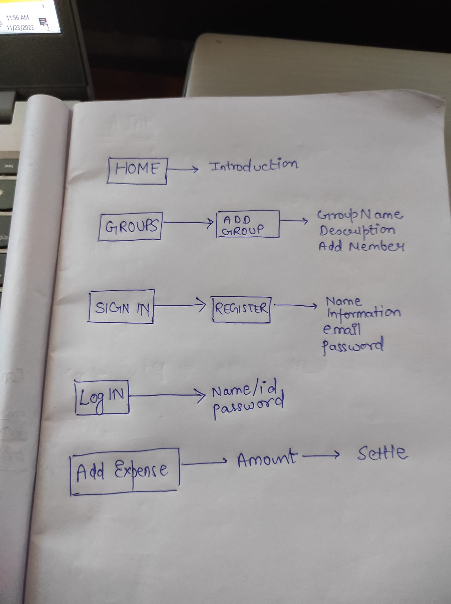

**CHAPTER 3**

**RESULTS ANALYSIS AND VALIDATION**

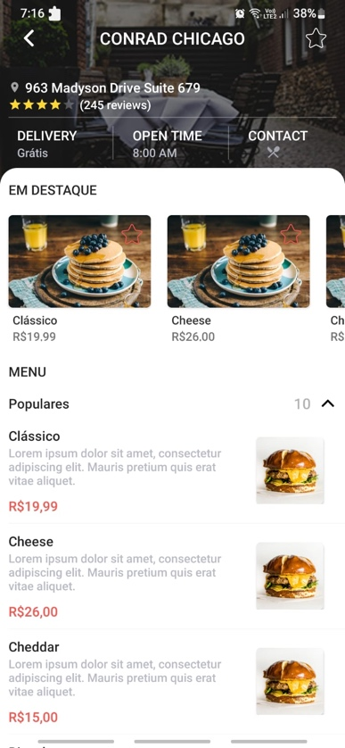

**CHAPTER 4**

#### CONCLUSION AND FUTURE WORK

##### 4.1. Conclusion

Through this project we have been able to provide a user friendly environment for the users to split their monetary contributions among peers.

##### 4.2. Future work

We welcome all the suggestion and advise in our project and we will be working on it in near future to improve our project in many different ways.

We have also planned when we will be further moving in the project we will be associating payment gateway links and history sections for our users so that it will become easy for them to use.

**REFERENCES**

* FCC: https://www.freecodecamp.org/
* MDN: https://developer.mozilla.org/en-US/
* Mongo DB: https://www.mongodb.com/docs/
* www.google.com
* W3 School: https://www.w3schools.com/

#### FIGURES

#### 

#### Figure 1

#### 

#### Figure 2 Figure 3

#### 

#### Figure 4

#### 

#### Figure 5

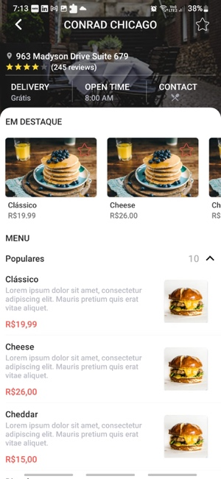

#### Figure 6

