**JAVA NOTES- ABDUL BARI UDEMY**

**Basic skeleton of a java program**

import java.lang * ; ---> imporTANT to write java programs --> lang is a package ---> this gets imported automatically

**// static---> can be called from the calss without creating an object.**

Class “filename” {

Public static void main (String arg[]){  
 // to print something

System.out.println(“Hellow World!”);

}

}

**how to read from keyboard**

Import java.util *

Class keybaord {

Public static void main (String arg[]){

Scanner s = new Scanner(System.in);

}

}

import java.util.*;

*// addtion of 2 number program*

public class input {

    public static void main(String[] args) {

        Scanner s = new Scanner (System.in);

        int a , b , ans ;

        System.out.println("Enter the value of a and b :") ;

        a = s.nextInt();

        b= s.nextInt();

        ans = a + b ;

        System.out.println("The  sum of 2 numbers is : " + ans) ;

    }

}

**DATATYPE:**

For every datatype there s a class for it to get its features

Int -- > Integer

Float --> Float

These features can be size of the data type , MIN_VALUE,MAX_VALUE ;

**INCREMENT DECREMENT**

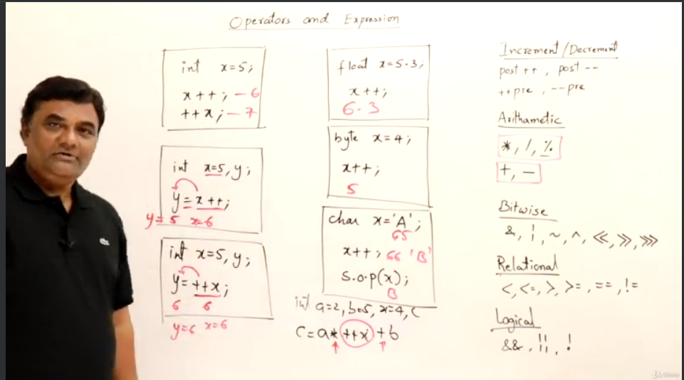

**PRINT METHODS - only one parameter**

Print()- print only

Println() - print and move cursor to next line ;

+ -> concatenation . -- attach anything to a string .

Printf() - similar to c language . --> takes 2 arguments --> takes format specifier similar to c .

**Format specifier - “ %{flag}{width}format spec.(for particular datatype)”**  ---> flag - “0” , “+” , “-”, ‘(“ .

**STRING**

String str = “ Java Program” ---> str is reference and “ Java Program” is object .

New keyword creates a heap memory where as in general it forms pool.

