**The** RISC-V Instruction Set Architecture (ISA) is an open standard that defines a modular and extensible set of instructions for computer processors. It includes a base set of instructions for general-purpose computing, along with optional extensions for specific applications, such as cryptography and vector processing. The architecture supports various data types and formats, including integer and floating-point operations. RISC-V is designed to be simple and efficient, making it suitable for a wide range of devices, from embedded systems to high-performance computing. Its open nature encourages innovation and collaboration in hardware and software development.

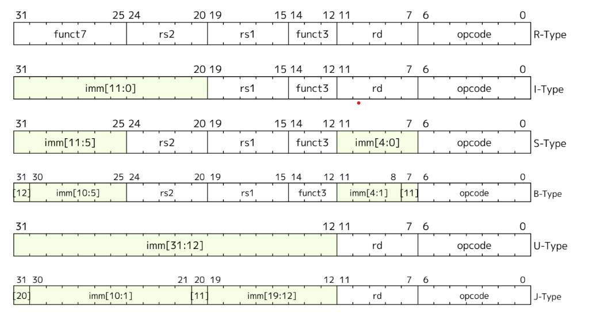

**R-Type Instructions:**

* Used for arithmetic and logical operations involving two source registers, with the result stored in a destination register.
* Instruction format includes fields for opcode, destination register (rd), two source registers (rs1, rs2), a funct3 field, and a funct7 field for additional operation specification.



* Common examples: add (addition), sub (subtraction), and (bitwise AND), or (bitwise OR), xor (bitwise XOR), sll (shift left logical), and srl (shift right logical).
* Executed in a single clock cycle in most RISC-V implementations, offering high computational efficiency.
* Essential for algorithms requiring arithmetic calculations, such as mathematical computations, data processing, and control algorithms.
* Can create data dependencies, as the result of one instruction may be needed for subsequent operations.

**I-Type Instructions:**

* Used for operations involving an immediate value, such as arithmetic operations with constants, loading data from memory, and controlling program flow.
* Format includes an opcode, destination register (rd), source register (rs1), funct3 field, and a 12-bit immediate value.
* Examples include addi (add immediate), slti (set less than immediate), xori (XOR immediate), and load instructions like lb (load byte), lh (load halfword), and lw (load word).



* Often employed to load data from memory into registers, which is vital for data manipulation and processing.
* Some I-Type instructions, such as jalr (jump and link register), enable control flow, supporting function calls and returns.
* Use of immediate values enables more compact code and reduces the number of instructions needed for specific operations.

**S-Type Instructions:**

* Designed for storing data from registers into memory, facilitating data management in programs.
* Format includes an opcode, source register (rs1), funct3 field, an immediate value (split into two parts), and a second source register (rs2) containing data to be stored.
* Common examples: sb (store byte), sh (store halfword), sw (store word).



* Essential for writing data back to memory, a critical operation in programs manipulating data.
* The effective address for the store operation is calculated by adding the immediate value to the value in the source register (rs1).
* Crucial for managing data structures, arrays, and buffers, ensuring efficient data storage and retrieval.

**B-Type Instructions:**

* Used for conditional branching, allowing changes in the program’s flow based on specific conditions.
* Format includes an opcode, two source registers (rs1, rs2) for comparison, a funct3 field to specify the type of comparison, and an immediate value representing the branch target.
* Examples include beq (branch if equal), bne (branch if not equal), blt (branch if less than), and bge (branch if greater than or equal).



* Essential for implementing control structures like loops and conditionals, enabling dynamic program behavior.
* The branch target address is calculated by adding the immediate value to the address of the instruction following the branch.
* Can introduce pipeline hazards in pipelined architectures, as the outcome of the branch is not known until execution.

**U-Type Instructions:**

* Used for loading large immediate values into registers, particularly for operations requiring a 20-bit immediate.
* Format includes an opcode, destination register (rd), and a 20-bit immediate value placed in the upper 20 bits of the register.
* Examples include lui (load upper immediate) and auipc (add upper immediate to program counter).



* Often used in combination with other instructions to construct full 32-bit addresses or large constants.
* Efficient as they allow direct loading of large immediate values into registers, reducing the number of instructions needed.
* Especially useful in systems programming, where large constants or addresses are frequently manipulated.

**J-Type Instructions:**

* Used for unconditional jumps, allowing the program to jump to a specified address in the instruction stream.
* Format includes an opcode, destination register (rd), and a 20-bit immediate value that specifies the jump target.
* Primary example: jal (jump and link), which also saves the return address in the destination register.



* Essential for implementing function calls and returns, supporting modular programming and code reuse.
* The jump target address is calculated by adding the immediate value to the address of the instruction following the jump.
* Crucial for control flow management, enabling the implementation of complex program structures like loops and function calls.

**Unique RISC-V Instructions Identified :**

Based on the analysis of the assembly code, I identified the following unique RISC-V instructions:

1. **addi**: Add immediate - adds a constant value to a register.
2. **sd**: Store double - stores a 64-bit value from a register to memory.
3. **li**: Load immediate - loads a constant value into a register.
4. **jal**: Jump and link - jumps to a specified address and saves the return address.
5. **ld**: Load double - loads a 64-bit value from memory into a register.
6. **ret**: Return - returns from a function (typically used with jal).
7. **mv**: Move - copies the value from one register to another.
8. **beqz**: Branch if equal to zero - branches to a specified address if a register is zero.
9. **jalr**: Jump and link register - jumps to an address in a register and saves the return address.
10. **jr**: Jump register - jumps to the address contained in a register.
11. **bltz**: Branch if less than zero - branches if a register's value is negative.
12. **neg**: Negate - negates the value in a register.
13. **sll**: Shift left logical - shifts the bits of a register to the left.
14. **and**: Bitwise AND - performs a bitwise AND operation between two registers.
15. **sub**: Subtract - subtracts one register from another.
16. **lui**: Load upper immediate - loads a 20-bit immediate into the upper 20 bits of a register.
17. **auipc**: Add upper immediate to PC - adds a 20-bit immediate to the program counter.

**Here** are the 32-bit instruction encodings for 15 unique RISC-V instructions, presented in the respective instruction formats:

1. **addi** (I-type)
   * **Opcode**: 0010011
   * **Format**: imm[11:0] | rs1 | funct3 | rd | opcode
   * **Example**: 000000000001 | 00001 | 000 | 00010 | 0010011 (adds 1 to register x1 and stores in x2)
2. **sd** (S-type)
   * **Opcode**: 0100011
   * **Format**: imm[11:5] | rs2 | rs1 | funct3 | imm[4:0] | opcode
   * **Example**: 0000000 | 00010 | 00001 | 011 | 00000 | 0100011 (stores x2 into memory address in x1)
3. **jal** (J-type)
   * **Opcode**: 1101111
   * **Format**: imm[20] | imm[10:1] | imm[11] | imm[19:12] | rd | opcode
   * **Example**: 00000000000000000000 | 00000 | 1101111 (jumps to address)
4. **ld** (I-type)
   * **Opcode**: 0000011
   * **Format**: imm[11:0] | rs1 | funct3 | rd | opcode
   * **Example**: 000000000000 | 00001 | 011 | 00010 | 0000011 (loads from memory into x2)
5. **mv** (Pseudo-instruction, typically translated to addi)
   * **Example**: addi rd, rs1, 0
6. **beqz** (B-type)
   * **Opcode**: 1100011
   * **Format**: imm[12] | imm[10:5] | rs1 | rs2 | funct3 | imm[4:1] | imm[11] | opcode
   * **Example**: 000000000000 | 00001 | 00000 | 000 | 00000 | 1100011 (branch if x1 is zero)
7. **jalr** (I-type)
   * **Opcode**: 1100111
   * **Format**: imm[11:0] | rs1 | funct3 | rd | opcode
   * **Example**: 000000000000 | 00001 | 000 | 00010 | 1100111 (jumps to address in x1)
8. **bltz** (B-type)
   * **Opcode**: 1100011
   * **Format**: imm[12] | imm[10:5] | rs1 | rs2 | funct3 | imm[4:1] | imm[11] | opcode
   * **Example**: 000000000000 | 00001 | 00000 | 000 | 00000 | 1100011 (branch if x1 is less than zero)
9. **sll** (R-type)
   * **Opcode**: 0110011
   * **Format**: shamt | rs2 | rs1 | funct3 | rd | opcode
   * **Example**: 00000 | 00010 | 00001 | 001 | 00010 | 0110011 (shift left logical)
10. **and** (R-type)
    * **Opcode**: 0110011
    * **Format**: funct7 | rs2 | rs1 | funct3 | rd | opcode
    * **Example**: 0000000 | 00010 | 00001 | 111 | 00010 | 0110011 (bitwise AND)
11. **sub** (R-type)
    * **Opcode**: 0110011
    * **Format**: funct7 | rs2 | rs1 | funct3 | rd | opcode
    * **Example**: 0100000 | 00010 | 00001 | 000 | 00010 | 0110011 (subtract)

**Instruction: addi sp, sp, -16**

1. Register Mapping:
   * sp corresponds to register x2.
2. Instruction Breakdown:
   * Opcode: 0010011 (for immediate arithmetic operations)
   * rd: x2 (which is 00010 in binary)
   * rs1: x2 (which is also 00010 in binary)
   * funct3: 000 (for the addi operation)
   * Immediate: -16 (which is 1111111111110000 in 12-bit two's complement)
3. Encoding:
   * Immediate (12 bits): 111111111111 (for -16)
   * rs1 (5 bits): 00010 (for sp)
   * funct3 (3 bits): 000
   * rd (5 bits): 00010 (for sp)
   * Opcode (7 bits): 0010011
4. Final Encoding:
   * The instruction in binary format would be:
   * imm[11:0] | rs1 | funct3 | rd | opcode
   * 111111111111 | 00010 | 000 | 00010 | 0010011
5. Complete Binary Representation:
   * Combining these fields gives:
   * 11111111111100010 000 00010 0010011
   * This can be grouped into 32 bits:
   * 11111111111100010000000010010011
6. Binary to Hexadecimal:
   * Converting this binary to hexadecimal gives:
   * 0xFFF00013

**Verification of Given Hex Code**

The provided hex code ff010113 corresponds to the instruction addi sp, sp, -16 as follows:

1. Hexadecimal to Binary Conversion:
   * ff010113 in binary is:
   * 11111111 00000001 00010001 00010011
2. Instruction Breakdown:
   * The binary representation can be split into fields:
     + Opcode (7 bits): The last 7 bits are 00010011, which corresponds to the addi opcode.
     + rd (5 bits): The next 5 bits are 00010, which corresponds to register x2 (sp).
     + funct3 (3 bits): The next 3 bits are 000, which indicates the addi function.
     + rs1 (5 bits): The next 5 bits are 00010, which also corresponds to register x2 (sp).
     + Immediate (12 bits): The first 12 bits are 111111111111, which is -16 in two's complement.

Thus, the instruction ff010113 indeed corresponds to addi sp, sp, -16.

The 32-bit binary pattern for the instruction addi sp, sp, -16 is:

**11111111000100010000000100010011**

And the corresponding hexadecimal representation is:

0xFF010113