**Android Developer Fundamentals**

**1. Install android studio and run hello world program. Solution:**

Creating a project:

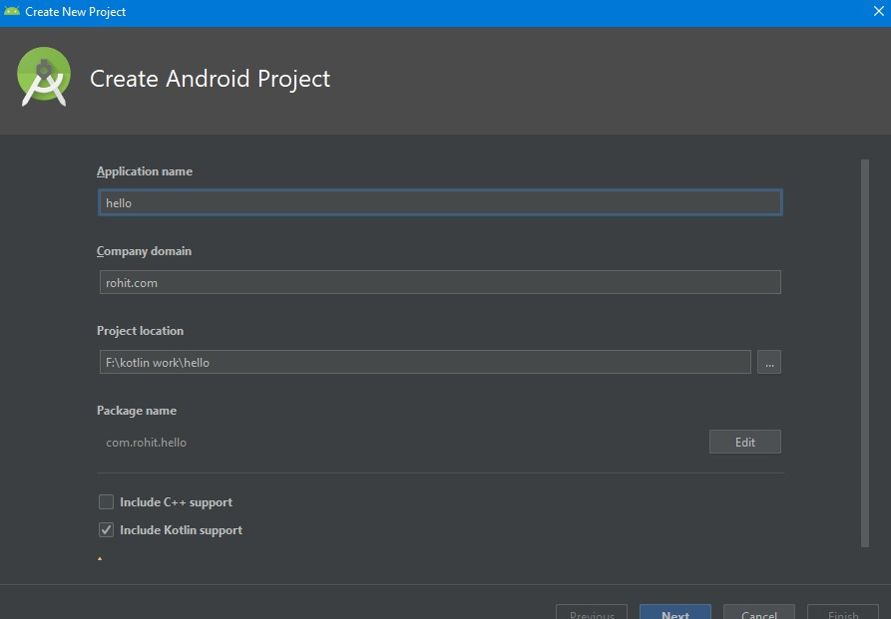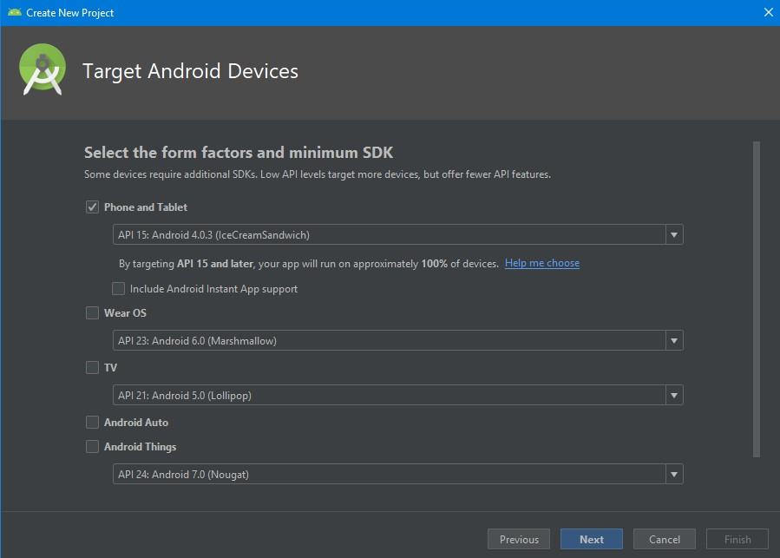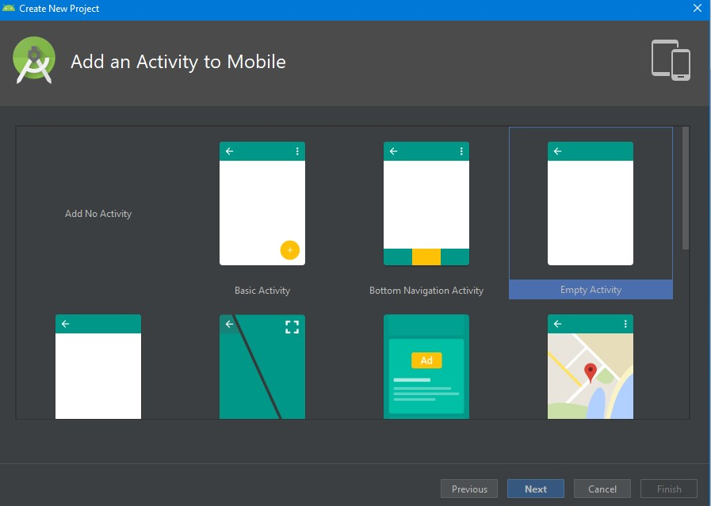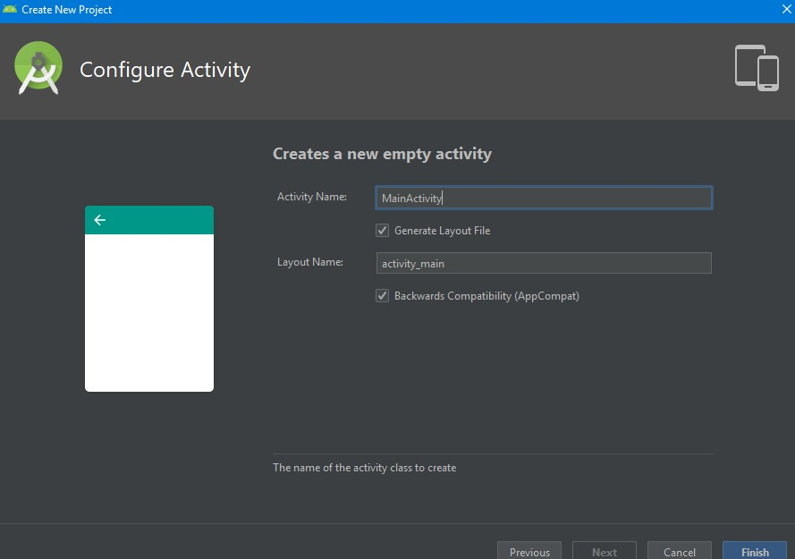

Activity_Main.Kt

|  |
| --- |
| package com.rohit.hello    import android.support.v7.app.AppCompatActivity import android.os.Bundle    class MainActivity : AppCompatActivity() {    override fun onCreate(savedInstanceState: Bundle?) { super.onCreate(savedInstanceState) setContentView(R.layout.*activity_main*)  }  } |

Activity_Main.xml

|  |
| --- |
| <?xml version="1.0" encoding="utf-8"?>    <android.support.constraint.ConstraintLayout    xmlns:android="http://schemas.android.com/apk/res/android"    xmlns:tools="http://schemas.android.com/tools"    xmlns:app="http://schemas.android.com/apk/res-auto"    android:layout_width="match_parent" |

android:layout_height="match_parent"

tools:context=".MainActivity">

<TextView

android:layout_width="wrap_content"

android:layout_height="wrap_content"

android:text="Hello World!"

app:layout_constraintBottom_toBottomOf="parent"

app:layout_constraintLeft_toLeftOf="parent"

app:layout_constraintRight_toRightOf="parent"

app:layout_constraintTop_toTopOf="parent"/>

</android.support.constraint.ConstraintLayout>

Apk in avd:

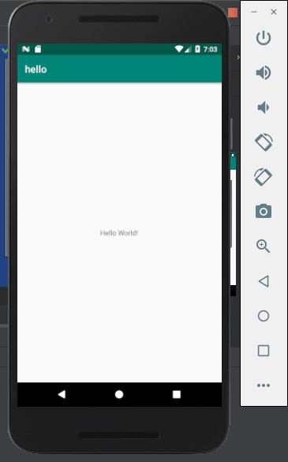

**2. create an android app with intereactive user interface using layouts Solution:**

|  |
| --- |
| <?xml version="1.0" encoding="utf-8"?>  <androidx.constraintlayout.widget.ConstraintLayout  xmlns:android="http://schemas.android.com/apk/res/android"  xmlns:app="http://schemas.android.com/apk/res-auto"  xmlns:tools="http://schemas.android.com/tools"  android:layout_width="match_parent"  android:layout_height="match_parent"  tools:context=".MainActivity">    <LinearLayout  android:layout_width="409dp"  android:layout_height="729dp"  android:orientation="vertical"  app:layout_constraintBottom_toBottomOf="parent"  app:layout_constraintEnd_toEndOf="parent" |

app:layout_constraintStart_toStartOf="parent"

app:layout_constraintTop_toTopOf="parent">

<TextView

android:id="@+id/textView"

android:layout_width="match_parent"

android:layout_height="wrap_content"

android:gravity="center"   
 android:text="Login form"

android:textSize="24sp" />

<EditText

android:id="@+id/editTextText"

android:layout_width="match_parent"

android:layout_height="wrap_content"

android:ems="10"

android:inputType="text"

android:hint="Enter your email" />

<EditText

android:id="@+id/editTextText2"

android:layout_width="match_parent"

android:layout_height="wrap_content"

android:ems="10"

android:hint="Enter your password"

/>

<Button

android:id="@+id/button"

android:layout_width="match_parent"

android:layout_height="wrap_content"

android:text="Button" />

</LinearLayout>

</androidx.constraintlayout.widget.ConstraintLayout>

**Output :**

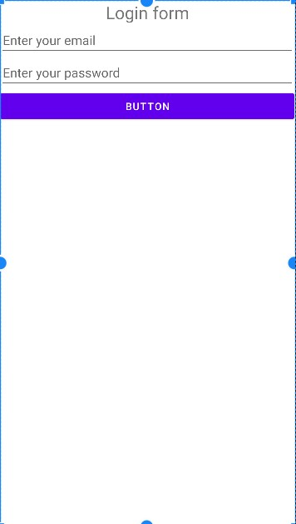

1. **Create an android app that demonstrate the working with TextView elements.**

**Solution :**

|  |
| --- |
| <?xml version="1.0" encoding="utf-8"?>  <androidx.constraintlayout.widget.ConstraintLayout  xmlns:android="http://schemas.android.com/apk/res/android"  xmlns:app="http://schemas.android.com/apk/res-auto"  xmlns:tools="http://schemas.android.com/tools"  android:layout_width="match_parent"  android:layout_height="match_parent"  android:foregroundTint="#984E4E"  tools:context=".MainActivity">    <TextView  android:id="@+id/name” android:layout_width="0dp"  android:layout_height="wrap_content"  android:gravity="center"  android:text="Welcome page"  android:textColor="#A80606"   android:textSize="32sp"  android:background="#DCABAB"  android:textStyle="bold|italic"  app:layout_constraintBottom_toBottomOf="parent"  app:layout_constraintEnd_toEndOf="parent"  app:layout_constraintStart_toStartOf="parent"  app:layout_constraintTop_toTopOf="parent" /> </androidx.constraintlayout.widget.ConstraintLayout> |

**Output :**

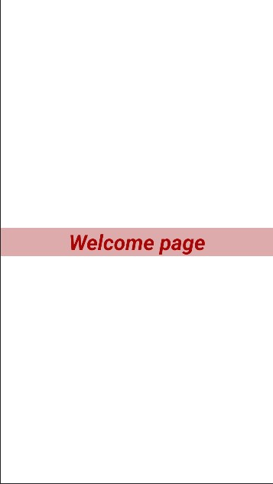

1. **Create an android app that demonstrate the activity life cycle and instance state**

**Solution :**

|  |
| --- |
| package com.example.myapplication;    import androidx.appcompat.app.AppCompatActivity;  import android.os.Bundle; importandroid.widget.Toast;    public class MainActivity extends AppCompatActivity { |
| @Override  protected void onCreate(Bundle savedInstanceState) {  super.onCreate(savedInstanceState);  setContentView(R.layout.*activity_main*);  }    @Override  protected void onStart() {  super.onStart();  Toast.*makeText*(getApplicationContext(), "onStart method", Toast.*LENGTH_SHORT*).show();  }    @Override  protected void onResume() {  super.onResume();  Toast.*makeText*(getApplicationContext(), "onResume method", Toast.*LENGTH_SHORT*).show();  }    @Override  protected void onPause() {  super.onPause();  Toast.*makeText*(getApplicationContext(), "onPause method", Toast.*LENGTH_SHORT*).show();  }    @Override  protected void onStop() {  super.onStop();  Toast.*makeText*(getApplicationContext(), "onStop method", Toast.*LENGTH_SHORT*).show();  }    @Override  protected void onDestroy() {  super.onDestroy();  Toast.*makeText*(getApplicationContext(), "onDestroy method", Toast.*LENGTH_SHORT*).show();  }  } |

|  |
| --- |
| <?xml version="1.0" encoding="utf-8"?>  <androidx.constraintlayout.widget.ConstraintLayout  xmlns:android="http://schemas.android.com/apk/res/android"  xmlns:app="http://schemas.android.com/apk/res-auto"  xmlns:tools=<http://schemas.android.com/tools>  android:layout_width="match_parent"  android:layout_height="match_parent"  tools:context=".MainActivity">    <EditText  android:id="@+id/editTextText"  android:layout_width="wrap_content"  android:layout_height="wrap_content"  android:ems="10"  android:inputType="datetime"  android:text="Name"  app:layout_constraintBottom_toBottomOf="parent"  app:layout_constraintEnd_toEndOf="parent"  app:layout_constraintStart_toStartOf="parent"  app:layout_constraintTop_toTopOf="parent" />    </androidx.constraintlayout.widget.ConstraintLayout> |

**Output :**

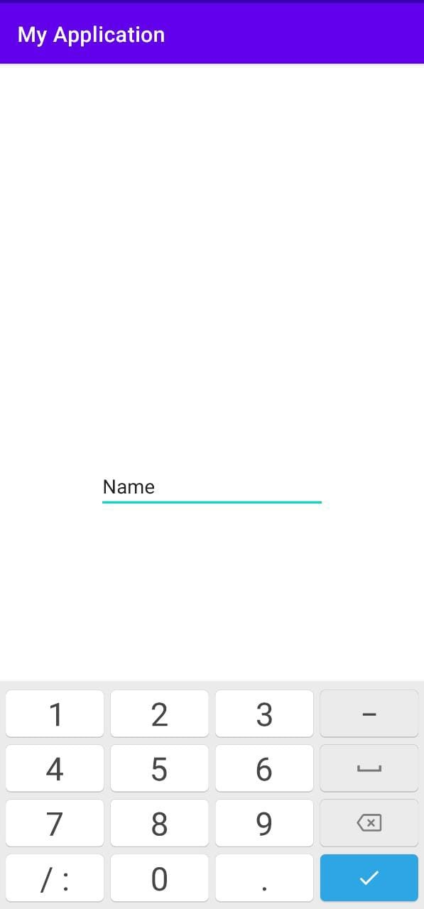

1. **create an android app that demonstrate the use of keyboards, Input controls, Alert, and pickers.**
2. **Keyboards:**

**Activity_main.xml**

|  |
| --- |
| <?xml version="1.0" encoding="utf-8"?>  <androidx.constraintlayout.widget.ConstraintLayout  xmlns:android=<http://schemas.android.com/apk/res/android>  xmlns:app=<http://schemas.android.com/apk/res-auto>  xmlns:tools=<http://schemas.android.com/tools>  android:layout_width="match_parent"  android:layout_height="match_parent  tools:context=".MainActivity">    <EditText  android:id="@+id/editTextText"  android:layout_width="wrap_content"  android:layout_height="wrap_content"  android:ems="10"  android:inputType="number|text"  android:text="Name"  app:layout_constraintBottom_toBottomOf="parent"  app:layout_constraintEnd_toEndOf="parent"  app:layout_constraintStart_toStartOf="parent"  app:layout_constraintTop_toTopOf="parent" /> </androidx.constraintlayout.widget.ConstraintLayout> |

**Output :**

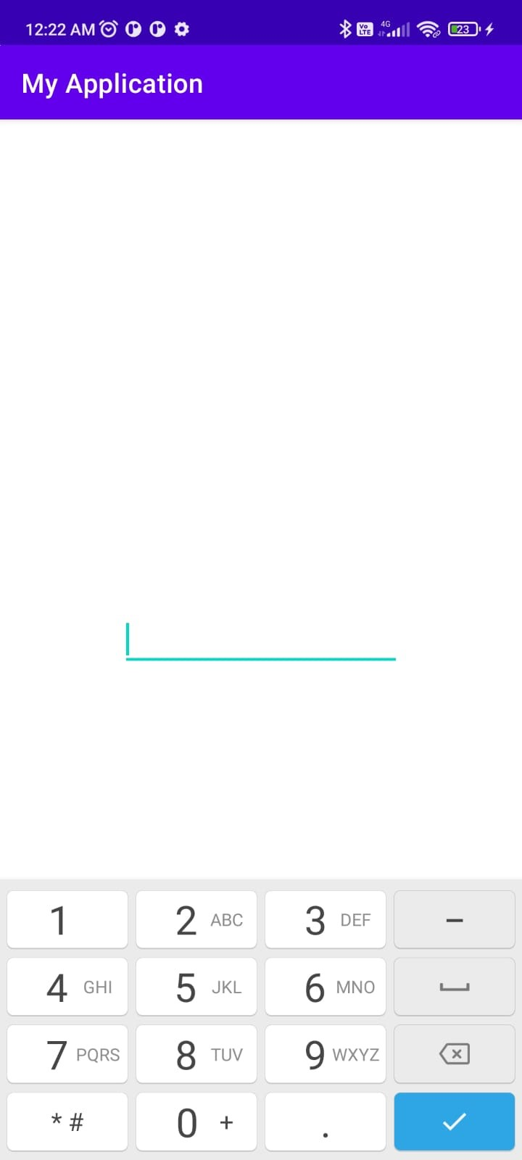

1. **Input controls :**

**radio button : Main.xml file**

|  |
| --- |
| <?xml version="1.0" encoding="utf-8"?>  <androidx.constraintlayout.widget.ConstraintLayout  xmlns:android=<http://schemas.android.com/apk/res/android>  xmlns:app=<http://schemas.android.com/apk/res-auto>  xmlns:tools="http://schemas.android.com/tools"  android:layout_width="match_parent"  android:layout_height="match_parent"  tools:context=".MainActivity">    <RadioGroup  android:id="@+id/radiogrp"  android:layout_width="wrap_content"  android:layout_height="wrap_content"  app:layout_constraintBottom_toBottomOf="parent"  app:layout_constraintEnd_toEndOf="parent"  app:layout_constraintStart_toStartOf="parent"  app:layout_constraintTop_toTopOf="parent">    <RadioButton  android:id="@+id/radioButton"  android:layout_width="match_parent"  android:layout_height="wrap_content"  android:text="male" />  <RadioButton  android:id="@+id/radioButton2"  android:layout_width="match_parent"  android:layout_height="wrap_content"  android:text="female" />  </RadioGroup>    <TextView  android:id="@+id/textView"  android:layout_width="wrap_content"  android:layout_height="wrap_content"  android:layout_marginTop="252dp"  android:text="Gender"  app:layout_constraintEnd_toEndOf="parent"  app:layout_constraintHorizontal_bias="0.498"  app:layout_constraintStart_toStartOf="parent"  app:layout_constraintTop_toTopOf="parent" />  </androidx.constraintlayout.widget.ConstraintLayout> |

**Output :**

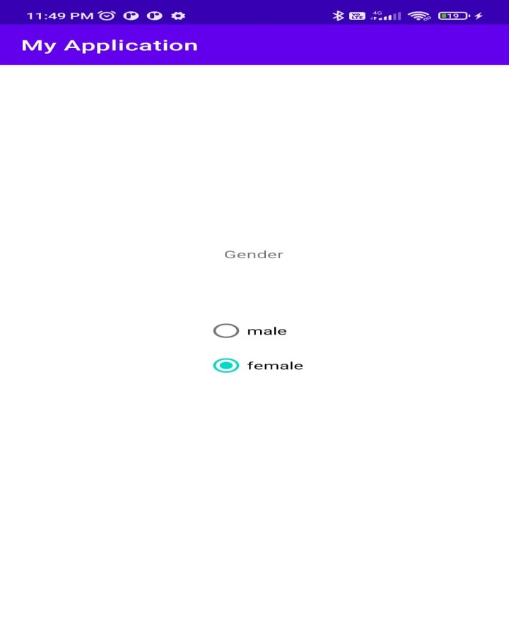

1. **Alert: Solution : activity_main.xml**

|  |
| --- |
| <?xml version="1.0" encoding="utf-8"?>  <androidx.constraintlayout.widget.ConstraintLayout  xmlns:android="http://schemas.android.com/apk/res/android"  xmlns:app="http://schemas.android.com/apk/res-auto"  xmlns:tools="http://schemas.android.com/tools"  android:layout_width="match_parent"  android:layout_height="match_parent"  tools:context=".MainActivity">    <Button  android:id="@+id/button"  android:layout_width="wrap_content"  android:layout_height="wrap_content"  android:text="Button"  app:layout_constraintBottom_toBottomOf="parent"  app:layout_constraintEnd_toEndOf="parent"  app:layout_constraintStart_toStartOf="parent"  app:layout_constraintTop_toTopOf="parent" /> </androidx.constraintlayout.widget.ConstraintLayout> |

**MainActivity.java**

package com.example.myapplication;

import androidx.appcompat.app.AlertDialog;

import androidx.appcompat.app.AppCompatActivity;

|  |
| --- |
| import android.content.DialogInterface; import android.os.Bundle;  import android.view.View;  import android.widget.Button;    public class MainActivity extends AppCompatActivity {    Button alertBtn;  AlertDialog.Builder builder;    @Override  protected void onCreate(Bundle savedInstanceState) {  super.onCreate(savedInstanceState);  setContentView(R.layout.*activity_main*);  alertBtn = findViewById(R.id.*button*);  builder = new AlertDialog.Builder(this);    alertBtn.setOnClickListener(new View.OnClickListener() {  @Override  public void onClick(View v) {  builder.setTitle("Alert")  .setMessage("Do you really want to close the application")  .setCancelable(true)  .setPositiveButton("yes", new DialogInterface.OnClickListener() {  @Override  public void onClick(DialogInterface dialog, int which) {  finish();  }  })  .setNegativeButton("no", new DialogInterface.OnClickListener() {  @Override  public void onClick(DialogInterface dialog, int which) {  dialog.cancel();  }  })  .show();    }  });  }  } |

**Output :**

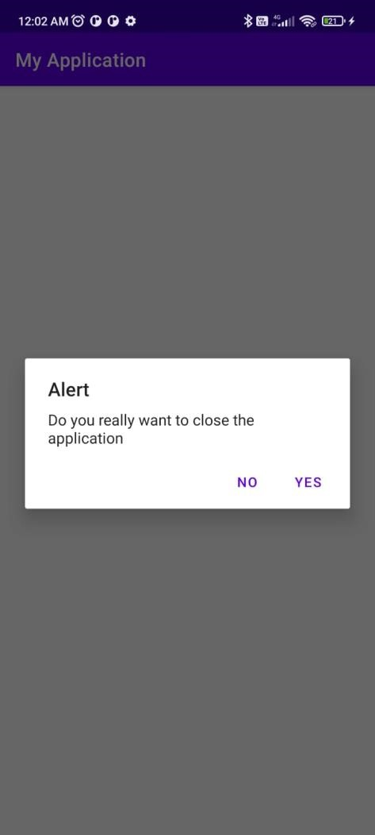

1. **Pickers :**

**Datepicker:**

**Activity_main.xml**

|  |
| --- |
| <?xml version="1.0" encoding="utf-8"?>  <androidx.constraintlayout.widget.ConstraintLayout  xmlns:android="http://schemas.android.com/apk/res/android"  xmlns:app="http://schemas.android.com/apk/res-auto"  xmlns:tools="http://schemas.android.com/tools"  android:layout_width="match_parent"  android:layout_height="match_parent"  tools:context=".MainActivity">      <EditText  android:id="@+id/dateEditText"  android:layout_width="wrap_content"  android:layout_height="wrap_content"  android:ems="10"  android:inputType="number|text"  android:hint="datepicker"  app:layout_constraintBottom_toBottomOf="parent"  app:layout_constraintEnd_toEndOf="parent"  app:layout_constraintStart_toStartOf="parent"  app:layout_constraintTop_toTopOf="parent" /> </androidx.constraintlayout.widget.ConstraintLayout> |

**MainActivity.java**

|  |
| --- |
| package com.example.myapplication;  import androidx.appcompat.app.AppCompatActivity;  import android.app.DatePickerDialog; import android.os.Bundle;  import android.view.View;  import android.widget.DatePicker; import android.widget.EditText;    import java.text.SimpleDateFormat; import java.util.Calendar;    public class MainActivity extends AppCompatActivity {  EditText editText; |
| @Override  protected void onCreate(Bundle savedInstanceState){  super.onCreate(savedInstanceState);  setContentView(R.layout.*activity_main*);  editText = findViewById(R.id.*dateEditText*);  editText.setOnClickListener(new View.OnClickListener() {  @Override  public void onClick(View v) {  Calendar calendar = Calendar.*getInstance*();  int year = calendar.get(Calendar.*YEAR*);  int month = calendar.get(Calendar.*MONTH*);  int day =calendar.get(Calendar.*DAY_OF_MONTH*);    DatePickerDialog datePicker = new DatePickerDialog(MainActivity.this, new  DatePickerDialog.OnDateSetListener() {  @Override  public void onDateSet(DatePicker view, int year, int month, int dayOfMonth) {  editText.setText(SimpleDateFormat.*getDateInstance*().format(calendar.getTime()));  }  },year, month, day);  datePicker.show();  }  });    }  } |

**output :**

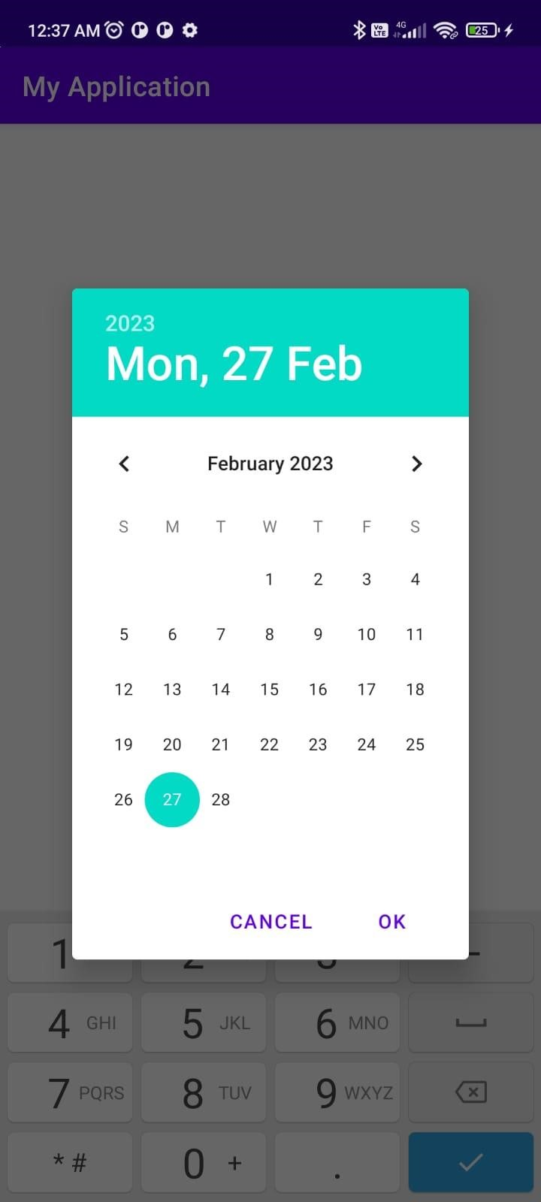

1. **create an android application that demonstrate the use of dropdown menu** step 1 :

create android resource directory(menu) by right clicking on “res” folder, select menu as a resource directory and directory name step 2:

right click on menu folder create new “menu resource file”. Give any name to the file, click on ok.

Menu file:

Example_menu.xml:

|  |
| --- |
| <?xml version="1.0" encoding="utf-8"?>  <menu xmlns:android="http://schemas.android.com/apk/res/android">  <item  android:id="@+id/bookmark"  android:title="bookmark"/>    <item android:id="@+id/downloads"  android:title="downloads"/>    <item android:id="@+id/settings"  android:title="settings"/> </menu> |

MainActivity.java:

|  |
| --- |
| package com.example.myapplication;    import androidx.annotation.NonNull;  import androidx.appcompat.app.AppCompatActivity;  import android.os.Bundle;  import android.view.Menu;  import android.view.MenuInflater; import android.view.MenuItem; import android.widget.Toast;    public class MainActivity extends AppCompatActivity {      @Override  protected void onCreate(Bundle savedInstanceState) {  super.onCreate(savedInstanceState);  setContentView(R.layout.*activity_main*);  }    @Override  public boolean onCreateOptionsMenu(Menu menu) {  MenuInflater inflater= getMenuInflater();  inflater.inflate(R.menu.*example_menu*, menu);  return true;    }    @Override  public boolean onOptionsItemSelected(@NonNull MenuItem item){  switch (item.getItemId()){  case R.id.*bookmark*:  Toast.*makeText*(getApplicationContext(), "you clicked on bookmark option", Toast.*LENGTH_SHORT*).show();  return true;    case R.id.*downloads*:  Toast.*makeText*(getApplicationContext(), "You clicked on downloads option", Toast.*LENGTH_SHORT*).show();  return true;  case R.id.*settings*:  Toast.*makeText*(getApplicationContext(), "You clicked on settings option",  Toast.*LENGTH_SHORT*).show();  }  return true;  }  } |

output :

