**Practical No. 1**

**Aim: Write C# programs for understanding C# basics involving:**

**a. Variables and Data Types b. Object-Based Manipulation**

**c. Conditional Logic d. Loops e. Methods**

**a. Variables and Data Types** **Program:**

using System;

using System.Collections.Generic; using System.Linq;

using System.Text;

namespace ConsoleApplication1

{

class Program

{

static void Main(string[] args)

{ int a = 20; bool b = true; double c = 5.5D; float d = 5.5F;

string val = "Hello World";

Console.WriteLine("Integer: " + a);

Console.WriteLine("Boolean Value: " + b);

Console.WriteLine("Decimal Value: " + c);

Console.WriteLine("Float Value: " + d);

Console.WriteLine("String Value: " + val);

Console.ReadKey();

}

}

}

**Output:**

**________________________________________________________________________________**

**b. Object-Based Manipulation**

**Program:**

using System;

using System.Collections.Generic; using System.Linq;

using System.Text;

namespace ConsoleApplication1

{

class Program

{

static void Main(string[] args)

{

string mystring;

int a = 100;

Console.WriteLine("Convert Number to String");

mystring = a.ToString();

Console.WriteLine("String is " + mystring);

string s = " This is test string";

Console.WriteLine("\nBefore Trim() Method: " + s); s = s.Trim();

Console.WriteLine("\nAfter Trim() Method: " + s);

s = s.Substring(0, 4);

Console.WriteLine("\nSubstring() Method: " + s);

s = s.ToUpper();

Console.WriteLine("\nUppercase String: " + s);

s = s.Replace("IS", "AT");

Console.WriteLine("\nReplace String: " + s);

int length = s.Length;

Console.WriteLine("\nLength of String is: " + length);

Console.WriteLine("\n**********************************");

Console.WriteLine("\nDateTime Object");

DateTime myDate = DateTime.Now;

Console.WriteLine("Today's date is: " + myDate);

myDate = myDate.AddDays(100);

Console.WriteLine("\nAfter 100 Days the Date is: " + myDate);

string dateString = myDate.Year.ToString();

Console.WriteLine("\nYear in String is: " + dateString);

DateTime myDate1 = DateTime.Now;

DateTime myDate2 = DateTime.Now.AddHours(3000);

Console.WriteLine("\nDate 1 : " + myDate1);

Console.WriteLine("\nDate 2 : " + myDate2);

TimeSpan difference;

difference = myDate2.Subtract(myDate1);

Console.WriteLine("\nDifference between 2 Dates: " + difference.Days.ToString()+" Days");

double numberOfMinutes;

numberOfMinutes = difference.TotalMinutes;

Console.WriteLine("\nNumber of Minutes: " + numberOfMinutes);

Console.WriteLine("\n**********************************");

Console.WriteLine("\nThe Array Type:");

int[] myArray = { 1, 2, 3, 4, 5 }; int numberOfElements; numberOfElements = myArray.Length;

Console.WriteLine("\nTotal Elements in array:" + numberOfElements);

Console.ReadKey();

}

}

}

**Output:**

______________________________________________________________________________________________

**c. Conditional Logic**

**1. If…Else Condition** **Program:**

using System;

using System.Collections.Generic; using System.Linq;

using System.Text;

namespace ConsoleApplication1

{

class Program

{

static void Main(string[] args)

{

double percentage;

Console.WriteLine("Enter your Percetage: ");

percentage = Convert.ToDouble(Console.ReadLine());

if (percentage >= 80.00)

{

Console.WriteLine("You get 'O' Grade.");

}

else if(percentage <= 79.99 && percentage >= 75.00)

{

Console.WriteLine("You get 'A' Grade.");

}

else if (percentage <= 74.99 && percentage >= 70.00)

{

Console.WriteLine("You get 'B' Grade.");

}

else if (percentage <= 69.99 && percentage >= 60.00)

{

Console.WriteLine("You get 'C' Grade.");

}

else if (percentage <= 59.99 && percentage >= 50.00)

{

Console.WriteLine("You get 'D' Grade.");

}

else if (percentage <= 49.99 && percentage >= 40.00)

{

Console.WriteLine("You get 'E' Grade.");

}

else

{

Console.WriteLine("You get 'F' Grade.");

}

Console.ReadKey();

}

}

}

**Output:**

**2. Switch Case** **Program:**

using System;

using System.Collections.Generic; using System.Linq;

using System.Text;

namespace ConsoleApplication1

{

class Program

{

static void Main(string[] args)

{ char op;

int first, second, result;

Console.Write("Enter first number: "); first = Convert.ToInt32(Console.ReadLine()); Console.Write("\nEnter second number: "); second = Convert.ToInt32(Console.ReadLine()); Console.Write("\nEnter operator (+, -, *, /): "); op = (char)Console.Read();

switch (op)

{ case '+':

result = first + second;

Console.WriteLine("\n" + first + " + " + second + " = " + result); break;

case '-':

result = first - second;

Console.WriteLine("\n" + first + " - " + second + " = " + result); break;

case '*':

result = first * second;

Console.WriteLine("\n" + first + " * " + second + " = " + result); break;

case '/': result = first / second;

Console.WriteLine("\n" + first + " / " + second + " = " + result); break;

default:

Console.WriteLine("Invalid Operator"); break;

}

Console.ReadKey();

}

}

}

**Output:**

______________________________________________________________________________________________

**d. Loops** **1. For Loop** **Program:**

using System;

using System.Collections.Generic; using System.Linq;

using System.Text;

namespace ConsoleApplication1

{

class Program

{

static void Main(string[] args)

{

int n = 10, sum = 0;

for (int i = 1; i <= n; i++)

{

sum = sum + i;

}

Console.WriteLine("Sum of first {0} natural numbers = {1}", n, sum); Console.ReadKey();

}

}

}

**2. While Loop** **Program:**

using System;

using System.Collections.Generic; using System.Linq;

using System.Text;

namespace ConsoleApplication1

{

class Program

{

static void Main(string[] args)

{

int n = 10, sum = 0, i = 1;

while (i <= n)

{

sum = sum + i;

i++; }

Console.WriteLine("Sum of first {0} natural numbers = {1}", n, sum); Console.ReadKey();

}

}

}

**Output:**

**3. Foreach Loop** **Program:**

using System;

using System.Collections.Generic; using System.Linq;

using System.Text;

namespace ConsoleApplication1

{

class Program

{

static void Main(string[] args)

{

int sum = 0;

int[] n = { 1, 2, 3, 4, 5, 6, 7, 8, 9, 10 };

foreach (int number in n)

{

sum = sum + number;

}

Console.WriteLine("Sum of first {0} natural numbers = {1}", n.Length.ToString(), sum); Console.ReadKey();

}

}

}

**Output:**

______________________________________________________________________________________________

**e. Methods** (**Method Overloading)** **Program:**

using System;

using System.Collections.Generic; using System.Linq; using System.Text;

namespace ConsoleApplication1

{

class Program

{

void calculate(int r)

{

double area,pi=3.14;

area = pi * r * r;

Console.WriteLine("Area of Circle: " + area);

}

void calculate(int l, int b)

{ double area;

area = l * b;

Console.WriteLine("Area of Rectangle " + area);

}

static void Main(string[] args)

{

Program p = new Program();

int r, l, b;

Console.WriteLine("Enter radius: ");

r = Convert.ToInt32(Console.ReadLine()); p.calculate(r);

Console.WriteLine("\n-----------------------------------\n");

Console.WriteLine("Enter Length: "); l = Convert.ToInt32(Console.ReadLine()); Console.WriteLine("Enter Breadth: ");

b = Convert.ToInt32(Console.ReadLine()); p.calculate(l, b);

Console.WriteLine("\n--------------------------------------\n");

Console.ReadKey();

}

}

}

**Output:**

**Practical No. 2**

**Aim: Write C# programs for Object oriented concepts of C# such as:**

**a. Program using classes b. Constructor and Function Overloading**

**c. Inheritance d. Namespaces**

**a. Program using Classes**

**Program:**

using System;

namespace sycs

{

class Employee

{

public string name;

public void work(string work)

{

Console.WriteLine("Work: " + work);

}

}

class EmployeeDrive

{

static void Main(string[] args)

{

// create Employee object

Employee e1 = new Employee();

Console.WriteLine("Employee 1");

// set name of the Employee

e1.name = "Gloria";

Console.WriteLine("Name: " + e1.name);

//call method of the Employee e1.work("Coding");

Console.ReadLine();

}

}

}

**Output:**

______________________________________________________________________________________________

**b. Constructor and Function Overloading**

**1. Constructor Overloading** **Program:**

using System;

namespace sycs

{

class gamescore

{

string user;

int age;

//Default Constructor

public gamescore()

{

user = "John"; age = 25;

Console.WriteLine("\nPrevious User {0} and he was {1} year old", user, age);

}

//Parameterized Constructor

public gamescore(string name, int age1)

{

user = name; age = age1;

Console.WriteLine("\nCurrent User {0} and he is {1} year old", user, age);

}

}

class sycs

{

static void Main(string[] args)

{

//Default Constructor Called

gamescore gs = new gamescore();

//Overloaded Constructor.

gamescore gs1 = new gamescore("Ram", 30);

Console.ReadLine();

}

}

}

**Output:**

**2. Function Overloading** **Program:** using System;

namespace sycs

{

class shape

{

public void Area(int side)

{

int square_area = side * side;

Console.WriteLine("\nThe Area of Square is :" + square_area);

}

public void Area(int length, int breadth)

{

int rect_area = length * breadth;

Console.WriteLine("\nThe Area of Rectangle is :" + rect_area);

}

public void Area(double radius)

{

double circle_area = 3.14 * radius * radius;

Console.WriteLine("\nThe Area of Circle is :" + circle_area);

} }

class sycs

{

static void Main(string[] args)

{

shape s = new shape(); s.Area(10);

s.Area(10, 20);

s.Area(10.8);

Console.ReadKey();

}

}

}

**Output:**

______________________________________________________________________________________________

**c. Inheritance:**

**Program:**

using System;

namespace sycs

{

class sycs

{

static void Main(string[] args)

{

Scooter sc = new Scooter(); sc.ScooterType();

Car c = new Car(); c.CarType();

Console.ReadKey();

}

}

//Creating Base Class

class Tyre

{

protected void TyreType()

{

Console.WriteLine("This is Tubeless Tyre");

}

}

//Creating Child Class

class Scooter : Tyre

{

public void ScooterType()

{

Console.WriteLine("\nScooter Color is Red");

TyreType();

}

}

//Creating Child Class class Car : Tyre

{

public void CarType()

{

Console.WriteLine("\n\nCar Type : Ferrari");

TyreType();

}

}

}

**Output:**

______________________________________________________________________________________________

**d. Namespacses:**

**1. Example of namespace in C# where one namespace program accesses another namespace program.**

**Program:**

using System; namespace First

{

public class Hello

{

public void sayHello()

{

Console.WriteLine("Hello First Namespace");

}

}

}

namespace Second

{

public class Hello

{

public void sayHello()

{

Console.WriteLine("Hello Second Namespace");

}

} }

public class TestNamespace

{

public static void Main(String[] args)

{

First.Hello h1 = new First.Hello(); Second.Hello h2 = new Second.Hello(); h1.sayHello();

h2.sayHello();

}

}

**Output:**

**2. Example of namespace where we are using "using" keyword so that we don't have to use a complete name for accessing a namespace program.**

**Program:**

using System; using First; using Second; namespace First

{

public class Hello

{

public void sayHello()

{

Console.WriteLine("Hello Namespace");

}

}

}

namespace Second

{

public class Welcome

{

public void sayWelcome()

{

Console.WriteLine("Welcome Namespace");

}

} }

public class TestNamespace

{

public static void Main(String[] args)

{

Hello h1 = new Hello();

Welcome w1 = new Welcome(); h1.sayHello();

w1.sayWelcome();

}

}

**Output:**

**Practical No. 3**

**Aim: Design ASP.NET Pages with** **Server Controls**

Default.aspx Page:

<%@ Page Language="C#" AutoEventWireup="true" CodeFile="Default.aspx.cs" Inherits="_Default" %>

<!DOCTYPE html PUBLIC "-//W3C//DTD XHTML 1.0 Transitional//EN"

"http://www.w3.org/TR/xhtml1/DTD/xhtml1-transitional.dtd">

<html xmlns="http://www.w3.org/1999/xhtml">

<head runat="server"> <title></title> </head>

<body>

<form id="form1" runat="server">

<div align="left">

<p align="center">

<asp:Label ID="Label1" runat="server" Text="Calculator" Font-Bold="True" Font-Italic="True"

Font-Names="Lucida Calligraphy" Font-Size="30pt" Font-Underline="True" ForeColor="#33CC33"> </asp:Label>

</p>

<asp:Label ID="Label2" runat="server" Text="Number 1 : " Font-Bold="True" Font-Italic="True"

Font-Names="Century Schoolbook" Font-Size="20pt"> </asp:Label>

<asp:TextBox ID="TextBox1" runat="server" Font-Names="Century Schoolbook" Font-Size="20pt"> </asp:TextBox>

<br /><br />

<asp:Label ID="Label3" runat="server" Text="Number 2 : " Font-Bold="True" Font-Italic="True"

Font-Names="Century Schoolbook" Font-Size="20pt"> </asp:Label>

<asp:TextBox ID="TextBox2" runat="server" Font-Names="Century Schoolbook" Font-Size="20pt"> </asp:TextBox>

<br /><br />

<asp:Label ID="Label4" runat="server" Text="Output : " Font-Bold="True" Font-Italic="True"

Font-Names="Century Schoolbook" Font-Size="20pt"> </asp:Label>

&nbsp;&nbsp;&nbsp;&nbsp;&nbsp;&nbsp;&nbsp;

<asp:TextBox ID="TextBox3" runat="server" ReadOnly="True" Font-Names="Century Schoolbook" Font-Size="20pt"> </asp:TextBox>

<br /><br />

<asp:RadioButtonList ID="RadioButtonList1" runat="server" Font-Bold="True"

Font-Names="Century Schoolbook" Font-Size="20pt">

<asp:ListItem Value="Add">Add ( + )</asp:ListItem>

<asp:ListItem Value="Subtract">Subtract ( - )</asp:ListItem>

<asp:ListItem Value="Multiply">Multiply ( * )</asp:ListItem>

<asp:ListItem Value="Division">Division ( / )</asp:ListItem> </asp:RadioButtonList>

<br />

<asp:Button ID="Button1" runat="server" Text="Calculate" Font-Bold="True"

Font-Names="Century Schoolbook" Font-Size="20pt" onclick="Button1_Click" />

</div>

</form>

</body>

</html>

Default.aspx.cs Page:

using System; using System.Collections.Generic; using System.Linq; using System.Web; using System.Web.UI; using System.Web.UI.WebControls;

public partial class _Default : System.Web.UI.Page

{

protected void Page_Load(object sender, EventArgs e)

{ }

protected void Button1_Click(object sender, EventArgs e)

{

double number1, number2,output; number1 = Convert.ToDouble(TextBox1.Text); number2 = Convert.ToDouble(TextBox2.Text);

string s;

s = RadioButtonList1.SelectedValue.ToString();

if (s == "Add")

{

output = number1 + number2; TextBox3.Text = output.ToString();

}

else if(s == "Subtract")

{

output = number1 - number2; TextBox3.Text = output.ToString();

}

else if (s == "Multiply")

{

output = number1 * number2; TextBox3.Text = output.ToString();

}

else if (s == "Division")

{

output = number1 / number2; TextBox3.Text = output.ToString();

}

}

}

**Output:**

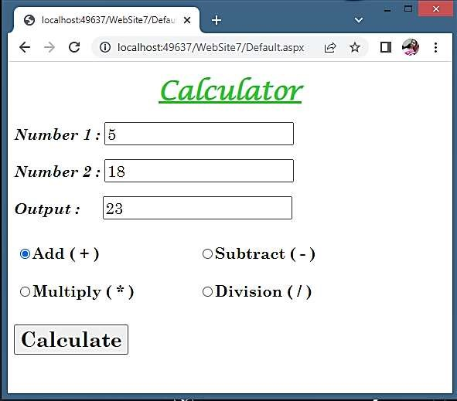

**Practical No. 4**

**Aim: Design ASP.NET Pages with Web controls and demonstrate the use of AutoPostBack.**

Default.aspx Page:

<%@ Page Language="C#" AutoEventWireup="true" CodeFile="Default.aspx.cs" Inherits="_Default" %>

<!DOCTYPE html PUBLIC "-//W3C//DTD XHTML 1.0 Transitional//EN"

"http://www.w3.org/TR/xhtml1/DTD/xhtml1-transitional.dtd">

<html xmlns="http://www.w3.org/1999/xhtml">

<head runat="server"> <title></title> </head>

<body>

<form id="form1" runat="server">

<div align="center" style="border: medium groove #FF0000; width: 600px; height: 300px;"> <p align="center">

<asp:Label ID="Label1" runat="server" Text="Calculator" Font-Bold="True" Font-Italic="True" FontNames="Lucida Calligraphy" Font-Size="30pt" Font-Underline="True" ForeColor="#33CC33"></asp:Label>

</p>

<asp:Label ID="Label2" runat="server" Text="Number 1 : " Font-Bold="True"

Font-Italic="True" Font-Names="Century Schoolbook" Font-Size="15pt"></asp:Label>

<asp:TextBox ID="TextBox1" runat="server" Font-Names="Century Schoolbook" Font-Size="15pt"></asp:TextBox>

<br /><br />

<asp:Label ID="Label3" runat="server" Text="Number 2 : " Font-Bold="True"

Font-Italic="True" Font-Names="Century Schoolbook" Font-Size="15pt"></asp:Label>

<asp:TextBox ID="TextBox2" runat="server" Font-Names="Century Schoolbook"

Font-Size="15pt" AutoPostBack="True" ontextchanged="TextBox2_TextChanged"></asp:TextBox>

<br /><br />

<asp:Label ID="Label4" runat="server" Text="" Font-Bold="True"

Font-Italic="True" Font-Names="Century Schoolbook" Font-Size="15pt"></asp:Label> </div>

</form>

</body>

</html>

Default.aspx.CS Page:

using System;

using System.Collections.Generic; using System.Linq; using System.Web; using System.Web.UI;

using System.Web.UI.WebControls;

public partial class _Default : System.Web.UI.Page

{

protected void Page_Load(object sender, EventArgs e)

{

}

protected void TextBox2_TextChanged(object sender, EventArgs e)

{

int sum = Convert.ToInt32(TextBox1.Text) + Convert.ToInt32(TextBox2.Text); Label4.Text = "The Sum = " + sum.ToString();

TextBox1.Text = "";

TextBox2.Text = "";

}

}

**Output:**

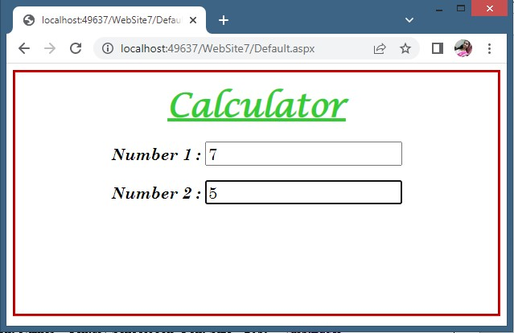

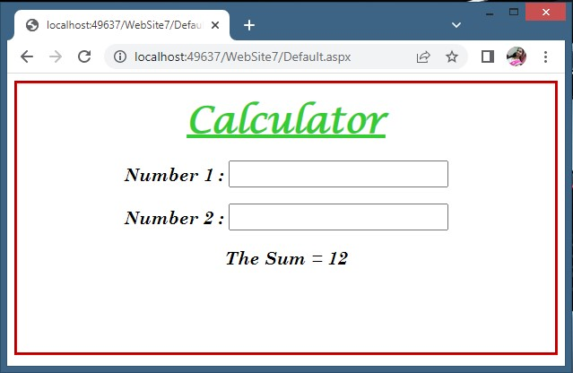

**Practical No. 5**

**Aim: Design ASP.NET Pages with Rich Controls (Calendar Control)**

Default.aspx Page:

<%@ Page Language="C#" AutoEventWireup="true" CodeFile="Default2.aspx.cs" Inherits="Default2" %>

<!DOCTYPE html PUBLIC "-//W3C//DTD XHTML 1.0 Transitional//EN"

"http://www.w3.org/TR/xhtml1/DTD/xhtml1-transitional.dtd">

<html xmlns="http://www.w3.org/1999/xhtml">

<head runat="server"> <title></title> </head>

<body>

<form id="form1" runat="server">

<div>

<asp:Label ID="Label1" runat="server" Text="Rich Controls (Calendar)"

Font-Bold="True" Font-Italic="True" Font-Names="Century Schoolbook"

Font-Size="20pt" Font-Underline="True" ForeColor="#336600"></asp:Label> <br /><br />

<asp:Calendar ID="Calendar1" runat="server" BackColor="White"

BorderColor="Black" BorderStyle="Solid" CellSpacing="1" Font-Names="Verdana"

Font-Size="12pt" ForeColor="Black" Height="250px" NextPrevFormat="ShortMonth" Width="330px"> <DayHeaderStyle Font-Bold="True" Font-Size="8pt" ForeColor="#333333" Height="8pt" /> <DayStyle BackColor="#CCCCCC" />

<NextPrevStyle Font-Bold="True" Font-Size="8pt" ForeColor="White" />

<OtherMonthDayStyle ForeColor="#999999" />

<SelectedDayStyle BackColor="#333399" ForeColor="White" />

<TitleStyle BackColor="#333399" BorderStyle="Solid" Font-Bold="True"

Font-Size="12pt" ForeColor="White" Height="12pt" />

<TodayDayStyle BackColor="#999999" ForeColor="White" /> </asp:Calendar>

<br />

<asp:Label ID="Label2" runat="server" Font-Names="Times New Roman" Font-Size="15pt" Text = "Todays Date: "></asp:Label> <br /><br />

<asp:Label ID="Label3" runat="server" Font-Names="Times New Roman" Font-Size="15pt" Text="Select Your Birth Date: "></asp:Label> <br /><br />

<asp:Label ID="Label4" runat="server" Font-Names="Times New Roman" Font-Size="15pt" Text="Days remaining for Yor Birthday: "></asp:Label> <br /><br />

<asp:Label ID="Label5" runat="server" Font-Names="Times New Roman" Font-Size="15pt" Text="Days Remaining for NEW YEAR: "></asp:Label>

<br /><br />

<asp:Button ID="Button1" runat="server" Text="Result" Font-Italic="False"

Font-Names="Times New Roman" Font-Size="15pt" Font-Bold="True"

onclick="Button1_Click" />

&nbsp;&nbsp;&nbsp;&nbsp;&nbsp;&nbsp;&nbsp;

<asp:Button ID="Button2" runat="server" Text="Reset" Font-Italic="False"

Font-Names="Times New Roman" Font-Size="15pt" Font-Bold="True" Height="34px" onclick="Button2_Click" />

<br />

</div>

</form>

</body>

</html>

Default.aspx.cs Page:

using System;

using System.Collections.Generic; using System.Linq; using System.Web; using System.Web.UI;

using System.Web.UI.WebControls;

public partial class Default2 : System.Web.UI.Page

{

protected void Page_Load(object sender, EventArgs e)

{ }

protected void Button1_Click(object sender, EventArgs e)

{

//Current Date

Label2.Text = Label2.Text + " " + Calendar1.TodaysDate.ToShortDateString();

//Birthday

Label3.Text = Label3.Text + " " + Calendar1.SelectedDate.Date.ToShortDateString();

//Calculation

int year = Calendar1.SelectedDate.Year; int month = Calendar1.SelectedDate.Month; int day = Calendar1.SelectedDate.Day;

TimeSpan d = new DateTime(year,month,day) - DateTime.Now;

Label4.Text = Label4.Text + " " + d.Days.ToString() + " Days";

//New Year

TimeSpan d1 = new DateTime(2023, 12, 31) - DateTime.Now;

Label5.Text = Label5.Text + " " + d1.Days.ToString() + " Days";

}

protected void Button2_Click(object sender, EventArgs e)

{

Response.Redirect("http://localhost:49637/WebSite7/Default2.aspx");

}

}

**Output:**

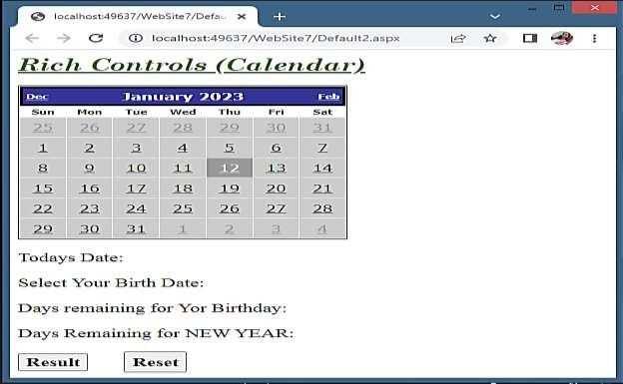

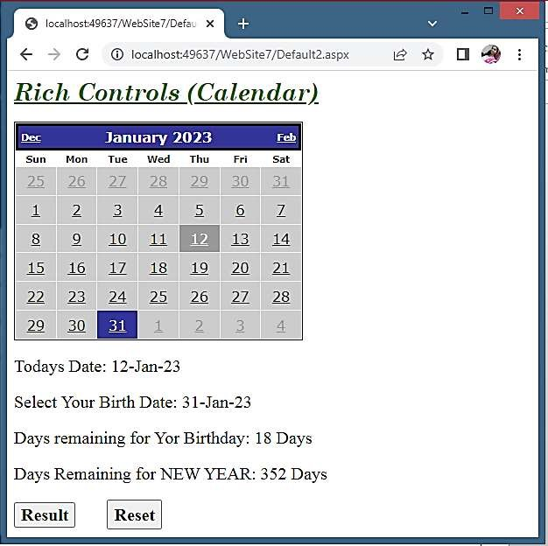

**Practical No. 6**

**Aim: Design ASP.NET Pages with Rich Controls (AdRotator Control)**

XMLFile.xml:

<?xml version="1.0" encoding="utf-8" ?>

<Advertisements>

<Ad>

<ImageUrl>computer-science-education.jpg</ImageUrl>

<NavigateUrl>https://www.google.co.in</NavigateUrl>

<AlternateText>Computer Science 1</AlternateText>

<Impressions>5</Impressions>

<Keyword>Hello 1</Keyword>

</Ad>

<Ad>

<ImageUrl>image (2).png</ImageUrl>

<NavigateUrl>https://www.google.co.in</NavigateUrl>

<AlternateText>Computer Science 2</AlternateText>

<Impressions>5</Impressions>

<Keyword>Hello 2</Keyword>

</Ad>

<Ad>

<ImageUrl>image.png</ImageUrl>

<NavigateUrl>https://www.google.co.in</NavigateUrl>

<AlternateText>Computer Science 3</AlternateText>

<Impressions>5</Impressions>

<Keyword>Hello 3</Keyword>

</Ad>

<Ad>

<ImageUrl>nULE0k.jpg</ImageUrl>

<NavigateUrl>https://www.google.co.in</NavigateUrl>

<AlternateText>Computer Science 4</AlternateText>

<Impressions>5</Impressions>

<Keyword>Hello 4</Keyword>

</Ad>

</Advertisements>

Default.aspx Page:

<%@ Page Language="C#" AutoEventWireup="true" CodeFile="Default3.aspx.cs" Inherits="Default3" %>

<!DOCTYPE html PUBLIC "-//W3C//DTD XHTML 1.0 Transitional//EN"

"http://www.w3.org/TR/xhtml1/DTD/xhtml1-transitional.dtd">

<html xmlns="http://www.w3.org/1999/xhtml">

<head runat="server"> <title></title> </head>

<body>

<form id="form1" runat="server">

<div>

<asp:AdRotator ID="AdRotator1" runat="server" AdvertisementFile="~/XMLFile.xml"

BorderStyle="Solid" Height="300px" Width="500px" />

</div>

</form>

</body>

</html>

**Output:**

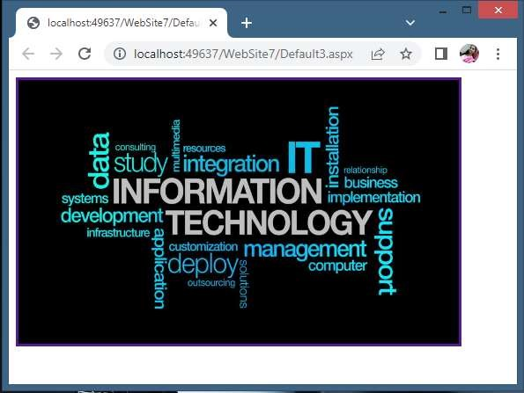

After refreshing page…

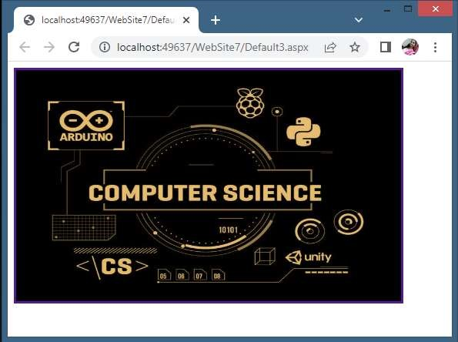

**Practical No. 7**

**Aim: Design ASP.NET Pages for State Management using Cookies** Default.aspx Page:

<%@ Page Language="C#" AutoEventWireup="true" CodeFile="Default4.aspx.cs" Inherits="Default4" %>

<!DOCTYPE html PUBLIC "-//W3C//DTD XHTML 1.0 Transitional//EN"

"http://www.w3.org/TR/xhtml1/DTD/xhtml1-transitional.dtd">

<html xmlns="http://www.w3.org/1999/xhtml">

<head runat="server"> <title></title> </head>

<body>

<form id="form1" runat="server">

<div>

<p align="center">

<asp:Label ID="Label1" runat="server" Text="State Management Using Cookies"

Font-Bold="True" Font-Italic="True" Font-Names="Century Schoolbook"

Font-Size="20pt" Font-Underline="True" ForeColor="#009900"></asp:Label>

<br /> <br />

<asp:Label ID="Label2" runat="server" Text="Username: " Font-Bold="True"

Font-Italic="True" Font-Names="Century Schoolbook" Font-Size="18pt"></asp:Label>

&nbsp;&nbsp;&nbsp;&nbsp;&nbsp;&nbsp;&nbsp;

<asp:TextBox ID="TextBox1" runat="server" Font-Names="Century Schoolbook" Font-Size="16pt"></asp:TextBox>

<br /> <br />

<asp:Label ID="Label3" runat="server" Text="Password: " Font-Bold="True"

Font-Italic="True" Font-Names="Century Schoolbook" Font-Size="18pt"></asp:Label>

&nbsp;&nbsp;&nbsp;&nbsp;&nbsp;&nbsp;&nbsp;&nbsp;

<asp:TextBox ID="TextBox2" runat="server" Font-Names="Century Schoolbook" Font-Size="16pt"></asp:TextBox>

<br /> <br />

<asp:Button ID="Button1" runat="server" Text="Create Cookie" Font-Bold="True"

Font-Names="Century Schoolbook" Font-Size="16pt" Width="200px"

BorderColor="Black" BorderStyle="Solid" onclick="Button1_Click" />

&nbsp;&nbsp;&nbsp;&nbsp;&nbsp;&nbsp;&nbsp;

<asp:Button ID="Button2" runat="server" Text="Retrieve Cookie" Font-Bold="True"

Font-Names="Century Schoolbook" Font-Size="16pt" Width="200px"

BorderColor="Black" BorderStyle="Solid" onclick="Button2_Click" />

<br /> <br />

<asp:Label ID="Label4" runat="server" Text="Status: " Font-Bold="True"

Font-Italic="True" Font-Names="Times New Roman" Font-Size="15pt" ForeColor="Red"></asp:Label>

</p>

</div>

</form>

</body>

</html>

Default.aspx.cs Page:

using System;

using System.Collections.Generic; using System.Linq; using System.Web; using System.Web.UI;

using System.Web.UI.WebControls;

public partial class Default4 : System.Web.UI.Page

{

protected void Page_Load(object sender, EventArgs e)

{ }

protected void Button1_Click(object sender, EventArgs e)

{

Response.Cookies["name"].Value = TextBox1.Text;

Response.Cookies["password"].Value = TextBox2.Text;

Response.Cookies["name"].Expires = DateTime.Now.AddMinutes(1);

Response.Cookies["password"].Expires = DateTime.Now.AddMinutes(1);

Label4.Text = Label4.Text + "Cookie Created";

TextBox1.Text = "";

TextBox2.Text = "";

}

protected void Button2_Click(object sender, EventArgs e)

{

if (Request.Cookies["name"] == null || Request.Cookies["password"] == null)

{

Label4.Text = "No cookie found";

} else

{

TextBox1.Text = Request.Cookies["name"].Value;

TextBox2.Text = Request.Cookies["password"].Value;

}

}

}

**Output:**

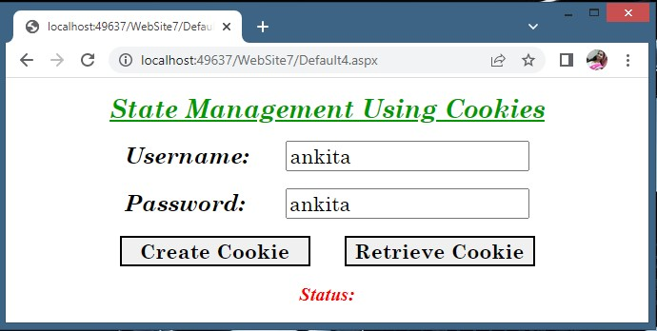

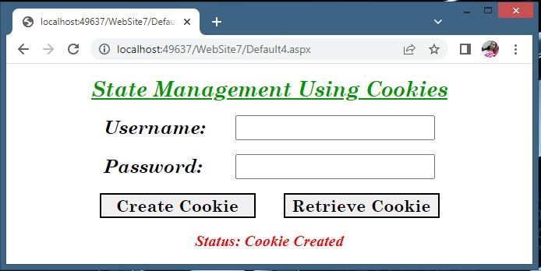

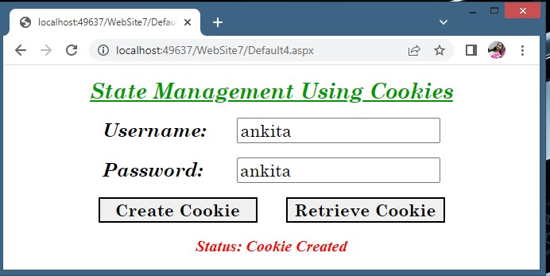

After 1 Minute….

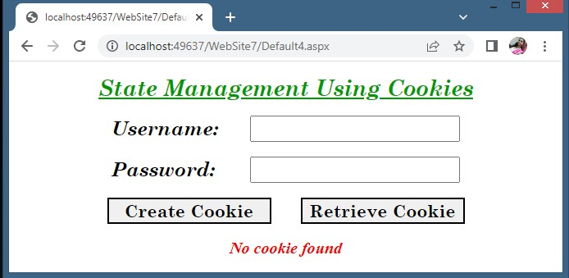

**Practical No. 8**

**Aim: Design ASP.NET page and perform validation using various Validation Controls** Default.aspx Page:

<%@ Page Language="C#" AutoEventWireup="true" CodeFile="Default5.aspx.cs" Inherits="Default5" %>

<!DOCTYPE html PUBLIC "-//W3C//DTD XHTML 1.0 Transitional//EN"

"http://www.w3.org/TR/xhtml1/DTD/xhtml1-transitional.dtd">

<html xmlns="http://www.w3.org/1999/xhtml">

<head runat="server"> <title></title> </head>

<body>

<form id="form1" runat="server">

<div>

<p align="center" style="font-family: 'Century Schoolbook'; font-size: xx-large; font-weight: bold; fontstyle: italic;">Please Fill The Form</p>

<table style="width:100%;">

<tr>

<td>

<asp:Label ID="Label1" runat="server" Text="Name:-" Font-Bold="True" Font-Italic="True"

Font-Names="Times New Roman" Font-Size="XX-Large"></asp:Label>

</td>

<td>

<asp:TextBox ID="TextBox1" runat="server" Height="25px" Width="270px" FontSize="Large"></asp:TextBox>

<asp:RequiredFieldValidator ID="RequiredFieldValidator1" runat="server" ErrorMessage="Enter

Some Text" ControlToValidate="TextBox1" ForeColor="Red"></asp:RequiredFieldValidator>

</td>

</tr>

<tr>

<td>

<asp:Label ID="Label2" runat="server" Text="Address:- " Font-Bold="True" Font-Italic="True"

Font-Names="Times New Roman" Font-Size="XX-Large"></asp:Label>

</td>

<td>

<asp:TextBox ID="TextBox2" runat="server" Height="70px" TextMode="MultiLine"

Width="270px" Font-Size="Large"></asp:TextBox>

<asp:RequiredFieldValidator ID="RequiredFieldValidator2" runat="server" ErrorMessage="Enter

Some Text" ControlToValidate="TextBox2" ForeColor="Red"></asp:RequiredFieldValidator>

</td>

</tr>

<tr>

<td>

<asp:Label ID="Label3" runat="server" Text="Age:- " Font-Bold="True" Font-Italic="True" Font-

Names="Times New Roman" Font-Size="XX-Large"></asp:Label>

</td>

<td>

<asp:TextBox ID="TextBox3" runat="server" Height="25px" Width="270px" FontSize="Large"></asp:TextBox>

<asp:RangeValidator ID="RangeValidator1" runat="server" ErrorMessage="Age Between 18 To

30" ControlToValidate="TextBox3" MaximumValue="30" MinimumValue="18"

ForeColor="Red"></asp:RangeValidator>

</td>

</tr>

<tr>

<td>

<asp:Label ID="Label4" runat="server" Text="Email ID:- " Font-Bold="True" Font-Italic="True"

Font-Names="Times New Roman" Font-Size="XX-Large"></asp:Label>

</td>

<td>

<asp:TextBox ID="TextBox4" runat="server" Height="25px" Width="270px" FontSize="Large"></asp:TextBox>

<asp:RegularExpressionValidator ID="RegularExpressionValidator1" runat="server"

ErrorMessage="Enter Valid Email ID" ControlToValidate="TextBox4" ValidationExpression="\w+([+.']\w+)*@\w+([-.]\w+)*\.\w+([-.]\w+)*" ForeColor="Red"></asp:RegularExpressionValidator>

</td>

</tr>

<tr>

<td>

<asp:Label ID="Label5" runat="server" Text="Password:- " Font-Bold="True" Font-Italic="True"

Font-Names="Times New Roman" Font-Size="XX-Large"></asp:Label>

</td> <td>

<asp:TextBox ID="TextBox5" runat="server" Height="25px" Width="270px"

TextMode="Password" Font-Size="Large"></asp:TextBox>

</td>

</tr>

<tr>

<td>

<asp:Label ID="Label6" runat="server" Text="Confirm Password:- " Font-Bold="True" Font-

Italic="True" Font-Names="Times New Roman" Font-Size="XX-Large"></asp:Label>

</td> <td>

<asp:TextBox ID="TextBox6" runat="server" Height="25px" Width="270px"

TextMode="Password" Font-Size="Large"></asp:TextBox>

<asp:CompareValidator ID="CompareValidator1" runat="server" ErrorMessage="Enter Correct

Password" ControlToCompare="TextBox5" ControlToValidate="TextBox6"

ForeColor="Red"></asp:CompareValidator>

</td>

</tr>

</table>

<br />

<p align="center">

<asp:Button ID="Button1" runat="server" Text="SUBMIT" Height="43px" Width="152px" FontBold="True" Font-Names="Comic Sans MS" Font-Size="X-Large"></asp:Button>

</p>

</div>

</form>

</body>

</html>

**Output:**

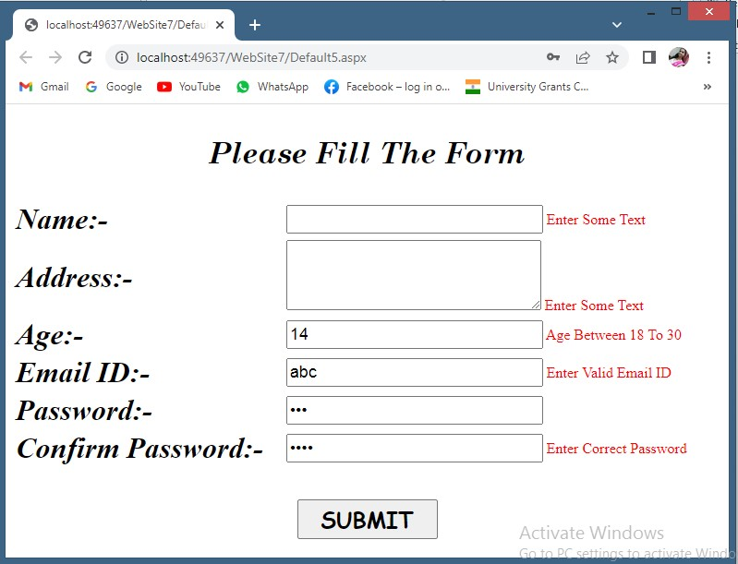

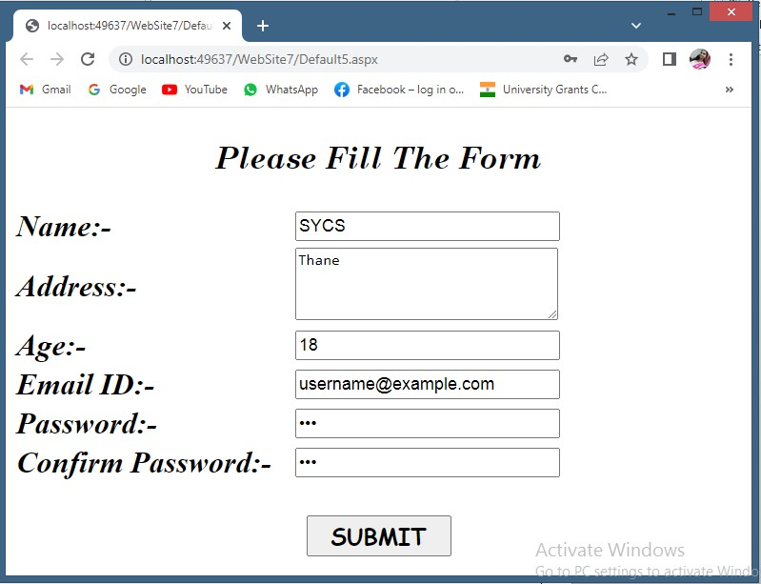

**Practical No. 9**

**Aim: Design an APS.NET master web page and use it other (at least 2-3) content pages.** MasterPage.master:

<%@ Master Language="C#" AutoEventWireup="true" CodeFile="MasterPage.master.cs" Inherits="MasterPage" %>

<!DOCTYPE html PUBLIC "-//W3C//DTD XHTML 1.0 Transitional//EN"

"http://www.w3.org/TR/xhtml1/DTD/xhtml1-transitional.dtd">

<html xmlns="http://www.w3.org/1999/xhtml">

<head runat="server"> <title></title>

<asp:ContentPlaceHolder id="head" runat="server"> </asp:ContentPlaceHolder> </head>

<body>

<form id="form1" runat="server">

<div>

<table style="width: 100%; vertical-align: middle;" align="center">

<tr valign="middle" align="center" style="background-image: url('/WebSite7/4kTn7x.png');"> <td colspan=4 height="130px">

<br />

<asp:Label ID="Label1" runat="server" Text="Computer Science Blog" Font-Bold="True" Font-

Names="Lucida Calligraphy" Font-Size="40pt" ForeColor="#CC0066"></asp:Label>

</td> </tr>

<tr align="center" bgcolor="Black" valign="middle">

<td width="150px" align="center" height="40px" valign="middle">

&nbsp;

<asp:LinkButton ID="LinkButton1" runat="server" Font-Italic="True"

Font-Names="Comic Sans MS" Font-Size="20pt" Font-Strikeout="False"

ForeColor="White" PostBackUrl="~/Default.aspx">Home</asp:LinkButton>

</td>

<td width="150px" height="40px">

&nbsp;

<asp:LinkButton ID="LinkButton2" runat="server" Font-Bold="False"

Font-Italic="True" Font-Names="Comic Sans MS" Font-Size="20pt"

Font-Underline="False" ForeColor="White"

PostBackUrl="~/Default1.aspx">Syllabus</asp:LinkButton>

</td>

<td width="150px" height="40px">

&nbsp;

<asp:LinkButton ID="LinkButton3" runat="server" Font-Italic="True"

Font-Names="Comic Sans MS" Font-Size="20pt" Font-Underline="False"

ForeColor="White" PostBackUrl="~/Default2.aspx">Theory</asp:LinkButton>

</td>

<td width="150px" height="40px">

&nbsp;

<asp:LinkButton ID="LinkButton4" runat="server" Font-Italic="True"

Font-Names="Comic Sans MS" Font-Size="20pt" Font-Underline="False"

ForeColor="White" PostBackUrl="~/Default3.aspx">Practical</asp:LinkButton>

</td>

</tr>

</table>

<asp:ContentPlaceHolder id="ContentPlaceHolder1" runat="server">

</asp:ContentPlaceHolder>

</div>

</form>

</body>

</html>

Default.aspx Page:

<%@ Page Title="" Language="C#" MasterPageFile="~/MasterPage.master" AutoEventWireup="true"

CodeFile="Default7.aspx.cs" Inherits="Default7" %>

<asp:Content ID="Content1" ContentPlaceHolderID="head" Runat="Server">

</asp:Content>

<asp:Content ID="Content2" ContentPlaceHolderID="ContentPlaceHolder1" Runat="Server">

<div align="center" style="background-color: #FFCC99">

<asp:Label ID="Label1" runat="server" Text="This is Home Page." Font-Bold="True" Font-Italic="True"

Font-Names="Century Schoolbook" Font-Size="30pt" ForeColor="Red"></asp:Label>

<br /> <br />

<asp:Image ID="Image1" runat="server" ImageUrl="~/image (2).png" Height="300px" Width="500px" />

<br /> <br /> <br /> <br />

</div>

</asp:Content>

Default1.aspx Page:

<%@ Page Title="" Language="C#" MasterPageFile="~/MasterPage.master" AutoEventWireup="true"

CodeFile="Default8.aspx.cs" Inherits="Default8" %>

<asp:Content ID="Content1" ContentPlaceHolderID="head" Runat="Server">

</asp:Content>

<asp:Content ID="Content2" ContentPlaceHolderID="ContentPlaceHolder1" Runat="Server">

<div align="center" style="background-color: #FFCC99">

<asp:Label ID="Label1" runat="server" Text="This is Syllabus Page." Font-Bold="True" Font-Italic="True"

Font-Names="Century Schoolbook" Font-Size="30pt" ForeColor="Red"></asp:Label>

<br /> <br />

<asp:Image ID="Image1" runat="server" ImageUrl="~/computer-science-education.jpg" Height="300px" Width="500px" />

<br /> <br /> <br /> <br />

</div>

</asp:Content>

Default2.aspx Page:

<%@ Page Title="" Language="C#" MasterPageFile="~/MasterPage.master" AutoEventWireup="true"

CodeFile="Default9.aspx.cs" Inherits="Default9" %>

<asp:Content ID="Content1" ContentPlaceHolderID="head" Runat="Server">

</asp:Content>

<asp:Content ID="Content2" ContentPlaceHolderID="ContentPlaceHolder1" Runat="Server">

<div align="center" style="background-color: #FFCC99">

<asp:Label ID="Label1" runat="server" Text="This is Theory Page." Font-Bold="True" Font-Italic="True"

Font-Names="Century Schoolbook" Font-Size="30pt" ForeColor="Red"></asp:Label>

<br /> <br />

<asp:Image ID="Image1" runat="server"

ImageUrl="~/fposter,small,wall_texture,product,750x1000.u2.jpg" Height="300px" Width="500px" />

<br /> <br /> <br /> <br />

</div>

</asp:Content>

Default3.aspx Page:

<%@ Page Title="" Language="C#" MasterPageFile="~/MasterPage.master" AutoEventWireup="true"

CodeFile="Default10.aspx.cs" Inherits="Default10" %>

<asp:Content ID="Content1" ContentPlaceHolderID="head" Runat="Server">

</asp:Content>

<asp:Content ID="Content2" ContentPlaceHolderID="ContentPlaceHolder1" Runat="Server">

<div align="center" style="background-color: #FFCC99">

<asp:Label ID="Label1" runat="server" Text="This is Practical Page."

Font-Bold="True" Font-Italic="True" Font-Names="Century Schoolbook" Font-Size="30pt" ForeColor="Red"></asp:Label>

<br /> <br />

<asp:Image ID="Image1" runat="server" ImageUrl="~/images.jpg" Height="300px" Width="500px" />

<br /> <br /> <br /> <br />

</div>

</asp:Content>

**Output:**

