PUNE INSTITUTE OF COMPUTER TECHNOLOGY, PUNE

Department of Computer Engineering

A.Y. 2020-21 SEM – II

Subject: WTL

Mini Project Synopsis

Under the Guidance of: Prof. V.S. Gaikwad

Project Management System

By:-

Aditya Sawant – 31302

Apurav Deshmukh – 31305

Aryan Gupta – 31306

Aditya Chavan – 31318

Topic: Project Management

Project Members:

* Aditya Sawant – 31302
* Apurav Deshmukh – 31305
* Aryan Gupta – 31306
* Aditya Chavan – 31318

Use Case Diagram:

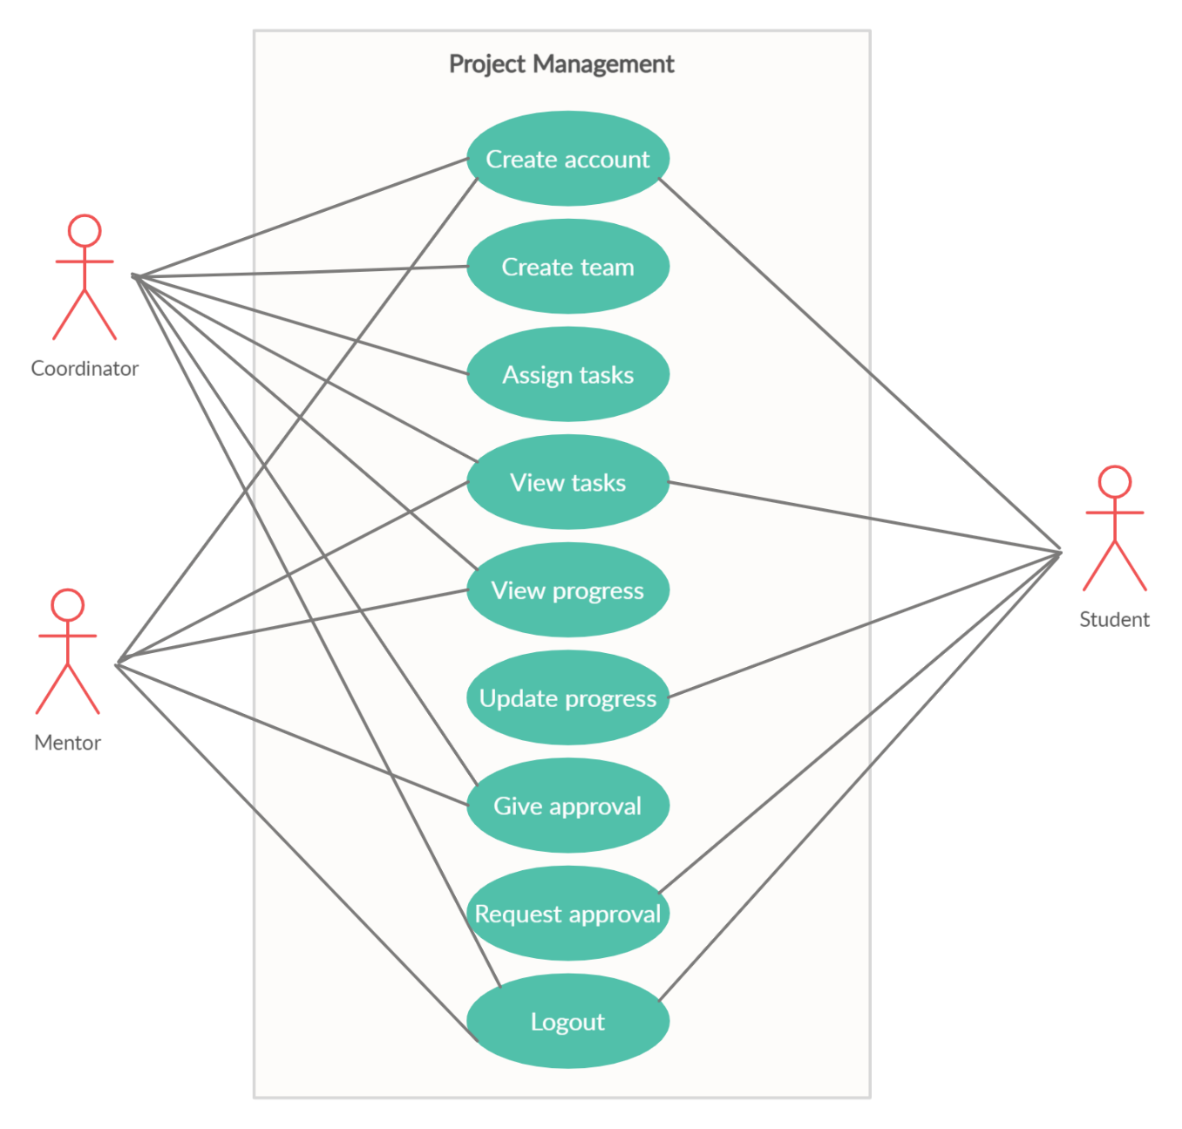

Technology Stack:

1. Front end: HTML, CSS, Bootstrap
2. Back end: JSP, Servlet, JavaScript
3. Database: MySQL

Role Distribution:

1. Aditya Chavan: Progress and Student module
2. Apurav Deshmukh: Home and Mentor page
3. Aryan Gupta: Login and Registration module
4. Aditya Sawant: Teams and Profile module