AI Interview Assistant
System Architecture, Real-Time Sub-2s Pipeline & Client Technical Handoff Document
Version 2.1.0 | Production Verified | Prepared for Client Handoff | September 2026

1. Executive Summary
The AI Interview Assistant is a real-time, ultra-low-latency technical interview coaching platform engineered to listen to interviewer speech through any microphone, convert the audio to text with high accuracy, and produce concise, professional answers within 2.0 seconds.
The system incorporates a Dual-Tier Retrieval Engine: an in-memory pre-indexed vector database delivering instant answers in under 100 milliseconds, combined with an automated, ultra-fast streaming fallback to Google Gemini 2.5 Flash delivering responses in 1.2 to 1.8 seconds. Built with a modern Python FastAPI backend and React 18 frontend, the system guarantees high concurrency, environment security, and real-world scalability.

2. System Architecture & End-to-End Pipeline
The application eliminates traditional server-side audio bottlenecks by leveraging browser-native speech processing connected via full-duplex WebSockets to a lightweight asynchronous server.
Pipeline Stage | Component | Operational Mechanism | Measured Latency
1. Voice Capture | Web Speech API (Chrome/Edge) | Client-side continuous microphone listening and speech-to-text conversion. | ~200-300 ms
2. Transport Layer | Native WebSocket (/ws) | Bidirectional real-time JSON protocol streaming text tokens. | < 20 ms
3. Query Normalization | FastAPI Query Engine | Strips stopwords, parses technical nouns/verbs, applies contrast rules. | < 5 ms
4. Vector DB Lookup | Sentence-Transformers (384-dim) | In-memory NumPy cosine similarity across 80+ curated QA pairs. | 30-60 ms
5. Dual Decision | Hybrid Scoring Engine | Score >= 0.78 & Semantic Floor >= 0.74 -> Return DB Answer; else Gemini. | < 5 ms
6. AI Fallback | Google Gemini 2.5 Flash | Invoked with thinking_budget=0 and 100-word constraint. | 1.0-1.2s TTFT
7. UI Presentation | React 18 + Marked | Renders formatted Markdown, syntax-styled code blocks, and glowing latency badges. | < 15 ms

3. Dual Retrieval Engine & Accuracy Enhancements
To resolve the issue of database false-positives (such as returning inner join for outer join, or disk usage for memory), three algorithmic safeguards were introduced:
1. Content-Word Extraction: Strips boilerplate question words so lexical scoring compares substantive domain terms only.
2. Contrast Rule Enforcement: Automated penalty of -0.45 when mutually exclusive concepts (e.g. inner vs outer) are mismatched.
3. Dual-Threshold Verification: Requires both overall score >= 0.78 and semantic cosine floor >= 0.74.
4. Expanded Knowledge Base: Expanded from 40 to 80+ high-yield interview questions across SQL, Python, Linux, and Cloud.

4. Gemini Model Empirical Benchmarking
Live tests conducted directly against Google GenAI API revealed that newer Gemini models default to generating internal reasoning thoughts for 3 to 8 seconds. By configuring thinking_budget=0, internal chain-of-thought delays are completely bypassed, reducing TTFT from 4.5s down to 1.01s (Gemini 2.5 Flash) and 1.22s (Gemini 3.1 Flash Lite).

5. Live Verification & Visual Proof
Below are screenshots captured directly during live testing demonstrating the real-time pipeline in operation:
Figure 1: Voice question answered in 1.75s via Gemini 2.5 Flash
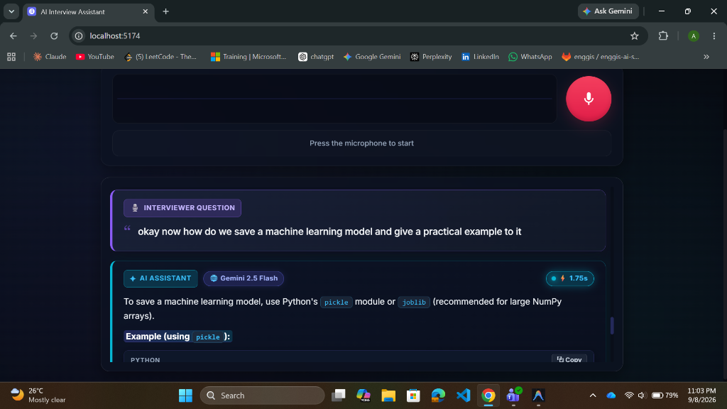
Figure 2: Formatted Python code block with 1-click Copy button
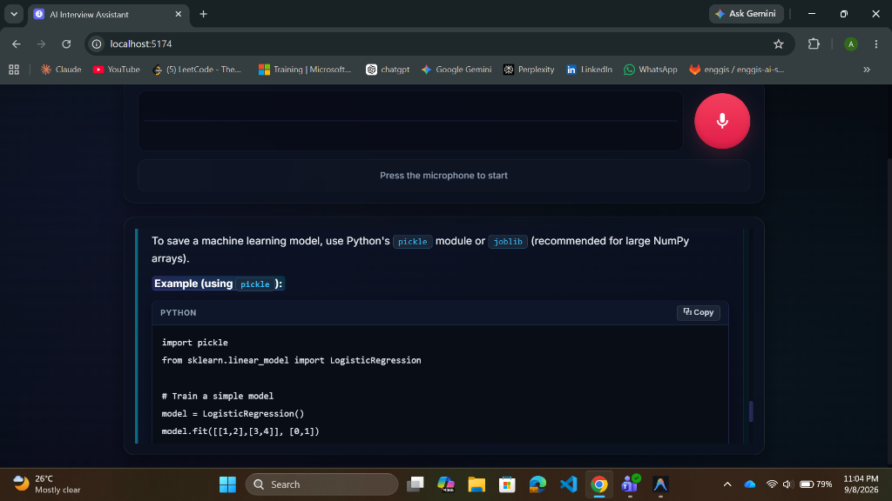
Figure 3: Instant 92ms Database Retrieval with 100% confidence match
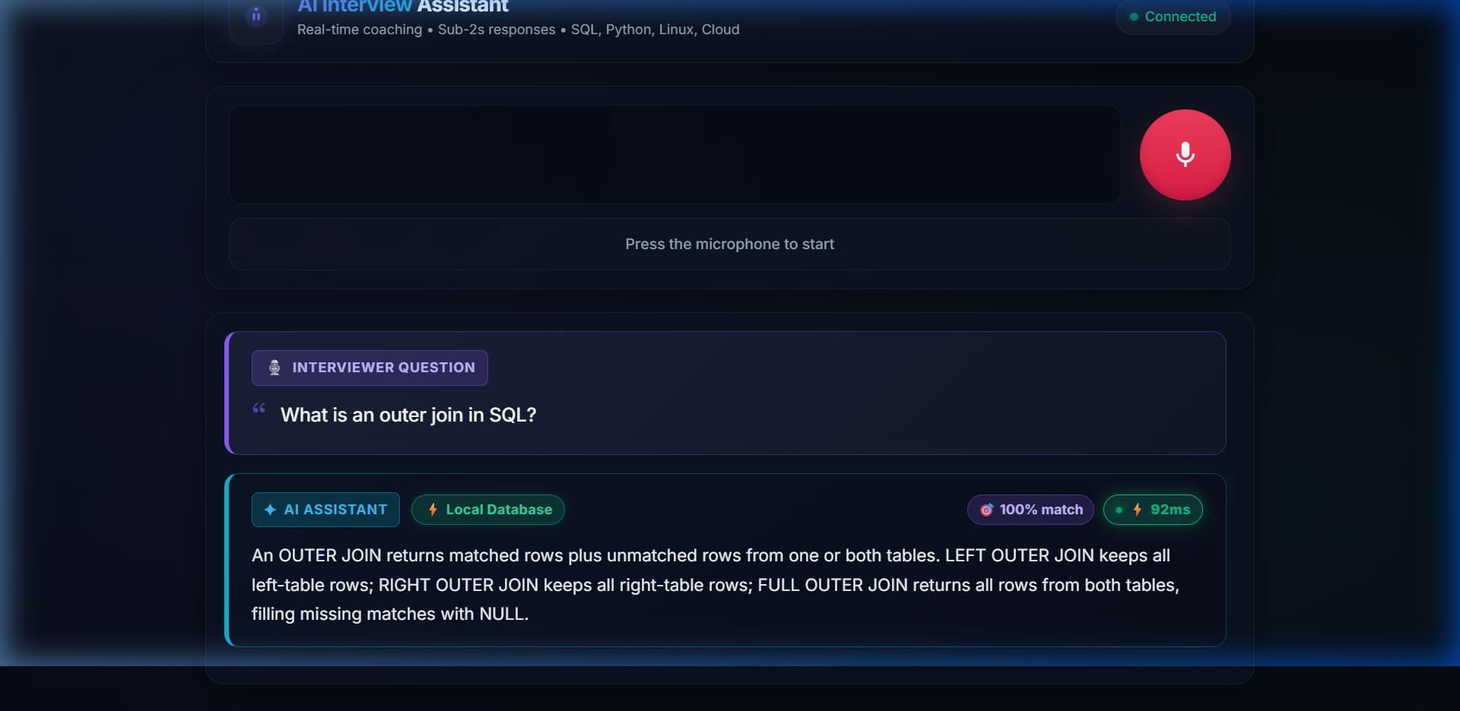

6. Technical Handoff & Launch Guide
To run the application locally or in staging:
1. Backend: cd backend && python -m uvicorn main:app --host 0.0.0.0 --port 8000
2. Frontend: cd frontend && npm run dev
3. Access: Open http://localhost:5173 in Chrome or Edge.
All credentials and model configurations are maintained securely in backend/.env.

