**Large Applications Practicum**

**Group-3**

Software Requirements Document

Vishnu Priya Jindal (B16041)

Ananya Shukla (B17007)

Aman Saxena (B17034)

Aaditya Arora (B17071)

***October 2019***

**Evoice:** The **Text-to-Speech** Synthesizer

Requirements Document

Revision History

|  |  |  |  |
| --- | --- | --- | --- |
| **Version** | **Date** | **Author(s)** | **Description** |
| v1.0 | 10/16/19 | Vishnu Priya Jindal, Aaditya Arora, Aman Saxena, Ananya Shukla | Initial version. |
| v1.5 | 10/22/19 | Vishnu Priya Jindal, Aaditya Arora, Aman Saxena, Ananya Shukla | Pdf support added. |
| v2.0 | 11/05/19 | Vishnu Priya Jindal, Aaditya Arora, Aman Saxena, Ananya Shukla | Final version. |

**Table of Contents**

**Introduction** **3**

Need and Purpose 3

Intended Audience 3

References 3

**Description** **3**

Features and Functions 3

Features 4

Functions 4

Users 4

Operating Environment 4

Hardware 4

Software 4

**Specific Requirements** **5**

External Interfaces 5

Design Constraints 5

GUI 5

**Mini-Project Plan** **6**

**Appendix A** **6**

# Introduction

Evoice is a text-to-speech synthesizer for English and several other languages.

## Need and Purpose*.*

Text-To-Speech synthesizers were developed in order to help the visually impaired people using computer generated voice which can read the text to the user. Also, it can cater to the needs of the students who face difficulty in reading and learning. The users can also choose a file to read from and this can be useful for children as well. Users can benefit from this software irrespective of their age.

## Intended Audience*.*

This document is intended for software designers and students who have an interest in the field of software development. This may also be read by the users of this product.

## References

[1] <http://espeak.sourceforge.net/>

[2] <http://www.cstr.ed.ac.uk/projects/festival/>

[3] <https://en.wikipedia.org/wiki/Speech_synthesis>

# Description

## Features and Functions

#### Features

*Evoice* enables users to either enter the text into a field or choose a file which is read by the software to the user. It also provides the option to change the speed at which the text is read

#### Functions

1. We can convert text, from the dialogue box (GUI) as well as from any file in .TXT, . PDF format to speech.
2. We can change the speed of speaking.
3. Inter-line and inter-para pause feature is added.
4. We can highlight the text, which we want to be read out.

## Users

1. Visually impaired people.
2. School going children.
3. Students who face trouble in reading.
4. Old people.

[Note: This product can be used by the users who have an OS that supports Festival}

## Operating Environment

### Hardware

*Evoice* requires a PC with keyboard and speaker.

### Software

* Operating system that supports Festival TTS.
* Festival TTS
* Python2 version 2.7.15+
* G++ version 7.4.0
* Make
* Tkinter

# Specific Requirements

## External Interfaces

* PC
* Keyboard
* Speaker

## Design Constraints

Festival TTS includes limited languages and accents.

## 3.3 GUI

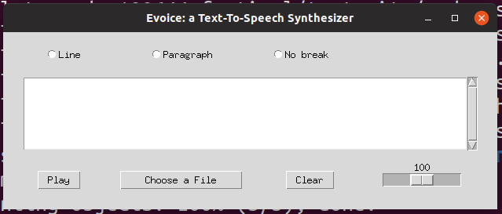

Fig 1. Basic GUI of the application. The three radio buttons - Line, Paragraph and No break are for the pause options. Scroll-text-space is to write the text that has to be spoken. ‘Choose a File’ button is to select file to be read out.’ Clear’ button is to remove the contents from text field. Scroller at bottom right is to adjust speed.

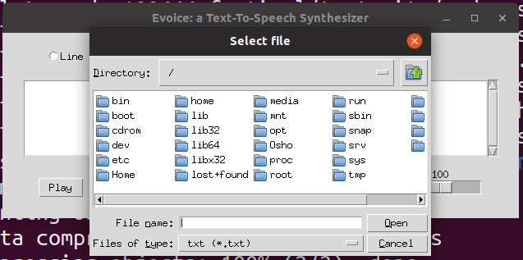

Fig 2. This GUI is to select a file to be read out when ‘Choose a File’ button is pressed.

# Mini-Project Plan



 