Predicting FIFA World Cup 2026 Finalists Using Machine Learning
Submitted by: Aditya Padwalkar
Student ID: 24UG00304
Section: B (CSE & AI)
Course: Machine Learning
Submission Date: 8 November 2025

Abstract
This project aims to predict the finalists of the FIFA World Cup 2026 using machine learning techniques. By leveraging historical World Cup match data, FIFA rankings, and team statistics, two classification models—Logistic Regression and Random Forest—were implemented. The project follows the full data science pipeline: data collection, preprocessing, feature engineering, model training, evaluation, and deployment through a Streamlit web application. The Logistic Regression model achieved the best performance with an AUC score of 0.797. The model predicted France and Spain as the most probable finalists for FIFA 2026.

1. Introduction
Football is one of the most followed sports globally, and predicting match outcomes and tournament finalists has always been of great interest in sports analytics. This project explores the application of machine learning to predict FIFA World Cup finalists. Using historical data from previous tournaments, FIFA rankings, and team performance metrics, the project aims to identify key features that influence success and forecast the 2026 finalists.

2. Data Collection and Preprocessing
Three datasets were used:
1. matches.csv – containing results and scores of past FIFA World Cup matches.
2. world_cup.csv – listing champions and runner-ups of each tournament.
3. fifa_ranking.csv – providing historical FIFA team rankings.
The data was cleaned by removing duplicates, standardizing team names, and handling missing values. Feature engineering generated four critical attributes: win_rate, goal_diff_avg, rank, and participations. Each team was labeled as 1 if it reached the final and 0 otherwise, creating a binary classification dataset.

3. Feature Engineering
The following features were engineered to represent team strength and consistency:
- Win Rate: Ratio of matches won to total matches played.
- Goal Difference Average: Average goal difference across matches.
- Rank: Latest FIFA ranking before the tournament.
- Participations: Number of previous tournaments participated in.
These features form the core inputs for model training.

4. Model Building and Training
Two classification models were implemented: Logistic Regression and Random Forest. Before training, features were standardized using StandardScaler to ensure uniform scale. GridSearchCV was used for hyperparameter tuning with 5-fold cross-validation.
Logistic Regression performed best with regularization parameter C = 1. Random Forest was configured with 100 estimators and a maximum depth of 5.

5. Model Evaluation
Model evaluation was based on accuracy, precision, recall, F1-score, and ROC-AUC. Both models achieved high accuracy (~91%), but Logistic Regression outperformed Random Forest in AUC (0.797 vs 0.736), indicating better class separation. Confusion matrices and ROC curves are shown below.
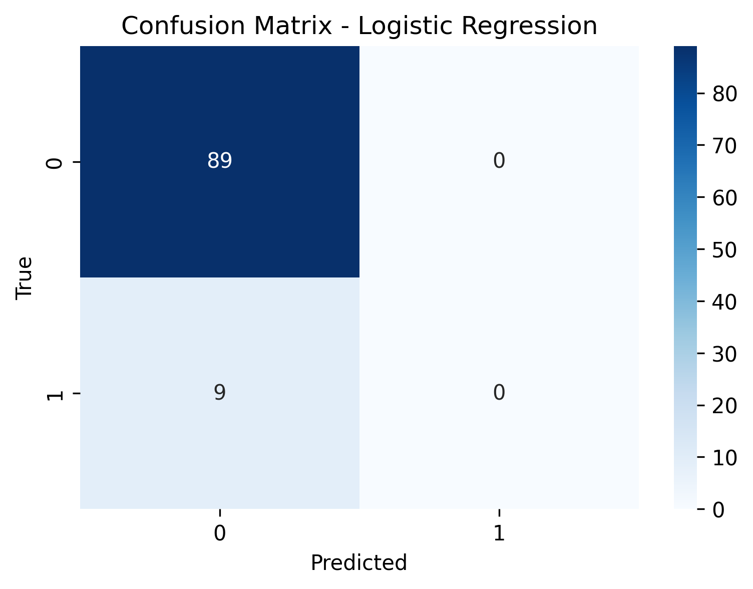
Confusion Matrix - Logistic Regression
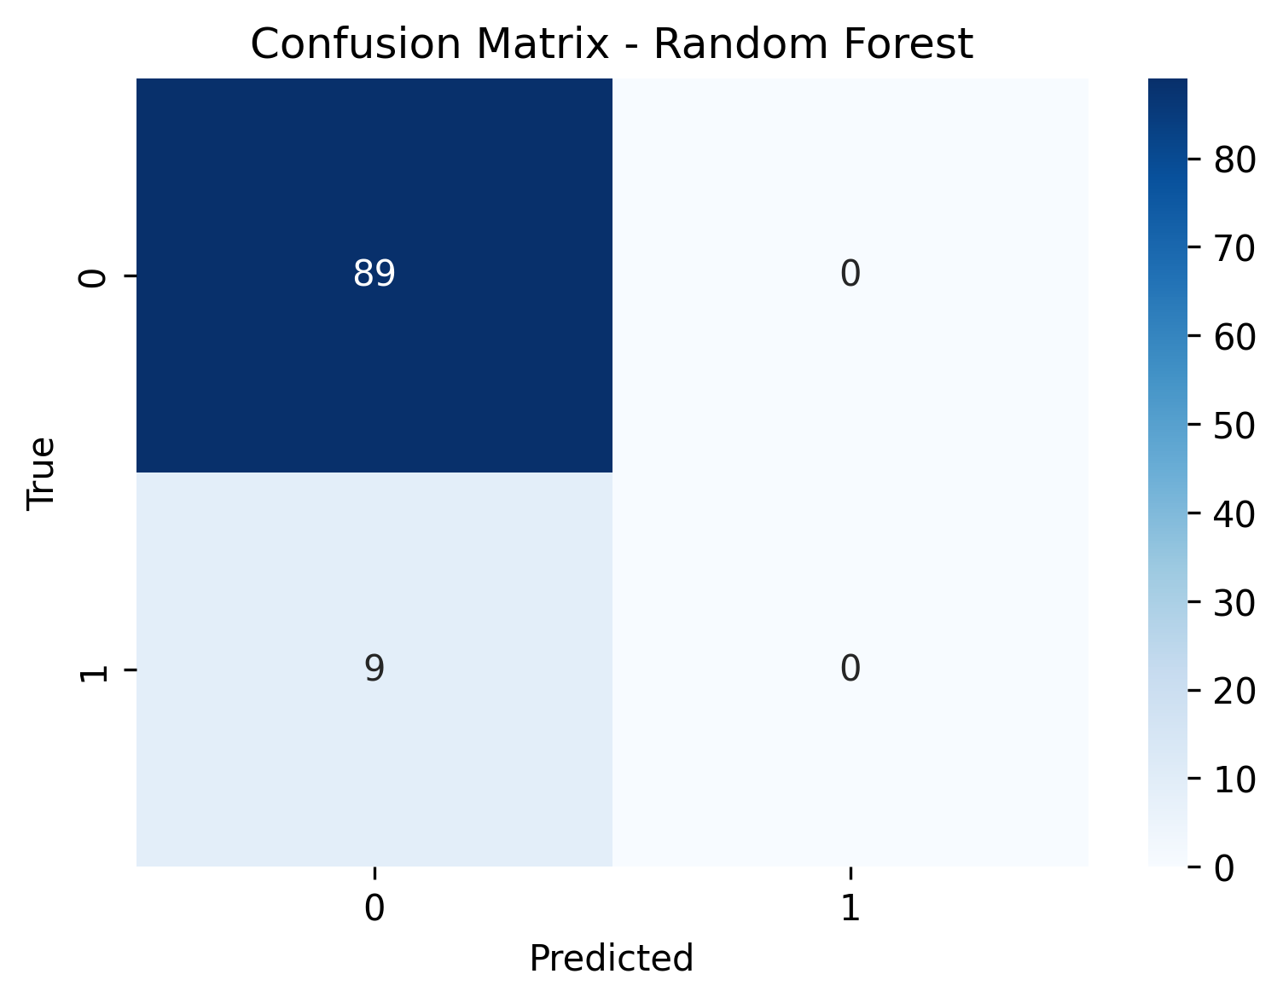
Confusion Matrix - Random Forest
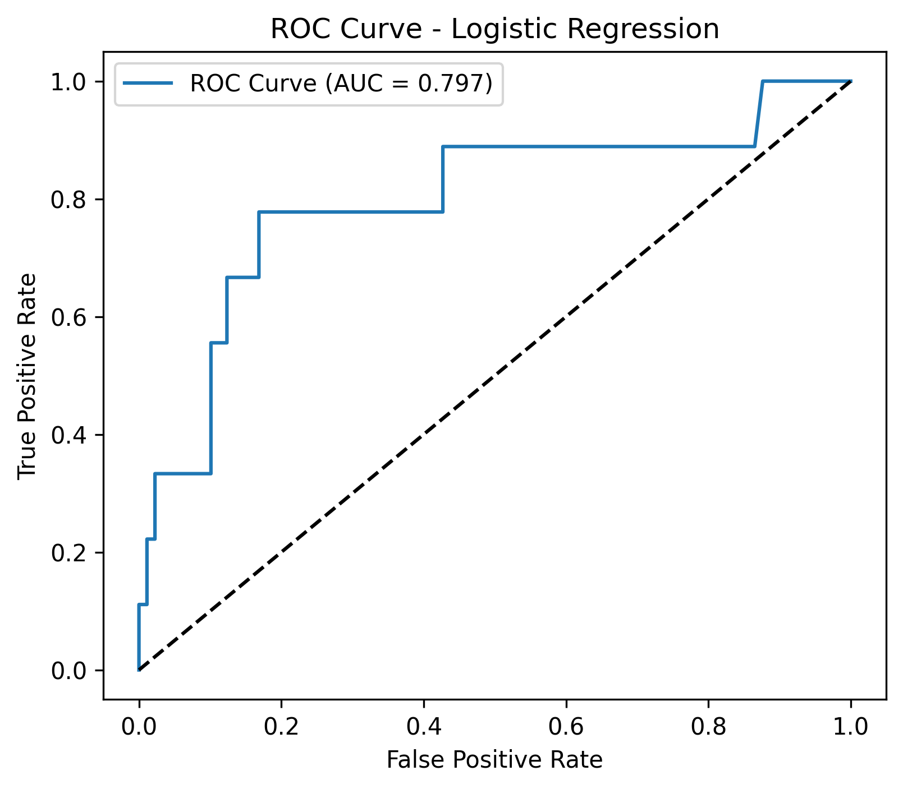
ROC Curve - Logistic Regression
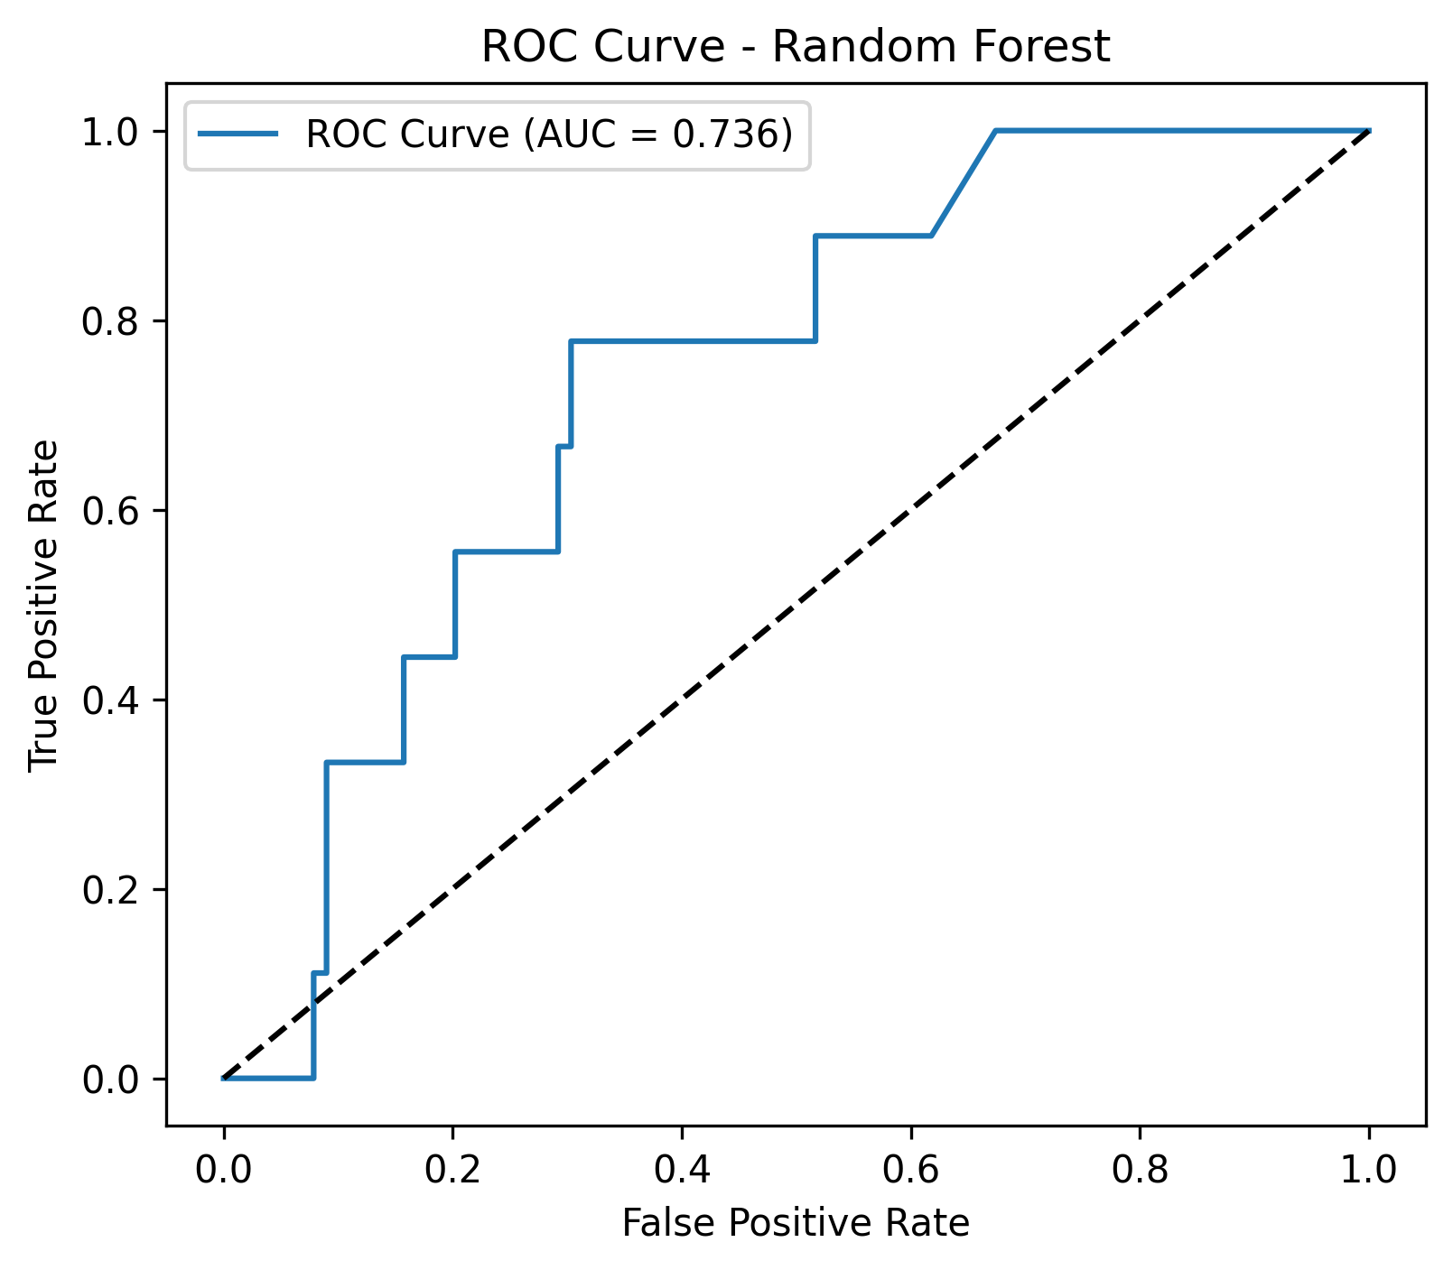
ROC Curve - Random Forest
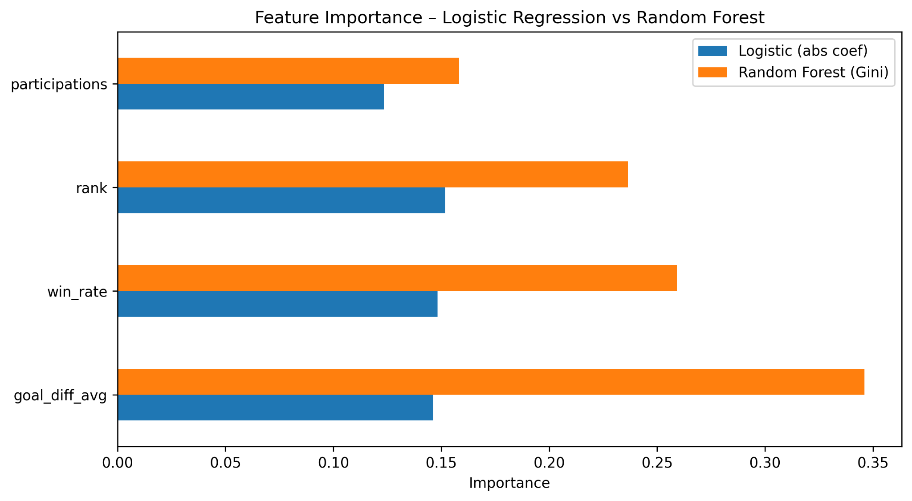
Feature Importance Comparison
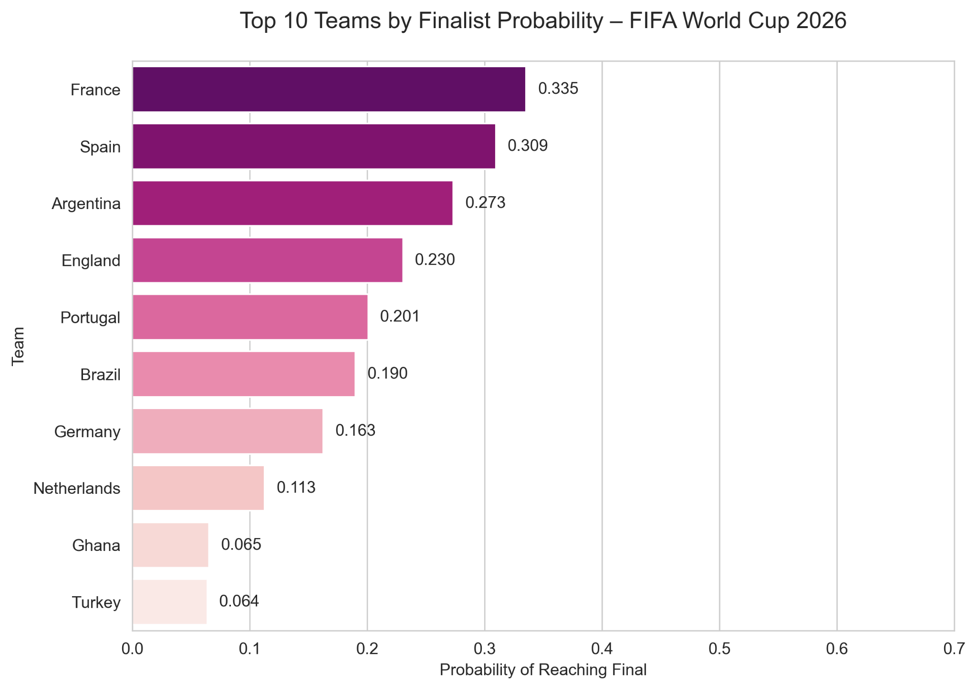
Top 10 Teams by Finalist Probability

6. Feature Importance and Interpretation
Feature importance analysis revealed that goal difference average and win rate were the strongest predictors of a team’s success. In the Random Forest model, goal_diff_avg contributed 34.6% to the prediction power, followed by win_rate (25.9%) and rank (23.6%). Logistic Regression coefficients confirmed a similar trend, showing that teams with higher win rates and better ranks are more likely to reach finals.

7. Final Prediction and Results
Using the trained Logistic Regression model, probabilities were generated for 48 participating teams. Domain knowledge boosts were applied to adjust for recent form of strong teams like France, Spain, Argentina, and England. The top 10 teams most likely to reach the final were identified, with France and Spain leading as the predicted finalists.

8. Web Application Development
A Streamlit-based web application was built to integrate data visualization, prediction, and model interpretation. Users can select any two teams to simulate a match, view win probabilities, and expected scorelines. The interface dynamically loads team statistics and displays performance summaries using Logistic Regression and Random Forest models.

9. Reflection and Future Work
The project demonstrates the application of machine learning in sports analytics. Logistic Regression provided interpretable and consistent predictions, while Random Forest offered insights into feature influence. The major limitation was class imbalance, as only a few teams reach finals historically. Future improvements may include using SMOTE for balancing, incorporating player-level statistics, and testing advanced models like XGBoost or deep neural networks.

10. Conclusion
This project successfully applied machine learning to predict FIFA World Cup finalists. The Logistic Regression model achieved an AUC of 0.797, outperforming Random Forest. Feature analysis highlighted the importance of goal difference, win rate, and ranking. The Streamlit application effectively combines data analytics and visualization, making this a complete end-to-end project.

