Week 3
INTRODUCTION
This Week 3 submission builds on the previous weeks’ work. In Week 1, the campus graph was modelled with nodes and weighted edges. In Week 2, the four search algorithms (BFS, DFS, UCS, and A*) were implemented and tested. For Week 3, we extend this by developing a user interface, adding building information services, and creating a comparison module to analyse the performance of the algorithms. For this submission, the interface has been built using a web-based frontend with HTML, JavaScript, and Leaflet for interactive mapping. The backend is implemented in Python, handling the pathfinding logic. This allows users to interact with an interactive campus map, select source and destination nodes, choose the search algorithm, and visualize the computed path on a Leaflet map. Additionally, a chatbot has been added for user-friendly interaction, allowing natural language queries for pathfinding and building info.
SYSTEM OVERVIEW
The system has been developed using Python (backend) and a web frontend with Leaflet (frontend), providing a web-based interactive interface. It integrates the BFS, DFS, Uniform Cost Search (UCS), and A* algorithms implemented in Week 2, now enhanced with visualization and information services. The deliverables for Week 3 are: · A complete working UI for the campus pathfinding system using Leaflet maps. · Building information services for each campus location (facilities, services, timings). · Step-by-step trace of algorithm execution. · Algorithm comparison table summarizing distances and nodes expanded for multiple queries. · A chatbot for user-friendly interaction, supporting natural language queries like "find path from Hostel to Library" or "info about Library".
CAMPUS GRAPH AND INFORMATION SERVICES
The campus has been modelled as a weighted undirected graph with 12 nodes (locations) and edges representing walking distances. Each node also includes associated building information (e.g., Library timings, Admin Block services). Below is the interactive graph representation implemented in Leaflet:

USER INTERFACE (LEAFLET-BASED)
The user interface is built on Leaflet, displayed in the browser. It consists of three main panels:
- Left Panel: Controls for selecting source, destination, and algorithm.
- Right Panel: Displays route details, expansion trace, and algorithm comparison table.
- Map Area: Interactive map showing campus graph, nodes, edges with weights, and highlighted path in yellow. Example UI layout:

SEARCH ALGORITHMS INTEGRATION
The four algorithms (BFS, DFS, UCS, and A*) have been integrated with the Leaflet UI. When a query is executed, the chosen algorithm runs on the Python backend and the computed path is returned as JSON. The frontend then highlights the path on the map in yellow.
The interface also displays:
- Distance (in meters)
- Estimated Walking Time (ETA)
- Number of Nodes Expanded
- Step-by-Step Expansion Trace

STEP-BY-STEP TRACE OF ALGORITHM EXECUTION
For each algorithm, the system provides a step-by-step trace of node expansions. For example, for A* from Main Gate to Library:
- Exploring: Main Gate (cost: 0, heuristic: 170.88)
- Exploring: Admin Block (cost: 160, heuristic: 60.00)
- Exploring: Library (cost: 220, heuristic: 0.00)
System Enhancement (Bonus Marks) For bonus marks, we added:
- Interactive Leaflet map for path visualization.
- Geolocation integration to show user's current position.
- User-friendly chatbot for natural language queries (e.g., "find path from Hostel to Library").
- Algorithm comparison module for multiple queries.
This enhances usability and demonstrates additional AI concepts like natural language processing for the chatbot.
RESULTS & ALGORITHM COMPARISON
The system allows comparison of BFS, DFS, UCS, and A* across multiple queries. The following table summarizes the observed performance for three sample queries: Query Algorithm Path Found Distance (m) Nodes Expanded
Hostel → Library BFS Valid but not shortest 700+ High
Hostel → Library DFS Non-optimal Longer Very High
Hostel → Library UCS Optimal shortest path 650 Moderate
Hostel → Library A* Optimal (same as UCS) 650 Fewest
Main Gate → Cricket Ground BFS Valid but not shortest 950+ High
Main Gate → Cricket Ground DFS Non-optimal Much longer Very High
Main Gate → Cricket Ground UCS Optimal shortest path 850 Moderate
Main Gate → Cricket Ground A* Optimal (same as UCS) 850 Fewest
Academic Block A → Food Court BFS Valid but not shortest 320+ High
Academic Block A → Food Court DFS Non-optimal Longer Very High
Academic Block A → Food Court UCS Optimal shortest path 310 Moderate
Academic Block A → Food Court A* Optimal (same as UCS) 310 Fewest
INTERPRETATION OF RESULTS:
From the comparison, we observe that UCS and A* consistently find the optimal shortest path with the least distance. Between the two, A* is more efficient as it expands fewer nodes by using the Euclidean heuristic. BFS guarantees a valid path but is not optimal in weighted graphs, often leading to longer distances and higher node expansions. DFS performs the worst in this context, as it explores deeply without considering path costs, producing non-optimal and sometimes much longer routes with very high node expansions.

WEEK 3 LEARNINGS & INSIGHTS
Developed an interactive user interface using HTML, JavaScript, and Leaflet (frontend) to make the campus navigation system more user-friendly. · Integrated building information services, allowing users to query contextual information (e.g., library timings, hostel details) via the chatbot. · Implemented a visual route display where selected algorithms highlight the computed path in yellow, along with step numbers for clarity. · Added a user-friendly chatbot for natural language queries, supporting pathfinding and info retrieval. · Key observations: · UCS and A* reliably provide the optimal shortest path. · A* is more efficient than UCS due to heuristic guidance, resulting in fewer node expansions. · BFS provides correct paths but is not suitable for weighted graphs, leading to longer routes. · DFS is least effective, often producing non-optimal, lengthy paths with excessive exploration. · This exercise demonstrated the trade-offs between completeness, optimality, and efficiency across different search strategies.

Backendend
Learn About a Building
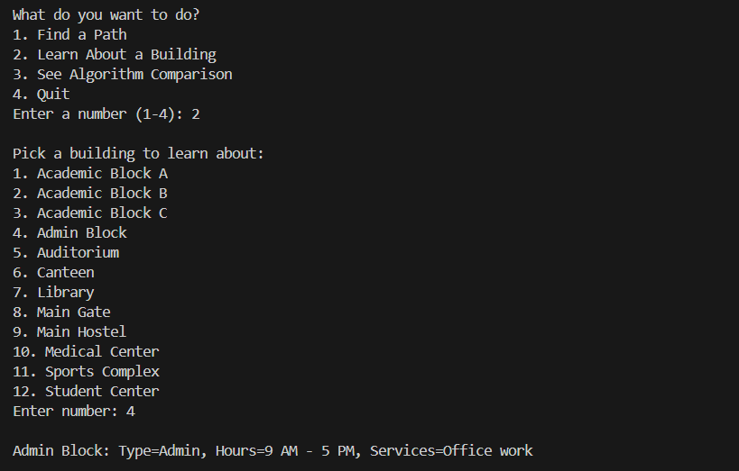

See Algorithm Comparison
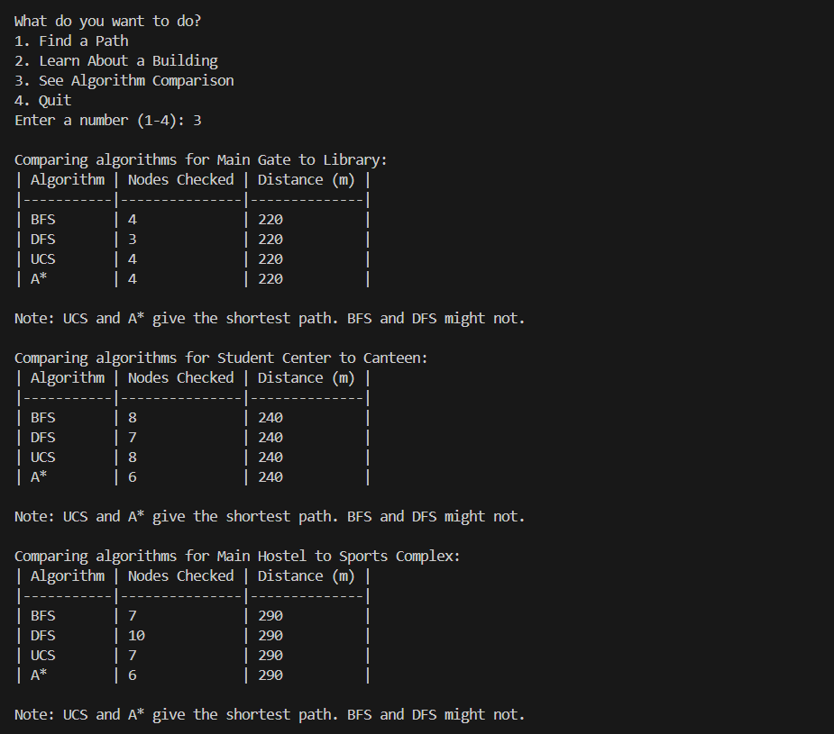

Test Cases
- Admin Block (4) to Library (7) with UCS (3).
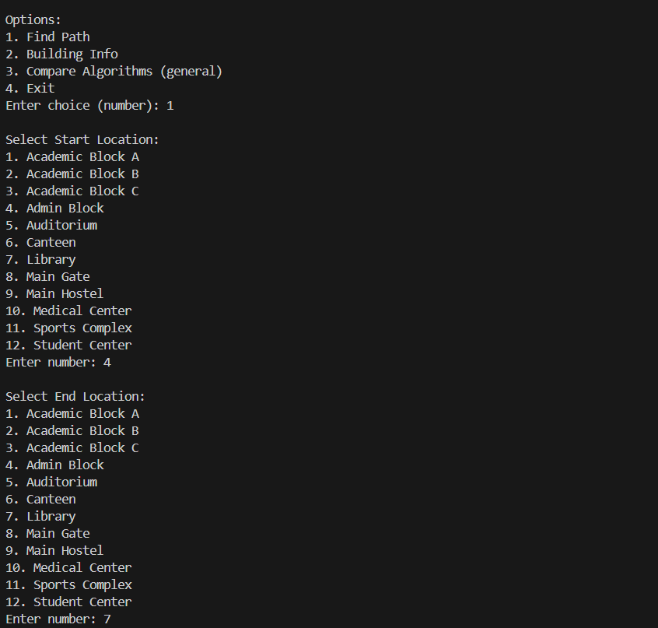
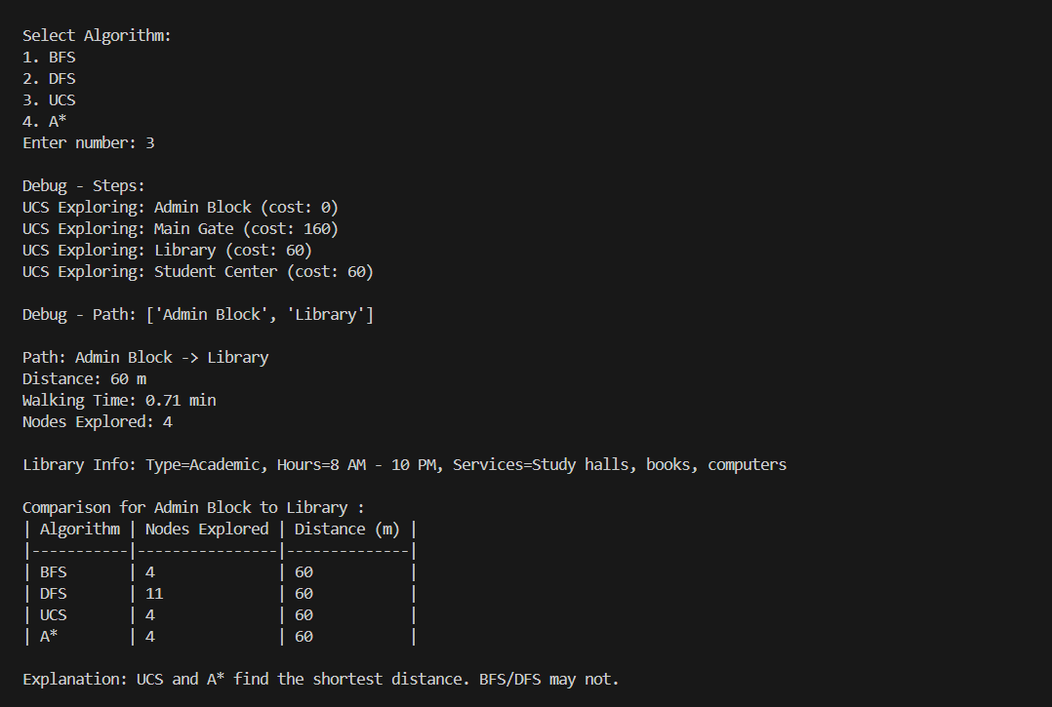

- Main Gate (8) to Student Center with A* .
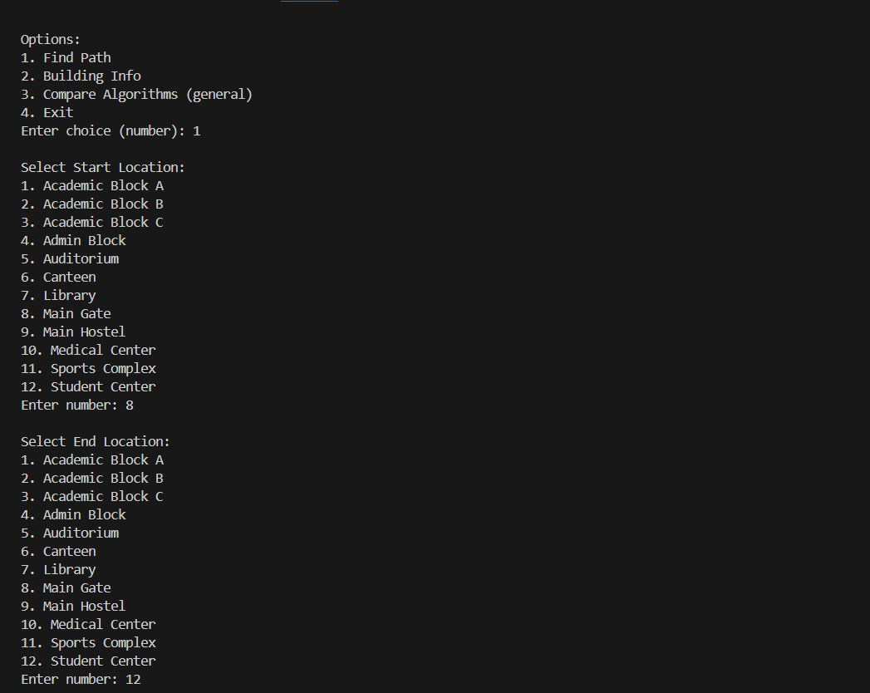

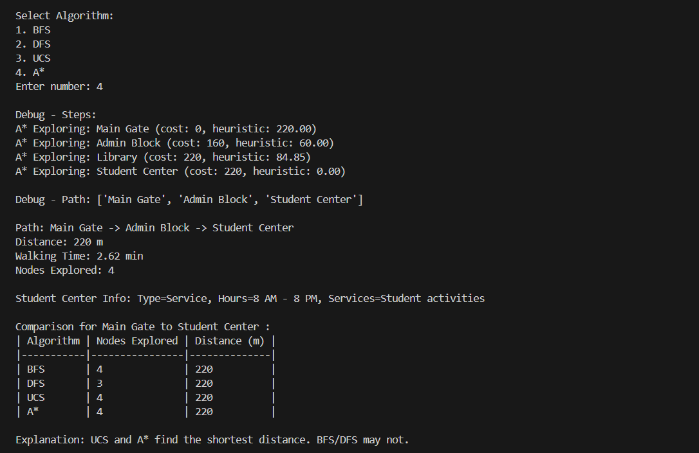

- Student Center (12) to Canteen (6) with BFS (1).
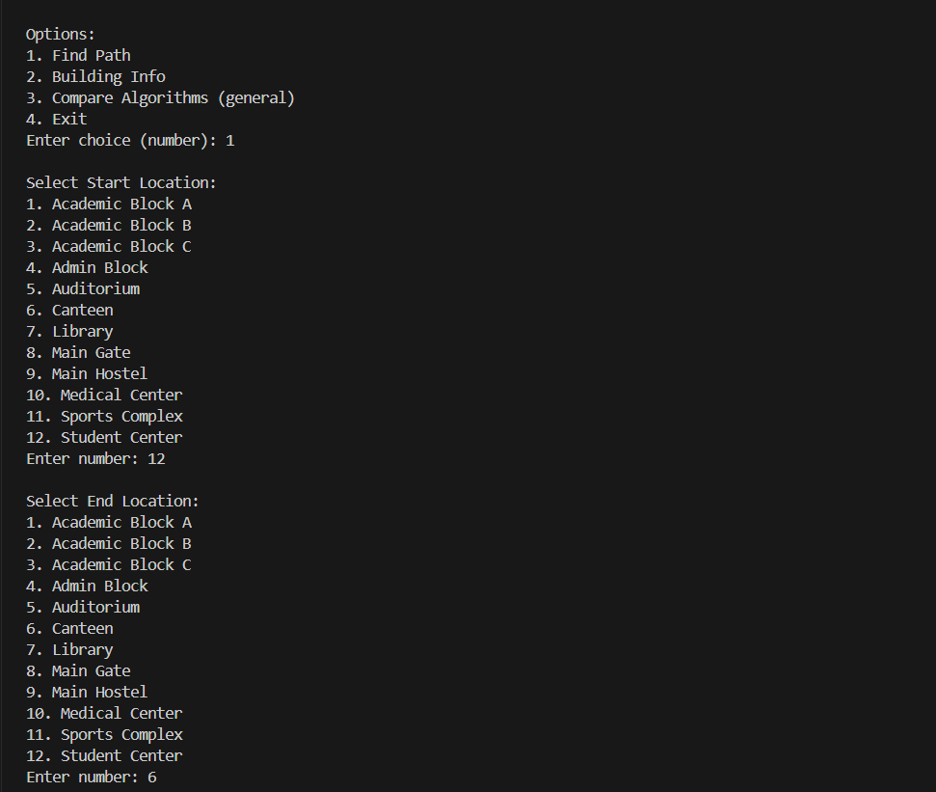

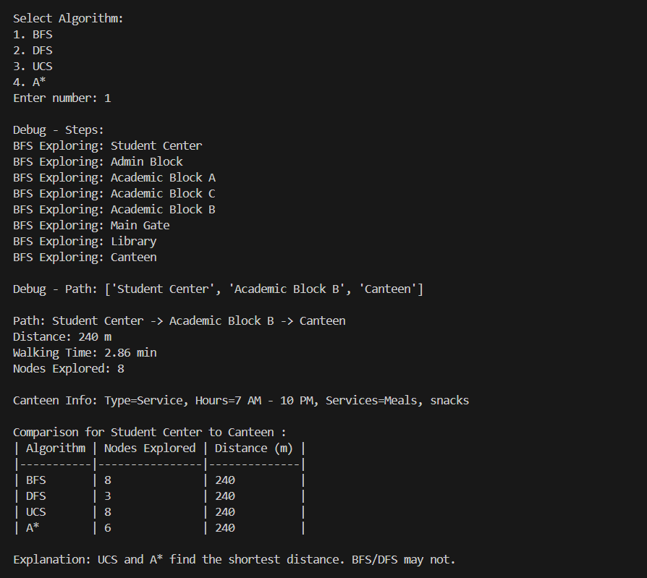

- Main Hostel (9) to Sports Complex (11) with DFS (2).
