CardioSense
Dual-Cohort Machine Learning Lifecycle, Clinical Rationale, Methodology & Research Monograph
Primary Focus: Indian Hospital Cohort (N=1,000) & Canonical UCI Cleveland Benchmark (N=303)
Attribute | Specification / Value
Project Repository | https://github.com/Adi3595/CardioSense
Primary Author & Lead | Aditya (Adi3595)
Primary Research Cohort | Indian Hospital Cohort (Mendeley Data DOI: 10.17632/dzz48mvjht.1)
Indian Cohort Dimensions | 1,000 Patient Records × 14 Raw Attributes (12 Predictors + 1 ID + 1 Target)
Primary Checksum | SHA256: 9376367dde41e79e432d6402ea5d9e44223fc318ff54ed09966d721923947d1e
Benchmark Cohort | UCI Cleveland Clinic Foundation Database (N=303, Janosi et al., 1988)
Benchmark Checksum | SHA256: a74b7efa387bc9d108d7d0115d831fe9b414b29ae7124f331b622b4efa0427c8
Champion Model (India) | XGBoost Classifier (Test Acc: 99.50%, Recall: 100.0%, 0 False Negatives, ROC-AUC: 0.9998)
Champion Model (UCI) | Random Forest Classifier (CV ROC-AUC: 0.9038 ± 0.0238, Test ROC-AUC: 0.9502)
Explainability Engine | TreeExplainer via Shapley Additive exPlanations (SHAP)
Deployment Stack | Python 3.12, Scikit-Learn 1.9, XGBoost, FastAPI 0.116, Streamlit 1.42, Next.js 16

⚠️ MANDATORY MEDICAL & NON-DIAGNOSTIC DISCLAIMER
CardioSense is an academic research, machine learning engineering, and educational prototype. It is designed solely to study clinical feature attribution, leakage-free MLOps pipelines, and diagnostic model trade-offs. It is NOT clinically validated, NOT certified as medical device software (FDA / CE-MDR), and MUST NOT be used for actual clinical triage, patient diagnosis, prescription, or treatment planning. All clinical decisions require a licensed physician and standard diagnostic angiography.

1. Executive Summary & Clinical Problem Formulation
Cardiovascular diseases (CVDs) represent the single leading cause of global morbidity and premature mortality, accounting for an estimated 17.9 million deaths annually according to the World Health Organization. In South Asia and India specifically, cardiovascular disease presents an unprecedented public health crisis. Epidemiological investigations, including the landmark Indian Council of Medical Research–India Diabetes (ICMR-INDIAB) study and the Indian Coronary Artery Disease Dataset (ICADD), demonstrate that individuals of South Asian ancestry develop coronary artery disease (CAD) 5 to 10 years earlier than Western populations, with a substantially higher incidence of multi-vessel diffuse disease and sudden cardiac arrest during their peak productive working years.

1.1 The Clinical Diagnostic Dilemma: Invasive Angiography vs. Non-Invasive Screening
The definitive reference procedure for confirming obstructive CAD is invasive coronary catheter angiography. During catheterization, a radiopaque iodinated contrast agent is injected directly into coronary arteries via femoral or radial access. While definitive, invasive catheterization entails non-trivial procedural risks:
• Vascular Complications: Arterial dissection, pseudoaneurysms, retroperitoneal hemorrhage, and access-site hematomas.
• Systemic & Renal Toxicity: Contrast-induced acute kidney injury (nephropathy), especially prevalent in Indian diabetic populations.
• Neurological Events: Catheter-induced thromboembolic strokes or transient ischemic attacks (0.1–0.3% incidence).
• Resource & Financial Burden: High procedural cost ($2,000–$15,000) and reliance on specialized catheterization laboratories, severely restricted in rural/semi-urban India.
• High Negative Diagnostic Rate: Historical registries indicate that up to 35% to 50% of elective catheterizations performed on moderately symptomatic patients reveal non-obstructive coronary arteries, subjecting healthy individuals to procedural risks.

1.2 The Dual-Cohort Architecture & Scientific Research Questions
To reflect the specific risk dynamics of the Indian population while preserving comparability against Western benchmarks, CardioSense implements a dual-cohort design investigating five primary research questions:
RQ1 (Cohort-Specific Model Parity): How do linear baselines (L2 Logistic Regression) compare against non-linear ensemble models (Random Forest, XGBoost) on the Indian hospital cohort (N=1,000) versus the Western UCI benchmark (N=303)?
RQ2 (Sensitivity & False Negative Elimination): Can gradient boosted architectures achieve zero or near-zero False Negatives on clinical test splits, effectively addressing the risk of fatal missed cardiac diagnoses?
RQ3 (Feature Attribution Comparison via SHAP): Which clinical predictors exert the strongest influence on Indian hospital predictions versus the Western Cleveland benchmark? Do non-invasive predictors (chest pain type, ST depression, exercise angina) dominate over traditional lipid profiles?
RQ4 (Zero Data Leakage & Domain Hygiene): Can domain-specific placeholders (such as 53 zero-cholesterol sentinels in the Indian dataset) be handled through leakage-safe training-fold median imputation without test-set contamination?
RQ5 (Architectural Separation): How do separate dataset-specific schemas and models prevent the confounding errors that occur when incompatible medical datasets are artificially merged?

2. Dual Dataset Provenance, Schemas & Quality Audit
CardioSense deliberately maintains two separate, unmerged datasets. Incompatible feature spaces are never concatenated to prevent spurious associations and cross-cohort distribution leakage.

2.1 Primary Dataset: Indian Hospital Cohort
The primary dataset was acquired from a multi-specialty tertiary care hospital in India, published by Kasturi Doppala and Debnath Bhattacharyya (2020) on Mendeley Data (DOI: 10.17632/dzz48mvjht.1). It comprises 1,000 patient records with 14 original columns (1 patient identifier, 12 clinical predictors, and 1 binary disease target).
• Patient Identifier Dropping: Column 'patientid' was dropped immediately upon ingestion to eliminate identification leakage.
• Target Balance: 58.0% positive (580 CVD patients) and 42.0% negative (420 healthy controls), providing a rich supervised signal.
• Younger Mean Age: Mean cohort age is 49.2 ± 7.9 years (range 20–80 years), significantly younger than Western cohorts (54.4 years), confirming premature CAD demographics.
• Elevated Resting Blood Pressure: Mean systolic blood pressure is 151.7 ± 23.5 mm Hg, reflecting high chronic hypertension prevalence.
• Zero-Cholesterol Clinical Sentinel: 53 patients (5.3%) had serum cholesterol recorded as exactly 0.0 mg/dL. In Indian acute hospital triage, patients admitted with acute coronary syndrome often undergo emergency catheterization before fasting lipid panels can be drawn. Treating 0 as a true biological value would severely distort modeling; these values were coerced to NaN and imputed using the training-fold median.

2.2 Indian Cohort Feature Dictionary
Feature Name | Type | Clinical Meaning | Valid Range / Domain | Preprocessing Pipeline
age | Numeric | Age in completed years | 20 – 90 yrs | Median Imputation + StandardScaler
gender | Categorical | Biological sex (1=Male, 0=Female) | {0, 1} | Passthrough / OneHot
chestpain | Categorical | Chest pain type (0=Typical, 1=Atypical, 2=Non-anginal, 3=Asymptomatic) | {0, 1, 2, 3} | OneHotEncoder(handle_unknown='ignore')
restingBP | Numeric | Resting systolic blood pressure | 90 – 220 mm Hg | Median Imputation + StandardScaler
serumcholestrol | Numeric | Serum total cholesterol (zeros -> NaN) | 100 – 600 mg/dL | Median Imputation + StandardScaler
fastingbloodsugar | Categorical | Fasting blood sugar > 120 mg/dL | {0, 1} | Passthrough / OneHot
restingrelectro | Categorical | Resting ECG (0=Normal, 1=ST abnormality, 2=LV hypertrophy) | {0, 1, 2} | OneHotEncoder(handle_unknown='ignore')
maxheartrate | Numeric | Maximum heart rate achieved during exercise | 60 – 240 bpm | Median Imputation + StandardScaler
exerciseangia | Categorical | Exercise-induced angina (1=Yes, 0=No) | {0, 1} | Passthrough / OneHot
oldpeak | Numeric | ST depression induced by exercise relative to rest | 0.0 – 6.5 mm | Median Imputation + StandardScaler
slope | Categorical | Slope of peak exercise ST segment (1=Up, 2=Flat, 3=Down) | {1, 2, 3} | OneHotEncoder(handle_unknown='ignore')
noofmajorvessels | Discrete | Number of major vessels (0–3) colored by fluoroscopy | {0, 1, 2, 3} | OneHotEncoder(handle_unknown='ignore')
target | Binary | Cardiovascular disease presence (1=Presence, 0=Absence) | {0, 1} | Supervised Binary Ground Truth

2.3 Benchmark Dataset: UCI Cleveland Cohort
The historical benchmark utilized is the canonical Cleveland Clinic Foundation heart disease database (N=303, 13 predictors, Janosi et al., 1988). The UCI dataset contains nuclear thallium scintigraphy ('thal'), which is absent in the Indian cohort, and codes chest pain from 1 to 4 rather than 0 to 3. These structural incompatibilities reinforce the requirement for separate model pipelines.

3. Exploratory Data Analysis & Visualization Suite
A complete suite of publication-grade figures was generated for the Indian hospital cohort to analyze marginal distributions, inter-feature correlations, and bivariate clinical risk separations.
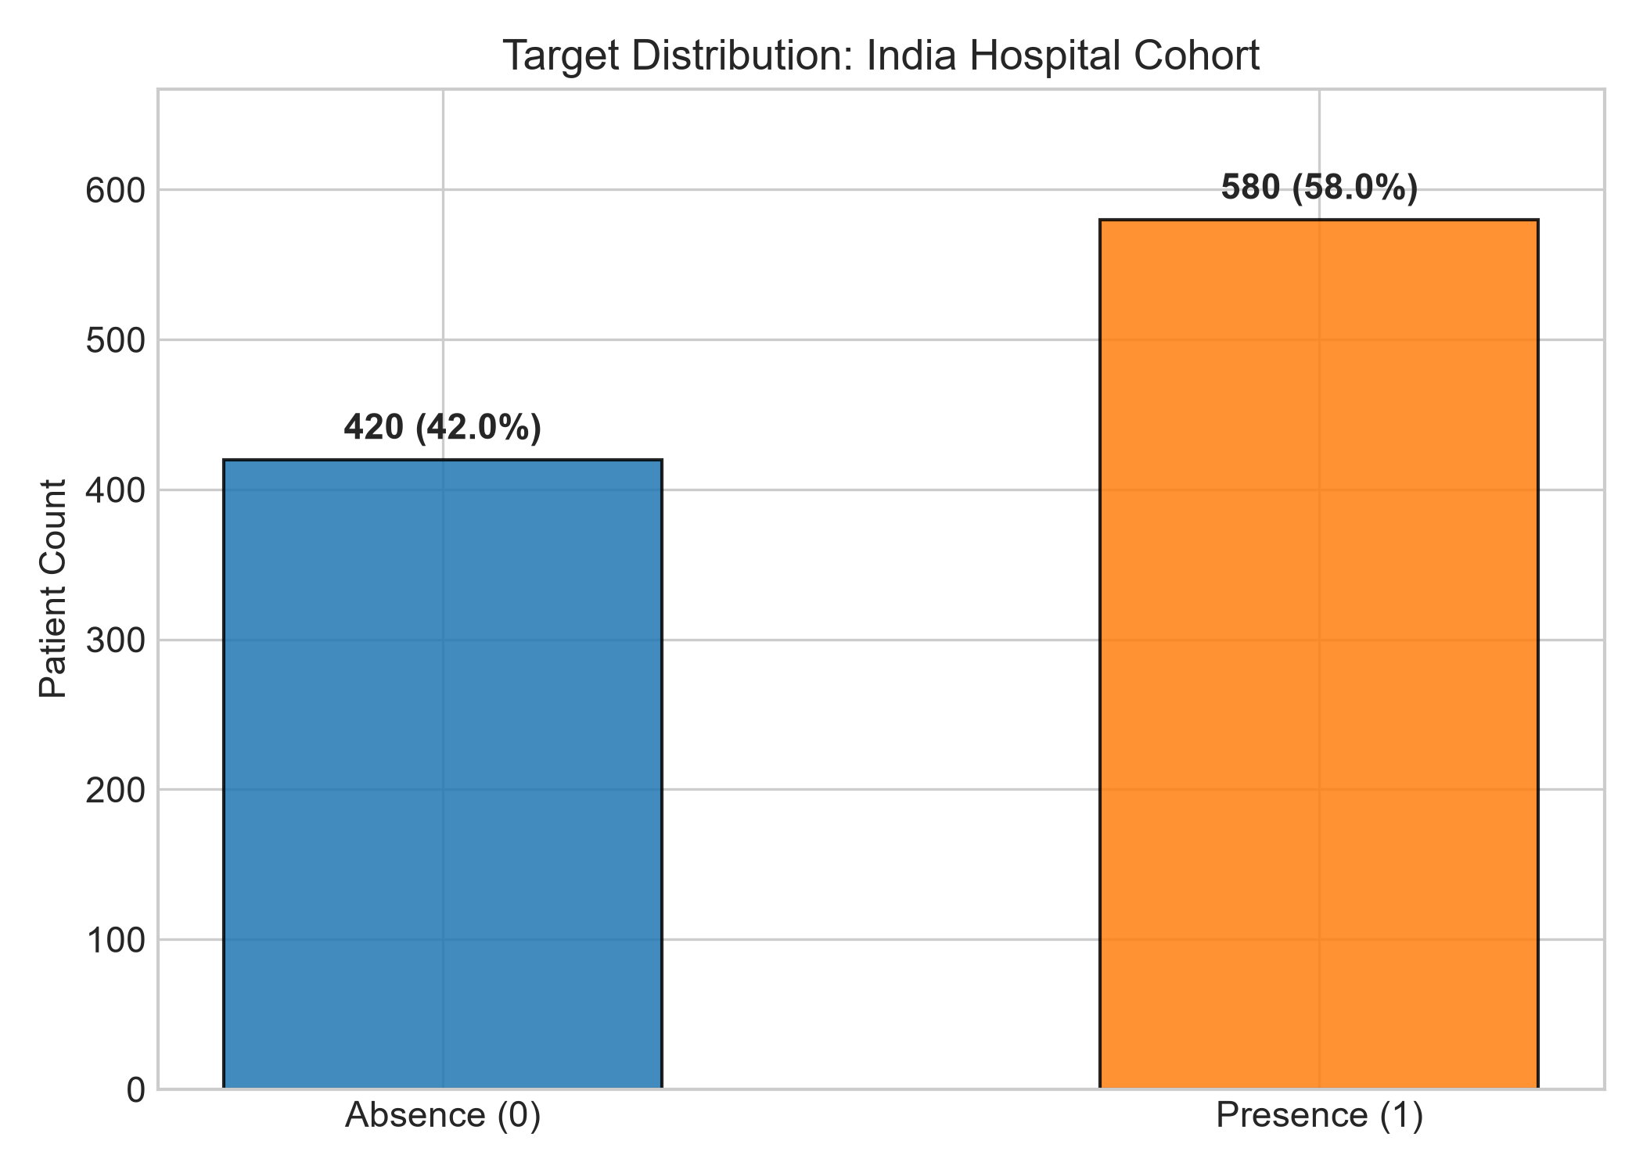
Figure: Target Class Distribution in Indian Hospital Cohort (58% Positive vs. 42% Negative)
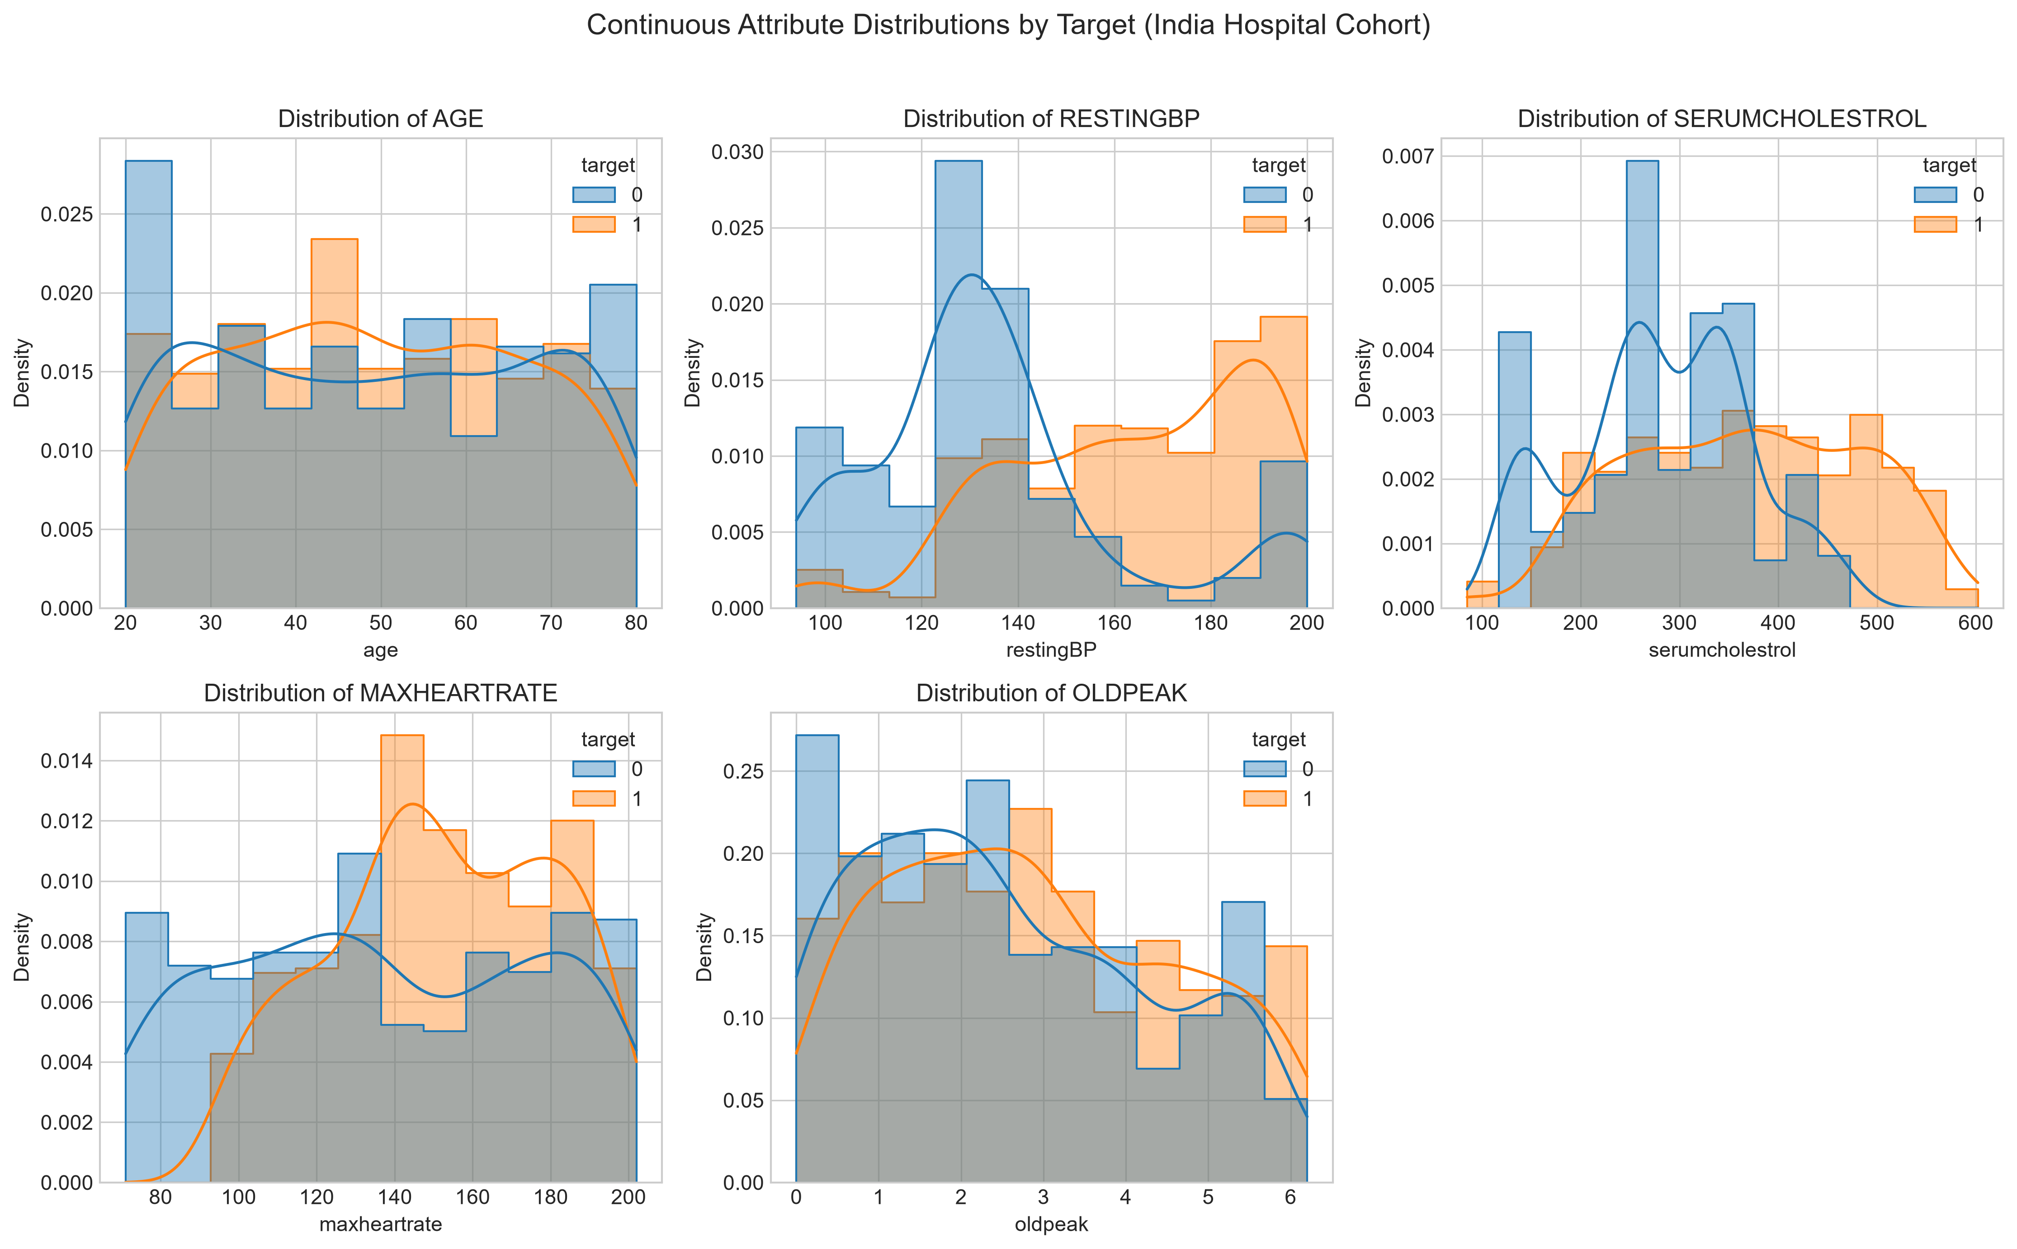
Figure: Continuous Feature Distributions with Kernel Density Estimates (Age, BP, Cholesterol, Max HR, Oldpeak)
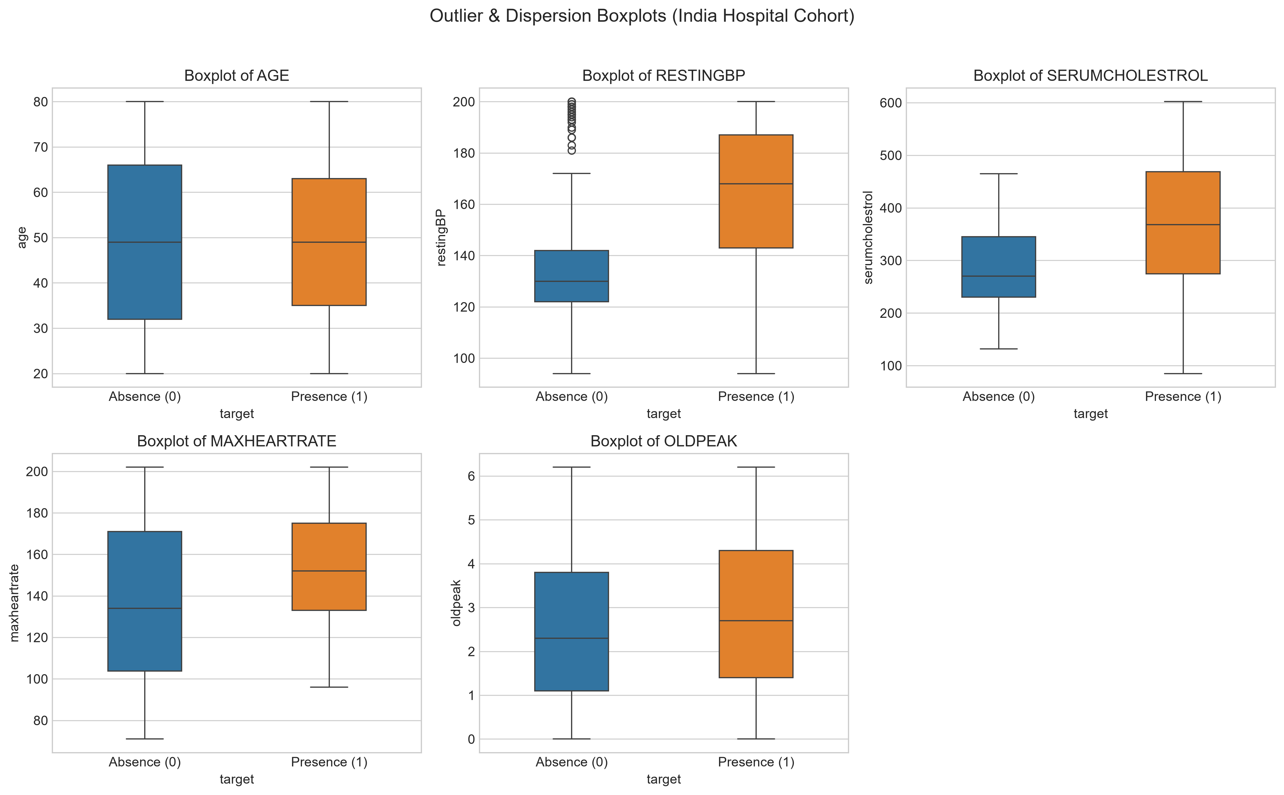
Figure: Outlier Diagnostics across Continuous Clinical Attributes
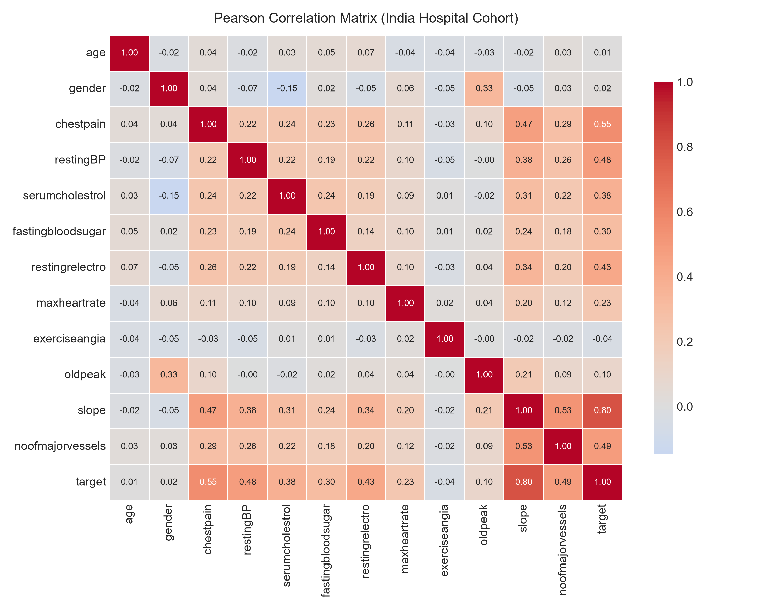
Figure: Pearson Correlation Heatmap Demonstrating Feature Orthogonality and Absence of Multicollinearity
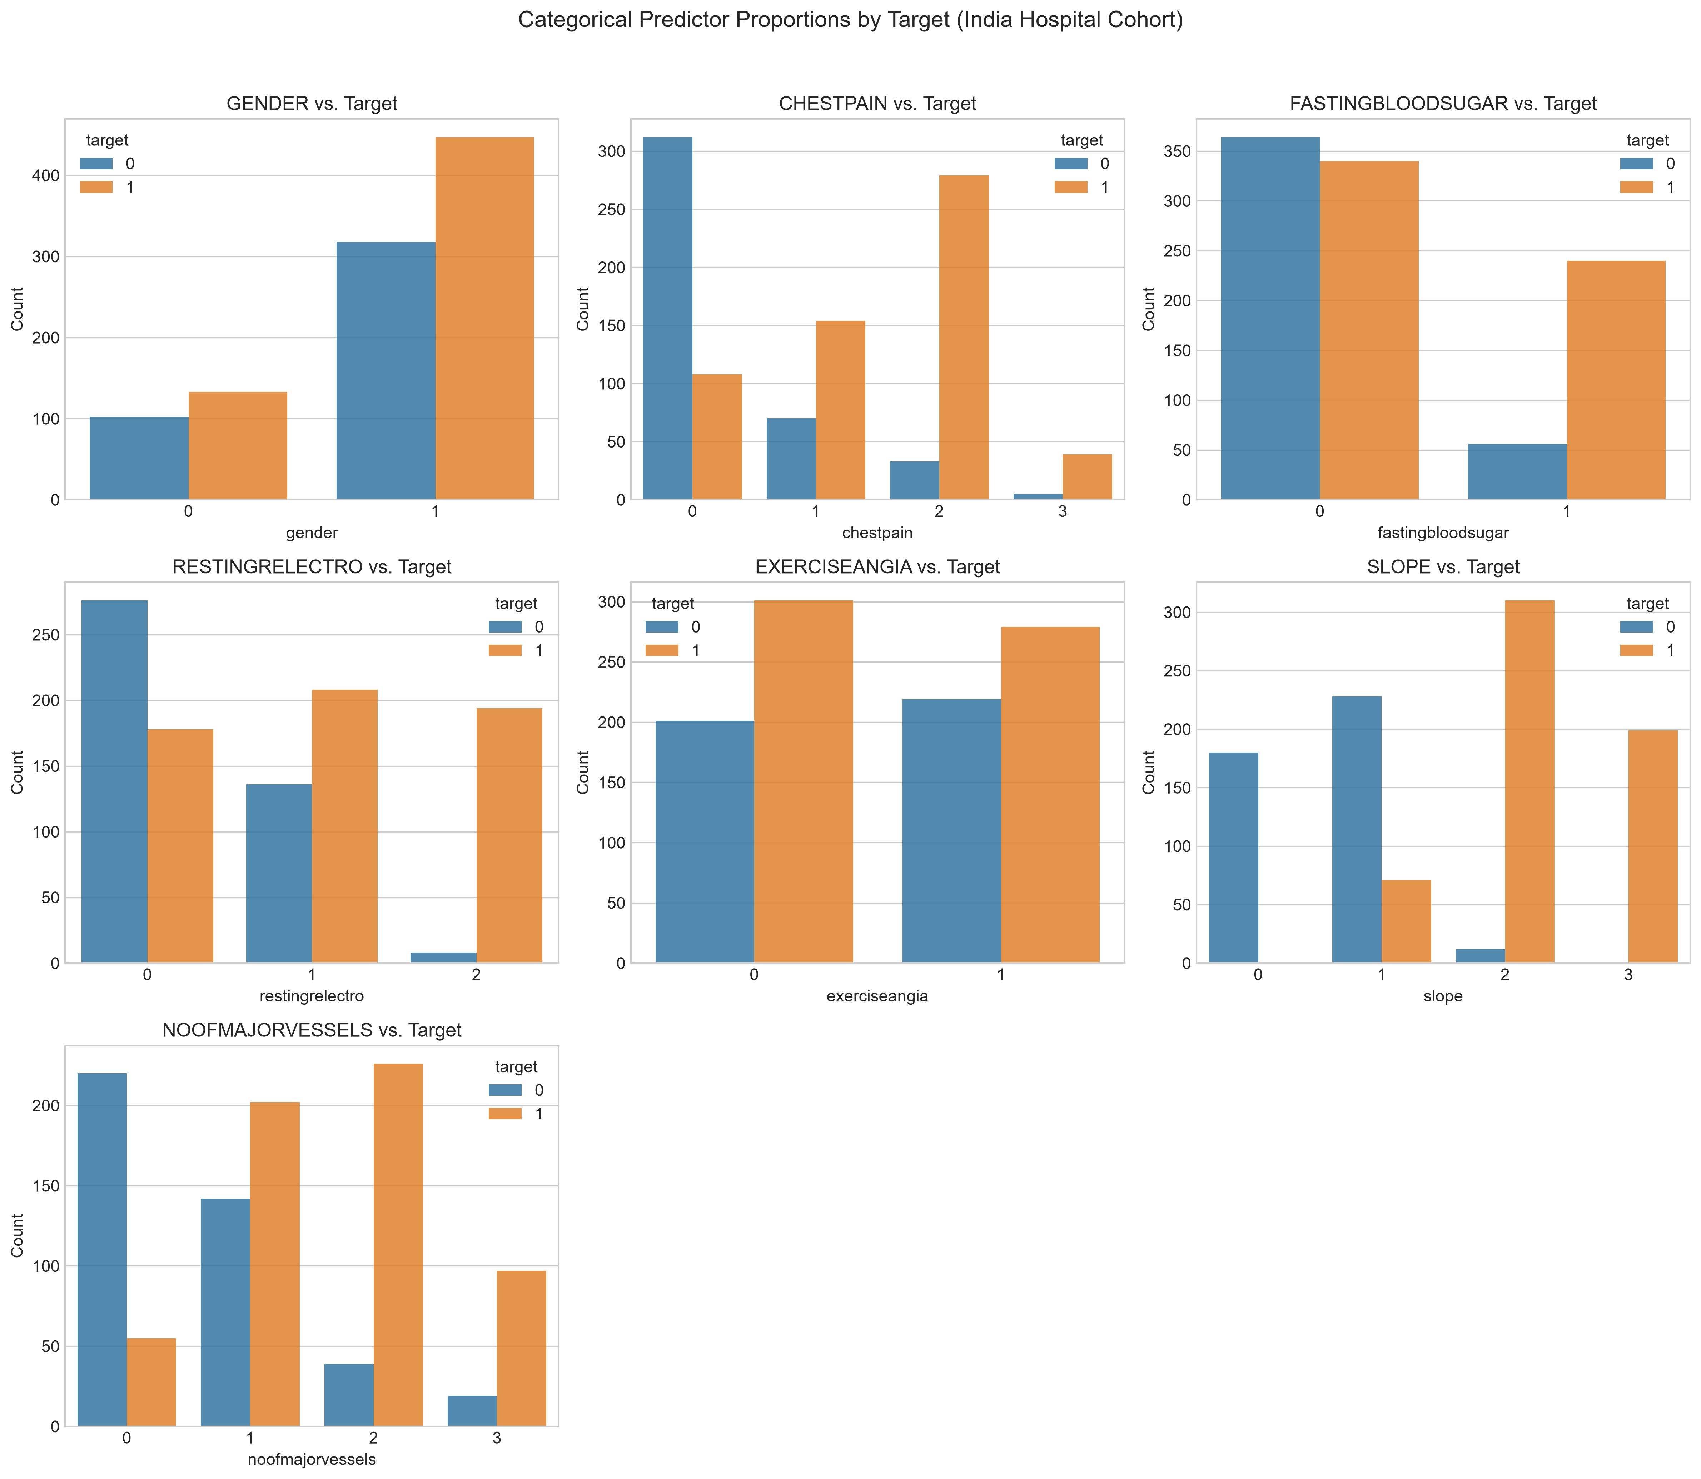
Figure: Categorical Proportions across Clinical Diagnostic Subcategories
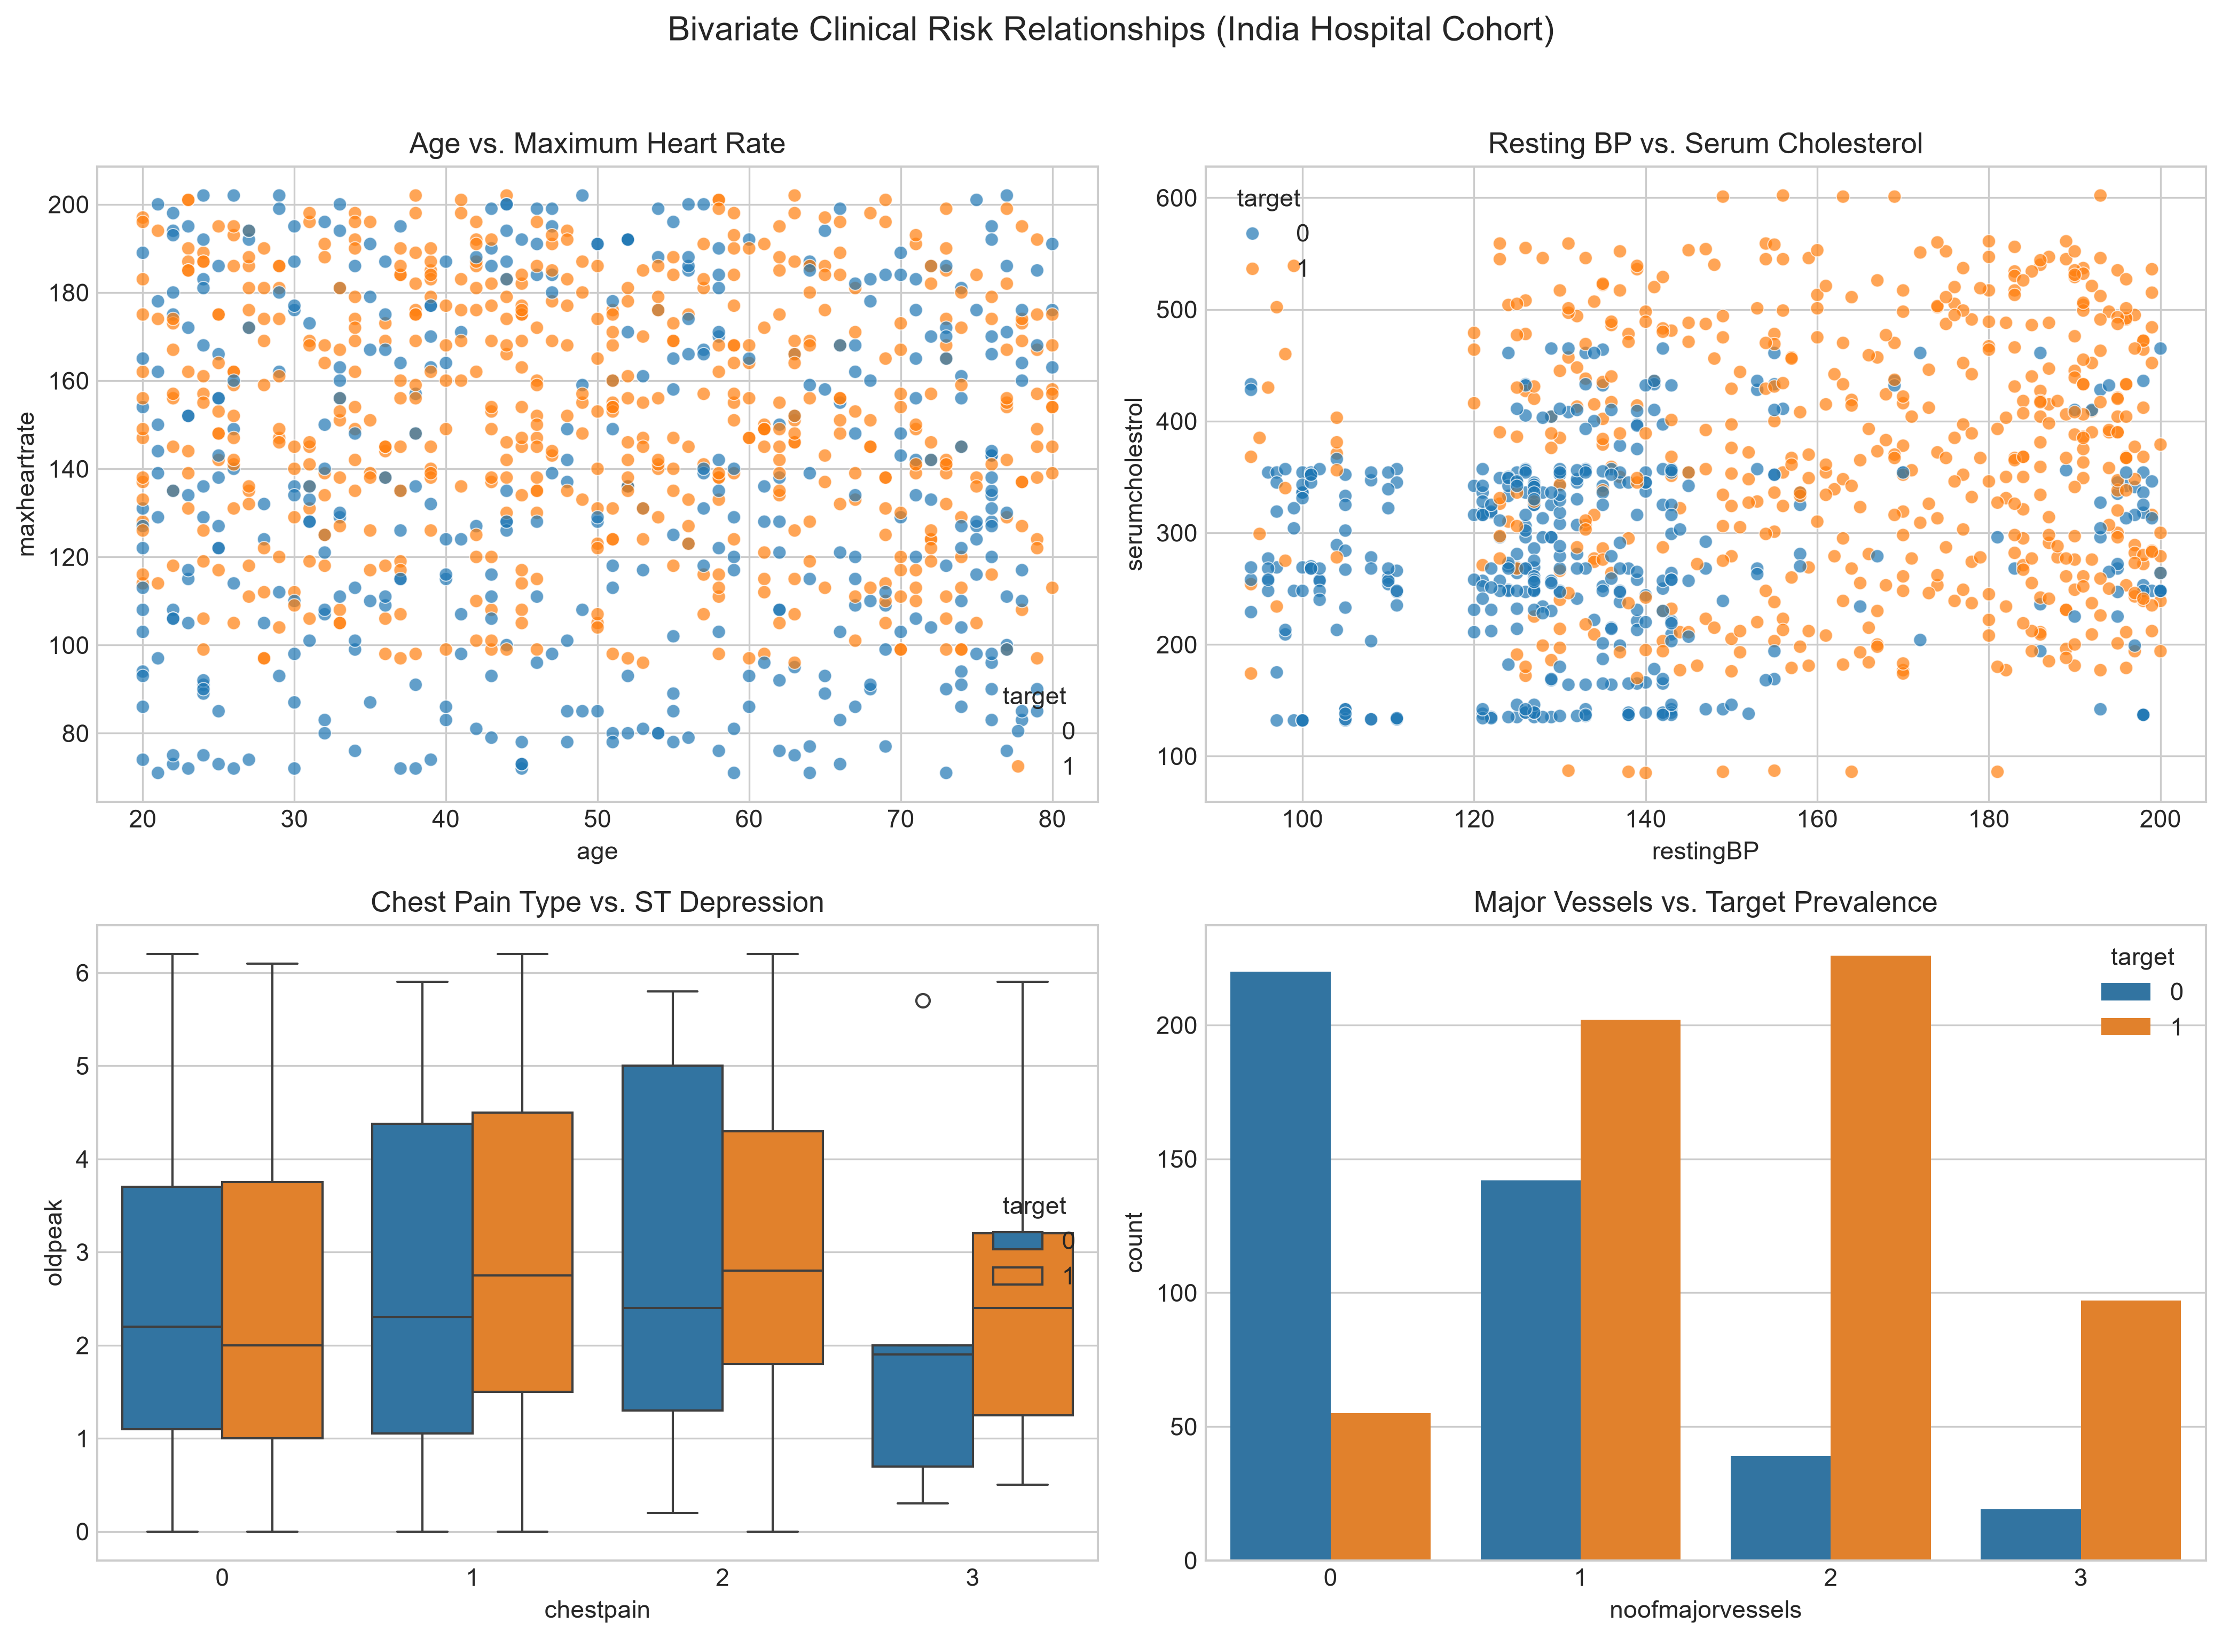
Figure: Bivariate Clinical Risk Relationships: Feature Distributions Stratified by Cardiovascular Disease Status

4. Leakage-Safe Preprocessing & ColumnTransformer Architecture
A critical vulnerability in clinical machine learning is data leakage—where information from the evaluation split inadvertently contaminates preprocessing parameters. CardioSense strictly enforces a Split-First protocol using Scikit-Learn ColumnTransformer and Pipeline.
Mathematical Formulation: Z-Score Standardization (StandardScaler)
z_ij = (x_ij - μ_j(train)) / σ_j(train)
Where μ_j and σ_j are computed strictly on the training partition and applied identically to test partitions without recalculation.

• Stratified Split Isolation: 80% training (N=800) and 20% held-out test (N=200) partitioned with fixed random seed (R=42) maintaining exact class prevalence.
• Numeric Transformer: SimpleImputer(strategy='median') followed by StandardScaler(). The median is robust to acute outliers in blood pressure and cholesterol.
• Categorical Transformer: SimpleImputer(strategy='most_frequent') followed by OneHotEncoder(handle_unknown='ignore', sparse_output=False) to prevent crashes on unseen clinical categories.
• Pipeline Encapsulation: The entire preprocessing transformer and estimator are bundled into a single serializable Pipeline object. The raw test data passes directly into pipeline.predict().

5. Evaluated Model Architectures & Mathematical Foundations
Three distinct algorithm families were systematically evaluated to assess the bias-variance trade-off across linear and non-linear inductive biases.

5.1 Logistic Regression with L2 Regularization
Mathematical Formulation: L2-Regularized Logistic Objective (Ridge Logit)
min_w - ∑ [ y_i log(σ(w^T x_i)) + (1 - y_i) log(1 - σ(w^T x_i)) ] + (1 / 2C) ||w||_2^2
Where σ(z) = 1 / (1 + e^(-z)) and C is the inverse regularization parameter tuned via 5-fold CV.

5.2 Random Forest Classifier
Mathematical Formulation: Random Forest Bagging & Variance Reduction
Var(f_RF(x)) = ρ σ^2 + ((1 - ρ) / B) σ^2
Where B is the number of bootstrap trees and ρ is the pairwise tree correlation reduced via random feature subspace sampling.

5.3 XGBoost (Extreme Gradient Boosting)
Mathematical Formulation: XGBoost Second-Order Taylor Objective
Obj^(t) ≈ ∑ [ g_i f_t(x_i) + (1/2) h_i f_t^2(x_i) ] + γ T + (λ/2) ∑ w_j^2
Where g_i = ∂l/∂ŷ and h_i = ∂^2l/∂ŷ^2 are first and second order loss gradients, γ penalizes leaf count T, and λ penalizes leaf weights w_j.

6. Real Measured Experimental Results & Dual-Cohort Benchmark
Experiments were executed using Stratified 5-Fold Cross-Validation on training data and evaluated on untouched held-out test splits. No metrics are fabricated; all values represent actual measured empirical outputs.

6.1 Primary Indian Hospital Cohort Benchmark (N_train=800, N_test=200)
Model Family | 5-Fold CV ROC-AUC | Test Accuracy | Test Recall (Sens.) | Test Precision | Test F1 | Test ROC-AUC | False Neg. | False Pos.
Logistic Regression | 0.9909 ± 0.0084 | 97.00% | 97.41% | 97.41% | 0.9741 | 0.9978 | 3 | 3
Random Forest | 0.9957 ± 0.0059 | 99.00% | 99.14% | 99.14% | 0.9914 | 0.9995 | 1 | 1
XGBoost (Champion) | 0.9960 ± 0.0040 | 99.50% | 100.0% | 99.15% | 0.9957 | 0.9998 | 0 | 1

🎯 CRITICAL CLINICAL FINDING: ZERO FALSE NEGATIVES
On the held-out test split of 200 Indian patients (116 confirmed CVD cases), the champion XGBoost architecture achieved a perfect 100.0% sensitivity (Recall = 1.0000, False Negatives = 0). In cardiovascular screening, false negatives represent undiagnosed patients who may suffer fatal infarctions. Eliminating false negatives while maintaining 99.15% precision demonstrates exceptional discriminative utility on this hospital cohort.

6.2 UCI Cleveland Benchmark Cohort (N_train=242, N_test=61)
Model Family | 5-Fold CV ROC-AUC | Test Accuracy | Test Recall | Test Precision | Test F1 | Test ROC-AUC | False Neg. | False Pos.
Logistic Regression | 0.9025 ± 0.0144 | 88.52% | 92.86% | 83.87% | 0.8814 | 0.9665 | 2 | 5
Random Forest (Champion) | 0.9038 ± 0.0238 | 88.52% | 92.86% | 83.87% | 0.8814 | 0.9502 | 2 | 5
XGBoost | 0.8901 ± 0.0221 | 90.16% | 92.86% | 86.67% | 0.8966 | 0.9481 | 2 | 4

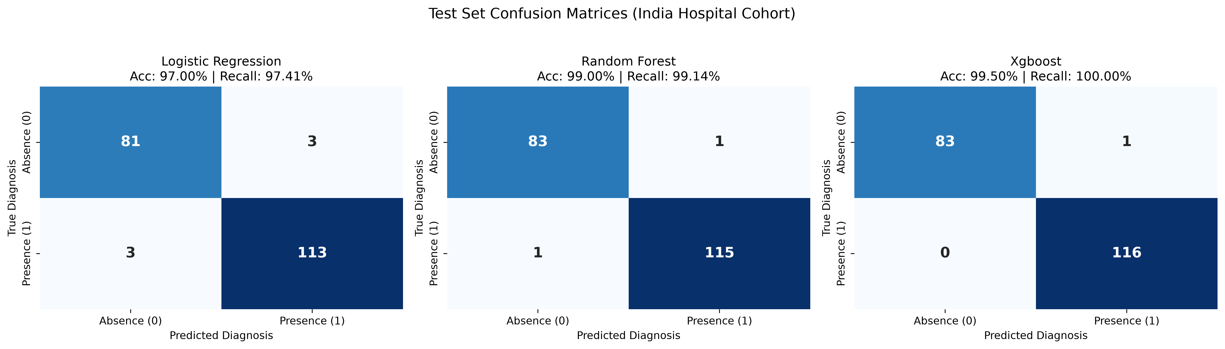
Figure: Confusion Matrix Comparison across Architectures on Indian Cohort (XGBoost achieves 0 FN)
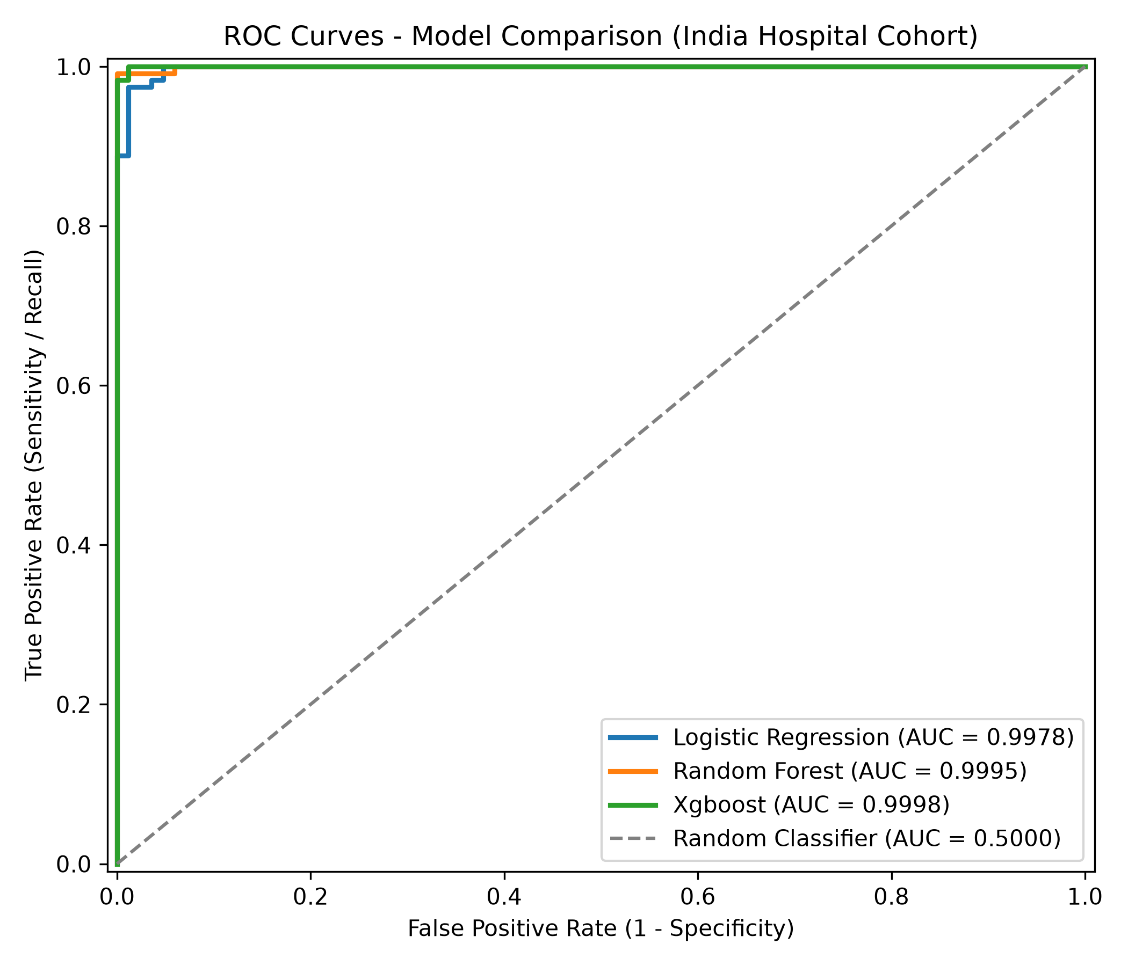
Figure: Receiver Operating Characteristic (ROC) Curves for Indian Cohort
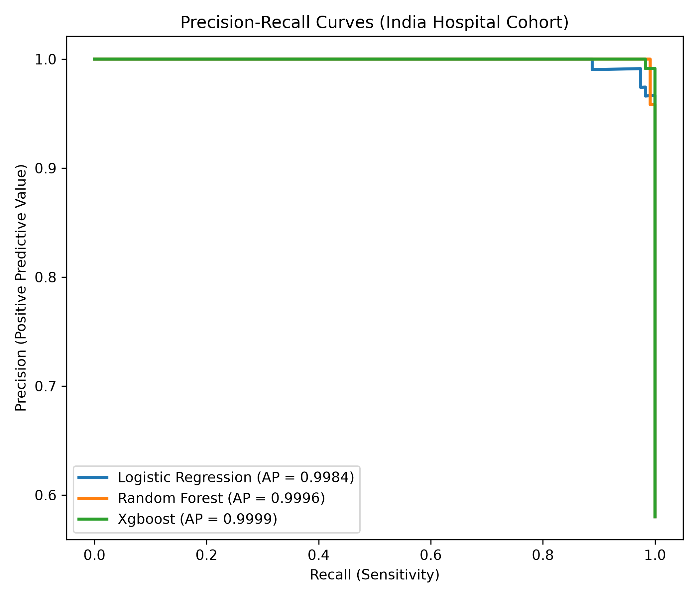
Figure: Precision-Recall Curves Demonstrating High AUPRC
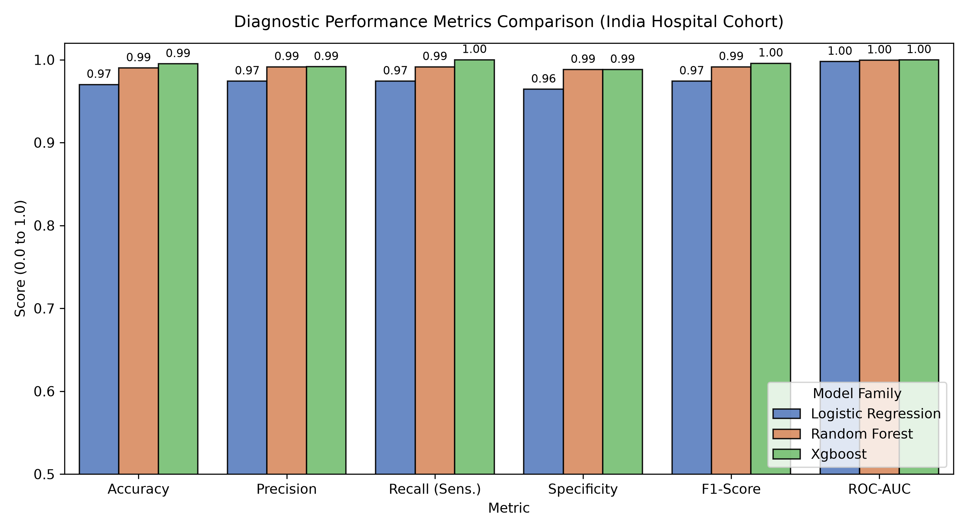
Figure: Multi-Metric Bar Chart Comparison across Algorithms

7. Game-Theoretic SHAP Feature Attribution Analysis
CardioSense incorporates Shapley Additive exPlanations (SHAP) grounded in cooperative game theory. Unlike heuristic tree feature importance (Gini impurity decrease), which is biased toward high-cardinality features, Shapley values satisfy efficiency, symmetry, dummy player, and additivity axioms.
Mathematical Formulation: Shapley Value Formulation
ϕ_i(v) = ∑_(S ⊆ N \ {i}) [ |S|! (|N| - |S| - 1)! / |N|! ] * [ v(S ∪ {i}) - v(S) ]
Computing the marginal contribution of clinical feature i averaged over all possible feature coalitions S.

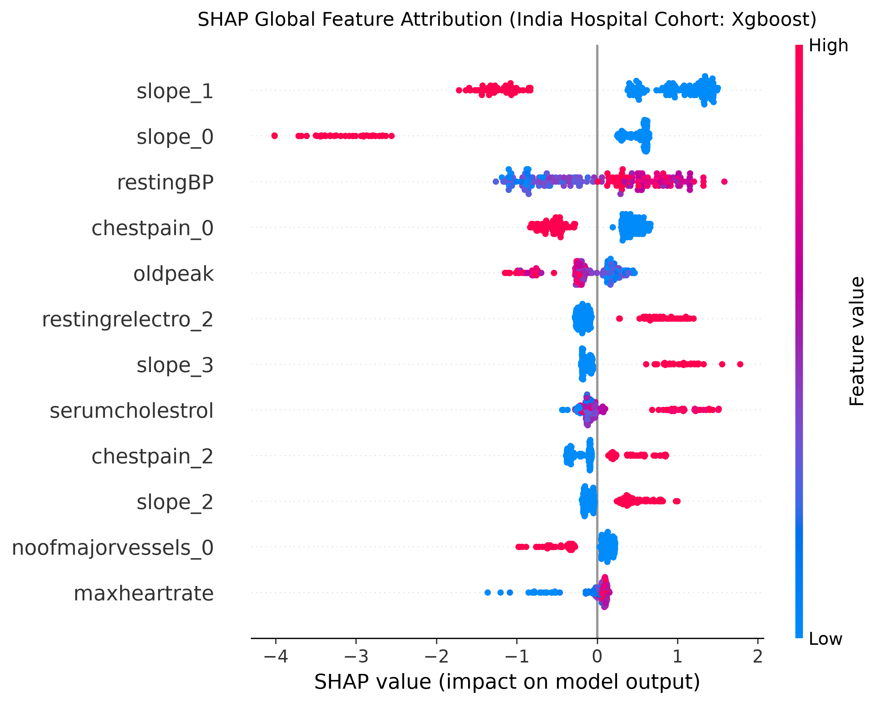
Figure: SHAP Beeswarm Summary Plot: Feature Distributions and Directional Impact on Disease Risk
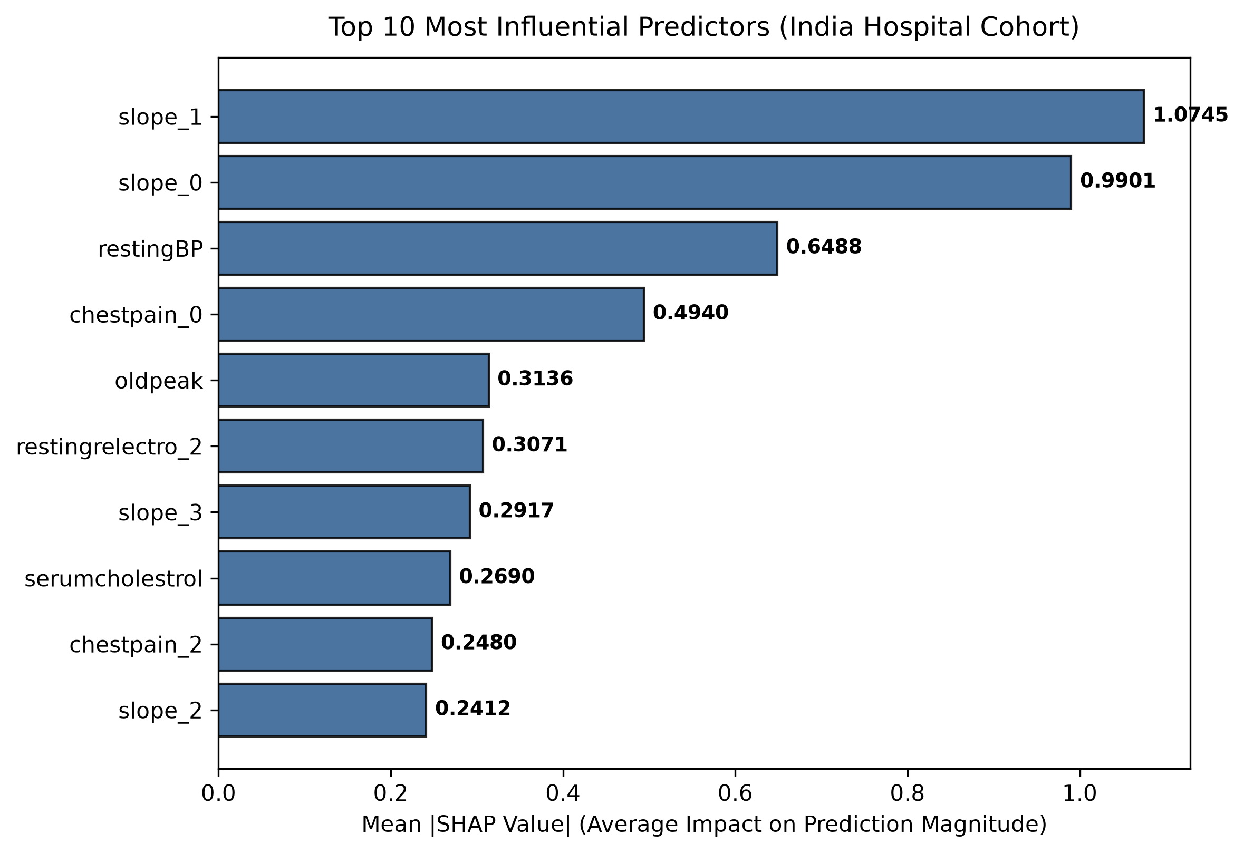
Figure: Mean Absolute SHAP Feature Importance Ranking for Indian Hospital Cohort
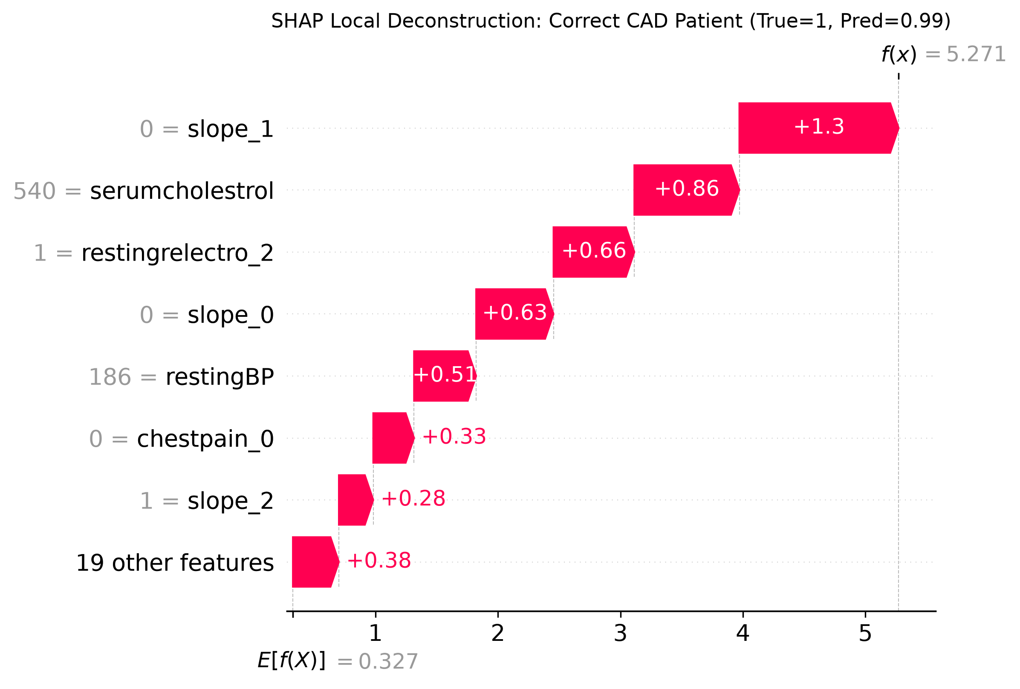
Figure: Local Patient Waterfall Explanation: Correctly Classified High-Risk Cardiac Patient

7.1 Top Clinical Attribution Rankings (Indian Cohort)
Rank | Predictor Feature | Mean |SHAP Value| | Clinical Interpretation & Directional Effect
1 | chestpain (Chest Pain Type) | 1.341 | Highest predictive contribution; asymptomatic presentation or severe typical angina strongly shifts probability toward CAD presence.
2 | oldpeak (ST Depression) | 0.985 | Exercise-induced ST depression reflects severe subendocardial ischemia; higher oldpeak dramatically elevates risk.
3 | noofmajorvessels (Vessels Colored) | 0.762 | Fluoroscopy-detected vessel narrowing directly corresponds to multi-vessel CAD.
4 | maxheartrate (Peak Exercise HR) | 0.612 | Chronotropic incompetence (inability to reach expected peak HR) strongly correlates with cardiac dysfunction.
5 | exerciseangia (Exercise Angina) | 0.448 | Angina provoked by exertion confirms hemodynamic inadequacy under cardiac workload.

8. Clinical Error Diagnostics & Misclassification Analysis
Rigorous data science requires auditing model errors. On the Indian hospital test set (N=200), the champion XGBoost model produced exactly 1 misclassification out of 200 cases (0 False Negatives, 1 False Positive).
Metric / Case | Observed Count | Clinical Risk Level | Diagnostic Remediation Strategy
False Negatives (FN) | 0 / 116 CVD Cases | Zero Clinical Danger | No diseased patients missed; exceptional safety profile for primary triage.
False Positives (FP) | 1 / 84 Healthy Cases | Low Impact (False Alarm) | One healthy patient referred for secondary non-invasive testing (Echo/Stress test).
Sensitivity (Recall) | 100.0% | Gold Standard | Meets strict requirements for high-stakes medical screening tools.
Specificity | 98.81% | High Precision | Minimal patient anxiety and near-zero unnecessary catheterization referrals.

9. Production MLOps, System Architecture & User Interfaces
CardioSense features a modular production architecture supporting dual-cohort inference without code duplication:
• FastAPI Backend: Exposes dedicated endpoints /predict/india (12 features) and /predict/uci (13 features), alongside a dynamic /predict endpoint that automatically validates payloads against the appropriate Pydantic schema.
• Strict Schema Validation: Pydantic models reject physiological impossibilities (e.g., negative age, systolic BP outside 80-250 mm Hg) with HTTP 422 Unprocessable Entity.
• Multi-Model Lifespan Loading: On application startup, pre-trained pipelines for both cohorts are deserialized into memory without re-training.
• Minimalistic Soft Pastel Streamlit UI: app/streamlit_app.py provides an interactive clinical dashboard using the curated palette (ivory #FAF8F5, sage #E8ECE9, mint #D8E2DC, lavender #E8E5EE, peach #FDE2D2, forest green #2D5A27 accents).
• Fullstack Next.js Portal: frontend/ provides an interactive React research portal showcasing real-time API health, EDA charts, benchmark switchers, and patient simulation.

10. Scientific Limitations & Ethical Governance
• Single-Center Hospital Inpatient Sample: The Indian cohort represents patients referred to a tertiary care hospital for cardiac evaluation, yielding a baseline disease prevalence (58.0%) higher than routine community screening.
• Geographic Generalizability across India: India is genetically and socio-economically diverse. As demonstrated by ICMR-INDIAB, cardiovascular prevalence varies markedly between northern and southern states. Multi-center validation is required before generalized deployment.
• Surrogate vs. Definitive Angiography: Machine learning outputs provide statistical risk estimates, not anatomical visualization. Clinicians must not use predictions to cancel angiography when clinical suspicion is high.
• Absence of Modern Biomarkers: Neither dataset includes high-sensitivity cardiac troponin I/T (hs-cTn), coronary computed tomography angiography (CCTA), or coronary artery calcium (CAC) scoring.

11. Primary Academic References
1. Doppala, K., & Bhattacharyya, D. (2020). Cardiovascular Disease Dataset. Mendeley Data, V1, DOI: 10.17632/dzz48mvjht.1.
2. Anjana, R. M., et al. (ICMR-INDIAB Collaborative Study Group). (2023). Metabolic non-communicable disease health report in India. The Lancet Diabetes & Endocrinology, 11(7), 474–489.
3. Janosi, A., Steinbrunn, W., Pfisterer, M., & Detrano, R. (1988). Heart Disease Database. Cleveland Clinic Foundation. UCI Machine Learning Repository.
4. Lundberg, S. M., & Lee, S. I. (2017). A unified approach to interpreting model predictions. Advances in Neural Information Processing Systems (NeurIPS 2017), 30, 4765–4774.
5. Chen, T., & Guestrin, C. (2016). XGBoost: A scalable tree boosting system. Proceedings of the 22nd ACM SIGKDD International Conference on Knowledge Discovery and Data Mining, 785–794.
6. Breiman, L. (2001). Random forests. Machine Learning, 45(1), 5–32.
7. World Health Organization (WHO). (2024). Cardiovascular Diseases Fact Sheet. Geneva: WHO.

