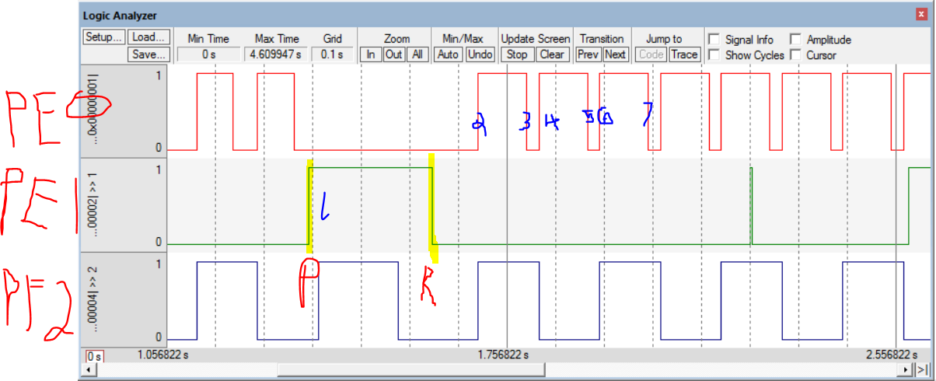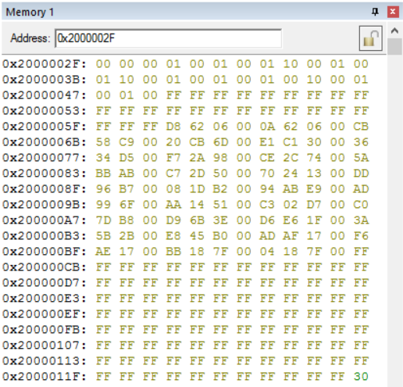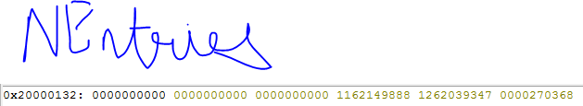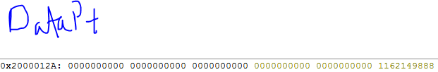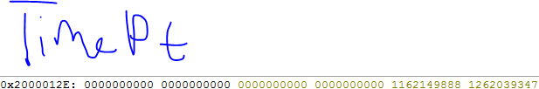

;****************** main.s ***************

; Program written by: Jerry Yang/Aditya Tyagi

; Date Created: 2/19/2017

; Last Modified: 2/14/2017

; Brief description of the program

; The LED toggles at 8 Hz and a varying duty-cycle

; Repeat the functionality from Lab2-3 but now we want you to

; insert debugging instruments which gather data (state and timing)

; to verify that the system is functioning as expected.

; Hardware connections (External: One button and one LED)

; PE1 is Button input (1 means pressed, 0 means not pressed)

; PE0 is LED output (1 activates external LED on protoboard)

; PF2 is Blue LED on Launchpad used as a heartbeat

; Instrumentation data to be gathered is as follows:

; After Button(PE1) press collect one state and time entry.

; After Buttin(PE1) release, collect 7 state and

; time entries on each change in state of the LED(PE0):

; An entry is one 8-bit entry in the Data Buffer and one

; 32-bit entry in the Time Buffer

; The Data Buffer entry (byte) content has:

; Lower nibble is state of LED (PE0)

; Higher nibble is state of Button (PE1)

; The Time Buffer entry (32-bit) has:

; 24-bit value of the SysTick's Current register (NVIC_ST_CURRENT_R)

; Note: The size of both buffers is 50 entries. Once you fill these

; entries you should stop collecting data

; The heartbeat is an indicator of the running of the program.

; On each iteration of the main loop of your program toggle the

; LED to indicate that your code(system) is live (not stuck or dead).

GPIO_PORTE_DATA_R EQU 0x400243FC

GPIO_PORTE_DIR_R EQU 0x40024400

GPIO_PORTE_AFSEL_R EQU 0x40024420

GPIO_PORTE_DEN_R EQU 0x4002451C

GPIO_PORTF_DATA_R EQU 0x400253FC

GPIO_PORTF_DIR_R EQU 0x40025400

GPIO_PORTF_AFSEL_R EQU 0x40025420

GPIO_PORTF_PUR_R EQU 0x40025510

GPIO_PORTF_DEN_R EQU 0x4002551C

SYSCTL_RCGCGPIO_R EQU 0x400FE608

GPIO_PORTF_LOCK_R EQU 0x40025520

GPIO_PORTF_CR_R EQU 0x40025524

GPIO_LOCK_KEY EQU 0x4C4F434B

; RAM Area

AREA DATA, ALIGN=2

;-UUU-Declare and allocate space for your Buffers

; and any variables (like pointers and counters) here

DataBuffer SPACE 50

TimeBuffer SPACE 200

DataPt SPACE 4

TimePt SPACE 4

NDumps SPACE 1

BlinkingDumps SPACE 1; To check when main loop hits 7 dumps

; ROM Area

IMPORT TExaS_Init

IMPORT SysTick_Init

IMPORT Read_SysTick

;-UUU-Import routine(s) from other assembly files (like SysTick.s) here

AREA |.text|, CODE, READONLY, ALIGN=2

THUMB

EXPORT Start

Start

; TExaS_Init sets bus clock at 80 MHz

BL TExaS_Init ; voltmeter, scope on PD3

CPSIE I ; TExaS voltmeter, scope runs on interrupts

LDR R0, =SYSCTL_RCGCGPIO_R; Clock

LDR R1, [R0]

ORR R1, #0x30

STR R1,[R0]

NOP

NOP

;2 bus cycles

LDR R1,=GPIO_PORTF_DIR_R ;Set PF0,PF4 as inputs and PF1-3 as outputs

LDR R0,[R1]

AND R0,#0x04

ORR R0,#0x04; PF2 high for heartbeat CHECK THIS, ADD ORR

STR R0,[R1]

LDR R1,=GPIO_LOCK_KEY ;Unlock Port F

LDR R0,=GPIO_PORTF_LOCK_R

STR R1,[R0]

LDR R1,=GPIO_PORTF_CR_R ;Allow changes to PF4

LDR R0,[R1]

ORR R0,R0,#0x10

STR R0,[R1]

LDR R1,=GPIO_PORTF_AFSEL_R ;Clear AFSEL bits to 0 to select regular I/O

LDR R0,[R1]

AND R0,R0,#0x00

STR R0,[R1]

LDR R1,=GPIO_PORTF_PUR_R ;Enable internal pull-up on PF4

LDR R0,[R1]

ORR R0,R0,#0x10

STR R0,[R1]

LDR R1,=GPIO_PORTF_DEN_R ;Enable data on PF4 bits

LDR R0,[R1]

ORR R0,R0,#0x14; PF2 for heartbeat

STR R0,[R1]

; set directon

LDR R0, =GPIO_PORTE_DIR_R

LDR R1, [R0]

ORR R1, #0x01 ;PE0 is the ourput, the rest are o and input?

STR R1, [R0]

;As of right now

; AFSEL

LDR R0,=GPIO_PORTE_AFSEL_R

AND R1, #0

STR R1, [R0] ;check this one //this seems right.

;set DEN

LDR R0, =GPIO_PORTE_DEN_R

LDR R1, [R0]

ORR R1, #0x1F

STR R1, [R0]

;DEFINE/INITIALIZE DEBUG VARS

Debug_Init

LDR R1,=NDumps

MOV R0,#0

STRB R0,[R1]

LDR R1,=BlinkingDumps

MOV R0,#9

STRB R0,[R1]

LDR R1,=DataPt; Initialize data pointer

MOV R0, #0x2 ; error: cannot MOV #0x20000030

LSL R0, #28

ADD R0, #0x30

STR R0,[R1]

LDR R1,=TimePt; Initialize time pointer

MOV R0, #0x2 ; error: cannot MOV #0x20000030 --> meant #0x20000062

LSL R0, #28

ADD R0, #0x62

STR R0,[R1]

MOV R12,#0xFFFFFFFF; Initialize buffer entries

LDR R1,=DataPt

LDR R1,[R1]

MOV R0,#124; Loop decrementor for do-while loop

L1 STR R12,[R1]

ADD R1,#2

SUBS R0,#1

BNE L1

BL SysTick_Init

;DEFINE BLINK VARS

MOV R4,#0; track state of button, 0-unpressed, not 0-pressed

MOV R5,#140; length of each cycle

MOV R6,#28; length of duty cycle

MOV R7,#28; incrementor

MOV R8,#1; track cycle, 1 if increasing, -1 if decreasing

BL Read_SysTick

;DEFINE BREATHE VARS

MOV R9,#1064; length of each cycle

MOV R10,#28; duty cycle

MOV R11,#7; incrementor

MOV R12,#1; track cycle, 1 if increasing, -1 if decreasing

;MAIN LOOOOOOOP

loop

LDR R1,=GPIO_PORTE_DATA_R; load PE, PF

LDR R0,[R1]

LDR R3,=GPIO_PORTF_DATA_R

LDR R2,[R3]

EOR R2, #0x4 ;Won't see toggling if breathe on, too fast.

STR R2,[R3]

AND R2,#0x10; checks if PF4 button is pressed

CMP R2,#0

BEQ BREATHELED_ON

; checks if PE1 button is pressed

AND R0,#0x02

CMP R0,#0

BNE SWPRESSED; Turns LED off while pressed, updates duty cycle

B BLINKLED_ON

B loop

;BLINK SUBROUTINE

BLINKLED_ON

PUSH {R10-R12,LR}

BL CHECKBLINKINGDUMPS

POP {R10-R12,LR}

PUSH{R4,LR}

ORR R0,R0,#0x1; Calculate PE0 & store

STR R0,[R1]

MOV R4,R6

PUSH {R0,R1}

MOV R0,#87 ; To exhibit change in brightness instead of blinking, use 10.

MUL R4,R0 ; Oscilloscope got between 124 (w/61), 125 (w/62)

POP {R0,R1} ; Logic Analyzer got ~>125 (w/87)

BL TIMERLOOP;

BLINKLED_OFF

PUSH {R10-R12,LR}

BL CHECKBLINKINGDUMPS

POP {R10-R12,LR}

EOR R0,#1

STR R0,[R1]

SUB R4,R5,R6

PUSH {R0,R1}

MOV R0,#87

MUL R4,R0

POP {R0,R1}

BL TIMERLOOP

POP{R4,LR}

MOV R4,#0

B loop

; BREATHE SUBROUTINE

BREATHELED_ON

PUSH {R4,LR}

EOR R0,R2,#0x10; Calculate PE0 & store

LSR R0,#4

STR R0,[R1]

LSL R0,#2; 2 debug instructions (heartbeat)

STR R0,[R3]

MOV R4, R10

BL TIMERLOOP;

BREATHELED_OFF

LSR R0,#2; 3 debug instructions (hearbeat)

EOR R0,#1

STR R0,[R1]

LSL R0,#2

STR R0,[R3]

BL CHECKDUTYCYCLE

BL UPDATEDUTYCYCLE

SUB R4,R9,R10

BL TIMERLOOP;

POP {R3-R5,LR}

POP {R4,LR}

B loop

; OTHER SUBROUTINES

TIMERLOOP ; delays for (R4)0.01 ms, input: R4, no outputs

CMP R4,#0

BEQ next

SUB R4,#1

PUSH {LR,R4,R5,R6}

BL TIMER

POP {LR,R4,R5,R6}

next CMP R4,#0

BNE TIMERLOOP

BX LR

TIMER; yields 0.01 ms delay

MOV R5, #16

DLoop

MOV R4, #10

DLoop1

SUBS R4, #1

BPL DLoop1

SUBS R5, #1

BPL DLoop

BX LR ;return

SWPRESSED ;Turns off LED indefinitely

AND R0,#0

STR R0,[R1]

CMP R4,#1;Checks if button is already pressed, Y-go to main, N-update duty cycle

BEQ loop

;PUSH {R0-R4,LR}; Debug dump

BL Debug_Capture

PUSH {R11,R12}; Reset BlinkingDumps to 0

LDR R12,=BlinkingDumps

MOV R11,#0

STR R11,[R12]

POP {R11,R12}

;POP {R0-R4,LR}; End debug dump

PUSH {LR,R0,R9-R12}; Store R9-R12 on stack, move R5-R8 into R9-R12

MOV R9,R5

MOV R10,R6

MOV R11,R7

MOV R12,R8

BL CHECKDUTYCYCLE

BL UPDATEDUTYCYCLE

POP {R3-R5,LR}

MOV R5,R9

MOV R6,R10

MOV R7,R11

MOV R8,R12

POP {LR,R0,R9-R12} ; Revert original R9-R12

CMP R8,#-1; Resets switch to 0

BNE pass

MOV R8,#1

MOV R6,#0

pass MOV R4,#1; Sets button state to 'pressed'

B loop

CHECKDUTYCYCLE ;Checks if duty cycle exceeds min/max values

CMP R10,R9 ;Check if duty cycle = cycle length

BNE notMax

MOV R12,#-1

notMax CMP R10,R11 ;Check if duty cycle = incrementor

BNE notMin

MOV R12, #1

notMin BX LR

UPDATEDUTYCYCLE; Updates duty cycle

PUSH {R3-R5,LR}

MUL R5,R12,R11

ADD R10,R5

BX LR

Debug_Capture ;ADD CALCULATIONS HERE IN COMMENTS: 100*(NUM INSTRUCTIONS*2)/TIME FOR ONE 8Hz CYCLE

PUSH {R0-R4,LR}

LDR R3,=NDumps;Check if buffers full

LDRB R2,[R3]

CMP R2,#50;

POP {R0-R4,LR}

BEQ back

;Dump port E

PUSH {R0-R4,LR}

LDRB R0,[R1]; Read port E

AND R2,R0,#0x3; Mask for PE1-0

LSL R3,R2,#3; Shift PE1 to bit 4

ADD R2,R3

AND R2,#0x11; Mask for bits to store

LDR R4,=DataPt; Calculate target address

LDR R4,[R4]

LDR R0,=NDumps

LDRB R0,[R0]

ADD R0,R4

STRB R2,[R0] ; Dump

;Dump SysTick

PUSH {R0,LR}

BL Read_SysTick; Output in R0

LDR R4,=TimePt; Calculate target address

LDR R4,[R4]

LDR R3,=NDumps

LDRB R3,[R3]

LSL R3,#2

ADD R3,R4

STR R0,[R3]; Dump

POP {R0,LR}

LDR R0,=NDumps

LDRB R1,[R0]

ADD R1,#1

STRB R1,[R0]

POP {R0-R4,LR}

back BX LR

CHECKBLINKINGDUMPS; Checks if necessary to dump

LDR R12,=BlinkingDumps; Check if enough data dumped

LDRB R11,[R12]

CMP R11,#7

BCS skip

PUSH {R0,LR}

BL Debug_Capture

ADD R11,#1

STR R11,[R12]

POP {R0,LR}

skip STR R11,[R12]

BX LR

ALIGN ; make sure the end of this section is aligned

END ; end of file

Part 4: 100*(Number of instructions*2*12.5ns)/125ms

= .0009

