A PROJECT REPORT ON
“PRESENTO – AI-POWERED SMART ATTENDANCE & ANALYTICS SYSTEM”
submitted in partial fulfillment of the requirements for the award of the degree of
BACHELOR OF TECHNOLOGY
IN
ELECTRONICS AND TELECOMMUNICATION ENGINEERING

Submitted By
Name | PRN
Aditya Saurabh Patil | 23UAM090
Paryusha Shreyans Nandre | 23UAM084
Piyush Vipul Patil | 23UAM092
Prajwal Sachin Patil | 23UAM094
Siddhant Ramesh Redekar | 23UAM118
Under the Guidance of
PROF. ONKAR KHAVARE

Department of Electronics and Telecommunication Engineering
DKTE SOCIETY'S
TEXTILE AND ENGINEERING INSTITUTE, ICHALKARANJI
An Empowered Autonomous Institute, Affiliated to Shivaji University, Kolhapur
Academic Year 2026-27

CERTIFICATE
This is to certify that the project entitled
“PRESENTO – AI-POWERED SMART ATTENDANCE & ANALYTICS SYSTEM”
submitted by
Student Name | PRN
Aditya Saurabh Patil | 23UAM090
Paryusha Shreyans Nandre | 23UAM084
Piyush Vipul Patil | 23UAM092
Prajwal Sachin Patil | 23UAM094
Siddhant Ramesh Redekar | 23UAM118

is an authentic record of the work carried out by the above students under our supervision and guidance, in partial fulfillment of the requirements for the degree of Bachelor of Technology in Electronics and Telecommunication Engineering at DKTE Society's Textile and Engineering Institute, Ichalkaranji (An Autonomous Institute Affiliated to Shivaji University, Kolhapur) during the academic year 2026-27. The students have satisfactorily completed the project work. To the best of our knowledge and belief, the matter embodied in this report has not been submitted to any other University or Institute for the award of any degree or diploma.
Place: Ichalkaranji
Date: ____________________
Prof. Onkar Khavare  Guide | Prof. (Dr.) J. P. Kharat  Head of Department | Prof. (Dr.) L. S. Admuthe  Director

DECLARATION
We declare that this written submission represents our ideas in our own words, and where others' ideas or words have been included, we have adequately cited and referenced the original sources. We also declare that we have adhered to all principles of academic honesty and integrity and have not misrepresented, fabricated, or falsified any idea, data, fact, or source in this submission. We understand that any violation of the above will be cause for disciplinary action by the Institute and can also evoke appropriate action from the sources whose work has not been properly cited or for which permission has not been obtained when required.

Name of the Student | Signature
Aditya Saurabh Patil
Paryusha Shreyans Nandre
Piyush Vipul Patil
Prajwal Sachin Patil
Siddhant Ramesh Redekar

Place: Ichalkaranji
Date: ____________________

ACKNOWLEDGEMENT
We would like to express our sincere gratitude to all those who supported us during the development and validation of the Presento project. The completion of this project involved study, implementation, integration, testing, and repeated validation of the hardware and software components.
We express our heartfelt gratitude to our project guide, Prof. Onkar Khavare, for his guidance, encouragement, technical suggestions, and continuous support throughout the project lifecycle.
We are thankful to Prof. (Dr.) J. P. Kharat, Head of the Electronics and Telecommunication Engineering Department, for providing the academic environment and facilities required for completing the project.
We also thank the faculty members and technical staff of the department for their support. Finally, we express our gratitude to our parents, friends, and peers for their encouragement and support during the development of the project.

ABSTRACT
Presento is an AI-powered smart attendance system designed to automate classroom attendance using face recognition and liveness verification. The final validated implementation combines a Logitech C270 USB webcam with a Raspberry Pi 4 Model B edge station. The vision pipeline uses SCRFD 500M for face detection and five facial landmarks, an ArcFace-family MobileFaceNet model for 512-dimensional L2-normalized facial embeddings, and similarity-based multi-reference identity matching. To reduce spoof-based attendance, the system uses a MobileNetV3-based anti-spoof model together with MiniFASNet V2 SE. Their outputs are processed using temporal liveness logic, and attendance is allowed only when the liveness state reaches REAL_LOCKED. Validated attendance events are sent to a FastAPI backend, which acts as the authoritative attendance layer. The backend validates the attendance session, class enrollment, liveness state, and duplicate conditions before storing records in SQLite through SQLAlchemy. The web interface is implemented using React 19, TypeScript, and Vite, with pages for login, dashboard, classes, students, attendance sessions, attendance history, and reports. The camera operates on demand rather than continuously. Offline attendance events can be queued and synchronized when the backend becomes available. Physical validation was conducted using the actual Raspberry Pi and Logitech C270 setup. The recorded results included approximately 29.5 FPS display performance, 8.4 ms ArcFace latency per face, approximately 32 ms combined anti-spoof latency, recognition similarity of 0.942 for the validated student case, and liveness confidence of 0.985 with REAL_LOCKED status. Automated testing reported 112/112 backend and integration tests passed, 15/15 frontend tests passed, and 9/9 physical integration scenarios passed. Notifications and machine-learning-based at-risk attendance prediction are not part of the final validated implementation and are therefore treated as future scope.
Keywords: Smart Attendance, Face Recognition, SCRFD, ArcFace, MobileFaceNet, Anti-Spoofing, MiniFASNet V2 SE, Raspberry Pi, FastAPI, SQLite, React.

TABLE OF CONTENTS
Right-click and update this Table of Contents in Word.
Note: Open the document in Microsoft Word and update the Table of Contents to refresh page numbers.

LIST OF FIGURES
Figure 3.1 Final Presento system architecture
Figure 5.1 AI attendance verification flow
Figure 6.1 Raspberry Pi 4 Model B with Logitech C270 – actual setup (placeholder)
Figure 6.2 On-demand camera lifecycle
Figure 7.1 Software architecture
Figure 7.2 Backend attendance validation flow
Figure 8.1 Physical validation setup (placeholder)
Figure 8.2 Attendance session screen (placeholder)

LIST OF TABLES
Table 2.1 Summary of related work
Table 3.1 Hardware requirements
Table 3.2 Software requirements
Table 4.1 Theoretical components used in Presento
Table 6.1 Hardware resources and functionality
Table 7.1 Final technology stack
Table 8.1 Automated testing results
Table 8.2 Physical performance results
Table 8.3 Physical validation scenarios
Table 9.1 Future scope items
Appendix B Project cost estimation

LIST OF ABBREVIATIONS
Abbreviation | Meaning
AI | Artificial Intelligence
API | Application Programming Interface
ASGI | Asynchronous Server Gateway Interface
CPU | Central Processing Unit
DB | Database
FPS | Frames Per Second
GPU | Graphics Processing Unit
HTTP | Hypertext Transfer Protocol
JWT | JSON Web Token
L2 | Euclidean L2 Norm
ML | Machine Learning
NMS | Non-Maximum Suppression
ONNX | Open Neural Network Exchange
ORM | Object-Relational Mapping
REST | Representational State Transfer
RPi | Raspberry Pi
SQL | Structured Query Language
USB | Universal Serial Bus
UI | User Interface
Vite | Frontend Build Tool
Wi-Fi | Wireless Fidelity

Chapter 1

Introduction

1.1 Background
Attendance is a basic academic activity that requires accurate identification of students and reliable recording of their presence in a class session. Conventional attendance methods generally depend on manual roll calls or manual updates by faculty. Such methods can consume classroom time and can be affected by proxy attendance, duplicate entries, or errors in maintaining records.
Presento was developed as a software-centered smart attendance system that combines computer vision, facial recognition, liveness verification, an edge device, a backend validation layer, and a web interface. The final implementation is designed around a Raspberry Pi 4 Model B connected to a Logitech C270 USB webcam. The camera is activated only during an attendance session.
The final AI pipeline uses SCRFD 500M for face detection and five facial landmarks, ArcFace-family MobileFaceNet for facial feature extraction, and a 512-dimensional L2-normalized embedding for identity matching. A dual anti-spoofing stage using MobileNetV3 and MiniFASNet V2 SE provides liveness verification. Attendance is generated only after the temporal liveness state reaches REAL_LOCKED.

1.2 Motivation
The motivation for Presento is to provide a practical attendance workflow in which identification is automated while attendance records remain controlled by a backend validation layer. The system also aims to reduce dependence on continuous camera operation by using an on-demand camera lifecycle.
- Reduce the manual effort involved in recording classroom attendance.
- Reduce the possibility of proxy attendance through face recognition and liveness verification.
- Use an edge computing device for camera-side AI processing.
- Maintain attendance records in a lightweight local database.
- Provide faculty-oriented web pages for classes, students, sessions, history, and reports.
- Support attendance event buffering and synchronization when the backend is temporarily unavailable.

1.3 Problem Statement
A practical attendance system must solve more than face identification alone. It must determine whether a visible face belongs to an enrolled student, verify that the presented face is live rather than a simple spoof, associate the event with a valid attendance session and class, prevent duplicate attendance, and reliably store the result. A system that performs only face recognition can therefore be insufficient for a controlled attendance workflow.
The problem addressed by Presento is the design and implementation of an integrated attendance system that combines face detection, face recognition, liveness verification, backend validation, database storage, and a web-based management interface while operating with a Raspberry Pi edge station.

1.4 Objectives
- Develop a face-based attendance verification pipeline using SCRFD 500M and an ArcFace-family MobileFaceNet model.
- Generate and use 512-dimensional L2-normalized facial embeddings for identity matching.
- Implement liveness verification using MobileNetV3 and MiniFASNet V2 SE with temporal decision logic.
- Use REAL_LOCKED as the final liveness gate before attendance generation.
- Integrate the AI pipeline with a FastAPI backend and SQLite database.
- Provide web-based pages for login, dashboard, class management, student management, attendance sessions, attendance history, and reports.
- Prevent duplicate attendance and reject invalid session, class, enrollment, or liveness conditions.
- Validate the integrated system using automated tests and physical Raspberry Pi testing.

1.5 Scope of the Project
The scope of the final validated project includes the AI attendance pipeline, Raspberry Pi edge station, FastAPI backend, SQLite database, React frontend, authentication, attendance-session management, attendance records, duplicate prevention, offline event synchronization, and physical validation.
The scope does not include SMS, WhatsApp, email, or in-app notification delivery. Machine-learning-based prediction of students at risk of low attendance is also not implemented in the final system. These items are treated as future scope rather than current functionality.

Chapter 2

Literature Survey

2.1 Related Work
Face recognition has been studied extensively for identity verification and automated attendance. Earlier attendance systems have used conventional face descriptors, deep face embeddings, or Raspberry Pi-based computer vision. Research on facial embeddings established the use of compact numerical representations for comparing face identities, while later approaches improved recognition through margin-based learning and lightweight network architectures.
Automated attendance studies demonstrate that face recognition can reduce manual attendance effort. Raspberry Pi-based systems are especially relevant because they show that low-cost edge hardware can be used as a practical deployment platform. Research on face anti-spoofing further shows that recognition alone is not sufficient when a printed image, phone display, or replayed media may be presented to the camera.
Reference / Work | Main Focus | Relevance to Presento
FaceNet (Schroff et al., CVPR 2015) | Deep face embeddings for recognition and clustering. | Supports the embedding-based identity representation used conceptually in Presento.
Automatic Class Attendance System Using Biometric Facial Recognition Technique Based on Raspberry Pi (2023) | Raspberry Pi-based facial recognition attendance. | Supports the use of edge hardware for attendance automation.
Face Recognition Based Smart Attendance System (IEEE ICIEM 2020) | Face recognition for attendance. | Demonstrates automated attendance through facial identification.
Smart attendance using deep learning and computer vision (2021) | Deep learning and computer vision for attendance. | Relevant to AI-based attendance automation.
Face Recognition for Identification and Verification in Attendance System: A Systematic Review (IEEE COMNETSAT 2021) | Review of face recognition attendance approaches. | Provides broader understanding of recognition-based attendance systems.
Smart Attendance System using Deep Learning (IEEE ICOEI 2023) | Deep-learning-based attendance. | Relevant to deep learning in academic attendance.
Smart Attendance System Using Face Recognition (IEEE ICCSC 2024) | Face-recognition attendance. | Relevant to recent attendance system design.
IoT-based Smart Attendance System using Face Recognition and Motion Detection (IEEE APSIPA ASC 2024/2025) | Face recognition with IoT and motion detection. | Relevant to combining vision with connected edge systems.

2.2 Research Gap
The reviewed systems show the feasibility of automated face-recognition attendance, but a practical deployment also requires reliable anti-spoofing, backend-side validation, duplicate protection, and integration between edge processing and academic attendance records. Presento addresses this integration by separating AI recognition from authoritative attendance storage.
- Recognition is combined with a dedicated liveness gate rather than relying only on identity similarity.
- The backend validates attendance events before writing them to the database.
- Attendance sessions, class enrollment, and duplicate conditions are checked before final storage.
- The camera is operated on demand rather than continuously.
- Offline events can be buffered and synchronized after backend recovery.
- The final implementation uses a lightweight SQLite database suitable for an academic prototype.

Chapter 3

SYSTEM ANALYSIS AND DESIGN

3.1 Existing System
The conventional attendance workflow depends on faculty members calling names, visually verifying students, or maintaining attendance records manually. Digital systems may improve record storage but can still require manual identity confirmation. Face-recognition attendance systems automate identification, but the final quality of an attendance workflow depends on recognition accuracy, liveness protection, session validation, duplicate prevention, and reliable storage.

3.2 Proposed System
Presento proposes an integrated edge-AI attendance workflow. The Logitech C270 provides the camera input to the Raspberry Pi 4 Model B. SCRFD detects faces and five facial landmarks. The detected face is aligned and processed by the ArcFace-family MobileFaceNet model to obtain a 512-dimensional L2-normalized embedding. The embedding is compared against multiple reference embeddings for enrolled students.
The recognized identity then passes through the anti-spoofing stage using MobileNetV3 and MiniFASNet V2 SE. Temporal liveness logic is used and attendance is gated by REAL_LOCKED. The resulting attendance event is sent to the FastAPI backend. The backend validates the session, enrollment, liveness state, and duplicate conditions before storing the attendance record in SQLite.

3.3 System Architecture
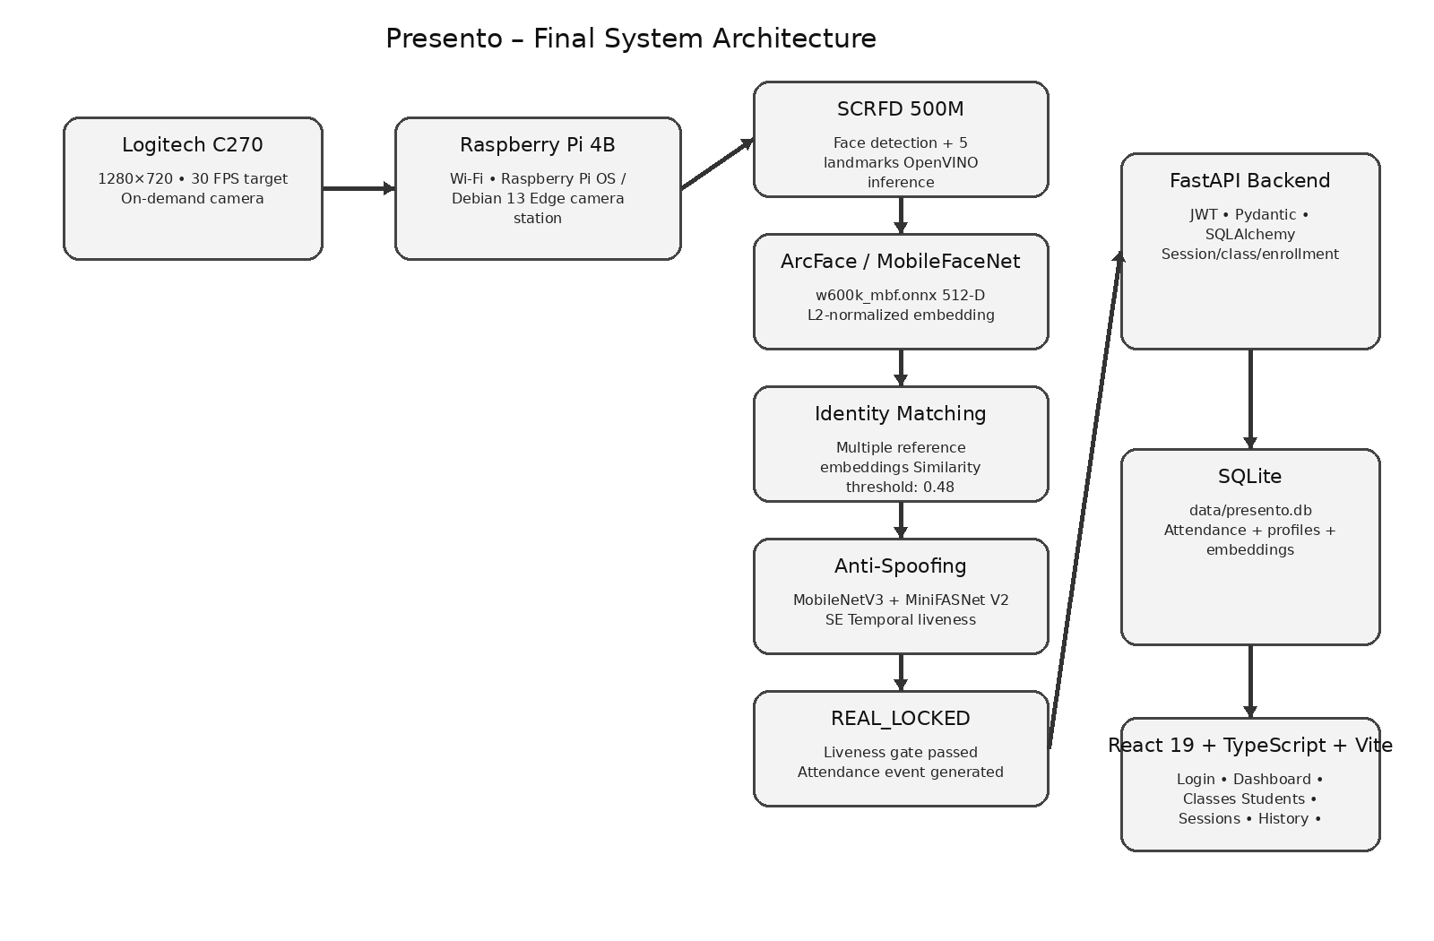
Figure 3.1: Final Presento system architecture
The architecture intentionally separates the AI decision process from the database write operation. The AI layer produces an attendance event, while the FastAPI backend acts as the authoritative attendance layer.

3.4 Hardware Requirements
Component | Specification | Purpose
Raspberry Pi | Raspberry Pi 4 Model B | Edge processing and camera station
Webcam | Logitech C270 HD USB Webcam | Live image/video capture
Storage | 64 GB microSD card; approximately 58 GB usable in the verified setup | Operating system and project data
Network | Wi-Fi | Local network communication and camera stream transfer
Power | Raspberry Pi power supply | Powering the edge station

3.5 Software Requirements
Software / Tool | Purpose
Python | AI pipeline and backend development
OpenVINO | Neural-network inference runtime
SCRFD 500M ONNX model | Face detection and five facial landmarks
ArcFace-family MobileFaceNet | Face feature extraction
MobileNetV3 anti-spoof model | Anti-spoofing
MiniFASNet V2 SE | Anti-spoofing
FastAPI | Backend REST API
SQLAlchemy 2.x | ORM layer
SQLite | Primary database
JWT | Authentication
React 19 | Frontend UI
TypeScript | Frontend implementation
Vite | Frontend build/development tool

3.6 Working Principle
- An authorized attendance session is started.
- The on-demand camera is activated.
- Live frames are obtained from the Logitech C270.
- SCRFD detects faces and five facial landmarks.
- The detected face is aligned for recognition.
- ArcFace-family MobileFaceNet generates a 512-D L2-normalized embedding.
- The embedding is matched against enrolled reference embeddings.
- MobileNetV3 and MiniFASNet V2 SE evaluate liveness.
- Temporal liveness logic waits for the REAL_LOCKED state.
- An attendance event is generated only after the liveness gate passes.
- FastAPI validates the session, class enrollment, and duplicate conditions.
- The attendance record is stored in SQLite or buffered for later synchronization if the backend is unavailable.
- After the session is completed, the camera is switched off.

Chapter 4

Theoretical Background

4.1 Face Detection
Face detection is the first vision stage in Presento. The final implementation uses SCRFD 500M, an ONNX face detector executed through OpenVINO. The model provides a face bounding box and five facial landmarks. These outputs identify the face region and provide geometric points required for alignment.

4.2 Face Alignment
Face alignment reduces variation caused by head position and orientation before feature extraction. The five facial landmarks supplied by SCRFD are used to obtain a normalized facial crop suitable for the recognition model.

4.3 Face Recognition and Facial Embeddings
Face recognition in Presento uses an ArcFace-family MobileFaceNet model identified as w600k_mbf.onnx. The model converts an aligned face into a numerical representation. Presento uses a 512-dimensional L2-normalized embedding. Multiple reference embeddings can be associated with an enrolled student.

4.4 Similarity-Based Identity Matching
Identity matching compares the embedding obtained from the current frame with stored reference embeddings. The final system uses a similarity threshold of 0.48 in the validated configuration. A higher similarity indicates that the compared representations are more closely related under the matching metric used by the implementation.

4.5 Liveness and Anti-Spoofing
Liveness verification determines whether the face presented to the camera is likely to be a live subject rather than a spoof. The final Presento pipeline uses two complementary anti-spoofing models: a MobileNetV3-based model and MiniFASNet V2 SE. Their outputs are processed through temporal liveness logic.

4.6 REAL_LOCKED Liveness Gate
Presento does not create attendance solely from an identity match. The liveness state must reach REAL_LOCKED before an attendance event can be generated. This creates an explicit gate between recognition and attendance recording.

4.7 Edge Computing with Raspberry Pi
The Raspberry Pi 4 Model B is used as the edge camera station. Edge processing reduces the need to move the complete camera workflow to a separate cloud service. The validated setup uses Wi-Fi and a network camera stream. The camera is activated only for an attendance session.

4.8 FastAPI and REST APIs
FastAPI provides the backend application interface. REST APIs are used for communication between the frontend, backend, and attendance event workflow. Pydantic schemas support request and response validation, while JWT authentication is used for authenticated access.

4.9 SQLite and SQLAlchemy
SQLite is the primary database in the final implementation. It stores users, teachers, students, classes, class enrollments, attendance sessions, attendance records, face profiles, and face embeddings. SQLAlchemy 2.x is used as the ORM layer. SQLite was selected because it is lightweight, reliable, and easy to deploy for an academic prototype.

4.10 React, TypeScript and Vite
The frontend uses React 19 with TypeScript and Vite. It communicates with FastAPI through REST APIs and provides pages for login, dashboard, classes, class details, students, attendance sessions, attendance history, and reports.

4.11 Offline Event Synchronization
The system supports asynchronous attendance event handling. When the backend is temporarily unavailable, attendance events can be buffered and synchronized after backend recovery. This allows the edge workflow to tolerate temporary network or backend interruptions.

Chapter 5

Implementation

5.1 Development Environment
The final physical validation environment used a Raspberry Pi 4 Model B running Raspberry Pi OS / Debian GNU/Linux 13 with kernel 6.18.50+rpt-rpi-v8. The device was connected through Wi-Fi and was accessed on the local network using the hostname presento-pi.local. The Logitech C270 webcam was the validated camera.

5.2 AI Vision Pipeline Implementation
The implementation follows the sequence: camera input → SCRFD detection → face alignment → ArcFace/MobileFaceNet embedding → identity matching → MobileNetV3 + MiniFASNet V2 SE liveness verification → temporal REAL_LOCKED state → attendance event.
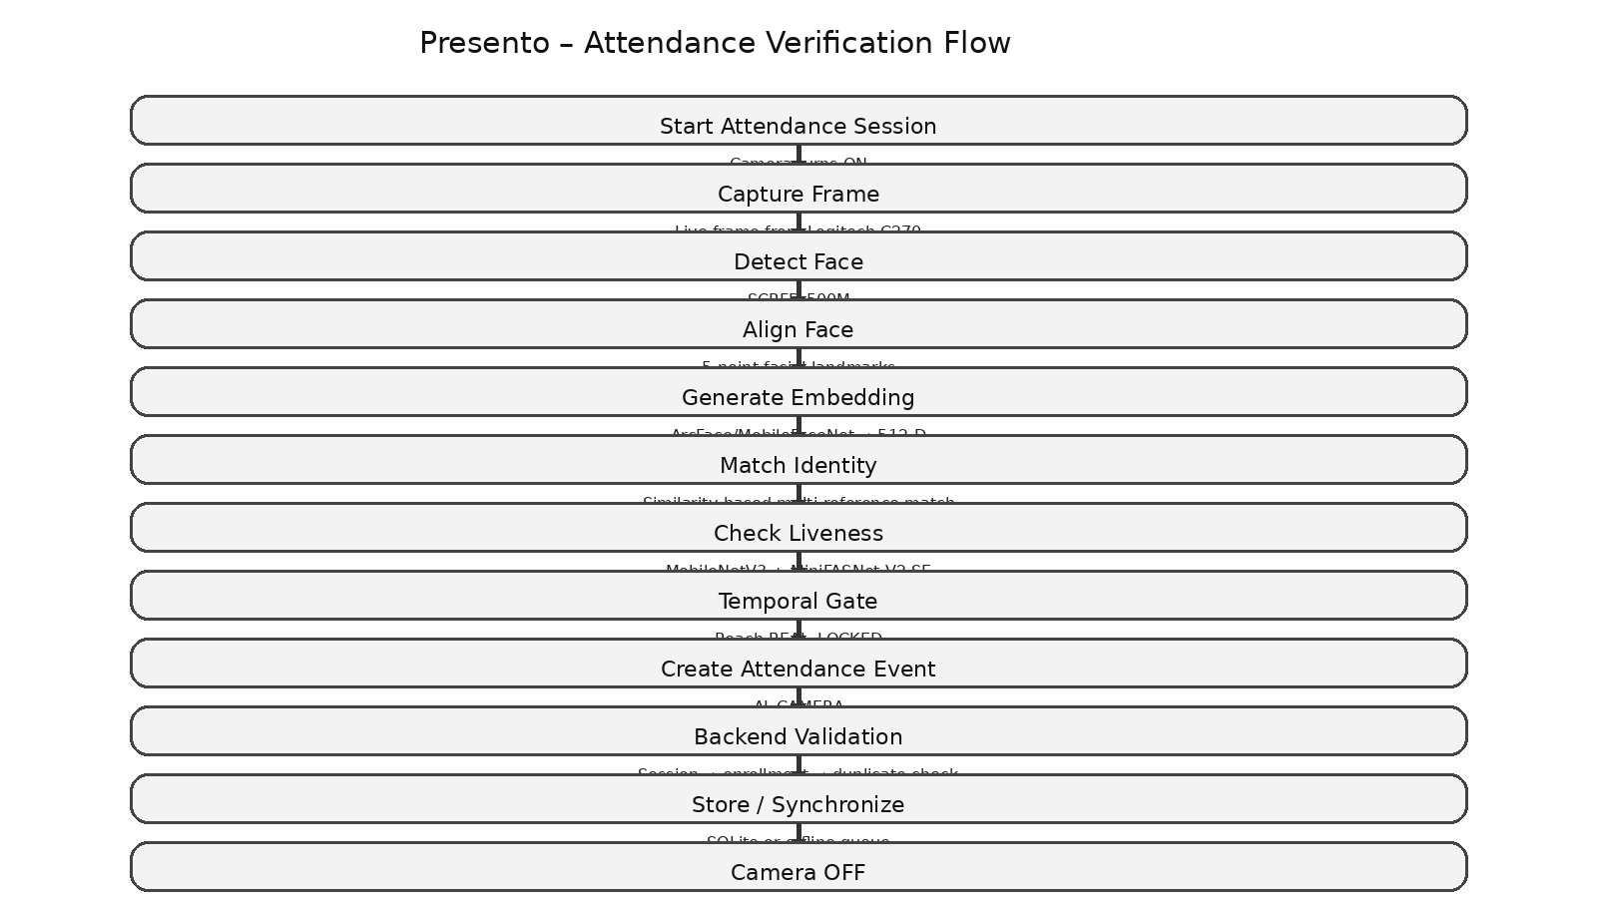
Figure 5.1: AI attendance verification flow

5.3 Face Enrollment
The final database supports face profiles and multiple reference embeddings for enrolled students. The stored embeddings provide reference representations for later similarity-based identity matching. The exact enrollment user interface and number of reference samples per student are not specified in the confirmed project information; therefore, no additional enrollment procedure is asserted here.

5.4 Recognition and Matching
For each detected face, the aligned crop is processed by the ArcFace-family MobileFaceNet model. The resulting 512-D L2-normalized vector is compared against the stored reference embeddings. The validated configuration uses a similarity threshold of 0.48. The physical validation recorded a similarity of 0.942 for the tested enrolled student case.

5.5 Liveness and Anti-Spoofing
The liveness stage uses MobileNetV3 and MiniFASNet V2 SE. Their outputs are evaluated using temporal logic. The final attendance gate is REAL_LOCKED. The physical validation recorded a liveness confidence of 0.985 and the state REAL_LOCKED for the validated student case.

5.6 Attendance Event Generation
After identity matching and successful liveness verification, the AI layer generates an attendance event. The event is not written directly to SQLite by the AI pipeline. It is passed to the FastAPI backend for validation.

5.7 Backend Validation
The backend is the authoritative attendance layer. The validation sequence includes attendance session validation, class enrollment validation, liveness validation, duplicate checking, and final attendance storage.
Validation Stage | Purpose
Authentication | Ensure the request is associated with an authorized system user.
Attendance Session | Ensure the target attendance session is valid and active.
Class Enrollment | Ensure the identified student belongs to the relevant class.
Liveness | Ensure the event has passed the required liveness gate.
Duplicate Check | Prevent multiple attendance records for the same applicable session/student condition.
Database Storage | Persist the validated attendance record in SQLite.

5.8 Frontend Implementation
The final frontend is intentionally focused on attendance management. The implemented pages are Login, Dashboard, Classes, Class Details, Students, Attendance Session, Attendance History, and Reports. Separate student-dashboard, at-risk prediction, and advanced ML analytics features are not part of the final validated frontend.

5.9 Camera Lifecycle
The camera is not continuously active. The validated lifecycle is: Idle → Camera OFF → attendance session starts → Camera ON → AI processing → attendance completed → Camera OFF. This lifecycle was physically verified during Phase 4 validation.

Chapter 6

Hardware Design and Implementation

6.1 Hardware Resources and Functionality
Hardware | Function in Presento | Confirmed Specification
Raspberry Pi 4 Model B | Edge camera station and processing platform | Model confirmed; RAM capacity not specified
Logitech C270 HD USB Webcam | Live video capture | 1280×720 during physical validation
64 GB microSD card | Operating system and project storage | Approximately 58 GB usable in verified setup
Wi-Fi network | Local communication | Used during physical validation

6.1.1 Raspberry Pi 4 Model B
The Raspberry Pi 4 Model B serves as the edge device in the physical Presento setup. The confirmed project information does not establish the exact RAM capacity of the board used; therefore, this report intentionally does not specify a RAM value.

6.1.2 Logitech C270 HD USB Webcam
The Logitech C270 is the actual webcam used during physical validation. The measured validation configuration used 1280×720 resolution with a target of 30 FPS and an observed display rate of approximately 29.5 FPS.

6.1.3 64 GB microSD Card
A 64 GB microSD card was used for the Raspberry Pi setup. The verified setup reported approximately 58 GB usable capacity.

6.2 On-Demand Camera Lifecycle
[ ACTUAL PHOTOGRAPH OF RASPBERRY PI 4 MODEL B + LOGITECH C270 SETUP ]

Figure 6.1: Raspberry Pi and Logitech C270 physical setup – insert actual project photograph
The camera lifecycle is intentionally event-driven. The camera remains off while the system is idle and is activated when an attendance session begins. After the attendance workflow is completed, the camera is switched off.
[ ON-DEMAND CAMERA LIFECYCLE DIAGRAM / ACTUAL SYSTEM SCREENSHOT ]

Figure 6.2: On-demand camera lifecycle – insert actual implementation screenshot/diagram if required

6.3 Physical Setup
The physical validation used the Raspberry Pi 4 Model B, Logitech C270 webcam, Wi-Fi connectivity, and the validated software environment. The camera stream was transferred from the Raspberry Pi to the AI application over the local network.

Chapter 7

Software and System Implementation

7.1 Software Architecture
Layer | Technology | Main Responsibility
Vision / AI | Python, OpenVINO, SCRFD, ArcFace/MobileFaceNet, MobileNetV3, MiniFASNet V2 SE | Detection, recognition, embeddings and liveness
Edge | Raspberry Pi 4 Model B | Camera station and edge integration
Backend | FastAPI + Python | Attendance validation and REST API
ORM / Database | SQLAlchemy 2.x + SQLite | Persistent data storage
Authentication | JWT | Authenticated backend access
Frontend | React 19 + TypeScript + Vite | Web-based attendance management
Communication | REST API + network camera stream | System integration
Offline Handling | Asynchronous attendance queue | Temporary buffering and recovery synchronization

7.2 Backend Attendance Control Flow
The backend receives an attendance event only after the AI pipeline has completed identity matching and liveness verification. It then performs the application-level checks needed before creating an attendance record.
[ BACKEND/API SCREENSHOT OR FLOWCHART FROM ACTUAL SYSTEM ]

Figure 7.2: Backend attendance validation – insert actual implementation screenshot if available

7.3 Database Design
The SQLite database file is data/presento.db. The confirmed entities include Users, Teachers, Students, Classes, Class Enrollments, Attendance Sessions, Attendance Records, Face Profiles, and Face Embeddings.
Entity | Purpose
Users | Application users and authentication-related information
Teachers | Teacher-related records
Students | Student master records
Classes | Class information
Class Enrollments | Student membership in classes
Attendance Sessions | Individual attendance session information
Attendance Records | Validated attendance outcomes
Face Profiles | Face profile information associated with students
Face Embeddings | Stored facial reference embeddings

7.4 REST API and Backend Functions
The backend provides functionality for authentication, user management, student management, class management, class enrollment, attendance sessions, attendance events, attendance records, AI attendance ingestion, duplicate prevention, liveness validation, student/class validation, closed-session validation, absent generation, attendance history, dashboard summary, recent attendance, and offline event synchronization.

7.5 Authentication and Roles
JWT authentication is implemented. The confirmed final backend roles are Admin and Teacher. A separate authenticated Student role is not claimed in this report because it is not part of the confirmed final implementation.

7.6 Frontend Pages
Page | Purpose
Login | User authentication
Dashboard | Attendance summary and recent information
Classes | Class management
Class Details | Class-specific information
Students | Student management
Attendance Session | Session-based attendance operation
Attendance History | Historical attendance records
Reports | Attendance statistics and reports

7.7 Offline Handling
Attendance events can be handled through an asynchronous queue when the backend is temporarily unavailable. After backend recovery, buffered events are synchronized. This behavior was included as one of the physical validation scenarios.

Chapter 8

Testing Methodology and Results

8.1 Testing Methodology
Testing was performed at multiple levels: backend/integration testing, frontend testing, and physical integration validation using the actual Raspberry Pi 4 Model B and Logitech C270 webcam. The physical validation was designed to cover valid attendance, duplicate attendance, unknown identities, spoof attempts, class/session validation, absent students, and temporary backend unavailability.

8.2 Automated Testing Results
Test Area | Result
Backend / Integration | 112/112 Passed
Frontend | 15/15 Passed
Physical Integration | 9/9 Passed

Table 8.1: Automated and physical validation summary

8.3 Physical Performance Results
Parameter | Measured Result
Camera | Logitech C270
Resolution | 1280 × 720
Target FPS | 30 FPS
Display FPS | 29.5 FPS
ArcFace latency | 8.4 ms/face
Anti-spoof combined latency | Approximately 32 ms
Anti-spoof execution | Background / asynchronous
Recognition similarity in validation | 0.942
Recognition threshold | 0.48
Liveness confidence | 0.985
Liveness state | REAL_LOCKED

Table 8.2: Physical performance results

8.4 Physical Validation Scenarios
Scenario | Result
Real enrolled student | PASS
Duplicate attendance | PASS
Unknown person | PASS
Spoof attempt | PASS
Wrong class | PASS
Closed session | PASS
Absent student | PASS
Backend offline buffering | PASS
Backend recovery synchronization | PASS

Table 8.3: Physical validation scenarios

8.5 Detailed Attendance Validation
For the validated student case associated with PRN 23UAM090, the physical test produced the following values: identity Aditya Patil, recognition similarity 0.942, liveness confidence 0.985, liveness state REAL_LOCKED, attendance PRESENT, and source AI_CAMERA. Exactly one attendance record was created. When the same student generated another event, the backend returned DUPLICATE and no second database record was created.

8.6 Interpretation of Results
All scenarios included in the defined physical validation test set were successfully completed, with no failures observed during the conducted validation. These results demonstrate that the implemented pipeline, backend validation layer, and physical edge setup operated correctly for the tested scenarios.
The results should not be interpreted as a claim of 100% recognition accuracy across all people, environments, or lighting conditions. The measured values represent the conducted validation set and the specific tested configuration.

8.7 Test Evidence Placeholders
[ ACTUAL LOGIN SCREENSHOT ]

Figure 8.1: Login page – insert actual screenshot
[ ACTUAL ATTENDANCE SESSION SCREENSHOT ]

Figure 8.2: Attendance session – insert actual screenshot
[ ACTUAL AI CAMERA / RECOGNITION SCREENSHOT ]

Figure 8.3: Live AI camera and recognition result – insert actual screenshot
[ ACTUAL LIVENESS / PRESENT RESULT SCREENSHOT ]

Figure 8.4: Liveness and PRESENT attendance result – insert actual screenshot

Chapter 9

Conclusion and Future Scope

9.1 Conclusion
Presento successfully integrates computer vision, face recognition, liveness verification, edge hardware, backend validation, database storage, and a web interface into a smart attendance workflow. The final validated AI pipeline uses SCRFD 500M for face detection, ArcFace-family MobileFaceNet for 512-dimensional face embeddings, and MobileNetV3 with MiniFASNet V2 SE for liveness verification. The REAL_LOCKED state acts as the attendance gate.
The Raspberry Pi 4 Model B and Logitech C270 form the physical edge station. The FastAPI backend provides the authoritative validation layer and stores validated attendance information in SQLite through SQLAlchemy. The React 19, TypeScript, and Vite frontend provides the implemented attendance-management pages. Physical testing demonstrated approximately 29.5 FPS display performance and successful completion of all defined validation scenarios.

9.2 Limitations
- The project has been validated using the specific hardware and test scenarios described in this report.
- Recognition performance can vary with changes in lighting, camera position, face pose, distance, and other environmental conditions.
- The exact RAM capacity of the Raspberry Pi used in validation was not confirmed in the provided project information.
- Notifications such as SMS, WhatsApp, email, or in-app notifications are not currently implemented.
- Machine-learning-based at-risk attendance prediction is not currently implemented.
- The report does not claim 100% recognition accuracy.

9.3 Future Scope
Future Enhancement | Description
SMS / WhatsApp / Email Notifications | Notify students or faculty about attendance-related events.
ML-Based At-Risk Prediction | Use historical attendance data to identify students who may be at risk of low attendance.
Advanced Analytics | Add deeper attendance trends and analytical dashboards.
Mobile Application | Provide a mobile interface for supported attendance-management workflows.
ERP / Student Information System Integration | Integrate Presento with institutional academic systems.
Multi-Camera Deployment | Extend the system to multiple classroom camera stations.
Further Liveness Improvements | Explore additional depth or stronger anti-spoofing approaches where appropriate.

References
[1] F. Schroff, D. Kalenichenko, and J. Philbin, “FaceNet: A Unified Embedding for Face Recognition and Clustering,” Proceedings of the IEEE Conference on Computer Vision and Pattern Recognition (CVPR), 2015, pp. 815–823. DOI: 10.1109/CVPR.2015.7298682.
[2] Shabaneh et al., “Automatic Class Attendance System Using Biometric Facial Recognition Technique Based on Raspberry Pi,” Óptica Pura y Aplicada, vol. 56, no. 3, 2023. DOI: 10.7149/OPA.56.3.51152.
[3] “Face Recognition Based Smart Attendance System,” IEEE ICIEM 2020. DOI: 10.1109/ICIEM48762.2020.9160184.
[4] “Smart attendance using deep learning and computer vision,” Materials Today: Proceedings, vol. 46, 2021, pp. 4091–4094. DOI: 10.1016/j.matpr.2021.02.625.
[5] “Face Recognition for Identification and Verification in Attendance System: A Systematic Review,” IEEE COMNETSAT 2021. DOI: 10.1109/COMNETSAT53002.2021.9530817.
[6] “Smart Attendance System using Deep Learning,” IEEE ICOEI 2023. DOI: 10.1109/ICOEI56765.2023.10126022.
[7] “Smart Attendance System Using Face Recognition,” IEEE ICCSC 2024. DOI: 10.1109/ICCSC62048.2024.10830336.
[8] “IoT-based Smart Attendance System using Face Recognition and Motion Detection,” IEEE APSIPA ASC 2024/2025. DOI: 10.1109/APSIPAASC63619.2025.10849070.
[9] “Trajectory-Aware Attendance Risk Prediction in Higher Education,” IEEE, 2026. DOI: 10.1109/ICICI68773.2026.11580718. Included only as related/future-work context; it is not evidence that Presento implements at-risk prediction.
[10] Raspberry Pi 4 Model B documentation and hardware information, as used for the project hardware selection and setup.
[11] FastAPI documentation, used as the backend framework reference.

Appendix A – Final Technology Stack
Category | Actual Presento Implementation
Face Detection | SCRFD 500M
Face Recognition | ArcFace-family MobileFaceNet
Embedding | 512-D L2-normalized
Face Matching | Multi-reference identity matching
Anti-Spoofing | MobileNetV3 + MiniFASNet V2 SE
Liveness | Temporal liveness state machine
Liveness Gate | REAL_LOCKED
Edge Device | Raspberry Pi 4 Model B
Camera | Logitech C270 USB Webcam
Inference Runtime | OpenVINO
Backend | FastAPI + Python
ORM | SQLAlchemy
Database | SQLite
Authentication | JWT
Frontend | React 19 + TypeScript + Vite
Communication | REST API + network camera stream
Offline Handling | Asynchronous attendance queue
Notifications | Not implemented
At-risk ML | Not implemented
Testing | 112 backend + 15 frontend + 9 physical scenarios
Physical FPS | Approximately 29.5 FPS
Camera Operation | On-demand

Appendix B – Project Cost Estimation
The final report should not invent component purchase prices. The confirmed project information recommends using actual hardware cost or, if the hardware was already available to the project team/institution and no additional purchase was required, reporting zero additional development cost.
Component / Cost Item | Cost (INR)
Raspberry Pi 4 Model B | ₹0 / Already available*
64 GB microSD card | ₹0 / Already available*
Logitech C270 webcam | ₹0 / Already available*
Other hardware | ₹0
Software / Open-source libraries | ₹0
Total additional project cost | ₹0

*The ₹0 entries should be retained only if the hardware was already available to the project team/institution and was not purchased specifically for Presento. If actual purchase costs are available, replace the relevant values with those actual costs.

Appendix C – Project Timeline
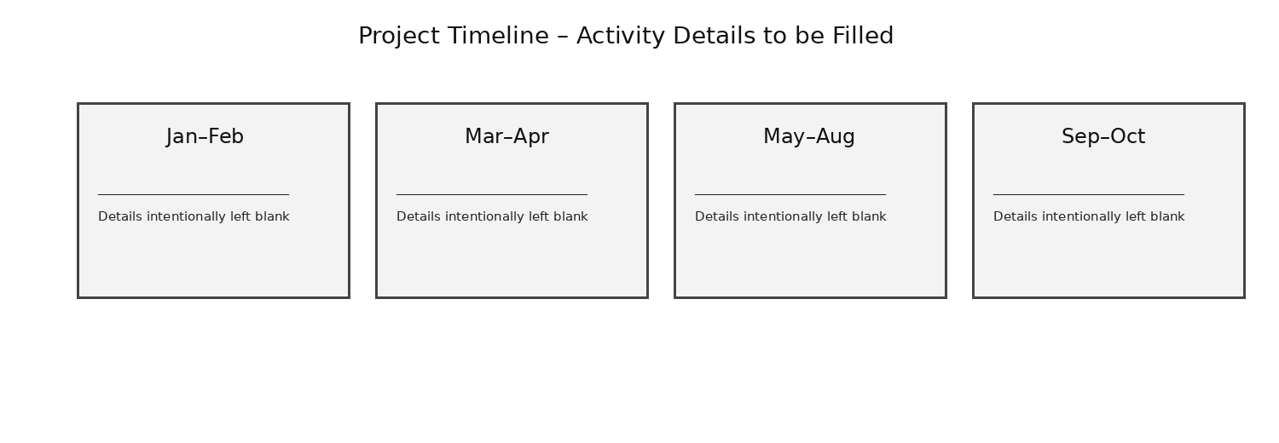
Figure C.1: Project timeline with activity fields intentionally left blank where confirmed details were not provided.
Period | Project Activity
Jan–Feb
Mar–Apr
May–Aug
Sep–Oct

The activity descriptions have been left blank rather than inventing a development history. They can be filled with the team's actual milestones.

Appendix D – Screenshot Checklist
Insert only screenshots captured from the final validated Presento system. The following checklist is based on the confirmed project information.
Screenshot | Status / Insert Here
Login page
Dashboard
Class management
Student management
Attendance session
Raspberry Pi + Logitech C270 setup
Live AI camera feed
Face recognition result
Liveness / anti-spoof result
PRESENT attendance result
Attendance history
Database / backend / API verification

Appendix E – Important Implementation Notes
- Do not describe MediaPipe as part of the final active AI pipeline.
- Do not describe dlib/face_recognition as part of the final active AI pipeline; it was only tested during development.
- Do not describe EAR/eye-blink detection as the final liveness method.
- Do not describe Supabase/PostgreSQL as the final database.
- Do not claim SMS, WhatsApp, email, or in-app notifications are implemented.
- Do not claim an ML-based at-risk student prediction module is implemented.
- Do not claim 100% recognition accuracy.
- Do not specify the Raspberry Pi RAM capacity without physical confirmation.
- Keep the final architecture consistent: SCRFD → ArcFace/MobileFaceNet → 512-D embeddings → identity matching → MobileNetV3 + MiniFASNet V2 SE → temporal REAL_LOCKED → FastAPI → SQLite → React.

