**EXERCISE 6.2:**

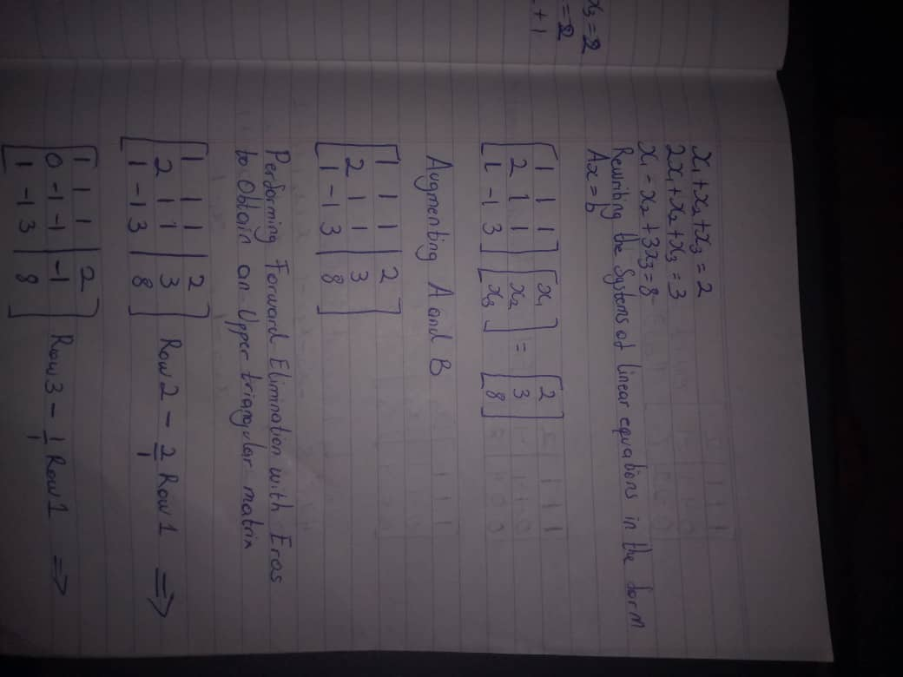**Q1.**

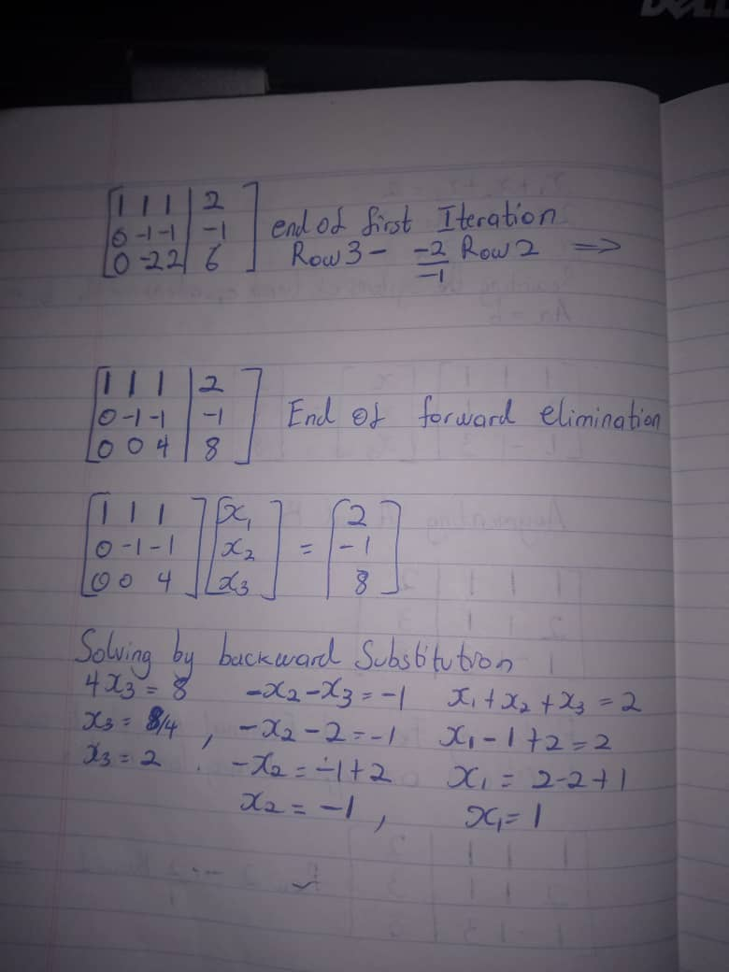

**Q2.a**

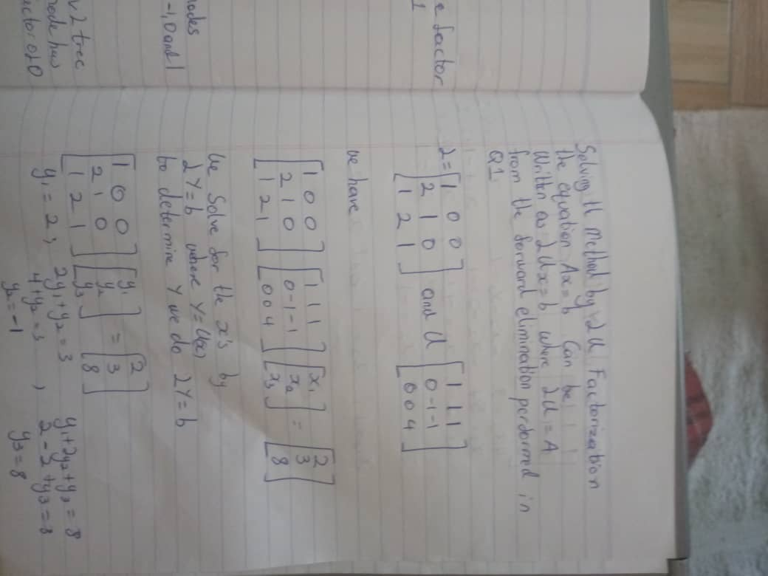

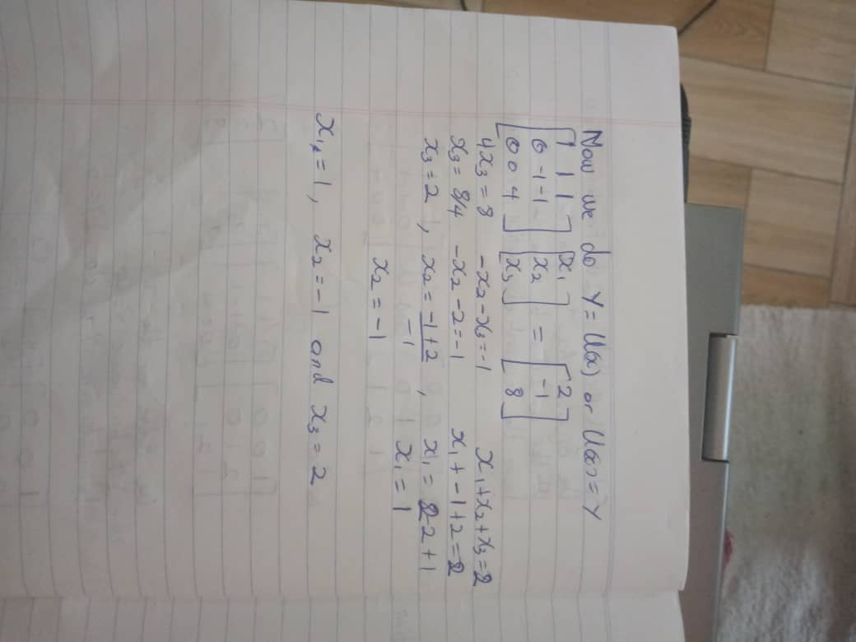

**Q5. Gaussian Backward Substitution Pseudocode**

// Finds the solution of a n unknowns using back substitution on an upper triangular

// matrix and column vector of results

// Input: Matrix A [1…n, 1…n+1] with the first n column in the upper triangular form

//Output: Solution of the n linear system of equations in n unknowns

for i n to 1 do

initial = 0

for j n to i +1 do

initial initial + A [i, j] *x[j]

x[i] (A[i, n+1] – initial) / A[i,i]

return x

$$T\left(n\right)= \sum_{i=1}^{n}{\sum_{j=i+1}^{n}{1}}$$

$$= \sum_{i=1}^{n}{(n-i-1+1)}$$

$$= \sum_{i=1}^{n}{(n-i)}$$

$$=\frac{n^{2}-n}{2}$$

$$∈∅(n^{2})$$

**EXERCISE 6.3:**

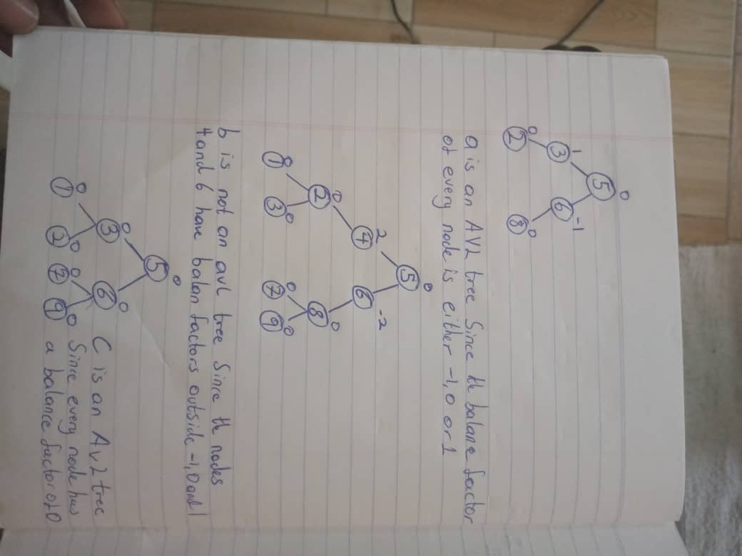**Q1.**

**Q4.**

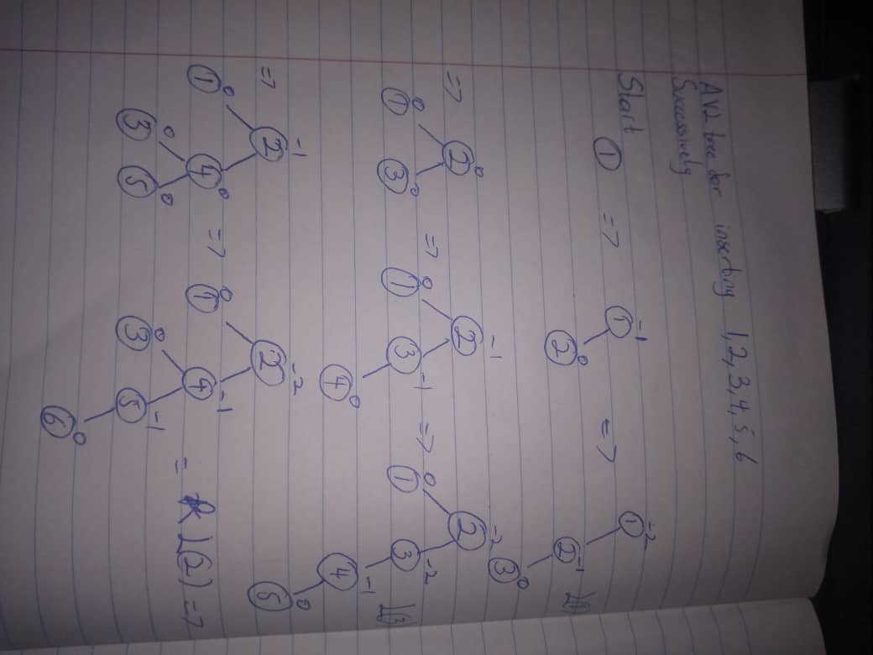

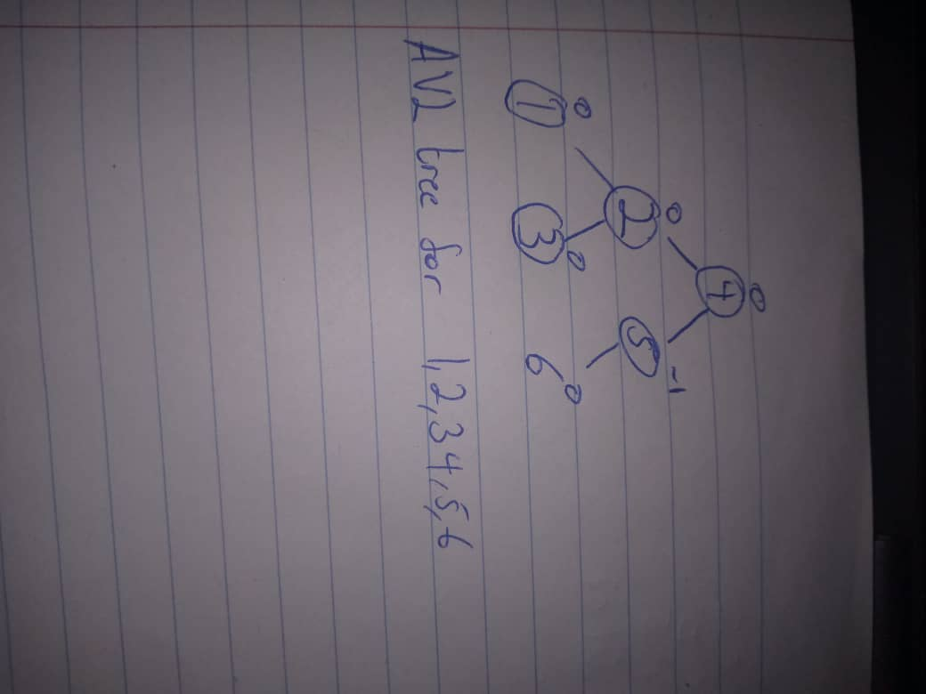

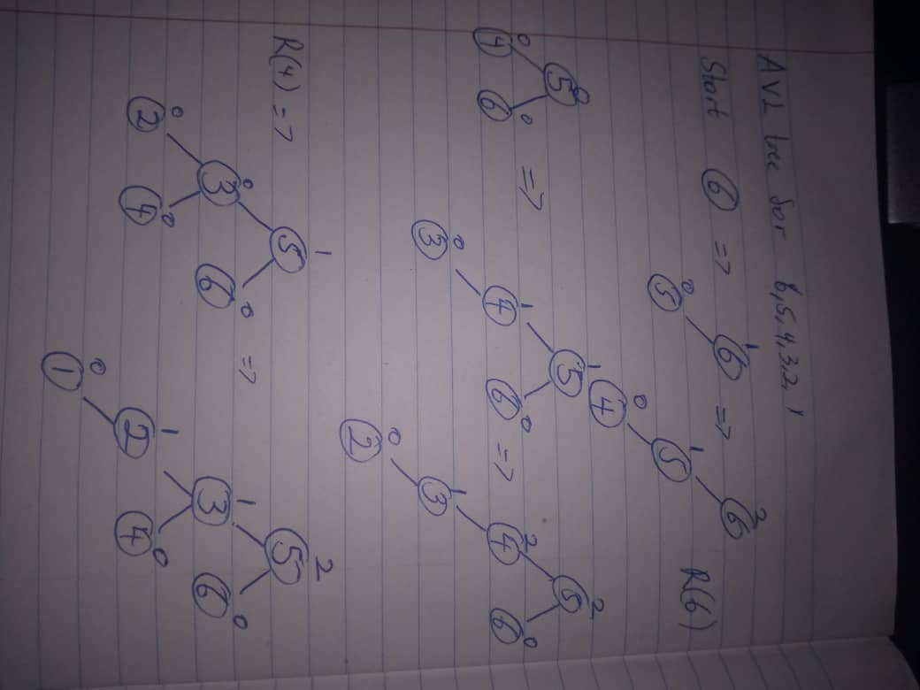

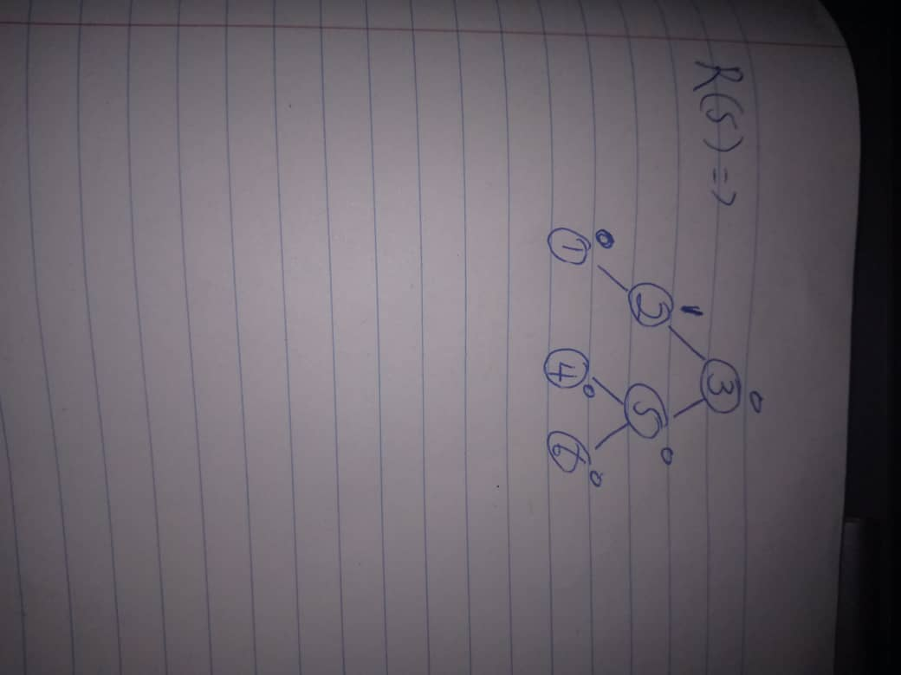

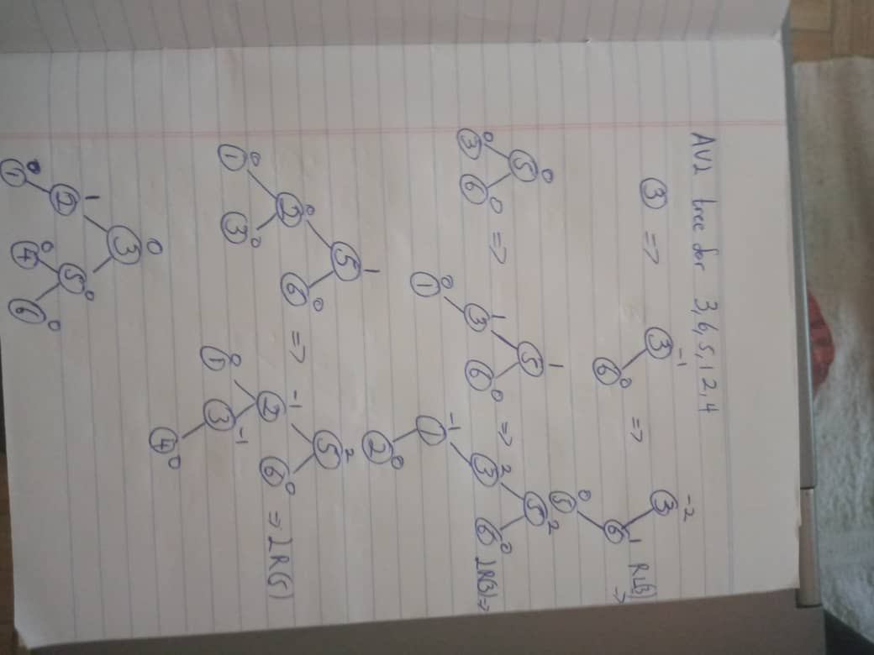

**Q6. Construct a program for creating an avl tree with n distinct elements**

**#include<iostream>**

**#include<cstdio>**

**#include<sstream>**

**#include<algorithm>**

**#define pow2(n) (1 << (n))**

**using namespace std;**

**struct Node {**

**int key;**

**struct Node *left;**

**struct Node *r;**

**}*r;**

**class avlTree {**

**public:**

**int height(Node *);**

**int difference(Node *);**

**Node *rightr_rotate(Node *);**

**Node *leftl_rotate(Node *);**

**Node *leftright_rotate(Node*);**

**Node *rightleft_rotate(Node *);**

**Node * balance(Node *);**

**Node * insert(Node*, int);**

**void show(Node*, int);**

**avlTree() {**

**r = NULL;**

**}**

**};**

**int avlTree::height(Node *t) {**

**int h = 0;**

**if (t != NULL) {**

**int leftHeight = height(t->left);**

**int rightHeight = height(t->r);**

**int maxHeight = max(leftHeight, rightHeight);**

**h = maxHeight + 1;**

**}**

**return h;**

**}**

**int avlTree::difference(Node *t) {**

**int leftHeight = height(t->left);**

**int rightHeight = height(t->r);**

**int b_factor = leftHeight - rightHeight;**

**return b_factor;**

**}**

**Node *avlTree::rightr_rotate(Node *parent) {**

**Node *t;**

**t = parent->r;**

**parent->r = t->left;**

**t->left = parent;**

**return t;**

**}**

**Node *avlTree::leftl_rotate(Node *parent) {**

**Node *t;**

**t = parent->left;**

**parent->left = t->r;**

**t->r = parent;**

**return t;**

**}**

**Node *avlTree::leftright_rotate(Node *parent) {**

**Node *t;**

**t = parent->left;**

**parent->left = rightr_rotate(t);**

**return leftl_rotate(parent);**

**}**

**Node *avlTree::rightleft_rotate(Node *parent) {**

**Node *t;**

**t = parent->r;**

**parent->r = leftl_rotate(t);**

**return rightr_rotate(parent);**

**}**

**Node *avlTree::balance(Node *t) {**

**int balFactor = difference(t);**

**if (balFactor > 1) {**

**if (difference(t->left) > 0)**

**t = leftl_rotate(t);**

**else**

**t = leftright_rotate(t);**

**} else if (balFactor < -1) {**

**if (difference(t->r) > 0)**

**t = rightleft_rotate(t);**

**else**

**t = rightr_rotate(t);**

**}**

**return t;**

**}**

**Node *avlTree::insert(Node *r, int v) {**

**if (r == NULL) {**

**r = new Node;**

**r->key = v;**

**r->left = NULL;**

**r->r = NULL;**

**return r;**

**} else if (v< r->key) {**

**r->left = insert(r->left, v);**

**r = balance(r);**

**} else if (v >= r->key) {**

**r->r = insert(r->r, v);**

**r = balance(r);**

**} return r;**

**}**

**void avlTree::show(Node *p, int left) {**

**int i;**

**if (p != NULL) {**

**show(p->r, left+ 1);**

**cout<<" ";**

**if (p == r)**

**cout << "Root -> ";**

**for (i = 0; i < left&& p != r; i++)**

**cout << " ";**

**cout << p->key;**

**show(p->left, left + 1);**

**}**

**}**

**int main() {**

**int size;**

**avlTree object;**

**cout<<"Enter the total element of the tree"<<endl;**

**cin>>size;**

**int value;**

**cout<<"------------------------"<<endl;**

**for (int i = 0; i < size; i++) {**

**cout<<"Enter value for location "<<i+1<<" and press ENTER to continue"<<endl;**

**cin>>value;**

**r = object.insert(r,value);**

**object.show(r,1);**

**cout<<endl;**

**}**

**return 0;**

**}**