The **natural environment** encompasses all living and non-living things occurring naturally on Earth or some region thereof. It is an environment that encompasses the interaction of all living species. Climate, weather, and natural resources that affect human survival and economic activity.



## Wildlife on Earth

A diverse variety of living organisms can be found in the biosphere on Earth, and properties common to these organisms—plants, animals, fungi, and bacteria—are a carbon- and water-based life form with complex organization and heritable genetic information.



Human on Earth

Humans are uniquely adept at utilizing systems of communication for self-expression and the exchange of ideas, and for organizing themselves into purposeful groups. Human population was estimated to be around 7.2 billion.

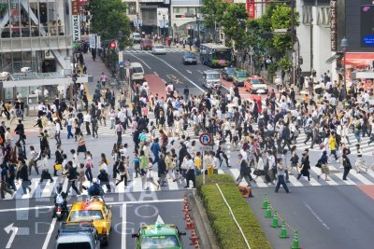

Plants on Earth

Plants are one of the two groups into which all living things were traditionally divided; the other is animals. Plants are photosynthetic, which means that they manufacture their own food molecules using energy obtained from light.



Weather on Earth

On **Earth**, the common **weather** phenomena include wind, cloud, rain, snow, fog and dust storms. Less common events include natural disasters such as tornadoes, hurricanes, typhoons and ice storms. Almost all familiar **weather** phenomena occur in the troposphere.



Ecosystems

An ecosystem is a natural unit consisting of all plants, animals and micro-organisms in an area functioning together with all of the non-living physical factors of the environment.

Pond ecosystem

**A pond ecosystem refers to fresh water ecosystem where there are communities of organism dependent on each other with the prevailing water environment for their nutrients and survival.Usually ponds are shallow water bodies with a depth of 12-15 feet in which the sun rays can penetrate to the bottom permitting the growth of plants there.**

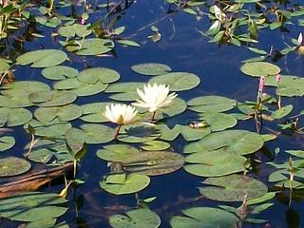

Greenhouse effect

The **greenhouse effect** is the process by which radiation from a planet's atmosphere warms the planet's surface to a temperature above what it would be in the absence of its atmosphere. If a planet's atmosphere contains radiatively active **gases** (i.e. **greenhouse gases**) the atmosphere radiates energy in all directions.

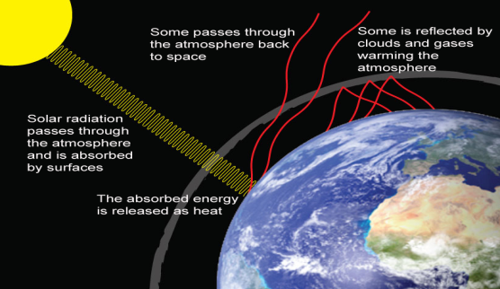

Global Warming

**Global Warming** is the increase of Earth's average surface temperature due to effect of greenhouse gases, such as carbon dioxide emissions from burning fossil fuels or from deforestation, which trap heat that would otherwise escape from Earth. This is a type of greenhouse effect.

Conclusion

Healthy environments become even more important as climate change becomes more severe. Climate change makes poverty worse, makes life harder and more dangerous for those who are poor, and adds to existing problems like food insecurity and risk of disaster. Fortunately, there are many easy and inexpensive activities that can be done to improve the environment. They provide a triple win by helping families become better able to provide for themselves today, securing resources for tomorrow and fighting climate change in the long run.