Global AI race
[CHEATSHEET] The country that will control AGI will control the future of humanity.
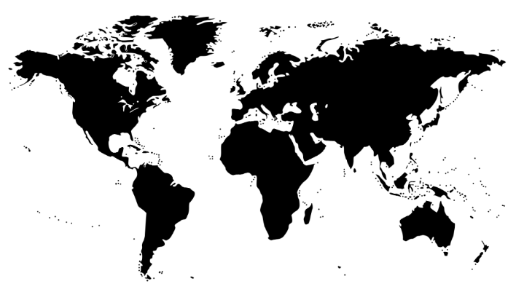
Countries are competing in the AI race. There are 5 levels and countries tend to put trade restrictions on these.
- Level 0: Supply
  - Components used by fab.
  - Machine lenses are made by Zeiss in Germany
  - High precision chip making machine (EUV lithography machine) from ASML in the Netherlands
  - Supply of AI research talent (US and China leading)

- Level 1: Production
  - Cost of entry: $20B; limited supply of precision machine (trade restrictions by US/EU).
  - Fab:
    - Taiwan: TSMC (major)
    - US: Intel (major but struggling)
    - Small players: PRC: SMIC; UAE: GlobalFoundries
  - Design of chips:
    - US: NVIDIA, ARM, AMD, Intel, Qualcomm
    - PRC (small): Cambricon, Huawei, Alibaba, Baidu

- Level 2: Infrastructure
  - Entry: Limited by the cost of AI factory setup ($14B)
  - xAI, Meta (350K GPUs each)
  - OpenAI stargate (2M GPUs)
  - Anthropic, Google, …
  - China: Limited stock of high-performance GPUs.

- Level 3: Frontier models / LLM
  - Entry: Limited by the cost to train models + research talent. Cost of entry: $2B.
  - US: OpenAI’s GPT, xAI’s Grok, Meta’s Llama.
  - China: DeepSeek V3, R1; ByteDance, Baidu.

- Level 4: Applications
  - Entry: Usage/API calls. Cost of entry: as low as $1M (for reasonable scale/number of users).
  - ChatGPT, Cursor, Notebook LM, Perplexity, …
  - Military, Healthcare, …

