Course Name: | Web Programming Laboratory (216U01L501) | Semester: | V
Date of Performance: | 19/ 07 / 26 | DIV/ Batch No: | A1
Student Name: | Aditya Chaugala | Roll No: | 16014024012

Experiment No: 1
Title: Design the static web pages with the help of HTML5

Aim and Objective of the Experiment:
Design the static web pages with the help of HTML5.
Example: Need to change the application
A) Design the following static web pages required for your WPL Mini Project
For Example Online Book store website.
1) HOME PAGE:
2) LOGIN PAGE:
3) CATOLOGUE PAGE: The catalogue page should contain the details of all the Books available in the website in a table.
4) REGISTRATION PAGE
B) Create a table to show your class timetable.

COs to be achieved:
CO1

Problem Statement:
- Develop structured and semantic HTML5 documents
- Create interactive and media-rich web pages
- Apply real-world problem context to web development
- Build a basic but complete front-end web portal

HTML tags used:
1. Document Structure & Metadata
- <html> – The root element that wraps all content on the web page.
- <head> – Contains machine-readable information (metadata) about the document, like the title and stylesheet links.
- <meta> – Used for specifying the character encoding (UTF-8) and setting up the viewport for responsive designs.
- <title> – Defines the document's title displayed in the browser's title bar or tab.
- <link> – Connects the external CSS file (styles.css) to the HTML document.
- <body> – Encloses all the visible, renderable content of the web page.
2. Layout & Semantic Sections
- <header> – Represents the introductory container at the top, used here for the website branding and navigation container.
- <nav> – Marks out a block of navigation links (the menu bar).
- <main> – Designates the dominant, core content area unique to each page.
- <section> – Groups related content together (e.g., the Hero banner or Featured Book grids).
- <div> – A generic block-level layout container used to style and structure elements like the forms and modern grids.
- <footer> – Defines the footer area at the bottom of the pages for copyright info.
3. Lists & Navigation Links
- <ul> – An unordered (bulleted) list used to structure the navbar links cleanly.
- <li> – Represents individual list items inside the navigation menu.
- <a> – An anchor tag used to create hyperlinks connecting the Home, Login, Catalogue, and Registration pages.
4. Text & Content Formatting
- <h1> & <h2> – Heading elements used to establish text hierarchy (e.g., Page titles and section labels).
- <p> – Standard paragraph element used for descriptions and text blocks.
- <strong> – Gives text strong importance, rendering it in a bold typeface (used for Book IDs and Days).
- <span> – An inline container used to target and style specific pieces of text, like the availability badges.
- <br> – Produces a line break in text (used to stack the letters vertically in the Lunch Break slot).
5. Forms & Interactive Elements
- <form> – Wraps interactive controls to collect user inputs for logging in or registering.
- <label> – Provides a clean text caption for form inputs, improving web accessibility.
- <input> – Creates data entry fields. Used with various types: type="email", type="password", type="text", type="tel", and type="checkbox".
- <textarea> – Creates a multi-line text input field, specifically utilized for entering the shipping address.
- <button> – Renders clickable buttons for submitting forms or triggering actions like "Add to Cart".
6. Tabular Data (Catalogue & Timetable)
- <table> – The parent element used to structure data into rows and columns.
- <thead> – Groups the header content of a table to define column names.
- <tbody> – Groups the core body rows containing the actual data of the table.
- <tr> – Defines a single table row.
- <th> – Defines a table header cell, which automatically centers and bolds text.
- <td> – Defines a standard table data cell containing text or buttons.

Code:

Stepwise-Procedure / Algorithm:
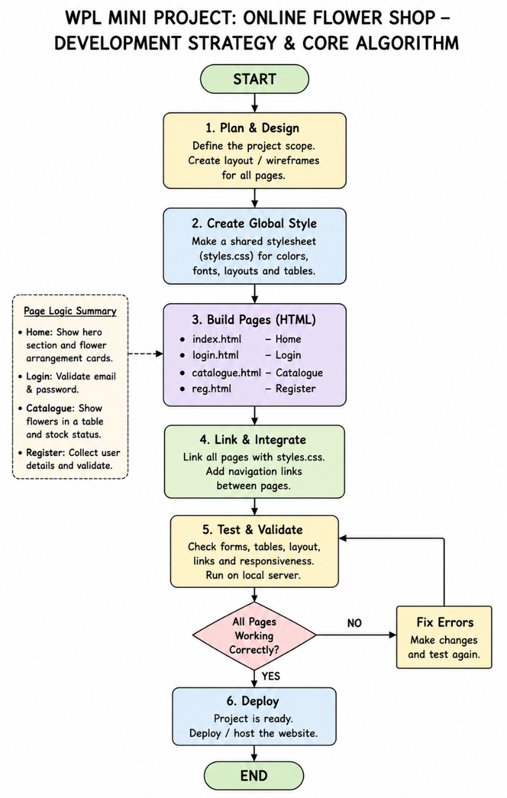

Output
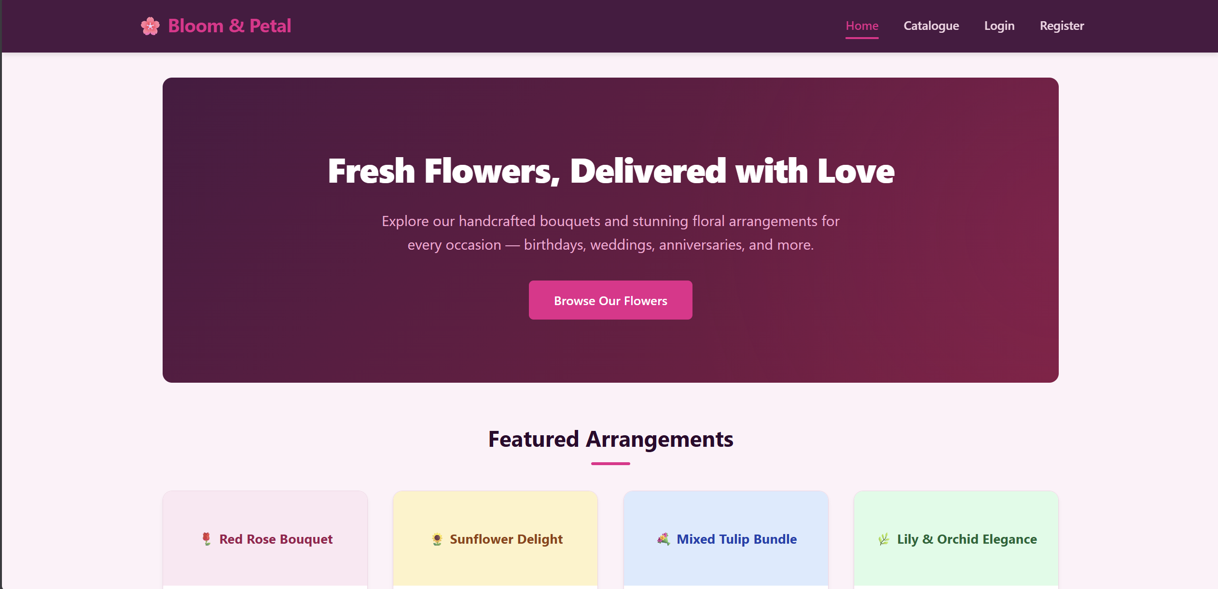
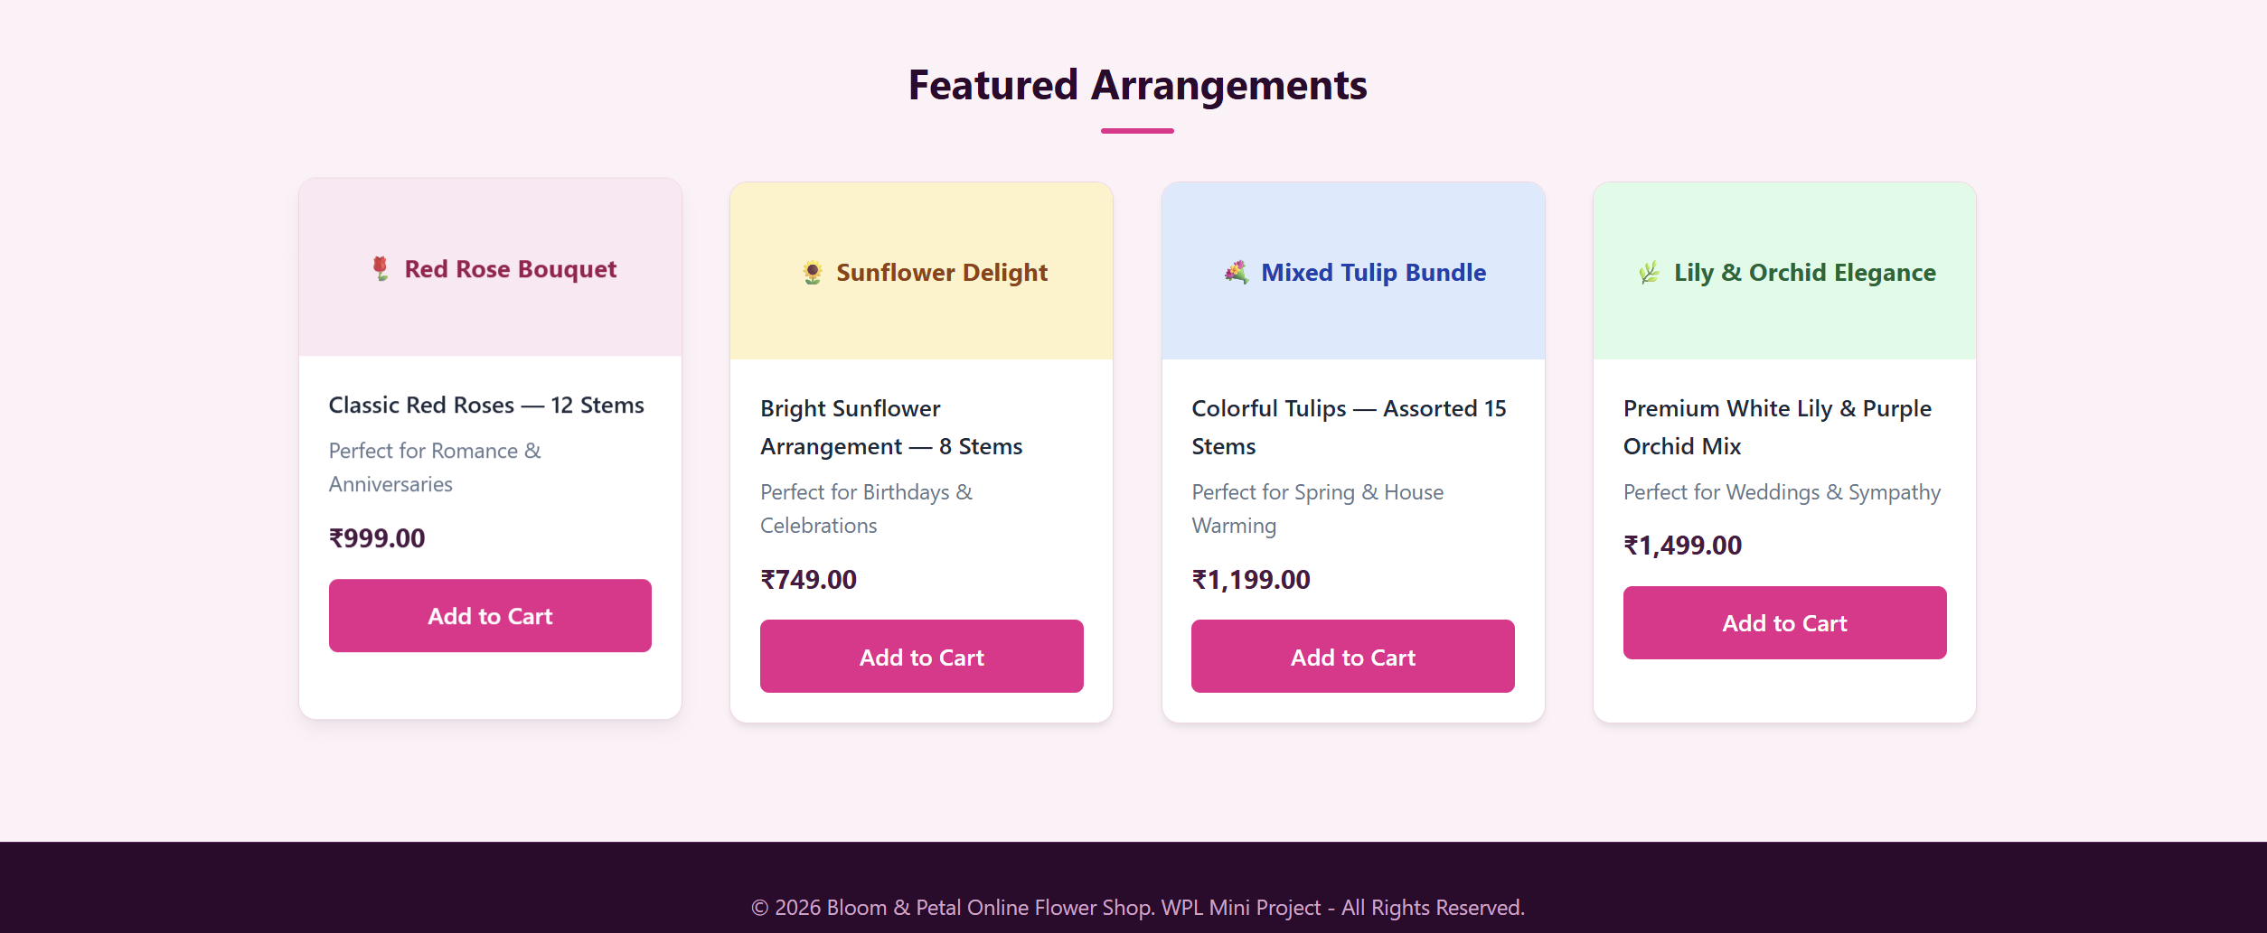
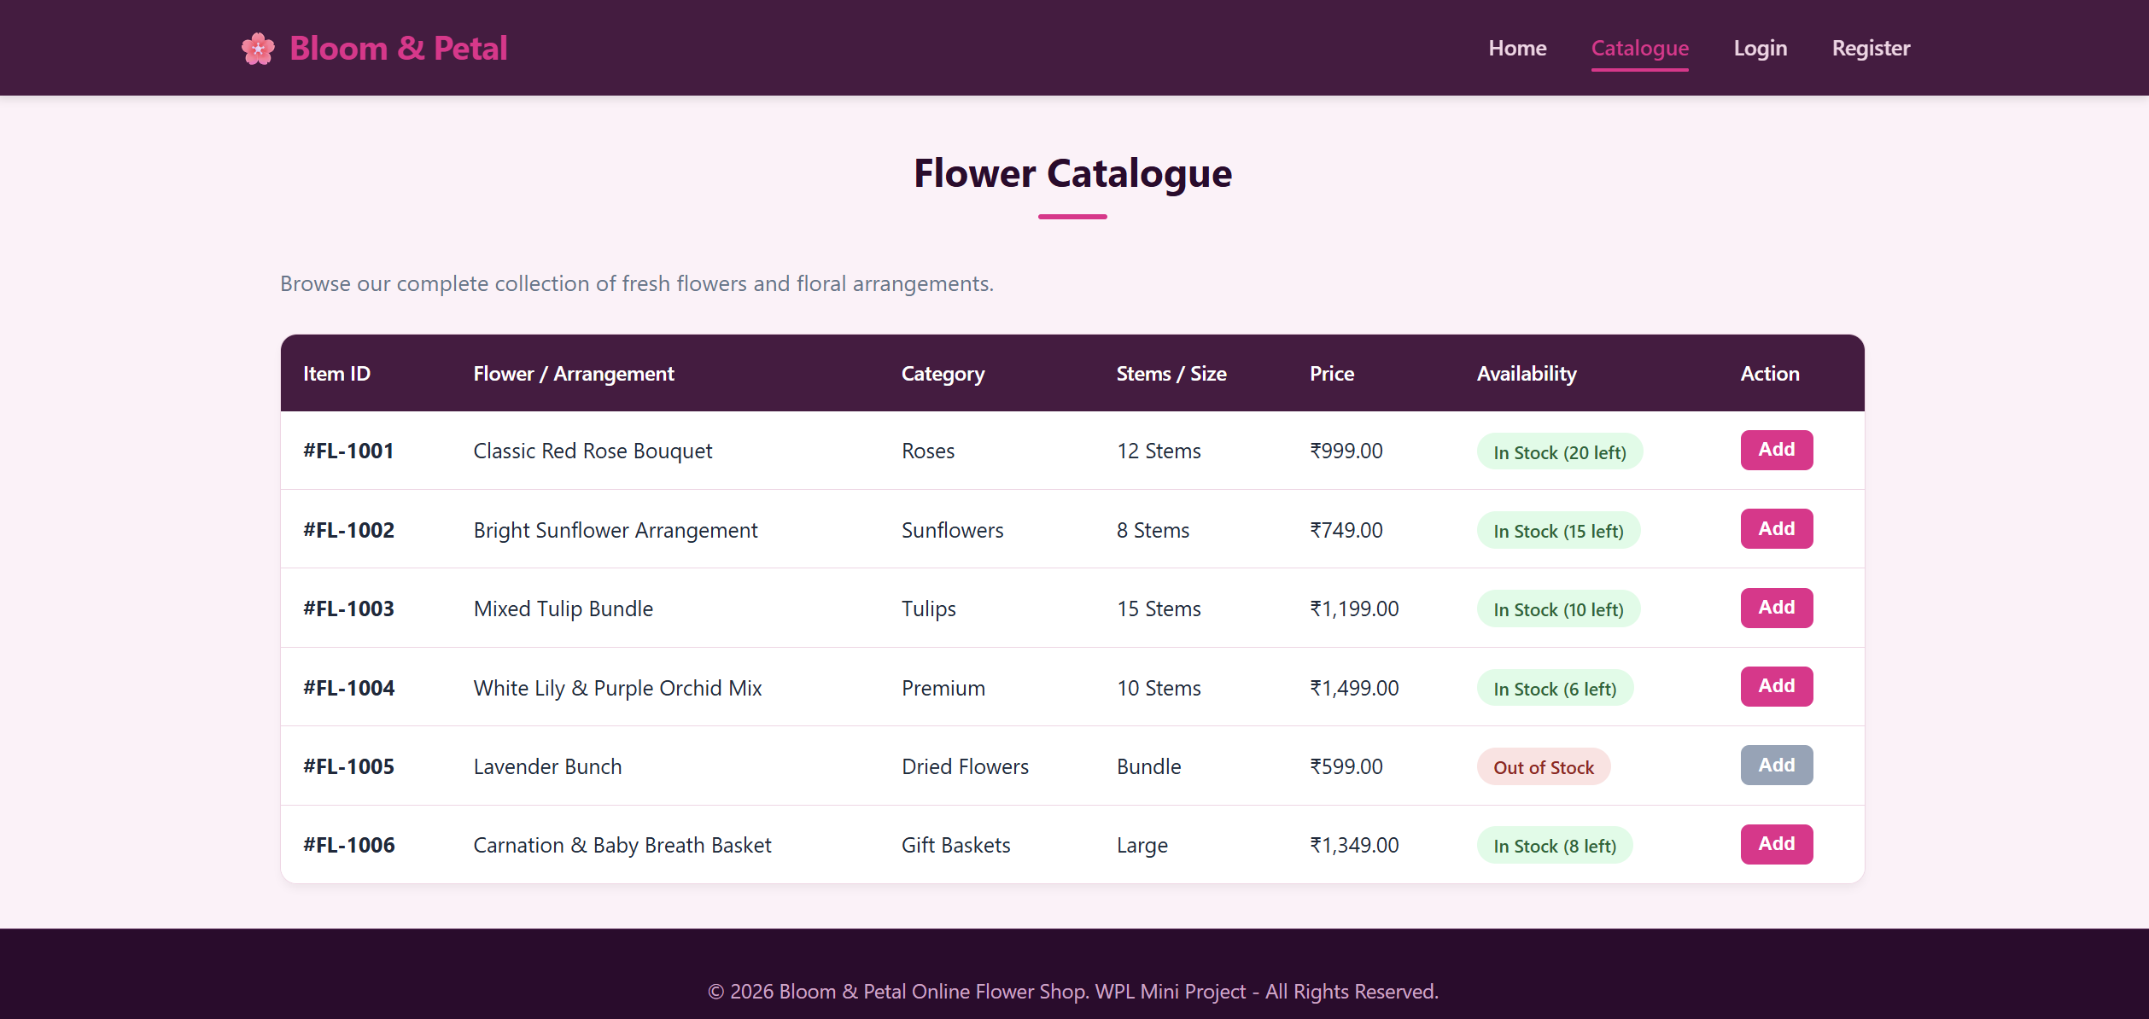
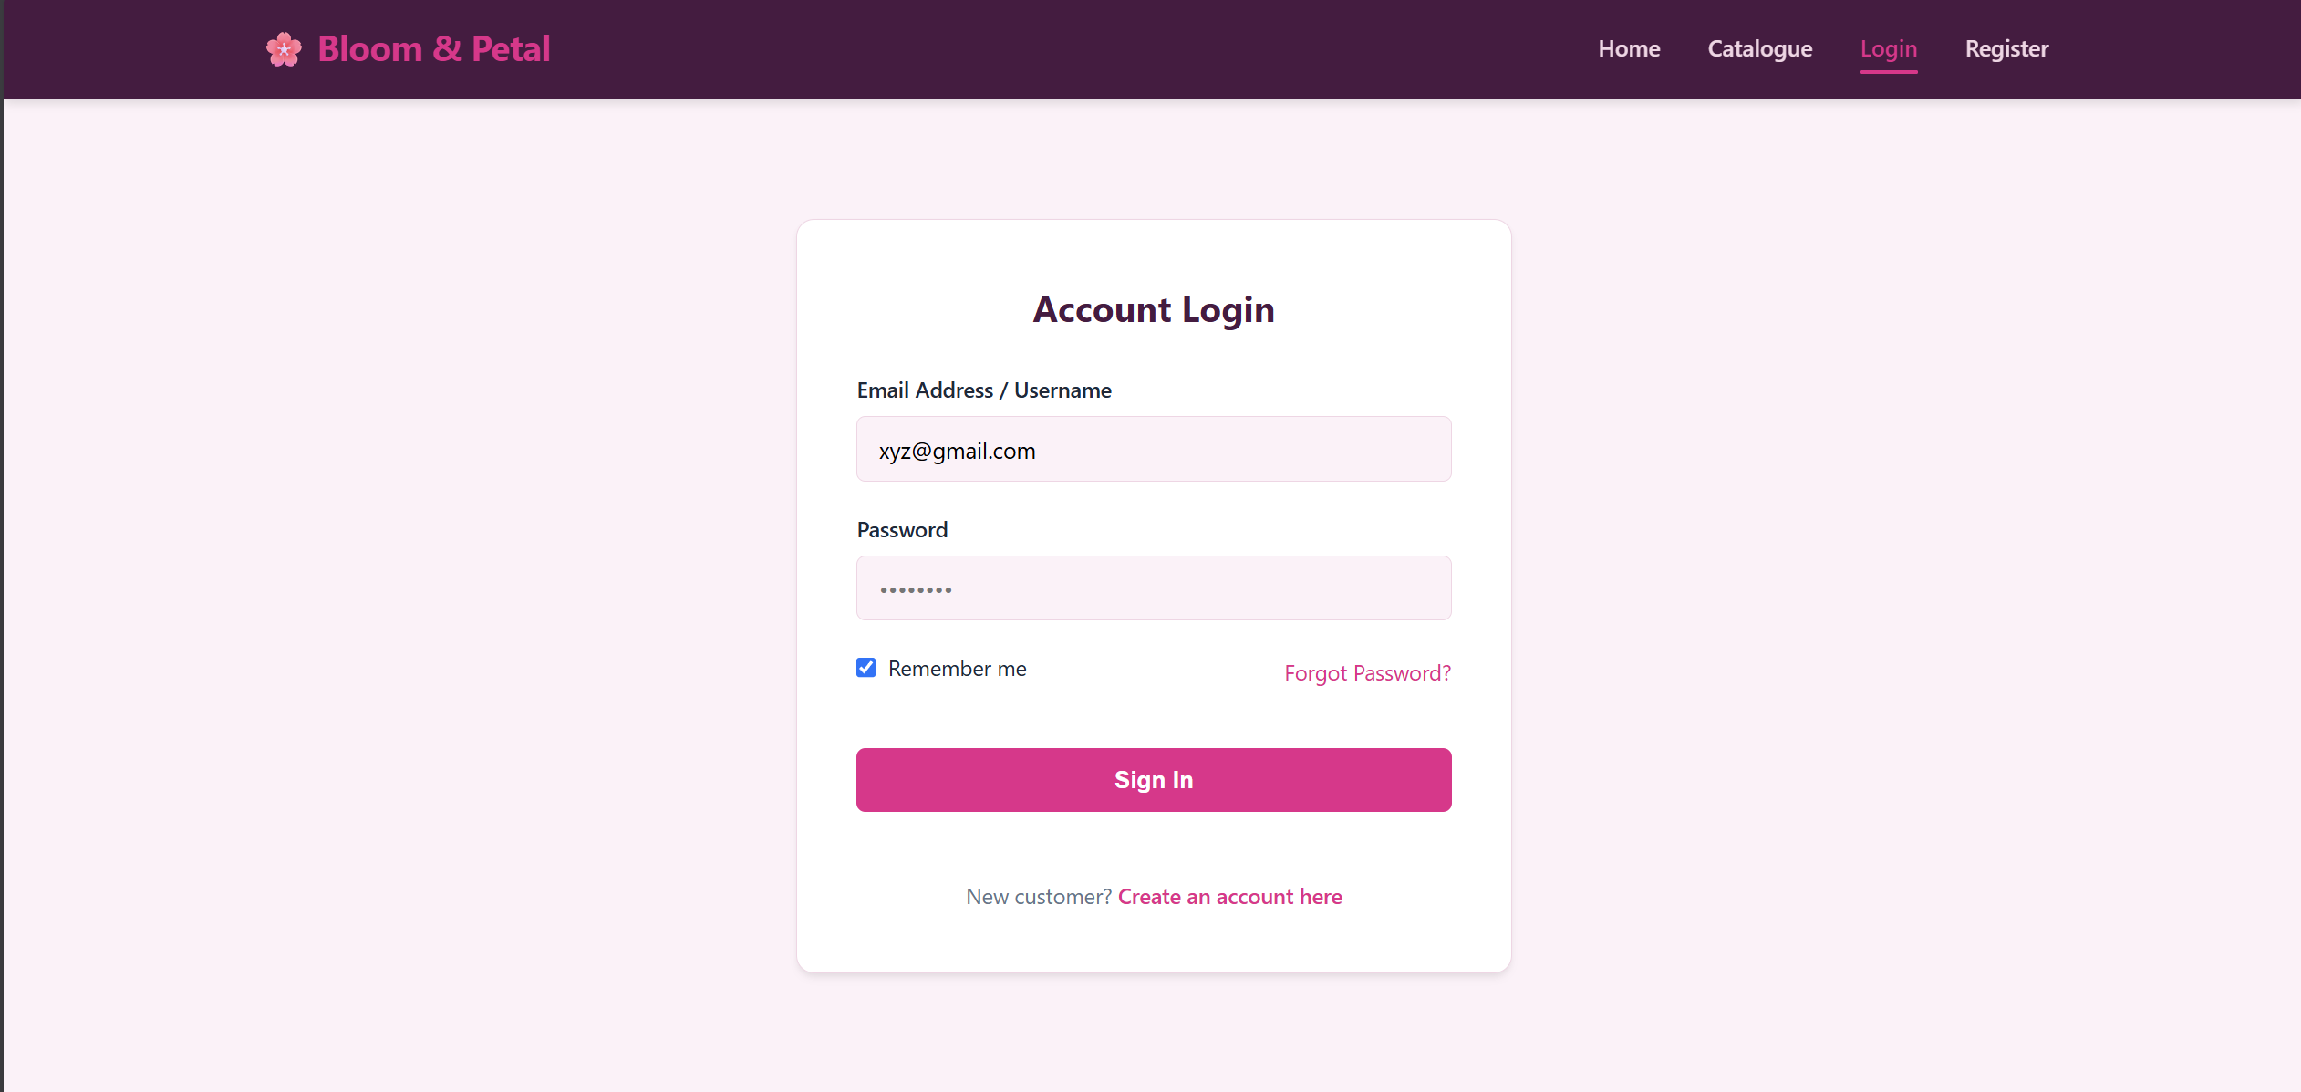
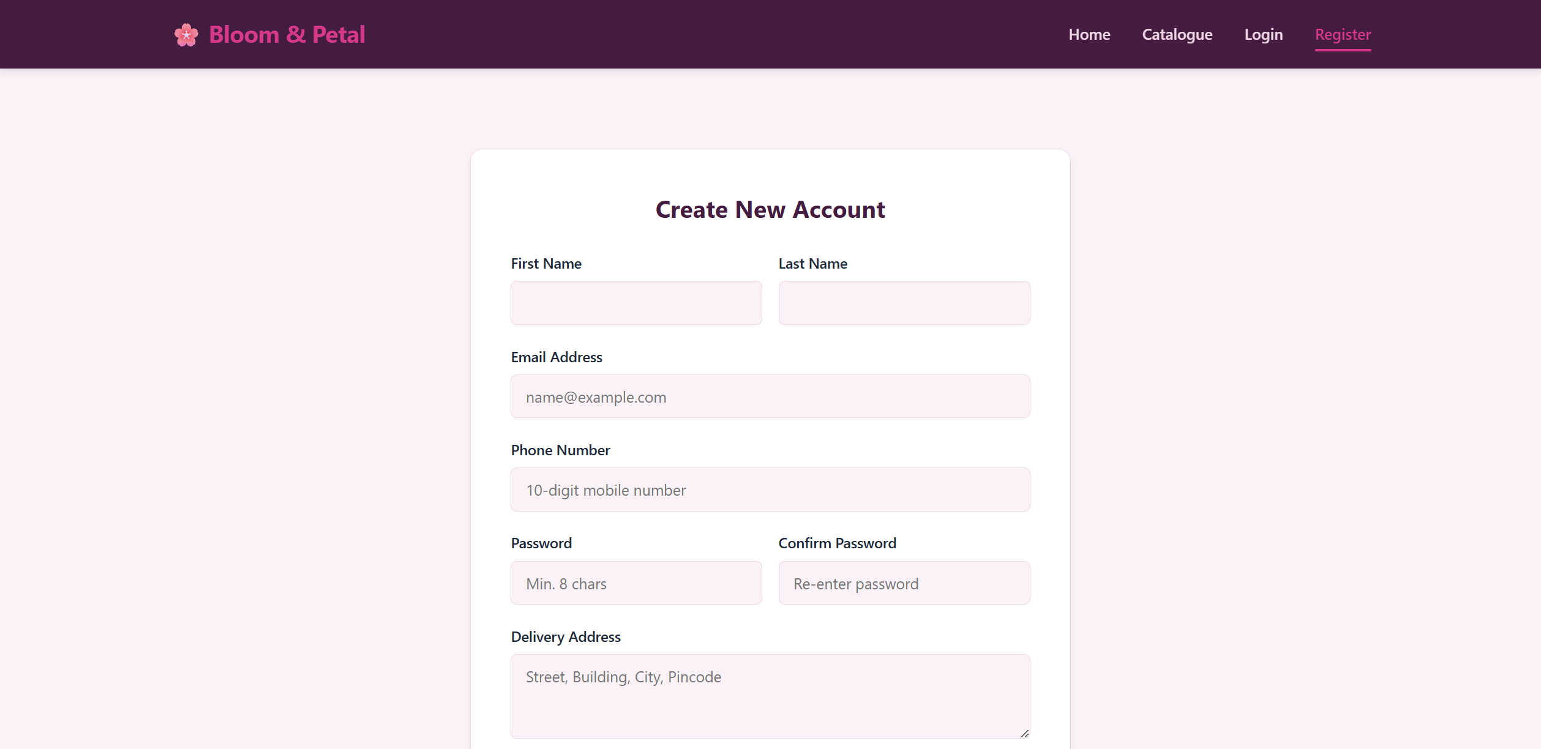

Link of the Generated website

Post Lab Subjective/Objective type Questions:
- Write HTML code to create a hyperlink that opens in a new tab.
<!DOCTYPE html>
<html lang="en">
<head>
<meta charset="UTF-8">
<meta name="viewport" content="width=device-width, initial-scale=1.0">
<title>Apex Books | Home</title>
<link rel="stylesheet" href="styles.css">
</head>
<body>

<header>
<div class="nav-container">
<a href="index.html" class="logo">📚 Apex Books</a>
<nav>
<ul>
<li><a href="index.html" class="active">Home</a></li>
<li><a href="catalogue.html">Catalogue</a></li>
<li><a href="login.html">Login</a></li>
<li><a href="register.html">Register</a></li>
<li><a href="timetable.html" target="_blank" rel="noopener noreferrer" style="background-color: var(--secondary-color); padding: 0.4rem 0.8rem; border-radius: 4px; color: white;">Academic Portal ↗</a></li>
</ul>
</nav>
</div>
</header>

<main>
<section class="hero">
<h1>Discover Your Next Great Read</h1>
<p>Explore thousands of books across tech, fiction, engineering, and academia at unbeatable prices.</p>
<a href="catalogue.html" class="btn">Browse Catalogue</a>
</section>

<h2 class="section-title">Featured Collections</h2>
<section class="book-grid">
<div class="book-card">
<div class="book-cover-placeholder" style="background-color: #dbeafe; color: #1e40af;">Embedded Systems & Architecture</div>
<div class="book-info">
<div class="book-title">Designing Embedded Systems with ESP32</div>
<div class="book-author">By K. R. Sharma</div>
<div class="book-price">₹799.00</div>
<a href="#" class="btn" style="text-align: center;">Add to Cart</a>
</div>
</div>

<div class="book-card">
<div class="book-cover-placeholder" style="background-color: #fef3c7; color: #92400e;">Machine Learning</div>
<div class="book-info">
<div class="book-title">Applied Telemetry & Predictive Models</div>
<div class="book-author">By Dr. Amit Verma</div>
<div class="book-price">₹1,249.00</div>
<a href="#" class="btn" style="text-align: center;">Add to Cart</a>
</div>
</div>

<div class="book-card">
<div class="book-cover-placeholder" style="background-color: #dcfce7; color: #166534;">Web Programming</div>
<div class="book-info">
<div class="book-title">Mastering HTML5, CSS3, & Modern JS</div>
<div class="book-author">By John Doe</div>
<div class="book-price">₹550.00</div>
<a href="#" class="btn" style="text-align: center;">Add to Cart</a>
</div>
</div>

<div class="book-card">
<div class="book-cover-placeholder" style="background-color: #fce7f3; color: #9d174d;">Data Structures</div>
<div class="book-info">
<div class="book-title">Algorithms & Huffman Optimizations</div>
<div class="book-author">By Sarah Jenkins</div>
<div class="book-price">₹890.00</div>
<a href="#" class="btn" style="text-align: center;">Add to Cart</a>
</div>
</div>
</section>
</main>

<footer>
<p>&copy; 2026 Apex Books Online Store. WPL Mini Project - All Rights Reserved.</p>
</footer>

</body>
</html>
- Differentiate between block-level and inline elements with examples.
Block-level elements (e.g., <div>, <p>) start on a new line and occupy the full width available. Inline elements (e.g., <span>, <a>) only take up as much space as their content and do not cause line breaks.
- Why are semantic tags preferred over <div> tags?
Semantic tags (e.g., <header>, <article>) communicate clear meaning about their content to browsers, screen readers, and search engines. Regular <div> tags carry no inherent meaning, offering zero context for SEO optimization or accessible assistive technologies.
- Why is <iframe> preferred over <frame> in modern HTML?
<frame> is deprecated because it breaks browser navigation, splitting a single webpage into rigid windows. Conversely, <iframe> embeds external documents fluidly within a standard HTML layout, preserving accessibility, responsive styles, and modern security permissions.

- Evaluate the importance of using alt attribute in images.
Suggest two additional features that can improve the given web portal and explain how HTML5 supports them
The alt attribute delivers essential textual descriptions for screen readers, providing web accessibility to visually impaired users. Additionally, it improves SEO rankings and acts as a descriptive fallback if an image fails to load.

Conclusion:
Modern HTML web architecture relies heavily on semantic structure, precise layout mechanics, and accessible design patterns. Prioritizing fluid table layouts, cross-origin secure hyperlinks, and meaningful container tags over generic wrappers guarantees cross-browser responsiveness, optimal search engine indexing, and seamless navigation across desktop and mobile environments.

Signature of faculty in-charge with Date:

