**How-To-Use**

**Environment Configuration**

1. Go to my SPM repo: <https://github.com/AdiMatam/Battery-Pybamm/tree/sei-pack>
   1. Download repository as a ZIP file and extract to any directory on your machine

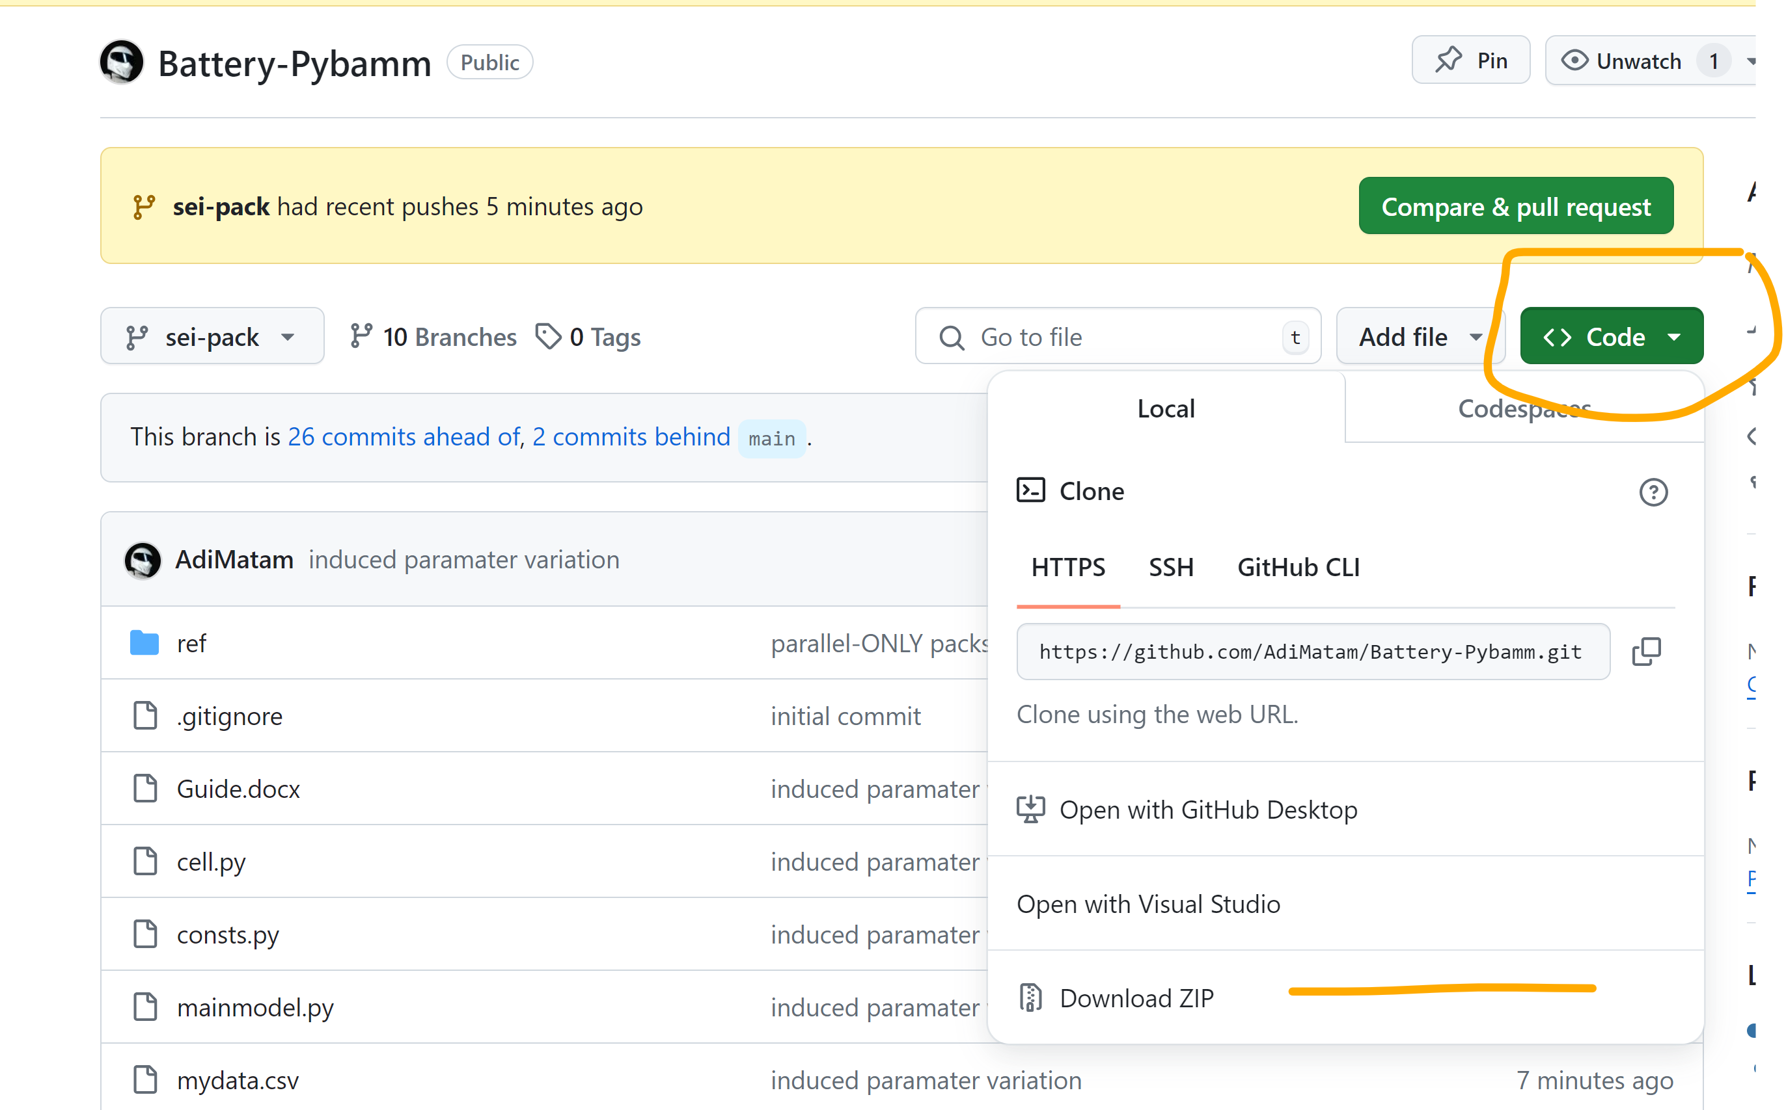

1. Install VSCode: <https://code.visualstudio.com/>
   1. *Default installation settings*
2. Launch the editor and identify the column of icons on the left side (see pic below)
3. Install Python extension

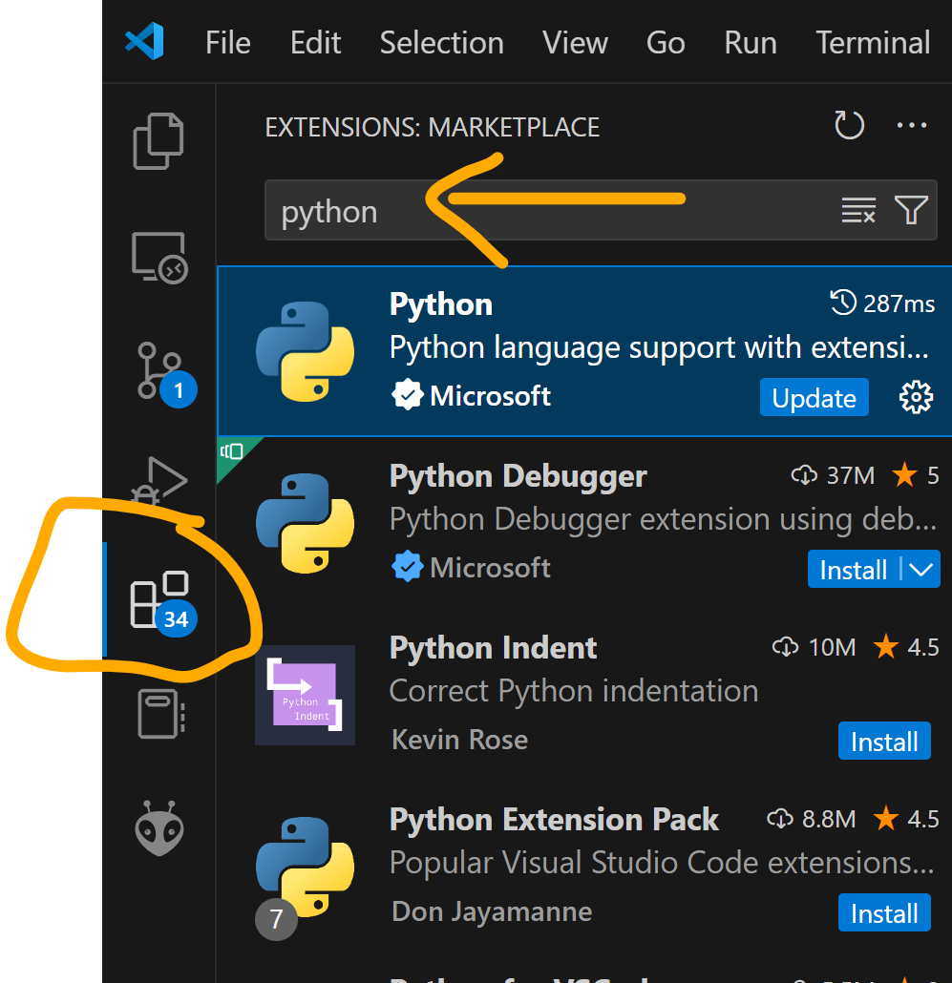

1. Open the downloaded repository in VSCode

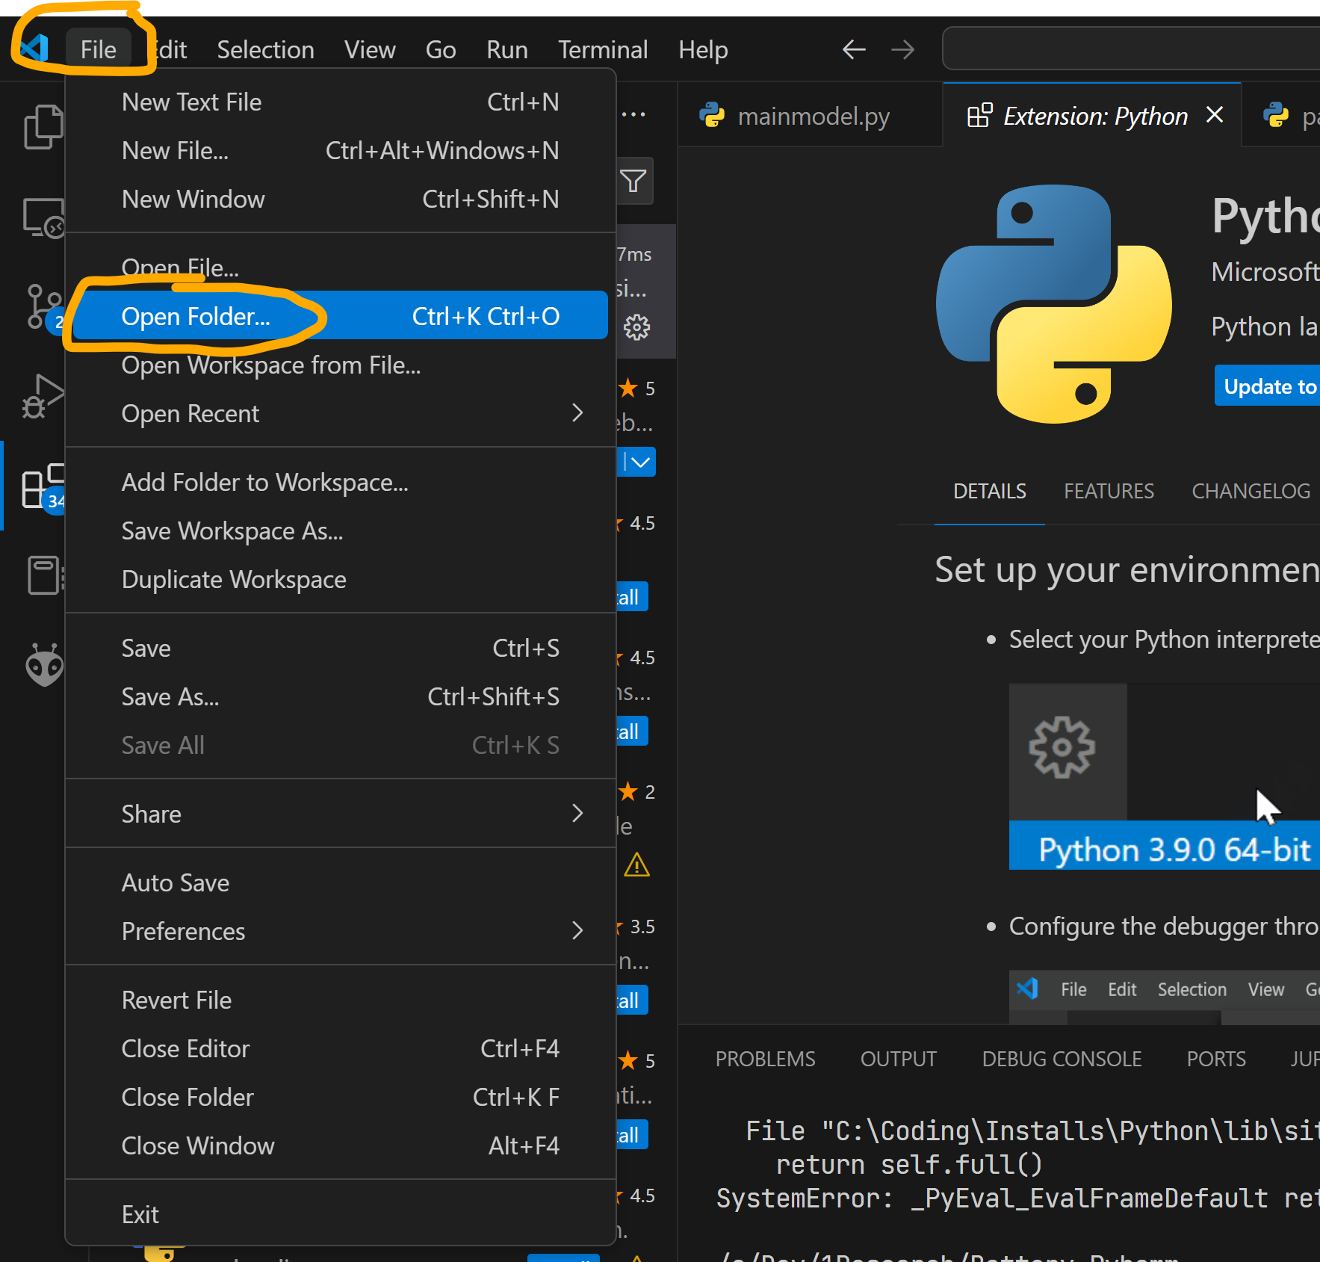

* 1. A file explorer dialog will open when you select “Open Folder…”. Navigate to the FOLDER from Step 1 and click “Select Folder”

1. You should see something like this:

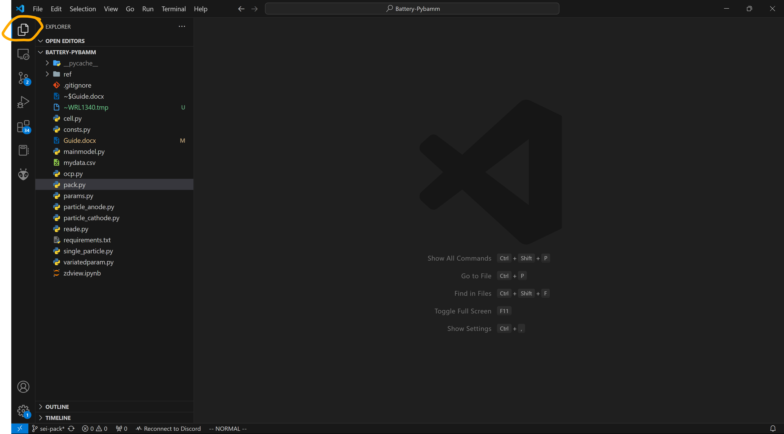

You MAY have to click on the orange circle to see the list-out of files in this directory.

1. Press CTRL + ~. This is the button to the left of the 1 key. A terminal window will appear, run the following:
   1. **pip install -r requirements.txt**
   2. **python mainmodel.py**

**MAIN FILES (That concern running the sim)**

**mainmodel.py:** ’Main’ program which initializes Packs or Cells – runs simulation, cycling and any plotting/post-processing routines

* *See the VARIABLES IN ALL CAPS AT THE TOP this program*

**params.py:** Defines cell-level parameters (see ‘VariedParameter’)

* POS_ELEC_POROSITY = VariatedParameter.from_percent(0.50, 5)
  + *The positive electrode’s porosity will be 0.5 +/- 5% across all cells in pack*

**Top Down Look:**

**pack.py:** Builds X Cells in series, Y Cells in parallel (X, Y are input params).

* Builds the DAE for the pack – all algebraic equations for coupling
* Includes discretization method and cycling protocol

**cell.py:** Couples 2 Single_Particles (which consistute one ‘Cell’)

* Cathode called Positive Electrode (+)
* Anode called Negative Electrode (-)

**single_particle.py:** Defines model of a single electrode.

* Diffusion ODEs, boundary/initial conditions for Lithium concentration, and Butler-Volmer calculations for electrode potential
* Global meshing geometry, parameter structures are updated
* *Note that this program can be run standalone to validate the ‘charge’ / ‘discharge’ of a single particle.*