Game

A fast paced flight-based capture the flag

Contributors:

- James Stow - StoB2

Core Idea:
A game combining aspects of genres including;
- Endless Runners
- Flight Simulators
- First Person Shooters

The player commands a single fighter-jet style sprite.
They will view the game from the sprites point of view.

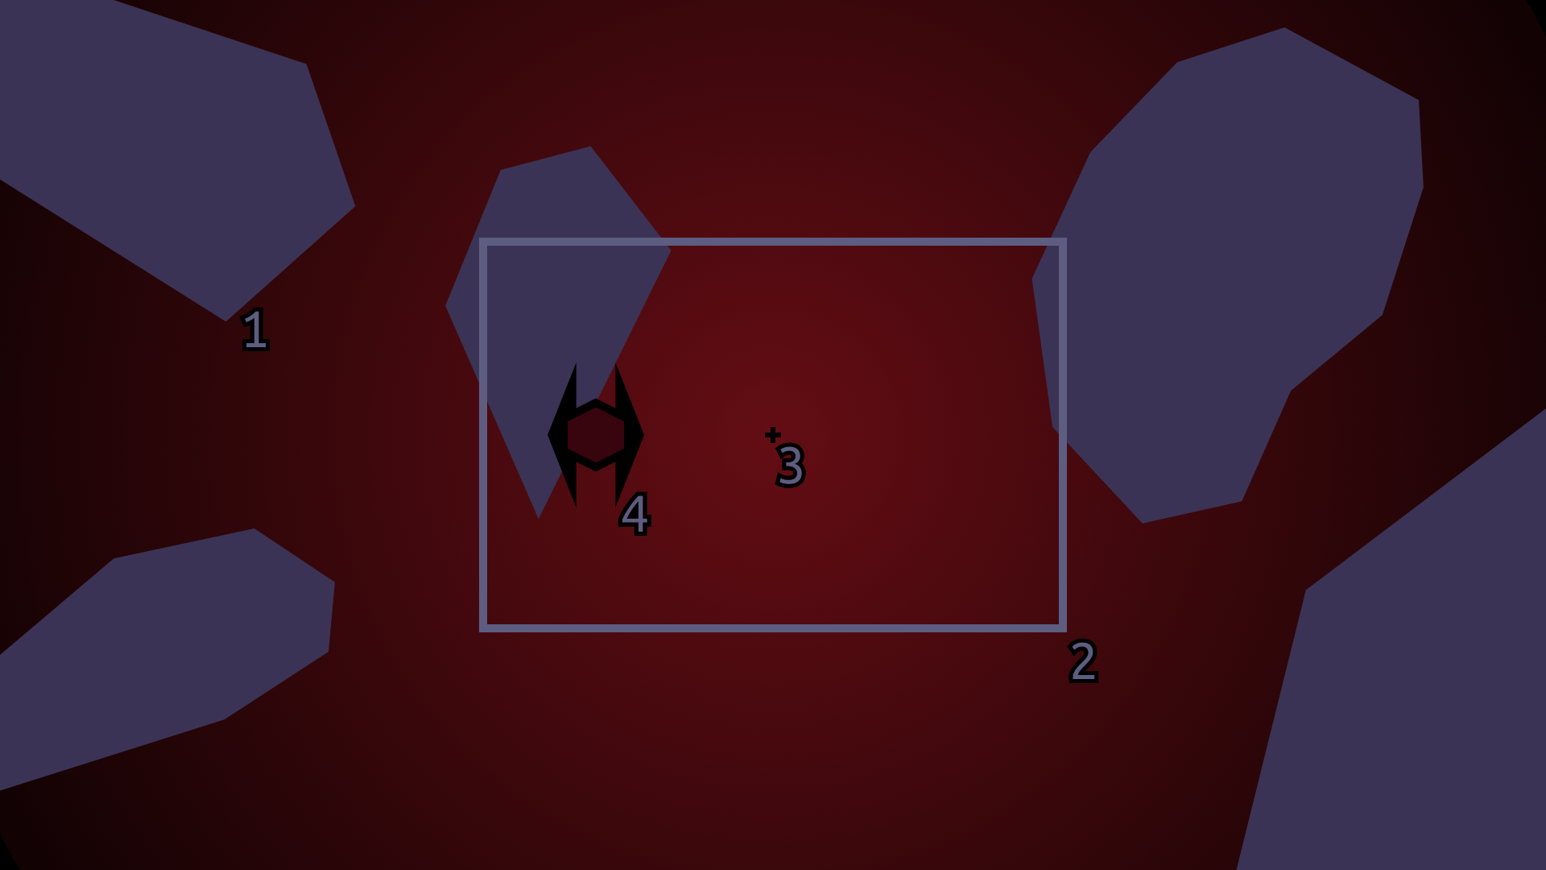
.Overview/exampleScreengrab_annotated.png
- Environment Obstacle
- Target zone
- Centre Reticle
- Other player sprite



Mouse/keyboard/joystick controls enable pitch and roll of the sprite
The player moves in the direction they are facing at a constant velocity

The first main objective is to avoid environment obstacles → Colliding with an environment obstacle ‘kills’ the player

The second main objective is to eliminate other players:
- Locate them inside the target zone
- Keep them there for ~3 seconds

Game concepts will be further discussed in
- Application/Concept/MechanicsOverview
and subfolders of: Application/Concept/
Documentation:
The documentation for this project is currently spread across multiple files and directories according to their relevance.

It is planned to redesign the documentation implementation early.

Documentation Tree: (Blue folders contain further folders/files)

Home
- Overview
- Priority Tasks
Distribution
Application

DevSystems
- Documentation
Software
- Continuous
Integration
- Team management
Webserver
- Webserver
Installer
- Installer
Implementation
Implementation
Concept
- MechanicsOverview
*various mechanics*

Graphics
- Theme
Vehicles
Maps
*various maps*

*various vehicles*

Implementation
Desktop
- DesktopApplication
Web
- WebApplication
Implementation
Desktop
- DesktopAPI
Web
- WebAPI
Multiplayer
- Multiplayer

