Sentinel-GL: Dependency-Safe Multisensor Masked Autoencoding and Retrospective Anomaly Diagnostics for Himalayan Glacial Lakes
Aditya Shrestha^{1*}
¹Department of Computer Science and Engineering (DoCSE), School of Engineering, Kathmandu University, Dhulikhel, Nepal
Abstract
Reliable satellite anomaly analysis for glacial lakes requires separating measurement support, deterministic feature dependencies, and developmental model fitting. This study investigates what source-supported reconstruction and latent anomaly trajectories emerge over two Himalayan glacial lake regions—South Lhonak and Khangchung Tsho—during the 2023 cascade season when derived-index leakage, fitting support, and sensor missingness are strictly controlled. We assemble 48 Sentinel-2 L2A optical observations spanning January–November 2023 across 20-m EPSG:32645 query grids alongside one shared September 2023 Sentinel-1 VV/VH SAR acquisition. A 1,062,919-parameter temporal masked autoencoder (T-MAE) is trained across five seeds using four-fold quadrant cross-masking, optical band-index dependency closure, and parity-0 pre-breach Welford normalization, and is compared against Isolation Forest, One-Class SVM, sensor-stratified Robust PCA, and CUSUM. Across all 188 genuinely observed query quadrants per seed, South Lhonak's median masked reconstruction error changes from 0.0477 pre-breach to 0.0442 post-breach, whereas latent embedding distance rises from 1.0086 to 3.1894 at South Lhonak and 1.3871 to 2.9591 at Khangchung Tsho, with One-Class SVM and CUSUM also increasing post-event. Optical Robust PCA converges in 413 iterations at rank 3. These findings characterize retrospective surface-anomaly diagnostics and demonstrate that ROI-wide anomaly scores require shoreline isolation and multi-year exposure before operational GLOF warning use.
Keywords: Glacial lakes, Sentinel-1, Sentinel-2, masked autoencoders, anomaly detection
*Corresponding author: Aditya Shrestha
Department of Computer Science and Engineering (DoCSE), School of Engineering, Kathmandu University, Dhulikhel, Nepal
Email: adityashrestha39@gmail.com (Institutional: as03233622@student.ku.edu.np)
(Received: Accepted: to be filled by the Editorial Board)
1. Introduction
Rapid glacial lake expansion across High Mountain Asia increases exposure to glacial lake outburst floods (GLOFs) (Shugar et al., 2020; Zheng et al., 2021; Taylor et al., 2023). The 3–4 October 2023 South Lhonak moraine breach in Sikkim demonstrated how a cascading hazard requires rigorous physical and statistical interpretation (Veh et al., 2018; Sattar et al., 2025). When applying self-supervised transformers to satellite time series, band-index algebraic dependencies, cloud-induced missingness, and spatial autocorrelation can create silent data leakage (Sarfraz et al., 2024). We evaluate a dependency-safe multisensor masked autoencoder (Sentinel-GL) over South Lhonak and Khangchung Tsho across January–November 2023.
2. Methodology
Fixed 499 × 499 query grids (20-m pixel spacing in EPSG:32645; 99.6004 km²) are centered at South Lhonak (27.915°N, 88.204°E) and Khangchung Tsho (27.985°N, 88.752°E). Across 24 equal-duration temporal bins between 1 January and 15 November 2023, score-blind catalogue selection retains 24 Sentinel-2 L2A scenes per site (Drusch et al., 2012) plus one shared 1 September 2023 Sentinel-1 IW GRD VV/VH acquisition (Torres et al., 2012). Optical validity requires Scene Classification Layer (SCL) classes 4, 5, or 6, and NDWI (McFeeters, 1996) and MNDWI (Xu, 2006) are computed without epsilon clamping.
A 16-pixel checkerboard split assigns parity-0 pixels of pre-breach acquisitions (ending strictly before 2 October 2023, 18:30 UTC) to fitting and parity-1 pixels to development monitoring. Streaming float64 Welford moments normalize each channel using parity-0 support only (Welford, 1962). Each acquisition is pooled into four spatial quadrant tokens. A 1,062,919-parameter Temporal Masked Autoencoder (Vaswani et al., 2017; He et al., 2022; Zerveas et al., 2021) masks each quadrant in four separate folds while hiding all five optical channels at the targeted quadrant to prevent algebraic reconstruction of B03 from B08 and NDWI. Five seeds are optimized with AdamW (Loshchilov and Hutter, 2019) for up to 80 epochs. Reconstruction MSE (T-MAE A), eight-component PCA five-nearest-neighbor latent distance (T-MAE B), and fit-standardized fused scores (T-MAE C) are compared with Isolation Forest (Liu et al., 2008), PSD RBF One-Class SVM (Schölkopf et al., 2001), sensor-stratified ADMM Robust PCA (Candès et al., 2009; Lin et al., 2010), and CUSUM (Page, 1954), while noting that Peaks-Over-Threshold calibration (Pickands, 1975; Davison and Smith, 1990) requires multi-year exposure.
3. Results
All 188 genuinely observed parity-1 quadrants per seed are scored across 49 unique provider products (950 method-seed-observation rows), with zero checkpoint replay error across all five seeds (selected monitor MSE 0.101839 to 0.215871). Optical Robust PCA converges in 413 iterations at rank 3 (normalized primal residual 9.9450 × 10⁻⁶; dual residual 1.4947 × 10⁻⁶).
Table 1. Optical acquisition-level median anomaly scores across pre- and post-breach periods (SL: South Lhonak; KT: Khangchung Tsho).
Method | SL pre (n=21) | SL post (n=3) | KT pre (n=19) | KT post (n=4)
T-MAE A (MSE) | 0.0477 | 0.0442 | 0.0359 | 0.0244
T-MAE B (Latent) | 1.0086 | 3.1894 | 1.3871 | 2.9591
T-MAE C (Fused) | -0.3062 | 0.2853 | -0.3217 | 0.0454
Isolation Forest | 0.4277 | 0.4890 | 0.4189 | 0.4476
One-Class SVM | -0.1898 | 0.0394 | -0.1897 | -0.0396
RPCA residual | 0.0515 | 0.0368 | 0.0427 | 0.0324
CUSUM | 0.0000 | 0.2171 | 0.0000 | 0.0000

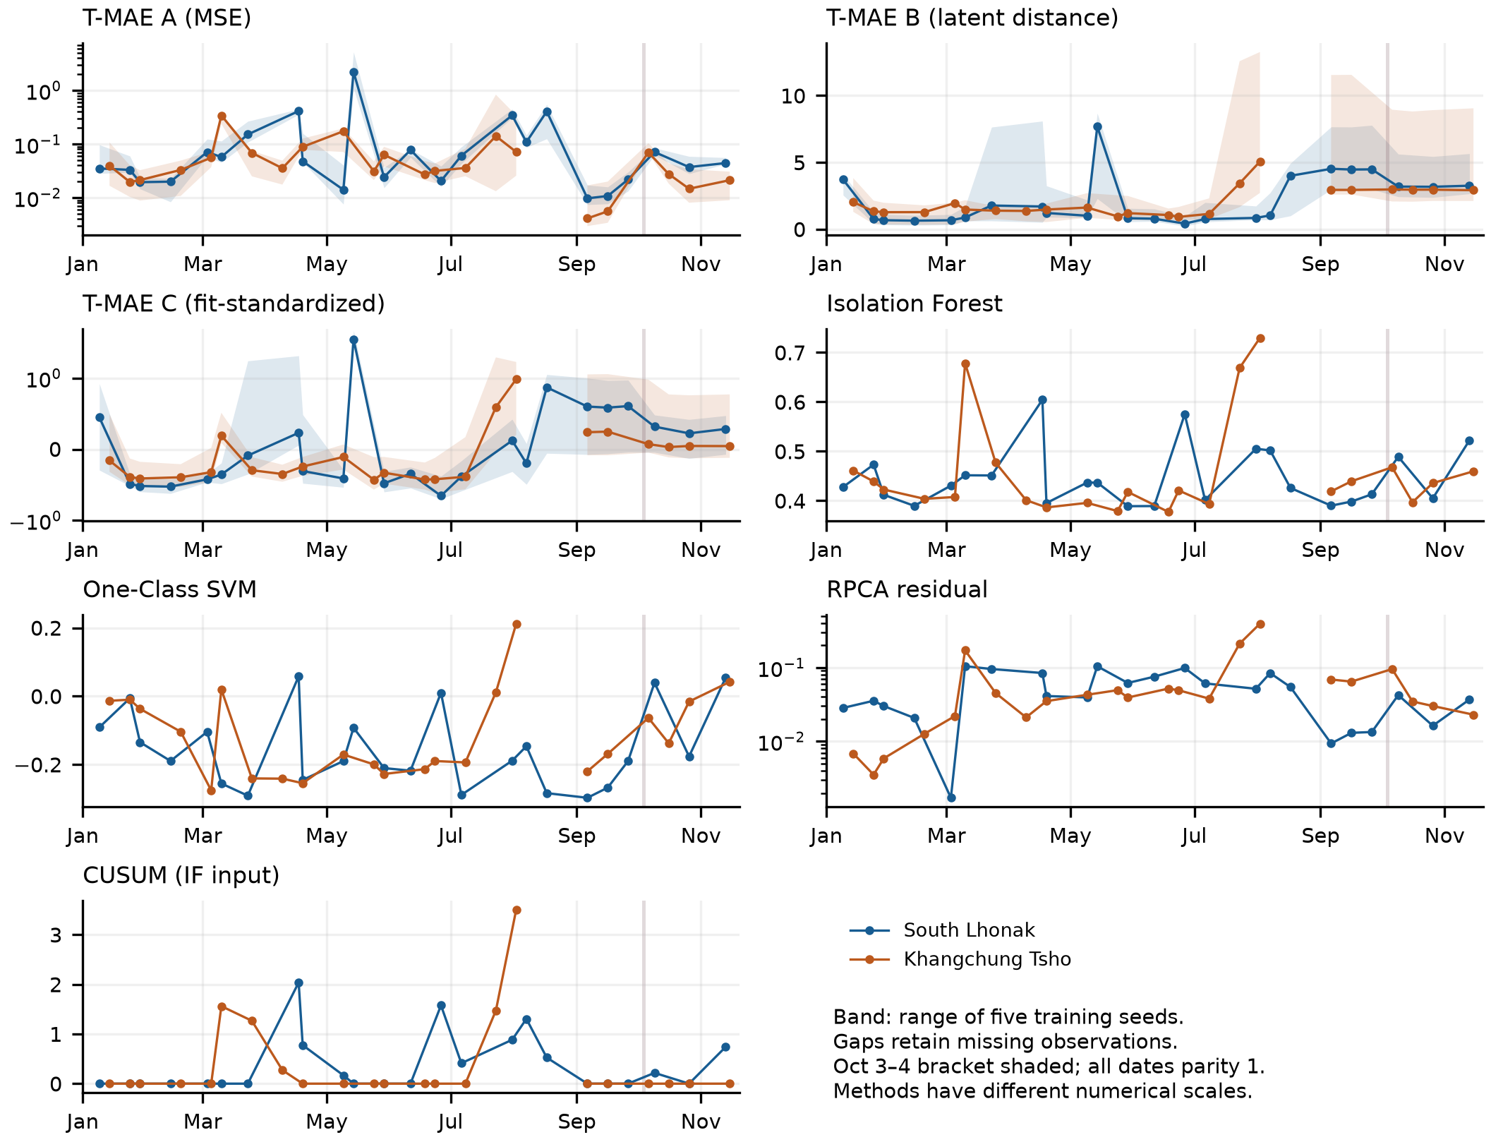
Figure 1. Optical acquisition-level parity-1 anomaly score trajectories across 2023 for South Lhonak and Khangchung Tsho. Shaded vertical band marks the 3–4 October 2023 breach.
4. Conclusion
Sentinel-GL establishes a dependency-safe, byte-auditable multisensor anomaly analysis workflow. While post-breach surface drainage is visually evident in Sentinel-2 imagery and increases latent distance, One-Class SVM, Isolation Forest, and CUSUM scores at South Lhonak, ROI-wide reconstruction error does not spike because surrounding terrain and seasonal snow/cloud support dominate the 99.6 km² grid. Shoreline-isolated masks, multi-date SAR time series, and multi-year exposure calibration are required before operational warning use.
Acknowledgement
This research was conducted independently at the Department of Computer Science and Engineering (DoCSE), School of Engineering, Kathmandu University, without institutional or external grant funding. Copernicus Sentinel-1 and Sentinel-2 data were accessed via the Copernicus Data Space Ecosystem and Element 84 Earth Search. AI tools assisted with coding, verification scripting, and manuscript drafting under the author's architectural direction; Aditya Shrestha retains sole responsibility for all technical decisions, verification, and content.
References
Candès, E.J., Li, X., Ma, Y. & Wright, J. (2009). Robust principal component analysis? arXiv:0912.3599.
Davison, A.C. & Smith, R.L. (1990). Models for exceedances over high thresholds. Journal of the Royal Statistical Society: Series B, 52(3), 393-425.
Drusch, M., Del Bello, U., Carlier, S. et al. (2012). Sentinel-2: ESA's optical high-resolution mission for GMES operational services. Remote Sensing of Environment, 120, 25-36.
He, K., Chen, X., Xie, S., Li, Y., Dollár, P. & Girshick, R. (2022). Masked autoencoders are scalable vision learners. Proc. of the IEEE/CVF Conf. on Computer Vision and Pattern Recognition, 16000-16009.
Lin, Z., Chen, M. & Ma, Y. (2010). The augmented Lagrange multiplier method for exact recovery of corrupted low-rank matrices. arXiv:1009.5055.
Liu, F.T., Ting, K.M. & Zhou, Z.H. (2008). Isolation forest. Proc. of 8th IEEE International Conf. on Data Mining, 413-422.
Loshchilov, I. & Hutter, F. (2019). Decoupled weight decay regularization. Proc. of International Conf. on Learning Representations.
McFeeters, S.K. (1996). The use of the Normalized Difference Water Index (NDWI) in the delineation of open water features. International Journal of Remote Sensing, 17(7), 1425-1432.
Page, E.S. (1954). Continuous inspection schemes. Biometrika, 41(1-2), 100-115.
Pickands, J. (1975). Statistical inference using extreme order statistics. The Annals of Statistics, 3(1), 119-131.
Sarfraz, M.S., Chen, M.Y., Layer, L., Peng, K. & Koulakis, M. (2024). Position: Quo vadis, unsupervised time series anomaly detection? Proc. of 41st International Conf. on Machine Learning, 235, 43461-43476.
Sattar, A., Cook, K.L., Rai, S.K. et al. (2025). The Sikkim flood of October 2023: Drivers, causes, and impacts of a multihazard cascade. Science, 387, eads2659.
Schölkopf, B., Platt, J.C., Shawe-Taylor, J., Smola, A.J. & Williamson, R.C. (2001). Estimating the support of a high-dimensional distribution. Neural Computation, 13(7), 1443-1471.
Shugar, D.H., Burr, A., Haritashya, U.K. et al. (2020). Rapid worldwide growth of glacial lakes since 1990. Nature Climate Change, 10, 939-945.
Taylor, C., Robinson, T.R., Dunning, S., Carr, J.R. & Westoby, M. (2023). Glacial lake outburst floods threaten millions globally. Nature Communications, 14, 487.
Torres, R., Snoeij, P., Geudtner, D. et al. (2012). GMES Sentinel-1 mission. Remote Sensing of Environment, 120, 9-24.
Vaswani, A., Shazeer, N., Parmar, N., Uszkoreit, J., Jones, L., Gomez, A.N., Kaiser, L. & Polosukhin, I. (2017). Attention is all you need. Advances in Neural Information Processing Systems, 30.
Veh, G., Korup, O., Roessner, S. & Walz, A. (2018). Detecting Himalayan glacial lake outburst floods from Landsat time series. Remote Sensing of Environment, 207, 84-97.
Welford, B.P. (1962). Note on a method for calculating corrected sums of squares and products. Technometrics, 4(3), 419-420.
Xu, H. (2006). Modification of normalised difference water index (NDWI) to enhance open water features in remotely sensed imagery. International Journal of Remote Sensing, 27(14), 3025-3033.
Zerveas, G., Jayaraman, S., Patel, D., Bhamidipaty, A. & Eickhoff, C. (2021). A transformer-based framework for multivariate time series representation learning. Proc. of 27th ACM SIGKDD Conf. on Knowledge Discovery and Data Mining, 2114-2124.
Zheng, G., Allen, S.K., Bao, A. et al. (2021). Increasing risk of glacial lake outburst floods from future Third Pole deglaciation. Nature Climate Change, 11, 411-417.

