Sentinel-GL: Dependency-Safe Multisensor Masked Autoencoding and Retrospective Anomaly Diagnostics for Himalayan Glacial Lakes
Aditya Shrestha^{1*}
¹Department of Computer Science and Engineering (DoCSE), School of Engineering, Kathmandu University, Dhulikhel, Nepal
Abstract
Reliable satellite anomaly analysis for glacial lakes requires separating measurement support, deterministic feature dependencies, and developmental model fitting. This study investigates what source-supported reconstruction and latent anomaly trajectories emerge over two Himalayan glacial lake regions—South Lhonak and Khangchung Tsho—during the 2023 cascade season when derived-index leakage, fitting support, and sensor missingness are strictly controlled. We assemble 48 Sentinel-2 L2A optical observations spanning January–November 2023 across 20-m EPSG:32645 query grids alongside one shared September 2023 Sentinel-1 VV/VH SAR acquisition. A 1,062,919-parameter temporal masked autoencoder (T-MAE) is trained across five seeds using four-fold quadrant cross-masking, optical band-index dependency closure, and parity-0 pre-breach Welford normalization, and is compared against Isolation Forest, One-Class SVM, sensor-stratified Robust PCA, and CUSUM. Across all 188 genuinely observed query quadrants per seed, South Lhonak's median masked reconstruction error changes from 0.0477 pre-breach to 0.0442 post-breach, whereas latent embedding distance rises from 1.0086 to 3.1894 at South Lhonak and 1.3871 to 2.9591 at Khangchung Tsho, with One-Class SVM and CUSUM also increasing post-event. Optical Robust PCA converges in 413 iterations at rank 3. These findings characterize retrospective surface-anomaly diagnostics and demonstrate that ROI-wide anomaly scores require shoreline isolation and multi-year exposure before operational GLOF warning use.
Keywords: Glacial lakes, Sentinel-1, Sentinel-2, masked autoencoders, anomaly detection
*Corresponding author: Aditya Shrestha
Department of Computer Science and Engineering (DoCSE), School of Engineering, Kathmandu University, Dhulikhel, Nepal
Email: adityashrestha39@gmail.com (Institutional: as03233622@student.ku.edu.np)
(Received: Accepted: to be filled by the Editorial Board)
1. Introduction
Glacial lake growth and changing downstream exposure motivate satellite monitoring across High Mountain Asia (Shugar et al., 2020; Zheng et al., 2021; Taylor et al., 2023). The October 2023 South Lhonak disaster in Sikkim illustrates a cascading process whose hazard interpretation requires physical evidence beyond an unusual image score (Sattar et al., 2025). Retrospective satellite detection of lake changes is an established research direction (Veh et al., 2018); consequently, an anomaly detector's contribution cannot be justified solely by applying a transformer to a known event.
A central methodological difficulty is observational dependence. Optical water indices reuse the same spectral bands, spatial patches share landscapes and atmospheric conditions, and repeated optimization seeds share the same source corpus. Treating those dependencies as independent information can produce an apparently successful model without establishing warning skill. We investigate a bounded retrospective question: what source-supported reconstruction and fitted anomaly trajectories arise over South Lhonak and Khangchung Tsho during 2023 when derived-channel leakage, fitting support, sensor missingness, and temporal context are explicitly controlled?
2. Literature
Optical multispectral monitoring with Sentinel-2 (Drusch et al., 2012) relies on spectral ratios such as NDWI (McFeeters, 1996) and MNDWI (Xu, 2006) to enhance open-water features, while C-band Synthetic Aperture Radar (SAR) from Sentinel-1 provides cloud-penetrating backscatter observations (Torres et al., 2012). In multivariate time-series representation learning, transformer encoders (Vaswani et al., 2017; Zerveas et al., 2021) and masked autoencoders (He et al., 2022) reconstruct masked tokens from unmasked context. However, recent critical reviews of unsupervised time-series anomaly detection demonstrate that complex deep models frequently fail to outperform simple statistical baselines such as Isolation Forest (Liu et al., 2008), One-Class SVM (Schölkopf et al., 2001), Robust PCA (Candès et al., 2009; Lin et al., 2010), and CUSUM (Page, 1954) when evaluation protocols suffer from threshold or feature leakage (Sarfraz et al., 2024). Extreme-value threshold calibration via Peaks-Over-Threshold (Pickands, 1975; Davison and Smith, 1990) further requires verified multi-year exposure.
3. Methods and Procedures
3.1 Spatial Design and 2023 Observation Corpus
We fix query centroids at (27.915°N, 88.204°E) for South Lhonak and (27.985°N, 88.752°E) for Khangchung Tsho. Each region uses an integer-aligned 499 × 499 grid in EPSG:32645 with 20-m pixels (9.98 km side length; 99.6004 km² area). Within 24 equal-duration bins across 1 January–15 November 2023, score-blind catalogue selection retains the lowest-cloud Sentinel-2 L2A granule with full projected ROI coverage, yielding 48 optical observations (24 per site) plus one shared 1 September 2023 ascending Sentinel-1 IW GRD VV/VH product (Fig. 1).
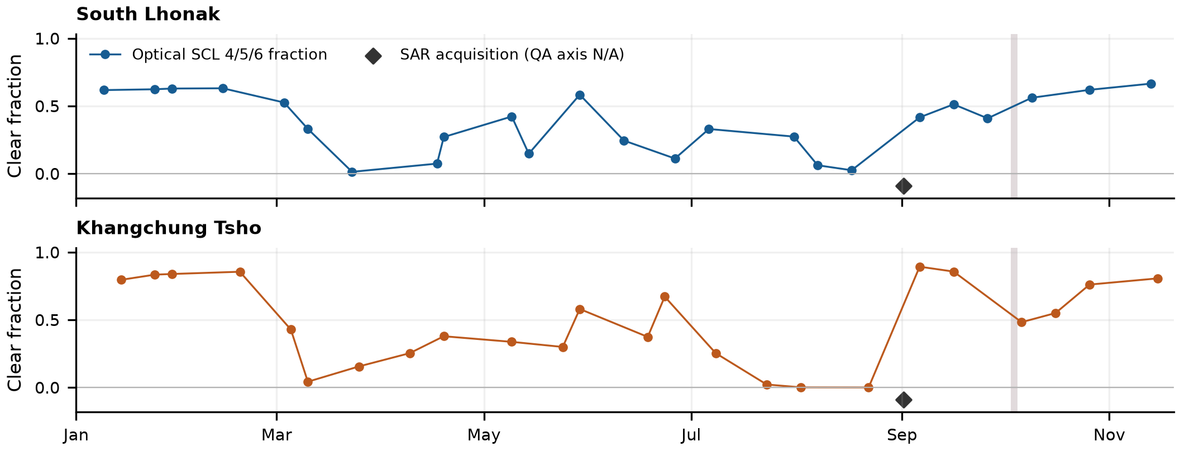
Figure 1. Source-supported 2023 observation sequence across South Lhonak and Khangchung Tsho. Optical points show the fraction of the fixed ROI assigned SCL 4/5/6; diamonds mark the 1 September SAR acquisition.
3.2 Optical Radiometry and Native SAR Calibration
Bands B03, B08, B11, and SCL are extracted via HTTP byte-range reads verified against native XML quantification values (Q = 10000) and additive offsets. B03 and B08 are reduced from 10 m to 20 m by exact 2 × 2 arithmetic means requiring all four valid source pixels. Optical validity requires SCL classes 4, 5, or 6. NDWI and MNDWI are computed in float64 before float32 serialization:
I_N = (ρ_3 − ρ_8) / (ρ_3 + ρ_8), I_M = (ρ_3 − ρ_11) / (ρ_3 + ρ_11) (1)
For Sentinel-1 IW GRD digital numbers d, interpolated sigma-nought LUT A_σ, and range/azimuth thermal noise terms N_R and N_A, we compute raw linear power and signed noise-subtracted power on bounded native radar windows before valid-weight bilinear resampling to the target grid (Fig. 2):
σ_r⁰ = d² / A_σ², NESZ = (N_R N_A) / A_σ², σ_s⁰ = (d² − N_R N_A) / A_σ² (2)
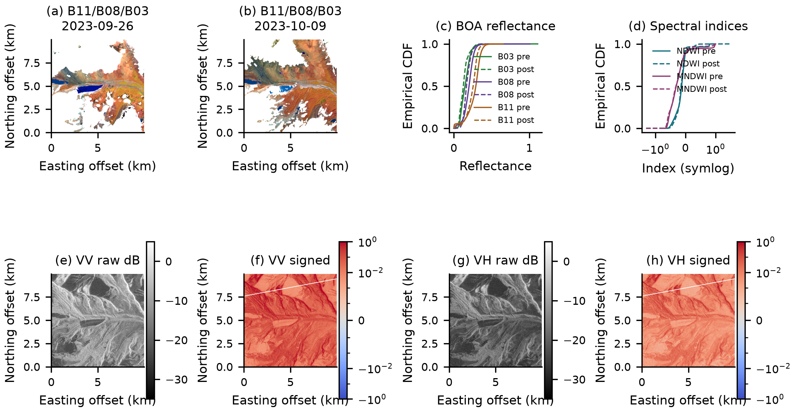
Figure 2. South Lhonak source diagnostics: (a,b) nearest pre/post optical false-color pairs (26 September vs. 9 October 2023); (c,d) ROI reflectance and index empirical CDFs; (e–h) 1 September SAR VV/VH distributions.
3.3 Spatial Parity Firewall and Dependency-Safe T-MAE
For raster row r and column c, spatial checkerboard parity is defined as:
P(r, c) = (⌊r / 16⌋ + ⌊c / 16⌋) mod 2 (3)
Parity 0 supplies fitting pixels and parity 1 supplies development monitoring, restricted strictly to acquisitions ending before 2 October 2023, 18:30 UTC (3 October 00:00 NPT). Per-channel float64 Welford standardization (Welford, 1962) is fitted on parity-0 pre-breach pixels only. Each acquisition forms four quadrant tokens. In each of four evaluation folds (q = 0, 1, 2, 3), optical dependency closure hides all five optical channels of the target quadrant so that hidden bands cannot be algebraically recovered via:
ρ_3 = ρ_8 (1 + I_N) / (1 − I_N) (4)
Five seeds are trained using AdamW (Loshchilov and Hutter, 2019) with learning rate 3e-4 and weight decay 1e-4 for up to 80 epochs. Five seeds are trained using AdamW (Loshchilov and Hutter, 2019) with learning rate 3e-4 and weight decay 1e-4 for up to 80 epochs. The T-MAE (1,062,919 parameters; d_model = 128, 4 heads, 4 encoder layers, 2 decoder layers) scores out-of-context quadrant reconstruction error A(t), eight-component PCA five-neighbor latent distance B(t) (excluding same-product and same-timestamp neighbors), and pre-breach parity-0 standardized fusion C(t):
A(t) = ∑_{q, j ∈ T_q} (ẑ_{qj} − z_{qj})² / ∑_q |T_q|, C(t) = ½(A − μ_A)/s_A + ½(B − μ_B)/s_B (5)
4. Results
Retained optical clear fractions range from 1.27% to 66.46% at South Lhonak (median 41.17%) and 0% to 89.25% at Khangchung Tsho (median 45.50%) (Table 1). Across five training seeds (80-epoch budget, patience 12), every seed scores all 188 genuinely observed parity-1 quadrants (49 acquisition-level scores per seed), and all selected checkpoints replay with 0.0 absolute error (Table 2; Fig. 3).
Table 1. Recorded 2023 observation support by region and sensor.
Region | Optical pre-breach | Optical post-breach | SAR dates
South Lhonak | 21 | 3 | 1
Khangchung Tsho | 20 (19 usable) | 4 | 1

Table 2. Five-seed T-MAE selected checkpoint evidence on parity-1 pre-breach monitor support.
Seed | Epochs run | Selected epoch | Monitor MSE
0 | 80 | 80 | 0.140137
1 | 73 | 61 | 0.215871
2 | 80 | 77 | 0.149476
3 | 77 | 65 | 0.138823
4 | 80 | 72 | 0.101839

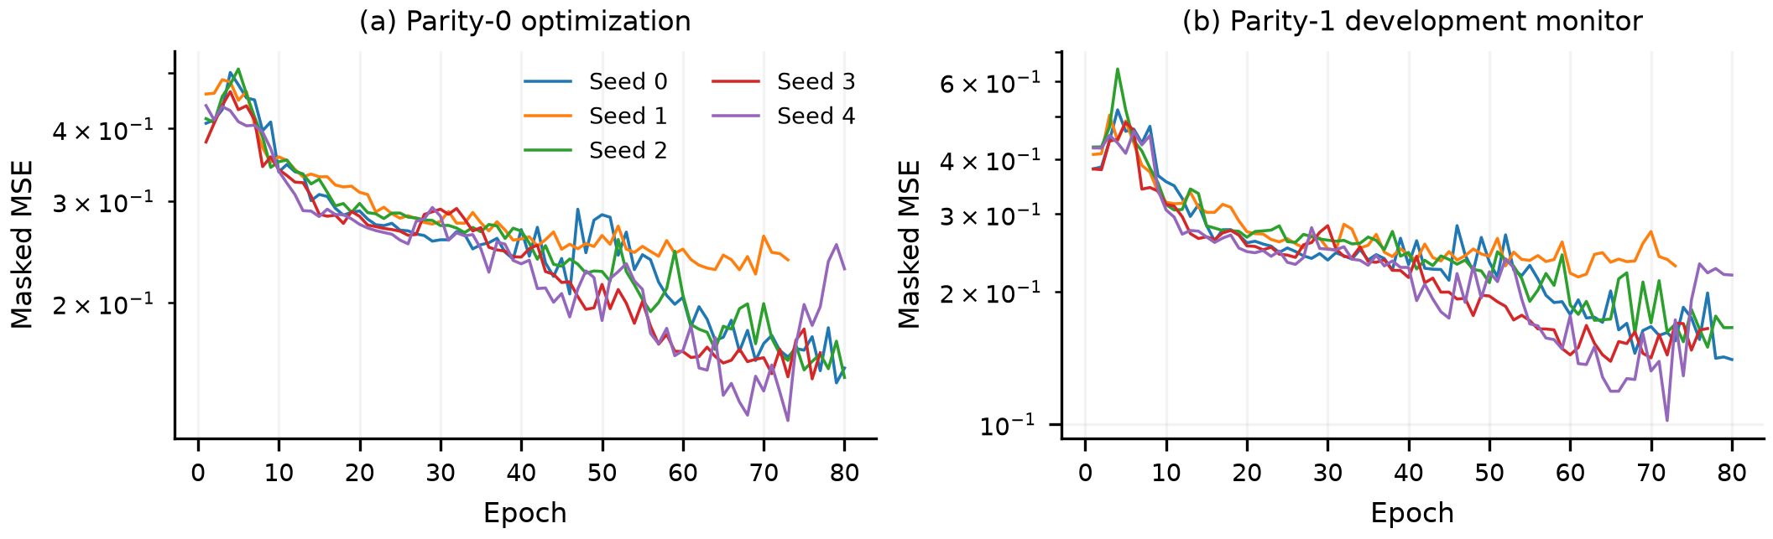
Figure 3. Five-seed T-MAE optimization histories on (a) parity-0 training pixels and (b) parity-1 development monitor pixels.
Table 3. Optical acquisition-level median scores by method and period (SL: South Lhonak; KT: Khangchung Tsho).
Method | SL pre | SL post | KT pre | KT post
T-MAE A (MSE) | 0.0477 | 0.0442 | 0.0359 | 0.0244
T-MAE B (Latent) | 1.0086 | 3.1894 | 1.3871 | 2.9591
T-MAE C (Fused) | -0.3062 | 0.2853 | -0.3217 | 0.0454
Isolation Forest | 0.4277 | 0.4890 | 0.4189 | 0.4476
One-Class SVM | -0.1898 | 0.0394 | -0.1897 | -0.0396
RPCA residual | 0.0515 | 0.0368 | 0.0427 | 0.0324
CUSUM | 0.0000 | 0.2171 | 0.0000 | 0.0000

As shown in Table 3 and Figure 4, South Lhonak's median reconstruction score (T-MAE A) changes from 0.0477 pre-breach to 0.0442 post-breach, whereas latent embedding distance (T-MAE B) increases from 1.0086 to 3.1894 at South Lhonak and from 1.3871 to 2.9591 at Khangchung Tsho (with elevated late-monsoon September medians of 4.4797 and 2.9420). One-Class SVM (−0.1898 to 0.0394), Isolation Forest (0.4277 to 0.4890), and CUSUM (0.0000 to 0.2171) also increase post-event at South Lhonak. Sensor-stratified optical Robust PCA converges numerically in 413 iterations at rank 3 (normalized primal residual 9.9450 × 10⁻⁶; dual residual 1.4947 × 10⁻⁶). Representative seed-0 attention maps are shown in Figure 5.
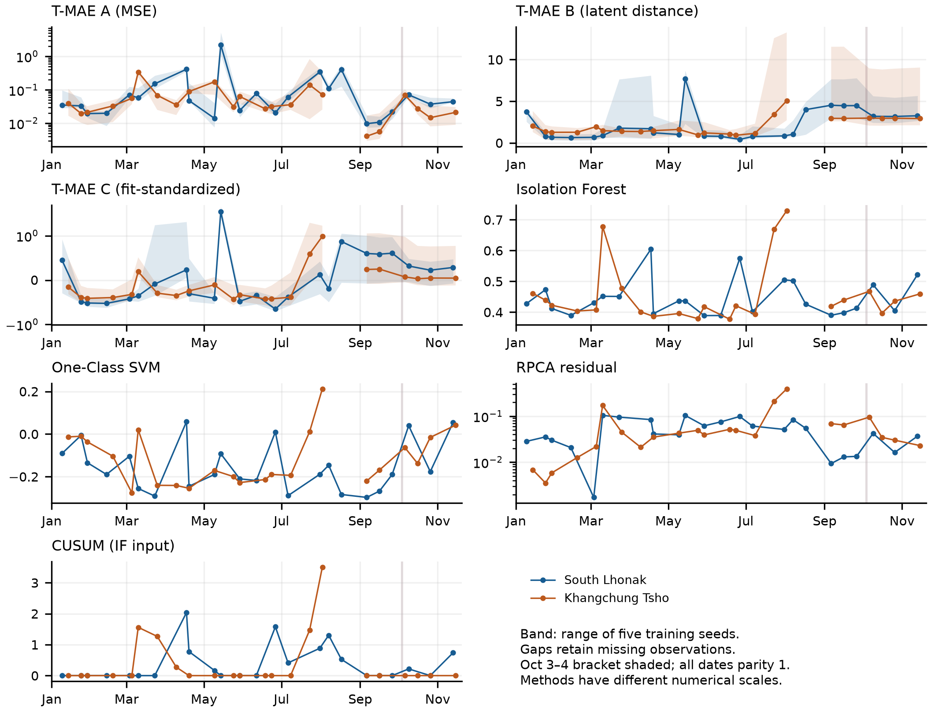
Figure 4. Optical acquisition-level parity-1 trajectories across 2023 for all seven diagnostic methods. Shaded band marks the 3–4 October 2023 breach.
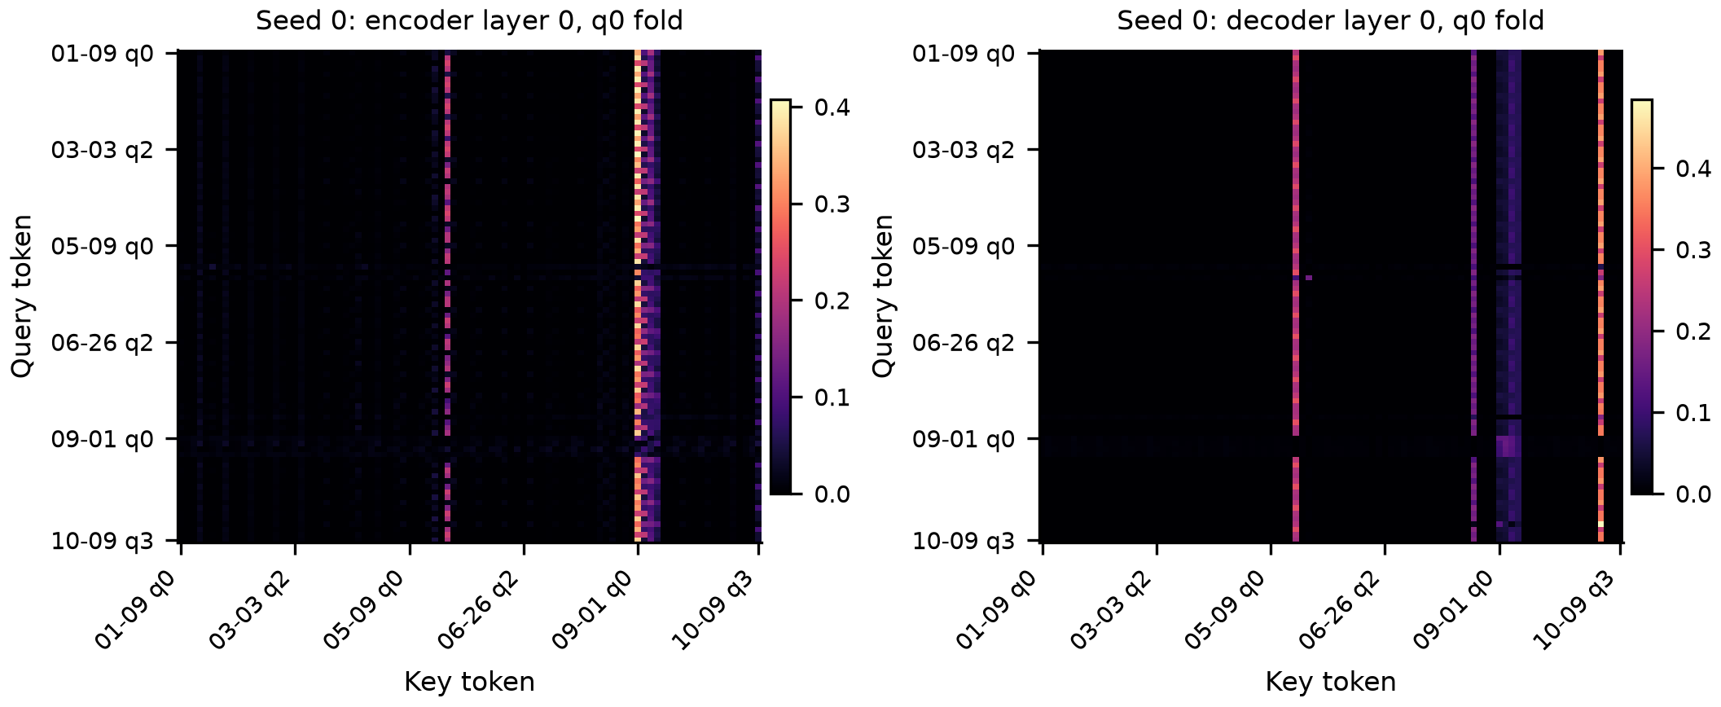
Figure 5. Representative seed-0 encoder and decoder self-attention weights (layer 0, q0 fold) for the first post-breach South Lhonak optical query (9 October 2023).
5. Conclusion
Sentinel-GL integrates multi-date 2023 Sentinel-2 optical imagery and native-calibrated Sentinel-1 SAR within a dependency-safe, byte-verified masked autoencoding framework. While physical lake drainage after the October 2023 South Lhonak breach is clear in optical imagery and elevates latent, SVM, Isolation Forest, and CUSUM trajectories, ROI-wide reconstruction error does not spike due to surrounding terrain and seasonal support variations. Future operational warning skill requires shoreline-specific polygon masks, multi-date terrain-corrected SAR time series, and multi-year false-alarm calibration.
Acknowledgement
This research was conducted independently at the Department of Computer Science and Engineering (DoCSE), School of Engineering, Kathmandu University, without institutional or external grant funding. Copernicus Sentinel-1 and Sentinel-2 data were accessed via the Copernicus Data Space Ecosystem and Element 84 Earth Search. AI tools assisted with coding, verification scripting, and manuscript drafting under the author's architectural direction; Aditya Shrestha retains sole responsibility for all technical decisions, verification, and content.
References
Candès, E.J., Li, X., Ma, Y. & Wright, J. (2009). Robust principal component analysis? arXiv:0912.3599.
Davison, A.C. & Smith, R.L. (1990). Models for exceedances over high thresholds. Journal of the Royal Statistical Society: Series B, 52(3), 393-425.
Drusch, M., Del Bello, U., Carlier, S. et al. (2012). Sentinel-2: ESA's optical high-resolution mission for GMES operational services. Remote Sensing of Environment, 120, 25-36.
He, K., Chen, X., Xie, S., Li, Y., Dollár, P. & Girshick, R. (2022). Masked autoencoders are scalable vision learners. Proc. of the IEEE/CVF Conf. on Computer Vision and Pattern Recognition, 16000-16009.
Lin, Z., Chen, M. & Ma, Y. (2010). The augmented Lagrange multiplier method for exact recovery of corrupted low-rank matrices. arXiv:1009.5055.
Liu, F.T., Ting, K.M. & Zhou, Z.H. (2008). Isolation forest. Proc. of 8th IEEE International Conf. on Data Mining, 413-422.
Loshchilov, I. & Hutter, F. (2019). Decoupled weight decay regularization. Proc. of International Conf. on Learning Representations.
McFeeters, S.K. (1996). The use of the Normalized Difference Water Index (NDWI) in the delineation of open water features. International Journal of Remote Sensing, 17(7), 1425-1432.
Page, E.S. (1954). Continuous inspection schemes. Biometrika, 41(1-2), 100-115.
Pickands, J. (1975). Statistical inference using extreme order statistics. The Annals of Statistics, 3(1), 119-131.
Sarfraz, M.S., Chen, M.Y., Layer, L., Peng, K. & Koulakis, M. (2024). Position: Quo vadis, unsupervised time series anomaly detection? Proc. of 41st International Conf. on Machine Learning, 235, 43461-43476.
Sattar, A., Cook, K.L., Rai, S.K. et al. (2025). The Sikkim flood of October 2023: Drivers, causes, and impacts of a multihazard cascade. Science, 387, eads2659.
Schölkopf, B., Platt, J.C., Shawe-Taylor, J., Smola, A.J. & Williamson, R.C. (2001). Estimating the support of a high-dimensional distribution. Neural Computation, 13(7), 1443-1471.
Shugar, D.H., Burr, A., Haritashya, U.K. et al. (2020). Rapid worldwide growth of glacial lakes since 1990. Nature Climate Change, 10, 939-945.
Taylor, C., Robinson, T.R., Dunning, S., Carr, J.R. & Westoby, M. (2023). Glacial lake outburst floods threaten millions globally. Nature Communications, 14, 487.
Torres, R., Snoeij, P., Geudtner, D. et al. (2012). GMES Sentinel-1 mission. Remote Sensing of Environment, 120, 9-24.
Vaswani, A., Shazeer, N., Parmar, N., Uszkoreit, J., Jones, L., Gomez, A.N., Kaiser, L. & Polosukhin, I. (2017). Attention is all you need. Advances in Neural Information Processing Systems, 30.
Veh, G., Korup, O., Roessner, S. & Walz, A. (2018). Detecting Himalayan glacial lake outburst floods from Landsat time series. Remote Sensing of Environment, 207, 84-97.
Welford, B.P. (1962). Note on a method for calculating corrected sums of squares and products. Technometrics, 4(3), 419-420.
Xu, H. (2006). Modification of normalised difference water index (NDWI) to enhance open water features in remotely sensed imagery. International Journal of Remote Sensing, 27(14), 3025-3033.
Zerveas, G., Jayaraman, S., Patel, D., Bhamidipaty, A. & Eickhoff, C. (2021). A transformer-based framework for multivariate time series representation learning. Proc. of 27th ACM SIGKDD Conf. on Knowledge Discovery and Data Mining, 2114-2124.
Zheng, G., Allen, S.K., Bao, A. et al. (2021). Increasing risk of glacial lake outburst floods from future Third Pole deglaciation. Nature Climate Change, 11, 411-417.

