Bus Management System for KR Mangalam University
By: Aditya Bhatia (2401010030), Mahin (2401010123), Abhas Mishra (2401010037), Lucky Kumar (2401010012)
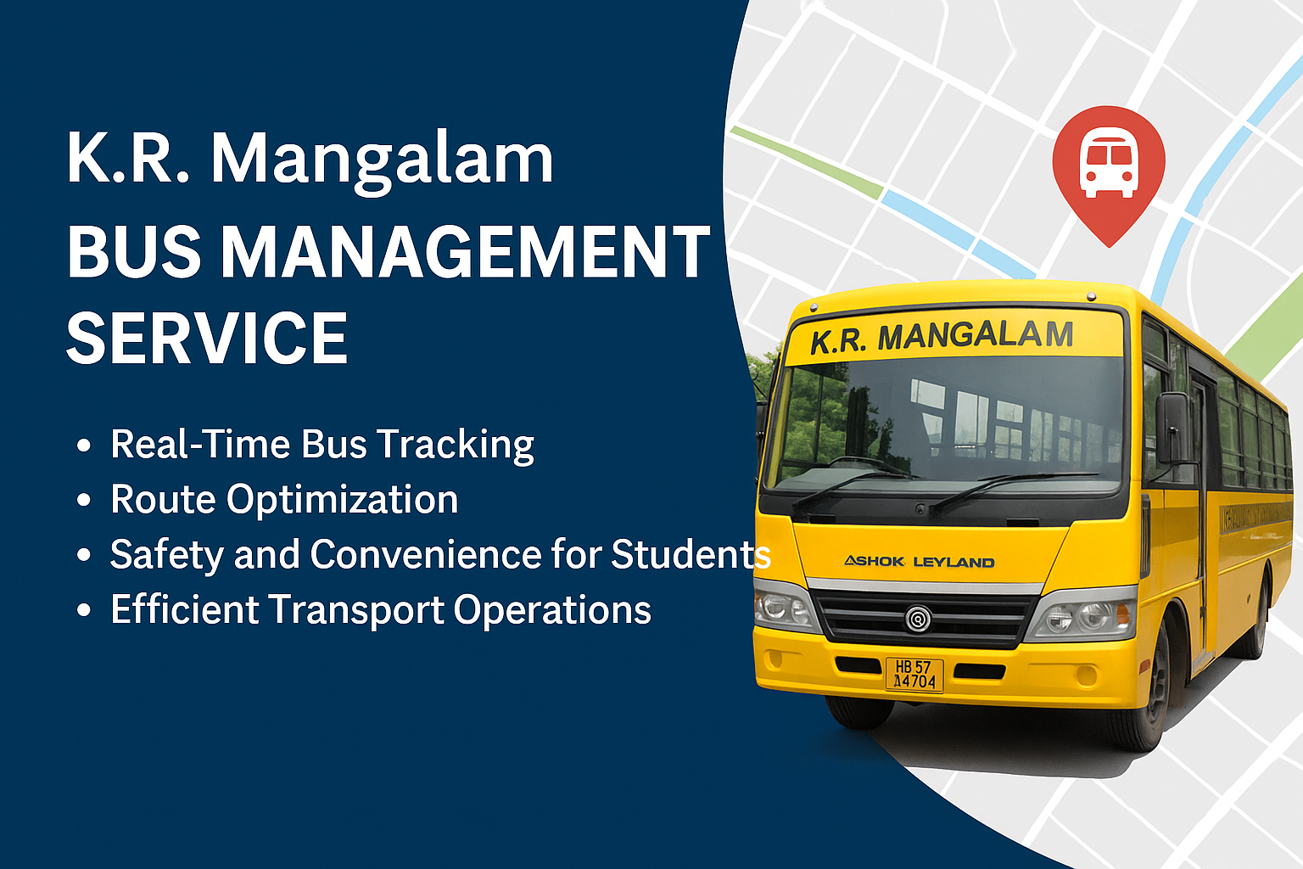

Abstract
Efficient transportation is pivotal for educational institutions to ensure timely and safe commutes for students. Recognizing challenges like unpredictable bus schedules and lack of real-time tracking, our team developed a Bus Management System (BMS) tailored for KR Mangalam University. This system leverages modern technologies to provide real-time bus tracking, route optimization, and user-friendly interfaces for students, staff, and administrators. Beyond addressing current transportation inefficiencies, the BMS is designed with scalability in mind, aiming to extend its benefits to other educational institutions and integrate with platforms like Google Maps for enhanced user experience.

Problem Statement
Traditional bus transportation systems in educational institutions often suffer from issues such as lack of real-time tracking, inefficient route management, limited communication between stakeholders, and safety concerns. Students and parents remain unaware of bus locations, leading to missed buses or prolonged waiting times. Static routes fail to adapt to changing traffic conditions, causing delays. Absence of instant communication channels between drivers, students, and administrators hampers timely updates. Without real-time monitoring, ensuring student safety during transit becomes challenging. These issues necessitate a comprehensive solution that modernizes transportation management, ensuring efficiency, safety, and reliability.

Objectives
- Implement GPS-based tracking for live bus location updates.
- Use data analytics to determine the most efficient routes.
- Develop intuitive platforms for students, parents, and staff.
- Establish instant notification systems for delays and emergencies.
- Ensure scalability to accommodate other institutions and future features.

Literature Review
Modern transportation systems have increasingly adopted technology to enhance efficiency and safety. Studies highlight the benefits of integrating GPS tracking, mobile applications, and data analytics in public transportation. For instance, SmartBus emphasizes how GPS tracking enhances student safety and fleet efficiency. Transfinder discusses future trends in school bus transportation, including the adoption of electric buses and AI-driven route planning. These insights underscore the importance of technological integration in modernizing transportation systems, especially in the educational sector.

Proposed Solution
Our Bus Management System consists of a frontend developed using HTML, CSS, and JavaScript, offering interactive maps and login portals. The backend is powered by Python (Flask framework), managing databases and communication via RESTful APIs. SQLite is used for storing schedules, routes, and user data. A mobile application built with React Native allows students to receive push notifications and submit feedback. An admin panel provides tools for route management, monitoring, and user control. This modular design allows flexibility and easy scalability.
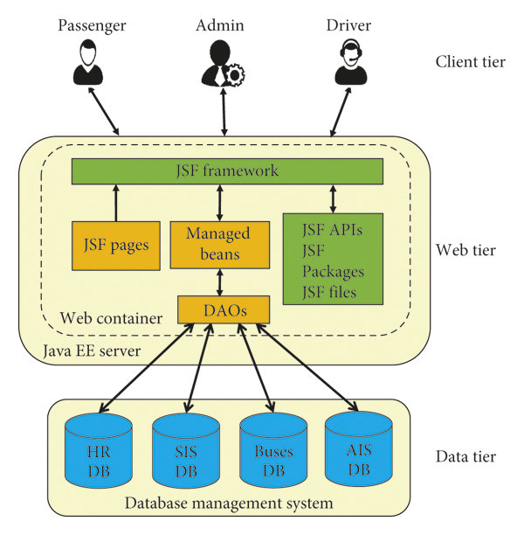

Results
Post-implementation at KR Mangalam University, the BMS showcased significant improvements in transportation efficiency and user satisfaction. The table below highlights key performance metrics before and after the system was deployed.

Metric | Before BMS | After BMS
Average Waiting Time | 15 minutes | 5 minutes
Missed Buses per Week | 10 | 2
Student Satisfaction Rate | 65% | 90%

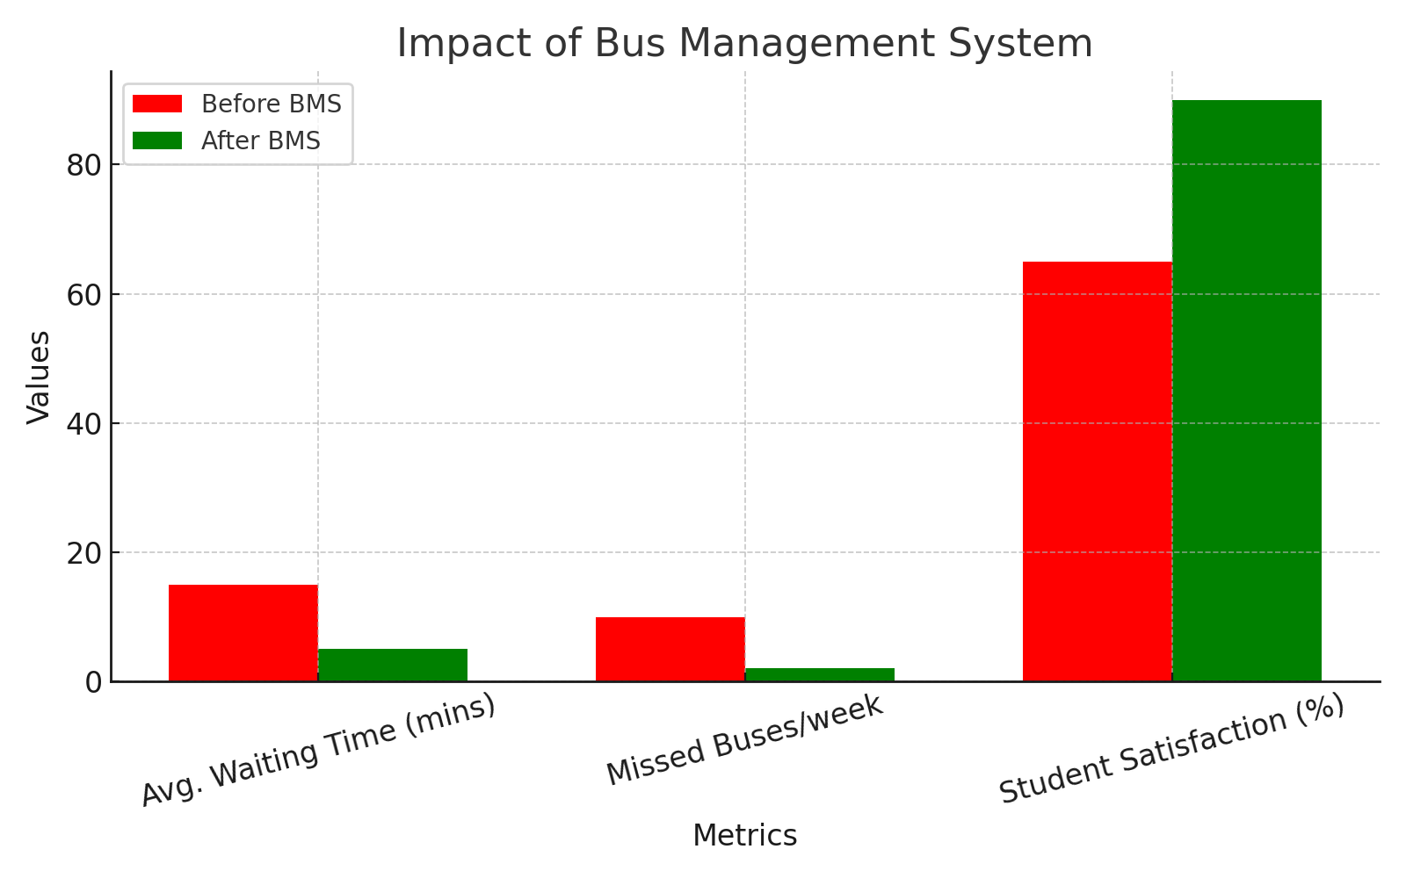

Future Scope
In the future, the BMS can be expanded to other schools and colleges, ensuring broader reach and consistent student safety. Integration with Google Maps will enhance route visualization and offer real-time traffic-based suggestions. AI-driven route planning will help optimize fuel usage and travel time. Compatibility with electric buses and dedicated parental access portals are also envisioned as part of the system’s growth trajectory.

Conclusion
The Bus Management System developed for KR Mangalam University addresses major transportation challenges through real-time tracking, efficient route management, and user-focused design. Its scalability and potential for future integrations make it a robust solution for educational transportation modernization.

