Model 6 Results — Green Bond Pricing (Greenium) Study
Common-sample specification comparison (N = 6,675) and conceptual path diagram

1. Preferred Common-Sample Comparison (N = 6,675)
All four Model 6 specifications were re-estimated on the same least-common sample of 6,675 observations so that Green coefficients are directly comparable across specifications. Standard errors are clustered by issuer.
Model | N | Green N | R² | Green Effect (bps)
M6-Core | 6,675 | 416 | 0.3070 | −7.59
M6 + Rating | 6,675 | 416 | 0.3082 | −10.53
M6 + ESG | 6,675 | 416 | 0.3072 | −8.99
M6-Full | 6,675 | 416 | 0.3083 | −11.66

The Green coefficient is negative and broadly stable across all four specifications, ranging from about −7.6 bps (Core) to −11.7 bps (Full). Adding Credit Rating and ESG does not eliminate or reverse the Green effect; it modestly increases its magnitude. R² is essentially flat across specifications (0.3070–0.3083), indicating that Rating and ESG add little incremental explanatory power once bond and market controls are already included.

Reference: Maximum-Data Runs (different sample per model — not directly comparable)
These figures use the largest available sample for each specification individually and are included only for reference; sample composition differs across rows, so coefficient changes here should not be attributed solely to the added variables.
Model | N | Green N | R² | Green Effect (bps)
M6-Core | 74,476 | 3,078 | 0.327 | +18.80
M6 + Rating | 21,595 | 965 | 0.252 | −3.33
M6 + ESG | 18,913 | 1,111 | 0.293 | −2.48
M6-Full | 6,675 | 416 | 0.308 | −11.66

2. Matched-Pair Greenium (Independent Robustness Check)
As a validation independent of the regression framework, green bonds were matched to comparable conventional bonds on issuer, currency, seniority, instrument type, issue year (±1 yr), tenor (±2 yrs), issue size, coupon, and credit rating where available.
Matched green/conventional pairs | 1,660
Unique issuers | 575
Median greenium | −0.021 bps
1%-trimmed mean greenium | −0.303 bps
95% cluster-robust CI | [−2.023, +1.417] bps

The matched-pair estimate is close to zero and its confidence interval spans zero, consistent with the regression-based finding of a small and not strongly significant Green effect.

3. Interpretation
- The Green coefficient remains negative in every common-sample specification (Core, +Rating, +ESG, Full).
- Its magnitude is modest: roughly −7.6 to −11.7 bps.
- Credit Rating and ESG do not explain away the Green effect; ESG and the Green label are related but not identical constructs.
- The fully controlled (maximum-data) Full model was not statistically significant (p ≈ 0.39; 95% CI included zero).
- The matched-pair greenium is near zero with a CI spanning zero.
Taken together, current evidence does not support a claim of a large, universal greenium. Instead, any green pricing advantage appears small and possibly conditional on issuer, certification, or market-segment characteristics — a direction for further interaction and heterogeneity analysis (Green × ESG, Green × Certification, issuer fixed effects).

4. Conceptual Path Diagram — Grouped by Construct
The ten Model 6 predictors are grouped into two theoretically motivated latent constructs plus two standalone observed variables, rather than shown as ten unrelated boxes:
- Sustainability / Green Profile (latent) ← Green Bond Label/Status, Certification, ESG Score — three different measures of the same underlying “greenness” trait.
- Credit Rating — kept as a standalone manifest predictor. With only one indicator available it cannot be treated as a separate latent construct without an unjustified fixed-loading assumption, so it is shown feeding YTM directly.
- Bond Structural / Contractual Characteristics (latent) ← Issue Size, Tenor, Coupon, Seniority, Instrument Type — the classic bundle of contractual bond terms.
- Currency × Issue Year Fixed Effects — an observed regime/market control, not a substantive latent trait, so it is kept separate.
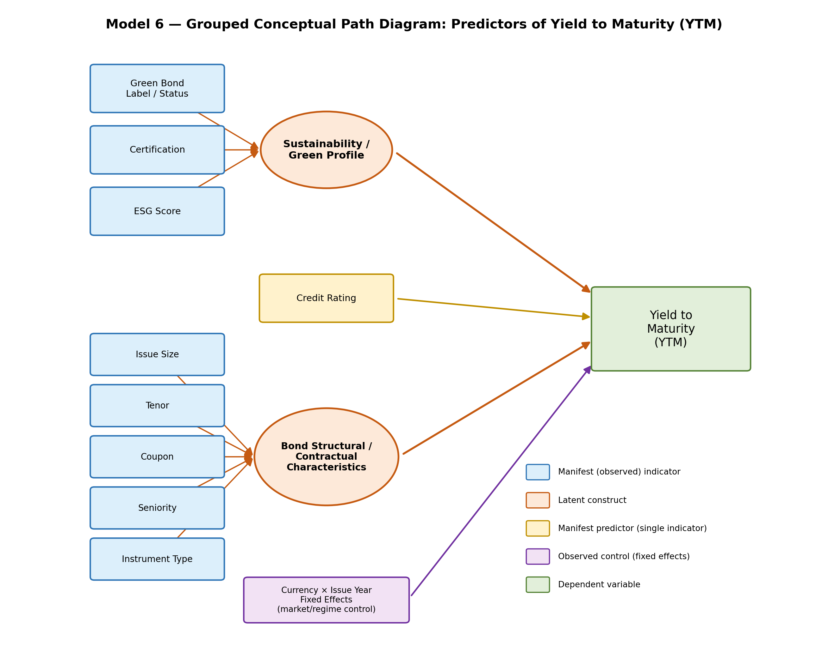
Note: blue rectangles are manifest indicators of a latent construct; orange ellipses are latent constructs (Sustainability/Green Profile; Bond Structural/Contractual Characteristics); the yellow box (Credit Rating) is a standalone manifest predictor; the purple box is the observed fixed-effects control; the rounded green rectangle is the dependent variable, Yield to Maturity (YTM).

