AQFP System Design
A Technical Reference for Adiabatic Machines
Adiabatic Quantum-Flux-Parametron Architecture, Cell Design,
EDA Flow, and AI Inference System Implementation
Adiabatic Machines, Inc.
Internal Reference Document
March 2026 - Version 1.0
CONFIDENTIAL - For Internal Use and Authorized Agents Only

Table of Contents

Chapter 1: Introduction and Physical Principles

1.1 What is AQFP?
The Adiabatic Quantum-Flux-Parametron (AQFP) is a superconducting logic family that operates by gradually transforming a potential energy landscape from a single-well to a double-well configuration. Unlike conventional RSFQ (Rapid Single Flux Quantum) logic, which switches rapidly and dissipates energy on the order of I_c * Phi_0 per operation, the AQFP exploits slow, quasi-static switching driven by RF excitation. The system remains near its potential energy minimum throughout the switching process, and the dissipated energy scales linearly with the ratio of the junction response time to the excitation rise time. This is the fundamental mechanism that enables operation at energy levels approaching the thermodynamic limit.
AQFP logic encodes binary information as the direction of circulating current in a superconducting loop containing Josephson junctions. A "1" corresponds to persistent current in one direction; a "0" corresponds to the opposite. The state is determined during each clock cycle by the combination of the excitation signal (which raises the potential barrier) and the input signal (which biases the system toward one well). Once the barrier is fully raised, the state is latched until the next clock cycle lowers it again.

1.2 The Adiabatic Switching Principle
The switching energy of a single AQFP gate is given by:
E_sw = 2 * Ic * Phi_0 * (tau_j / tau_x)
where I_c is the junction critical current, Phi_0 is the magnetic flux quantum (2.07 x 10^-15 Wb), tau_j is the junction characteristic time determined by the junction capacitance and critical current, and tau_x is the excitation rise time (equal to 1/(2f) for a sinusoidal clock at frequency f). The key insight is that as the clock frequency decreases (tau_x grows), the switching energy decreases proportionally. In the true adiabatic limit, dissipation approaches zero.
In practice, the key experimental energy measurement for AQFP is 1.4 zJ per junction (equivalently, 24 k_B*T at 4.2 K) in an AQFP adder at 5 GHz, reported by Takeuchi et al. (2019). This result, obtained by direct calorimetric measurement on an AIST 10 kA/cm^2 process, remains the primary experimental benchmark for AQFP switching energy. An earlier resonator-based measurement by the same group (Takeuchi 2013) yielded approximately 10 zJ per gate at 5 GHz. The MANA microprocessor paper (Ayala 2021) cites the 1.4 zJ/JJ figure but does not report an independent energy measurement; its contribution is the demonstration of a complete 4-bit processor with 21,460 JJs, operational at 100 kHz and with a breakout execution-stage chip verified at 2.5 GHz. This per-junction energy of ~1.4 zJ is roughly five orders of magnitude below the per-transistor switching energy of modern CMOS.
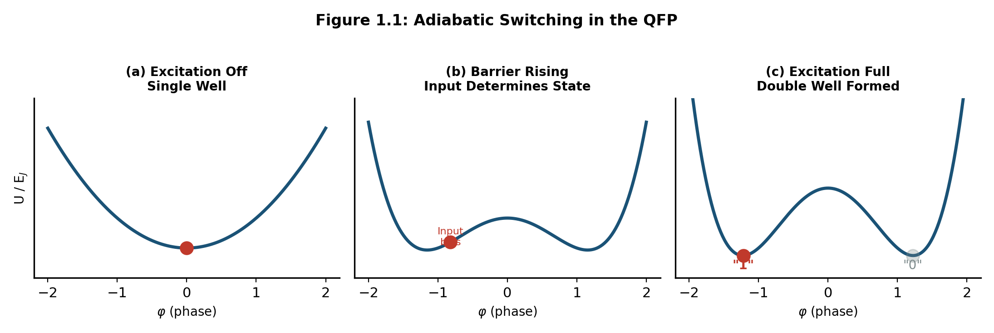
Figure 1.1: Adiabatic switching in the QFP. The potential energy landscape transitions from single-well (excitation off) to double-well (excitation on). The input bias determines which well the system settles into.

1.3 Thermodynamic Context
The Landauer limit for irreversible computation at 4.2 K is k_B*T*ln(2) = 0.04 zJ (4.0 x 10^-23 J). The measured 1.4 zJ/JJ (Takeuchi 2019) corresponds to about 24 k_B*T, or roughly 35 times the Landauer limit. This figure includes switching dissipation, clock network losses, and the thermodynamic cost of irreversible logic operations. Sub-k_B*T total-system operation has been simulated but has not been experimentally verified; any claims of sub-Landauer system operation should be treated with appropriate skepticism absent direct calorimetric data.
For system-level analysis, the relevant figure of merit is not gate-level energy alone but rather total power divided by throughput, accounting for the overhead of cryogenic cooling (typically 300-1000x at 4 K for a Gifford-McMahon or pulse tube cryocooler). Despite this penalty, the enormous advantage at the gate level (roughly 10,000-35,000x vs. CMOS per switching event) means AQFP-based systems can still achieve substantial net energy efficiency gains for workloads with high arithmetic intensity, such as matrix multiplication in AI inference.
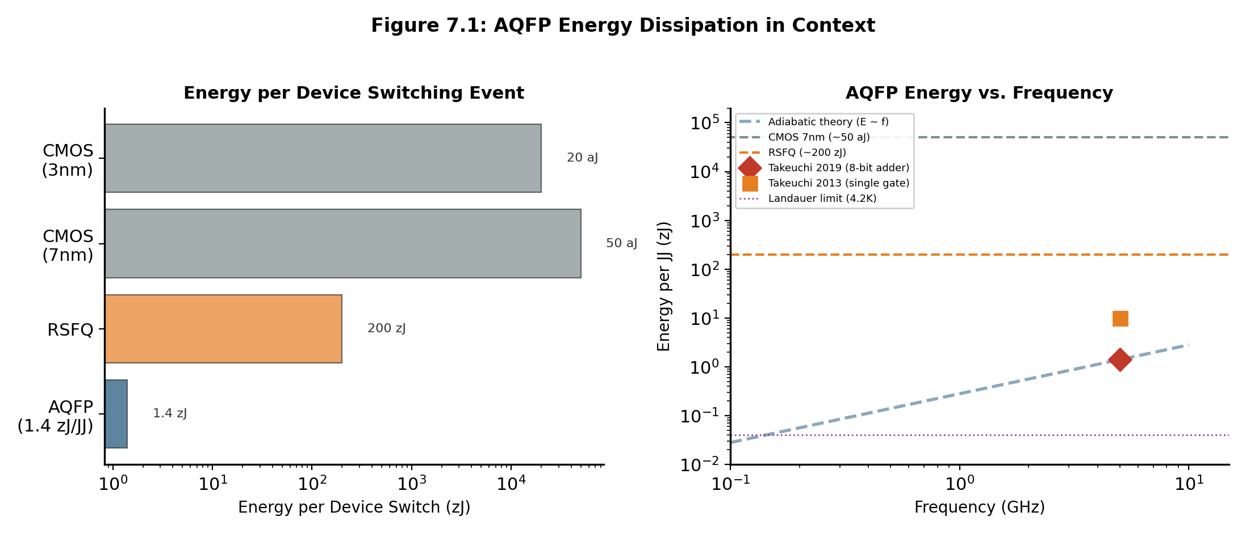
Figure 7.1: AQFP energy dissipation in context. Left: comparison across logic families. Right: AQFP energy versus frequency with measured data points.

1.4 Josephson Junction Physics
The Josephson junction (JJ) is the active device in all superconducting electronics. In AQFP circuits, each gate contains a DC SQUID: a superconducting loop interrupted by two JJs. The SQUID acts as a tunable barrier; its effective critical current is modulated by the magnetic flux threading the loop. The key parameters are:
Parameter | Symbol | Typical Value (SFQ5ee) | Notes
Critical current density | J_c | 10 kA/cm^2 | Sets JJ size for target I_c
Junction capacitance | C_s | ~50 fF/um^2 | Specific capacitance
Flux quantum | Phi_0 | 2.07 x 10^-15 Wb | Universal constant
McCumber parameter | beta_c | Process-dependent | Damping regime
Junction diameter | d_JJ | 0.5 - 2.0 um | SFQ5ee range

For the MIT-LL SFQ5ee process, junctions are externally shunted with Mo or MoNx resistors, which provides controlled damping and RSFQ-compatible design rules. In contrast, the AIST HSTP process uses unshunted junctions with intrinsic subgap damping (quality factor Q ~ 180), which yields lower energy dissipation per switching event but requires more careful bias optimization. At Adiabatic Machines, our primary development target is SFQ5ee, with AIST process compatibility maintained through parameterized cell generators.

1.5 Operating Margins and Thermal Noise
A critical practical concern for AQFP circuits is the excitation margin: the range of excitation amplitude over which the gate operates correctly. Simulations at 0 K predict margins of +/-26%, but measurements at 4.2 K consistently show degraded margins of roughly +/-19.4%. This ~25% reduction is caused by thermal noise in the junction, which introduces stochastic phase fluctuations that can cause the system to settle in the wrong potential well.
All designs at Adiabatic Machines must target a minimum of +/-20% excitation margin at the typical-typical (TT) process corner. This provides adequate room for process variation (typically +/-10% in J_c and inductance) while accounting for the measured margin degradation at operating temperature. Margins must be verified by JSIM or JoSIM simulation with thermal noise models enabled at 4.2 K. Quoting simulation margins at 0 K without thermal correction is not acceptable for design sign-off.
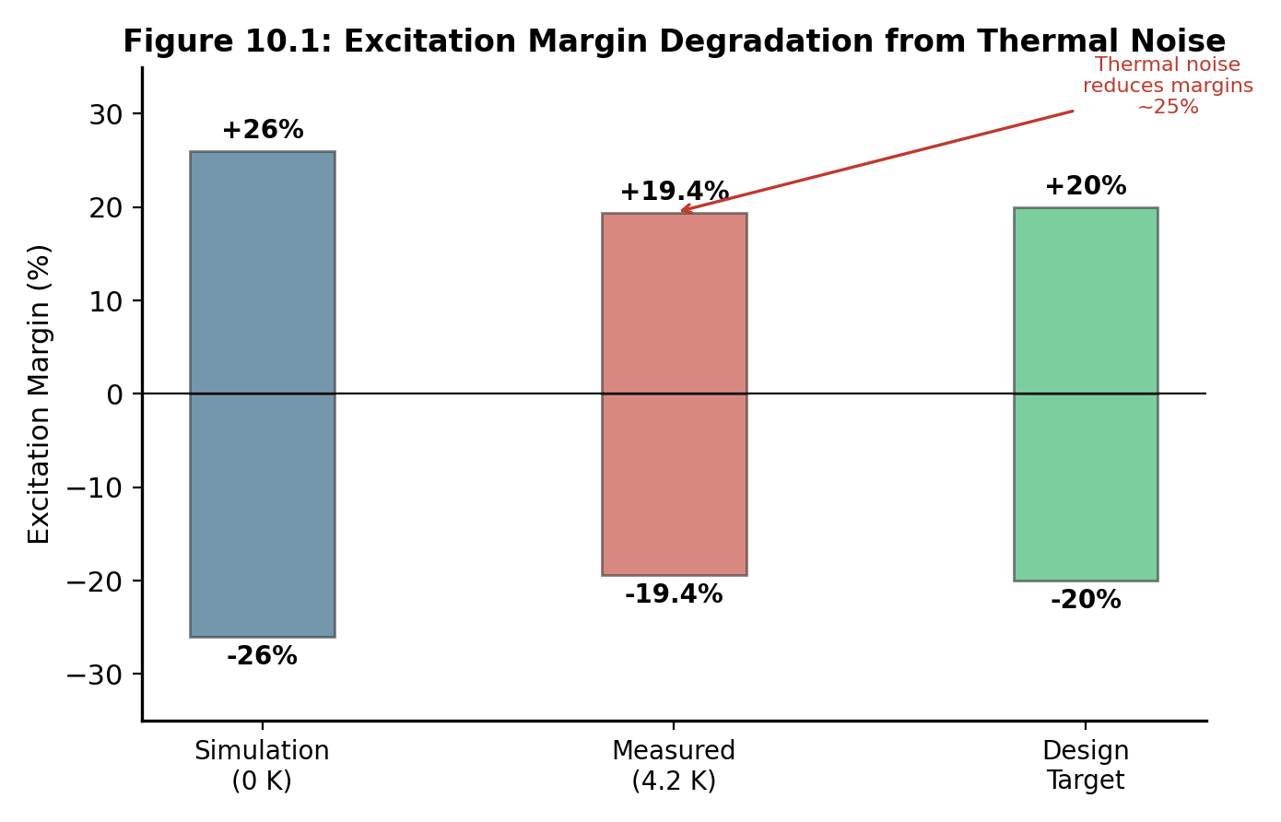
Figure 10.1: Excitation margin degradation from thermal noise. Simulation at 0 K overpredicts margins by roughly 25% compared to measurement at 4.2 K.

Chapter 2: Fabrication Process and Layer Stack

2.1 MIT Lincoln Laboratory SFQ5ee
The primary fabrication process for AQFP development in the United States is MIT Lincoln Laboratory's SFQ5ee process. This is a niobium-based superconductor integrated circuit process with 8 metal layers, Nb/AlO_x-Al/Nb Josephson junctions at 10 kA/cm^2 critical current density, and 250 nm minimum feature size. The process was originally developed for RSFQ logic but has been successfully adapted for AQFP circuits, most notably in the compact cell designs demonstrated by He et al. (2020), which achieved a 30% area reduction by exploiting the full 8-metal-layer stack.
For AQFP purposes, the critical layers are M4 through M7. M4 and M7 serve as ground planes, establishing the stripline environment that shields signals on the intermediate routing layers. M5 carries the Josephson junctions, SQUID loops, and primary signal routing. M6 provides additional routing and clock distribution. The dielectric layers (I4, I5, I6) are SiO_2 at approximately 200 nm thickness each.
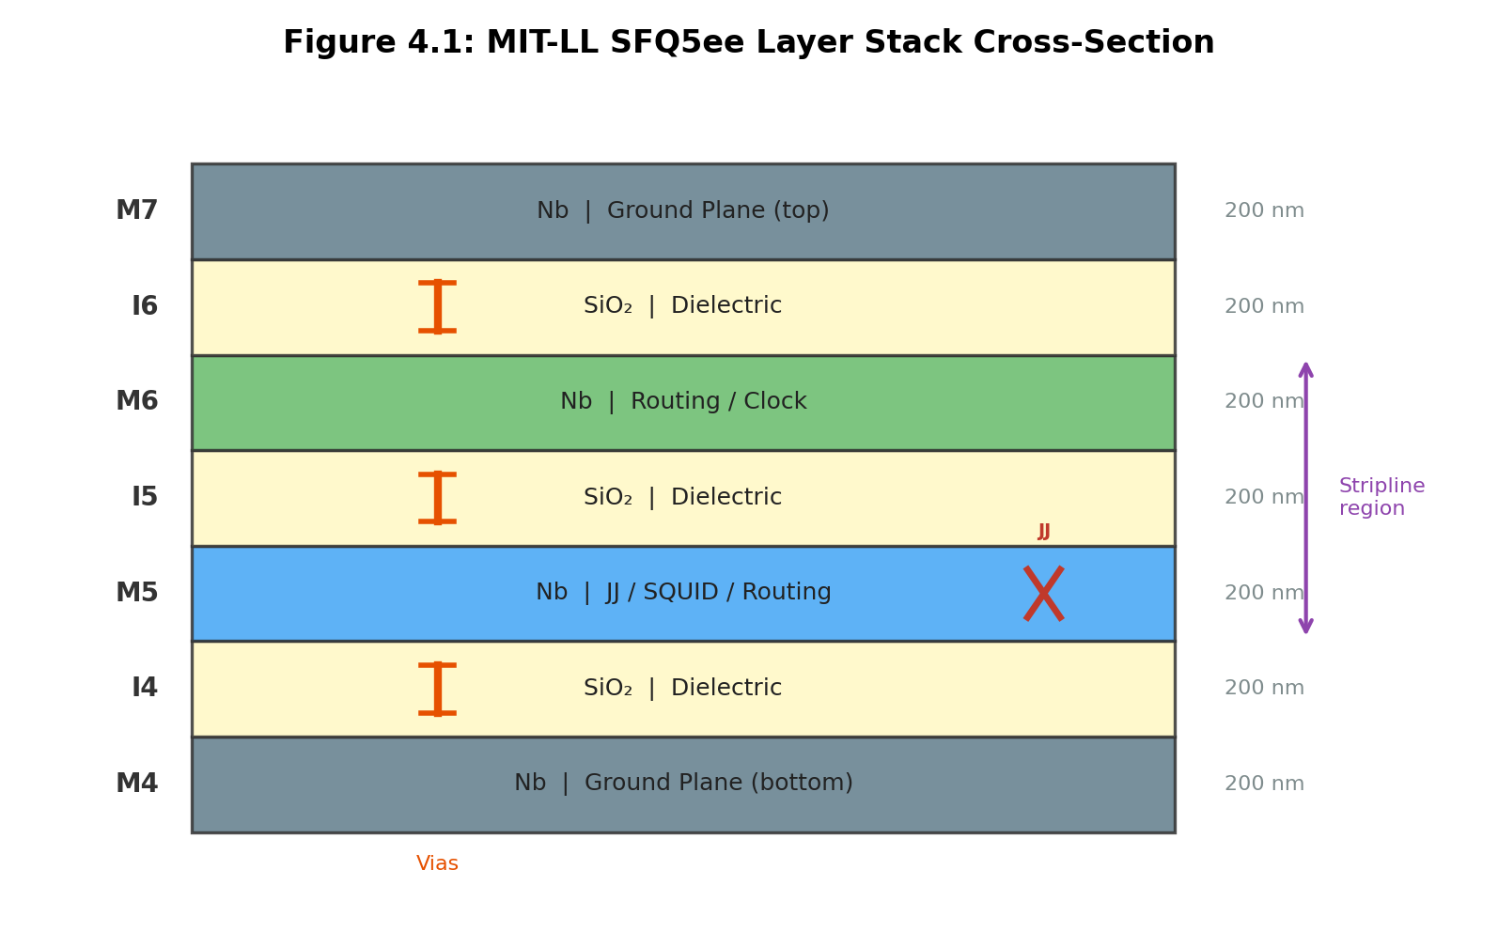
Figure 4.1: MIT-LL SFQ5ee layer stack cross-section. The M4-M7 layers form the active region for AQFP circuits, with stripline routing between ground planes.

2.2 Layer Stack Detail
Layer | Material | Function | Thickness
M7 | Nb | Ground plane (top) | 200 nm
I6 | SiO2 | Interlayer dielectric | 200 nm
M6 | Nb | Routing, clock distribution | 200 nm
I5 | SiO2 | Interlayer dielectric | 200 nm
M5 | Nb | JJ layer, SQUID loops, routing | 200 nm
I4 | SiO2 | Interlayer dielectric | 200 nm
M4 | Nb | Ground plane (bottom) | 200 nm

2.3 Design Rules
The SFQ5ee process imposes the following minimum geometry constraints:
Parameter | Value
Minimum linewidth | 250 nm
Minimum spacing | 250 nm
Via size | 250 x 250 nm
Via overlap (enclosure) | 50 nm minimum
JJ diameter range | 0.5 - 2.0 um

2.4 Inductance and Coupling
Inductance design is central to AQFP cell layout. For a niobium trace routed as a stripline between M4 and M7 ground planes, the sheet inductance on M5 and M6 is approximately 0.13 pH/square. For a stripline between both ground planes, the effective inductance is roughly 0.26 pH/square. The inductance of a trace scales approximately linearly with length and inversely with width, though ground plane effects (image currents) and kinetic inductance contributions modify these estimates. All inductance values used in design must be verified by 3D extraction using InductEx or FastHenry.
Transformer coupling coefficients, denoted k, are the most critical parameters in AQFP cell design. The coupling coefficient between two inductors is k = M / sqrt(L1 * L2), where M is the mutual inductance. Typical target values are k_in = 0.3 to 0.5 for input coupling, k_out = +/-0.3 for output coupling (sign determines buffer vs. inverter behavior), and k_x1, k_x2 = 0.3 for symmetric excitation. The constant cell uses asymmetric excitation coupling (k_x1 = 0.25, k_x2 = 0.35) to bias the output toward a fixed value.

2.5 Process Corners
Robust designs must account for process variation. The standard five-corner analysis includes TT (typical-typical), FF (fast-fast with +10% J_c and -10% inductance), SS (slow-slow with -10% J_c and +10% inductance), FS, and SF cross-corners. The target is +/-20% excitation margin at the TT corner, which provides sufficient guardband for the FF and SS extremes. Process corner simulation must be part of every cell sign-off.

2.6 AIST Processes
For reference and compatibility, the AIST STP2 process (2.5 kA/cm^2, 1.0 um minimum feature, 4 Nb layers) and HSTP process (10 kA/cm^2, 0.5 um minimum feature, 4 Nb layers, unshunted junctions) are also relevant. Most published AQFP experimental results, including the Takeuchi 2019 energy measurement and the Ayala 2021 MANA microprocessor, used AIST processes. The cell library generators at Adiabatic Machines are parameterized to support both SFQ5ee and AIST process variants through a common PDK abstraction layer.

2.7 Flux Trapping and Mitigation
When a superconducting circuit is cooled through its critical temperature (T_c ~ 9.2 K for niobium) in the presence of an ambient magnetic field, magnetic flux can become trapped in the superconducting ground planes. These trapped flux vortices create parasitic currents that shift the operating point of nearby SQUIDs and can cause gate failures. Mitigation requires two complementary approaches: shielding during cooldown and moat design in the layout.
Shielding is achieved with mu-metal enclosures that reduce the ambient field to below 1 uT at the chip location during the transition through T_c. A slow cooldown rate through the critical temperature further reduces trapping probability. With proper moat design (ground plane openings at cell boundaries only, never under transformer structures), operation probabilities of 95-100% have been demonstrated with residual field tolerance of 0.5-1.2 uT.
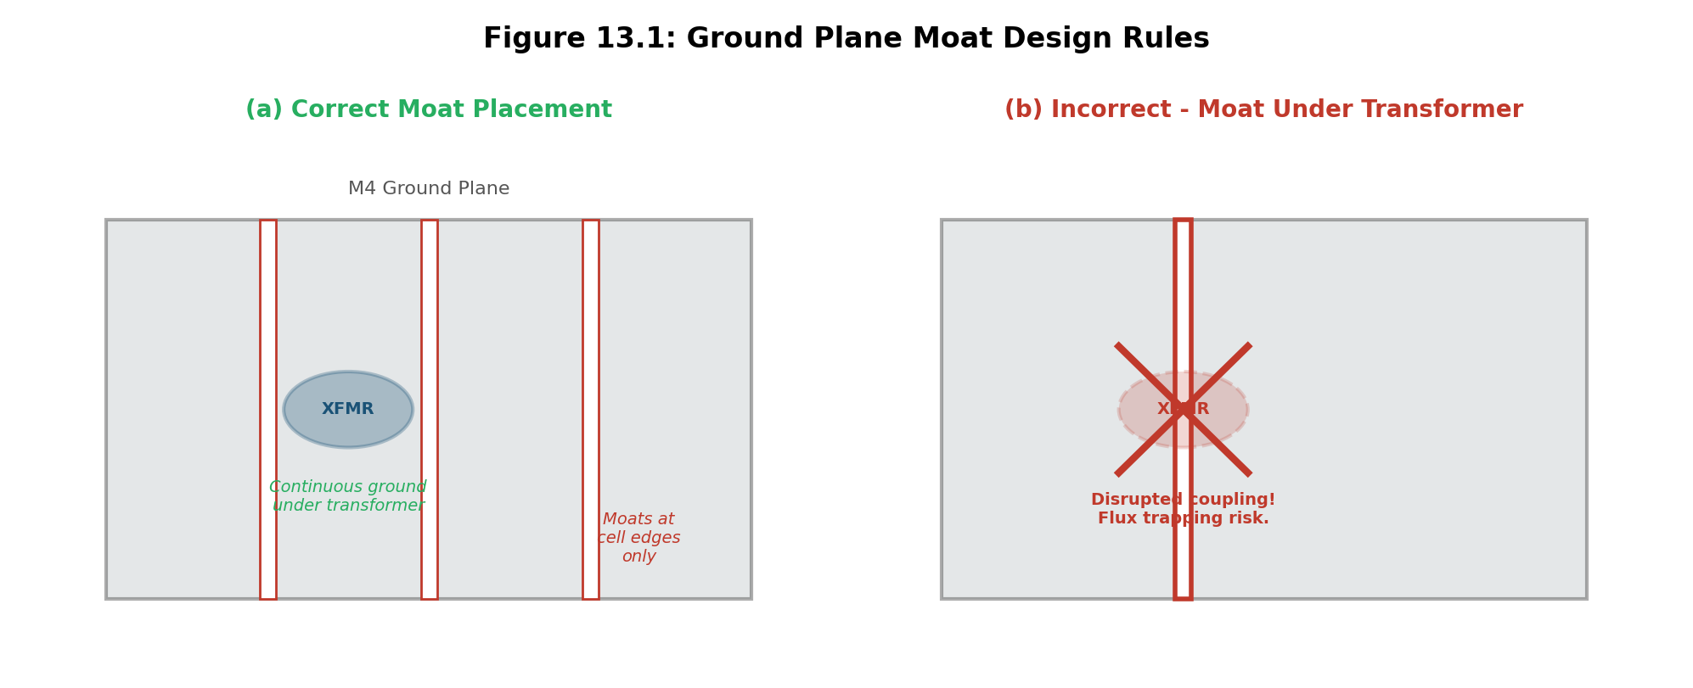
Figure 13.1: Ground plane moat design rules. Moats must be placed only at cell boundaries (a), never under transformer structures (b), to avoid disrupting magnetic coupling.

Chapter 3: Cell Library Design

3.1 The Minimalist Cell Library
AQFP logic synthesis is based on a minimalist cell library consisting of exactly four subcells: buffer (BUF), inverter (INV), constant (CONST), and branch (BR). Every Boolean function is constructed from combinations of these four primitives. This approach, formalized by Takeuchi et al. (2015), simplifies the design flow by reducing the number of unique physical cells that must be characterized and verified, while still providing complete logical functionality through majority-based synthesis.
Each subcell contains a DC SQUID with two Josephson junctions (the branch cell contains two SQUIDs, for a total of four JJs). The subcells differ only in the sign and symmetry of their transformer coupling coefficients, which determine whether the cell buffers, inverts, generates a constant, or splits its output.
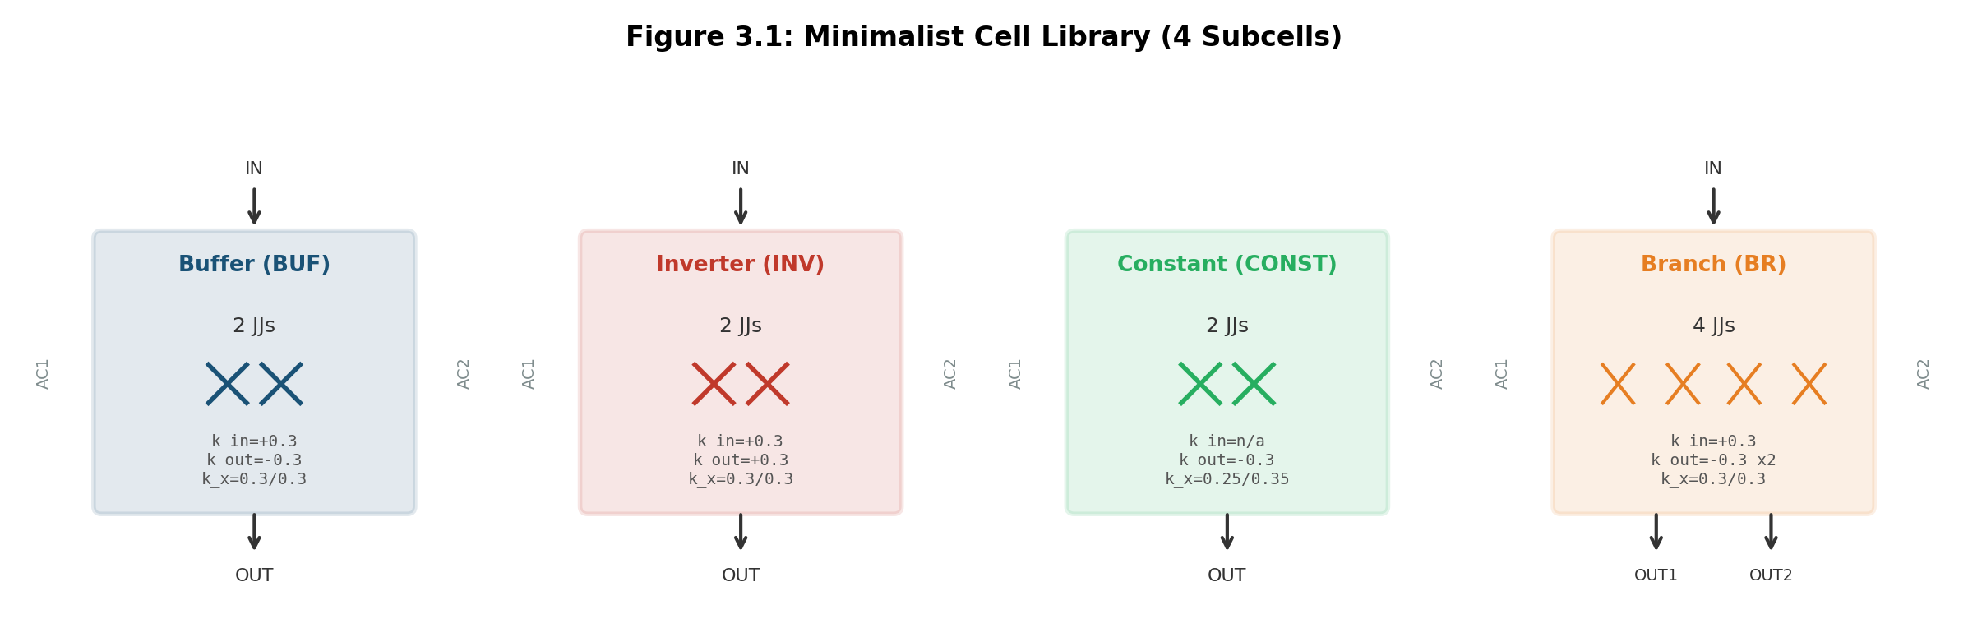
Figure 3.1: The four fundamental subcells of the minimalist AQFP cell library, showing JJ count and coupling coefficients.

3.2 Subcell Specifications

3.2.1 Buffer (BUF)
The buffer regenerates a signal without changing its polarity. It contains 2 JJs in a single SQUID. The input transformer couples with k_in = +0.3, and the output transformer couples with k_out = -0.3 (negative sign preserves the signal phase after accounting for the SQUID's intrinsic inversion). Symmetric excitation coupling (k_x1 = k_x2 = 0.3) ensures unbiased switching. The compact buffer cell (He 2020) occupies 15 x 20 um in the SFQ5ee process.

3.2.2 Inverter (INV)
The inverter is physically identical to the buffer except that the output coupling sign is flipped: k_out = +0.3. This reverses the output polarity relative to the input. The inverter occupies the same 15 x 20 um footprint and shares all other electrical parameters with the buffer.

3.2.3 Constant (CONST)
The constant cell generates a fixed logic value (0 or 1) by using asymmetric excitation coupling: k_x1 = 0.25 and k_x2 = 0.35. This imbalance biases the SQUID toward one potential well regardless of any (absent) input signal. The output value depends on the direction of the DC bias rail, which means the physical orientation of the constant cell within a row determines whether it produces a 0 or a 1. This coupling between cell orientation and DC rail direction is a critical detail that the placement algorithm must respect.

3.2.4 Branch (BR)
The branch cell provides fanout-of-two by driving two separate output transformers from a single SQUID pair. It contains 4 JJs (two SQUIDs). For higher fanout, branch cells are cascaded: fanout of N requires ceil(log2(N)) levels of branching, each adding one clock phase of latency. Minimizing unnecessary branching is a key optimization target because branch cells represent a significant fraction of the total JJ count in large circuits.

3.3 Boolean Gate Construction
All Boolean gates are built by combining subcells with a majority gate (MAJ3) as the fundamental logic primitive. The majority gate outputs the value held by at least two of its three inputs. Boolean operations are mapped as follows: AND(a,b) = MAJ(a, b, 0) using a constant-0 input; OR(a,b) = MAJ(a, b, 1) using a constant-1 input; NAND and NOR add an inverter to the output of AND and OR respectively. XOR requires a cascade of three majority gates and is consequently more expensive in both JJ count and latency.
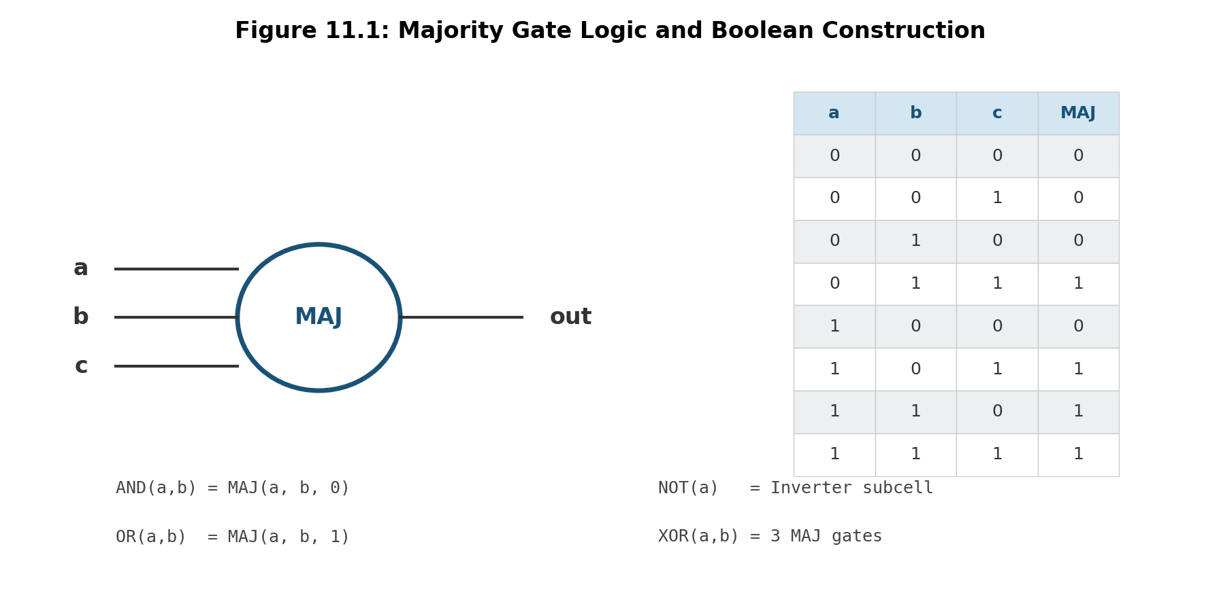
Figure 11.1: Majority gate logic and Boolean gate construction from subcell combinations.

3.4 JJ Count by Gate Type
Gate | JJ Count | Subcell Composition
Buffer | 2 | 1x BUF
Inverter | 2 | 1x INV
Constant | 2 | 1x CONST
Branch | 4 | 2x SQUID (fanout=2)
AND / OR | 6 | MAJ + CONST
NAND / NOR | 8 | MAJ + CONST + INV
MAJ3 | 6 | Single majority gate
XOR | 18 | 3x MAJ cascade
Half Adder | 24 | XOR + AND
Full Adder | 48 | 2x HA + OR

A notable consequence of this gate hierarchy is that buffer and branch cells, which perform no computation, often dominate the total JJ count of a design. In large circuits, buffers alone can account for more than 90% of all JJs due to path balancing requirements. This is the single largest overhead in AQFP system design and the primary motivation for retiming optimizations that reduce buffer insertion.

3.5 Cell Interface Standard
All cells in the library follow a standard interface convention: inputs enter from the top edge, outputs exit from the bottom edge, and clock/excitation rails (AC1, AC2, DC) connect on the left and right edges. Cells within the same row abut side-by-side and share the same clock phase. This row-based organization directly maps to the 4-phase clocking scheme, where Row N is assigned Phase (N mod 4), and data flows strictly from Row N to Row N+1.

3.6 Programmatic Cell Generation
At Adiabatic Machines, cell layouts are generated programmatically using gdsfactory with process-specific PDK parameters. Each cell is defined as a parameterized Python function decorated with @gf.cell, which provides automatic caching and composability. The generation pipeline follows a constraint-driven loop: an initial layout is generated from transformer templates, inductances and coupling coefficients are extracted using InductEx, the extracted values are compared against schematic targets, and the layout geometry is iteratively adjusted until all parameters converge within tolerance (typically +/-0.02 on k values, +/-5% on inductances). Visual renders are exported at each iteration for inspection.

Chapter 4: Clocking Architecture

4.1 Four-Phase Clocking
AQFP circuits use a four-phase AC clocking scheme in which two RF excitation signals (AC1 and AC2) are phase-shifted by 90 degrees relative to each other. Combined with the physical direction of the clock rail meander (left-to-right vs. right-to-left), this produces four distinct clock phases that repeat every four rows:
Phase 0 uses AC1 with the rail meandering to the right. Phase 1 uses AC2 meandering right. Phase 2 uses AC1 meandering left. Phase 3 uses AC2 meandering left. The phase assignment determines the timing at which each row's gates latch their inputs, and data propagation strictly follows the phase ordering: a gate in Phase N can only drive gates in Phase (N+1) mod 4.
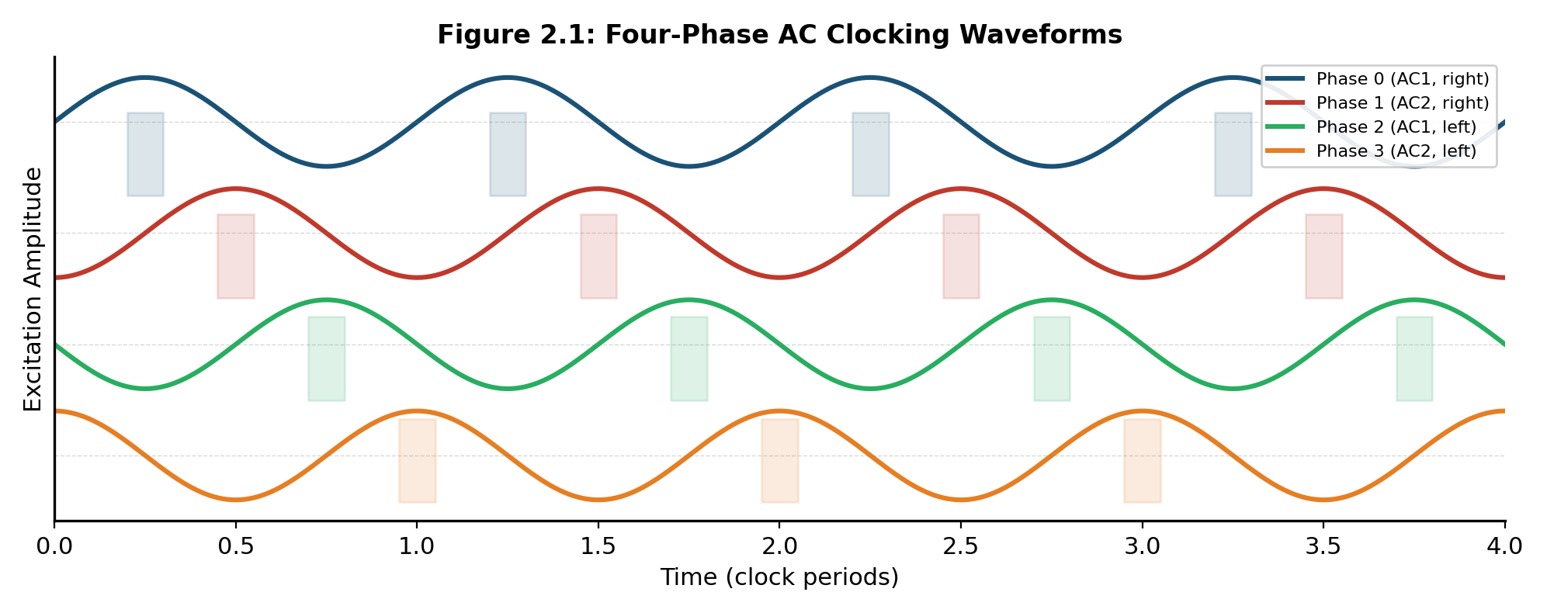
Figure 2.1: Four-phase AC clocking waveforms showing the excitation signals for each phase. Data is captured at the rising edge of each phase.

4.2 Clock Distribution Layout
The clock distribution network consists of three meander rails that wind through the chip: AC1, which meanders through rows assigned to Phases 0 and 2; AC2, which meanders through rows assigned to Phases 1 and 3; and a DC bias rail, which meanders through all rows and provides the static flux bias that determines constant cell output values and excitation polarity.
The meandering layout serves a dual purpose. First, it distributes the excitation signal to all cells in a row with minimal skew, since all cells in a row tap the same physical wire. Second, the direction of the meander (left-to-right vs. right-to-left) determines whether the excitation phase is 0 or 180 degrees, which is how the four phases are generated from only two RF sources.
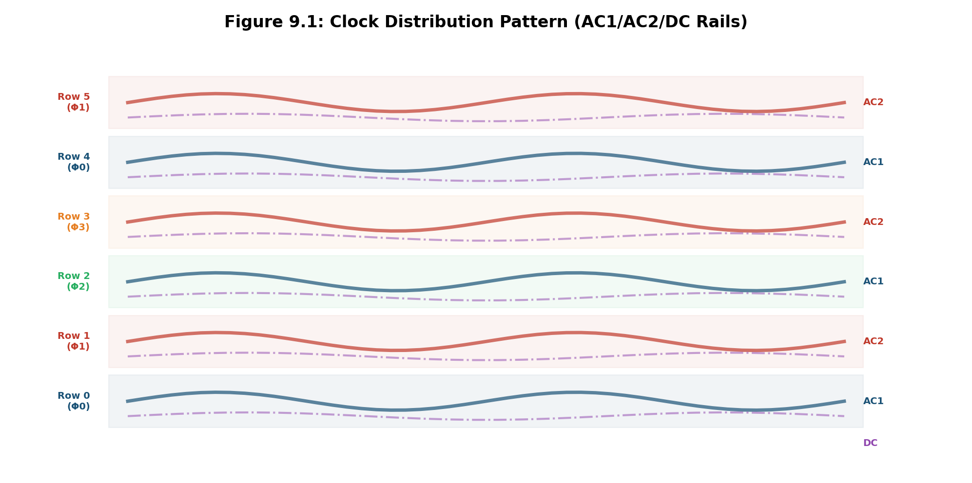
Figure 9.1: Clock distribution pattern showing AC1, AC2, and DC rail meanders through the row-based layout.

4.3 Clock Skew Management
Clock skew becomes problematic in large circuits because the meander wires have finite propagation delay. The standard mitigation is to divide the chip into grid blocks, each with its own local clock distribution. Inter-block timing is synchronized at boundaries, and the maximum block size is set by the acceptable skew budget for the target frequency. The highest frequency demonstrated for large AQFP circuits is 2.5 GHz; single gates have been measured at 5 GHz. The practical frequency limit is set by clock distribution rather than device physics.

4.4 Pipeline Threading
A direct consequence of 4-phase clocking is that the pipeline naturally supports "pipeline threading," in which up to four independent data streams can be interleaved through the same physical hardware. In each clock cycle, a different thread occupies each pipeline stage, and because the stages are clocked in strict phase order, there is no conflict between threads. This yields a throughput multiplier of approximately 3.4x (accounting for pipeline fill/drain overhead) compared to single-stream operation.
Pipeline threading is architecturally significant for the Adiabatic Machines systolic array because it means a single physical array can process four independent matrix tile computations simultaneously, dramatically increasing the utilization of the hardware. The data controller must manage the interleaving of activation and weight streams across threads, but the datapath itself requires no additional hardware beyond what single-stream operation demands.
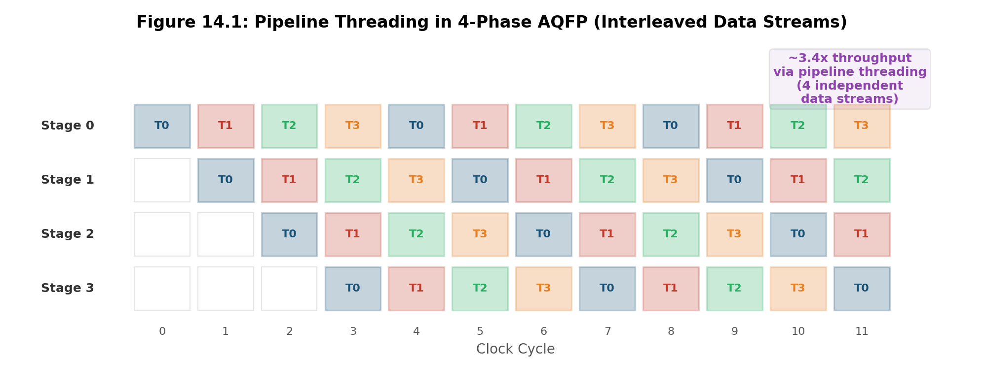
Figure 14.1: Pipeline threading in 4-phase AQFP. Four independent data streams (T0-T3) are interleaved across pipeline stages, achieving ~3.4x throughput improvement.

Chapter 5: EDA Design Flow

5.1 RTL-to-GDS Overview
The AQFP design flow transforms a hardware description in RTL (Verilog or similar) into a fabrication-ready GDS layout. The flow passes through several distinct stages: logic synthesis, majority conversion, buffer and splitter insertion, path balancing, row-based placement, channel routing, clock generation, verification, and GDS output. Each stage has constraints unique to AQFP that differ substantially from conventional CMOS flows, and the toolchain at Adiabatic Machines is purpose-built to handle these constraints.
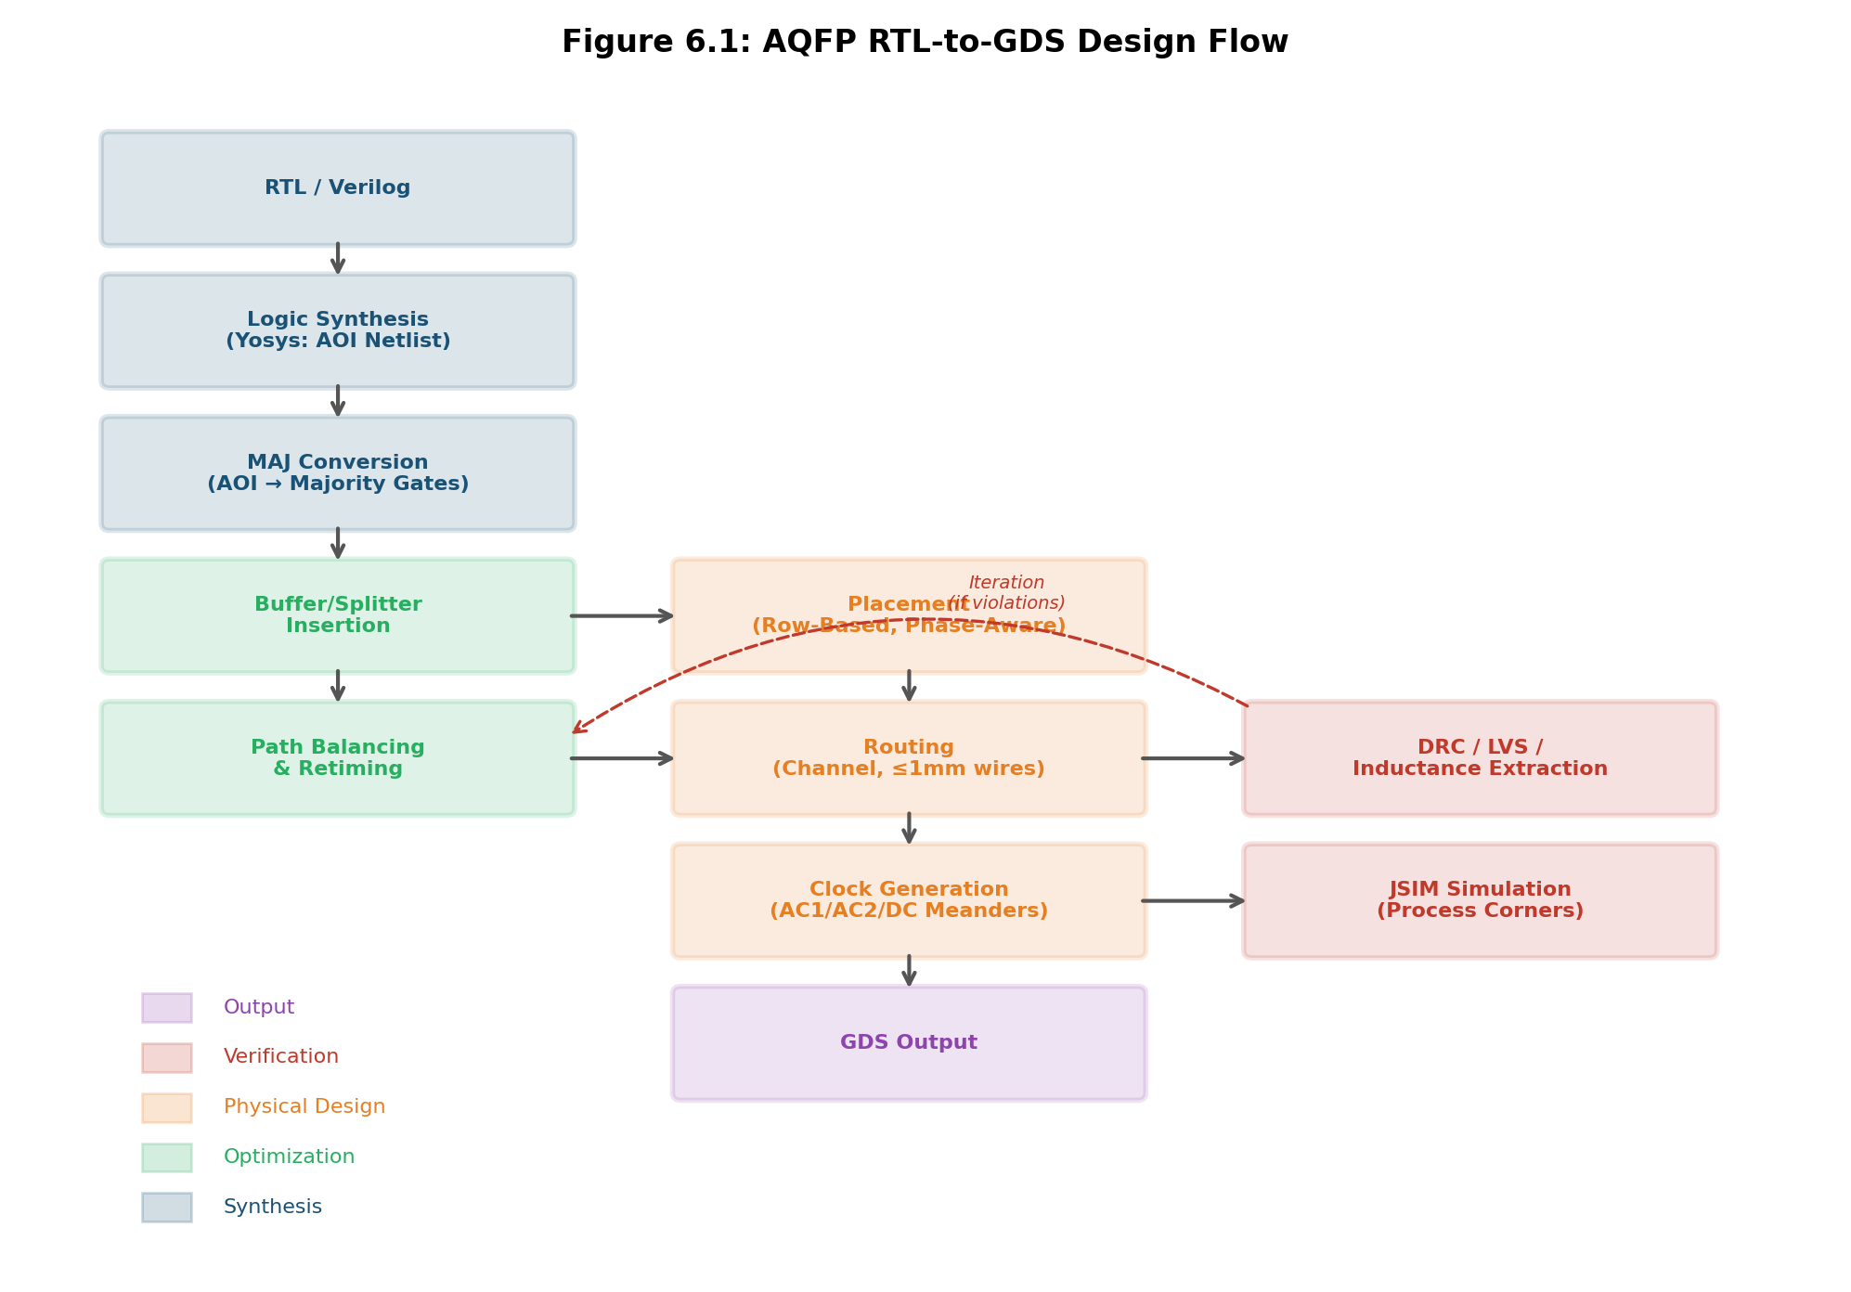
Figure 6.1: AQFP RTL-to-GDS design flow showing synthesis, optimization, physical design, and verification stages.

5.2 Logic Synthesis
The first stage uses Yosys (an open-source synthesis tool) to compile RTL into an AND-OR-Inverter (AOI) netlist. This netlist is then converted to a majority-based representation, where each logic operation is expressed as a composition of three-input majority gates. The majority mappings are:
AND(a,b) = MAJ(a, b, 0)
OR(a,b) = MAJ(a, b, 1)
NAND(a,b) = NOT(MAJ(a, b, 0))
NOR(a,b) = NOT(MAJ(a, b, 1))
XOR(a,b) = MAJ(NOT(a), b, MAJ(a, NOT(b), 0))

Optimization at this stage focuses on reducing the total number of majority gates (and consequently JJ count) through algebraic simplification. Tools from the EPFL majority-based synthesis framework and the ColdFlux library (80+ cells, Synopsys integration) are available for this purpose.

5.3 Buffer and Splitter Insertion
After majority synthesis, buffers and splitters must be inserted to satisfy two hard constraints. First, the maximum wire length between any two connected cells is 1 mm; beyond this, signal attenuation causes logic errors. Buffers must be inserted at intermediate points to regenerate signals on longer routes. Second, any net with fanout greater than 1 requires a branch (splitter) cell, and higher fanout requires cascaded branches.
Each buffer adds exactly one clock phase of pipeline latency. This means that all paths between a common source and destination must be balanced to the same number of pipeline stages, or the logic will produce incorrect results due to data arriving at different times. Path balancing is achieved by inserting additional buffers on the shorter paths, which is straightforward but expensive: buffer overhead can exceed 90% of the total JJ count in large, unoptimized designs.

5.4 Retiming
Retiming is the most effective optimization for reducing buffer overhead. By redistributing pipeline registers (which in AQFP correspond to clock-phase boundaries) across the circuit graph, retiming can reduce buffer count by 14-37% (Ayala 2020). The key insight is that moving a register from one side of a gate to the other can equalize path lengths without adding buffers, as long as the register movement preserves the functional correctness of the circuit. More aggressive retiming algorithms that exploit the N-phase clocking structure can achieve even larger improvements (31-74% reduction reported in the literature).

5.5 Placement
Placement assigns cells to physical locations on the chip. AQFP placement is fundamentally row-based: each cell is assigned to a row determined by its clock phase, and cells in the same row are arranged side-by-side. The objectives are to minimize total wirelength, avoid wire crossings, and respect the 1 mm maximum wire length constraint. Genetic algorithm-based placement (Tanaka 2019) and simulated annealing are both used.
The placement algorithm must also handle vertical routing channels for feedback paths and accommodate the clock meander layout. Tetris-based legalization resolves overlaps and snaps cells to the placement grid.
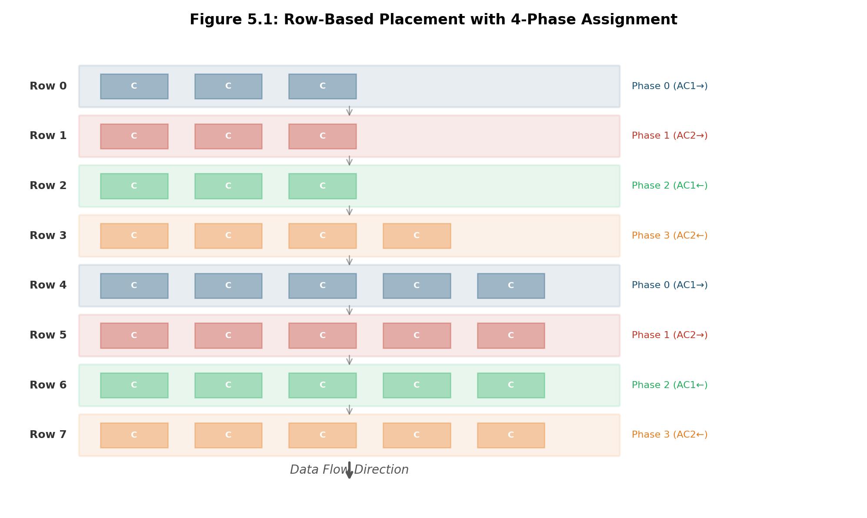
Figure 5.1: Row-based placement with 4-phase assignment. Cells are placed in rows by clock phase, and data flows strictly downward through the row stack.

5.6 Routing
Routing connects the outputs of one row's cells to the inputs of the next row's cells through inter-row channels. Signal routing uses M5 for horizontal segments and M6 for vertical segments, both within the M4-M7 stripline environment. The A* routing algorithm used in SuperFlow (2024) incorporates a timing-aware cost function that penalizes routes approaching the 1 mm limit and automatically inserts boosters for routes that cannot avoid exceeding it.
For interconnects longer than 1 mm, booster cells (Mizushima 2023) can extend the maximum wire length to 3.9 mm. However, each booster adds latency and power, so the routing algorithm prefers shorter paths. Routing must avoid passing under active cells to prevent parasitic magnetic coupling.

5.7 Verification
Verification consists of four checks, all of which must pass before a design is considered ready for fabrication:
Design Rule Check (DRC) verifies that all geometric constraints (minimum width, spacing, via enclosure, moat placement) are satisfied. DRC is performed using KLayout with a rule deck specific to the SFQ5ee process.
Layout vs. Schematic (LVS) compares the extracted netlist from the layout against the original schematic. For AQFP, LVS must verify not only connectivity but also inductance and coupling coefficient values, since these directly affect circuit behavior. InductEx provides the extraction, and a custom comparison tool checks each parameter against its target with specified tolerances.
Inductance Extraction uses InductEx (or FastHenry for frequency-dependent analysis) to compute all self- and mutual inductances in the layout. This is the most computationally expensive verification step but is essential because AQFP functionality is entirely determined by inductance ratios and coupling coefficients. Extracted values typically need to match targets within +/-5% for inductances and +/-0.02 for coupling coefficients.
Circuit Simulation uses JSIM or JoSIM to verify that the circuit operates correctly across all five process corners with thermal noise models enabled at 4.2 K. The simulation must confirm that excitation margins exceed +/-20% at the TT corner.

Chapter 6: System Architecture for AI Inference

6.1 The Systolic Array
Adiabatic Machines is developing an AQFP-based systolic array optimized for AI inference workloads, specifically large language model (LLM) serving. The architecture is designed around the computational structure of matrix-vector and matrix-matrix multiplication, which account for the dominant fraction of compute time and energy in transformer-based models.
Each processing element (PE) in the systolic array performs three operations: an FP4 multiply (4-bit floating-point weight times activation), a barrel shifter dequantization (converting the FP4 product to a wider integer representation), and a wide integer accumulate. This design eliminates the need for an FP4 adder within each PE, which would be prohibitively expensive in JJ count. Instead, floating-point conversion is performed only at the edge of the array, where the accumulated integer results are converted back to floating-point format for output.
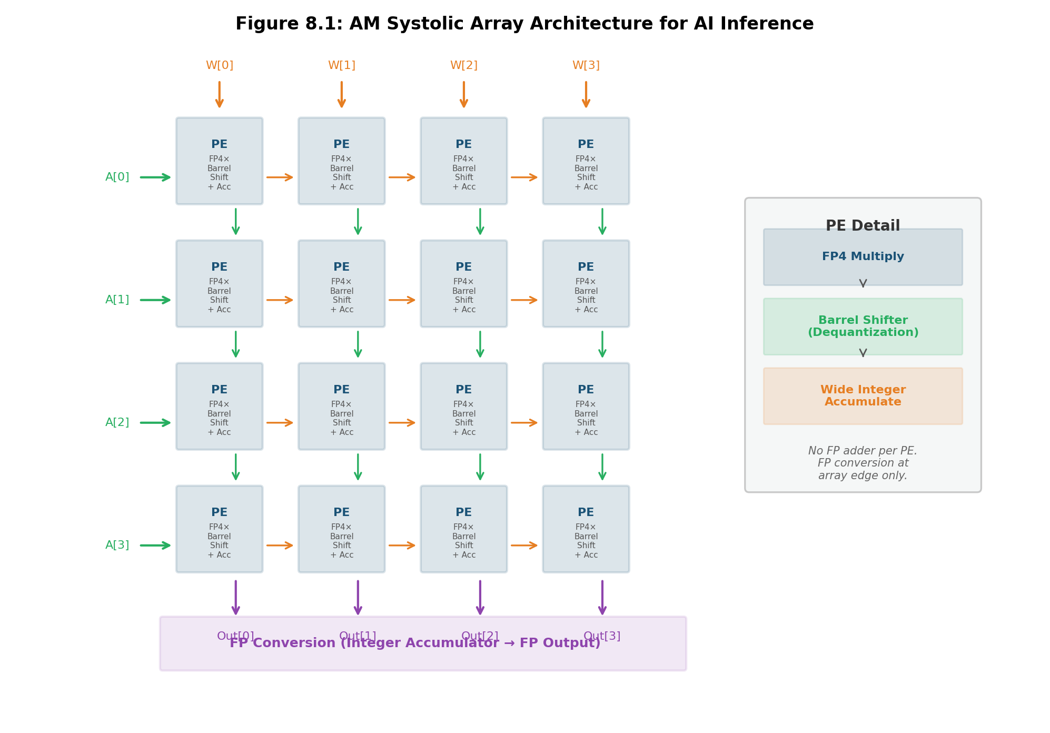
Figure 8.1: AM systolic array architecture. Each PE performs FP4 multiply, barrel shift dequantization, and wide integer accumulation. FP conversion occurs only at the array edge.

6.2 PE Microarchitecture
The PE microarchitecture reflects a series of deliberate tradeoffs to minimize JJ count and energy while maintaining sufficient numerical precision for LLM inference at FP4. The three stages are:
FP4 Multiply: The multiplier takes a 4-bit floating-point weight and a 4-bit floating-point activation as inputs. The FP4 format provides sufficient dynamic range for quantized LLM weights; recent work on LLM quantization has shown that FP4 achieves comparable perplexity to FP8 and INT8 for inference on large models.
Barrel Shifter Dequantization: The FP4 product is converted to a fixed-point integer representation by shifting the mantissa according to the combined exponent. The barrel shifter is the natural AQFP implementation of this operation, using a cascade of multiplexer stages. This is one of the areas where the v0.3 architecture spec resolved a critical dataflow correctness issue: 4-bit weight recirculation loops were introduced to ensure that the barrel shifter receives correctly aligned data on every cycle.
Wide Integer Accumulate: The shifted product is accumulated into a wide integer register (sufficient width to avoid overflow for the target tile size). Integer addition is substantially cheaper than floating-point addition in AQFP, both in JJ count and in pipeline depth, because there is no need for alignment shifting or renormalization. This is the key architectural insight that makes the edge-only FP conversion strategy viable.

6.3 Dataflow and Weight Recirculation
In the v0.3 architecture specification, a dataflow correctness bug was identified and resolved. The issue arose from the interaction between the 4-phase pipeline and the weight delivery schedule: weights arriving from memory must be synchronized with the activation stream such that each PE receives the correct weight on the correct pipeline thread. The solution was to introduce 4-bit weight recirculation loops within each PE, which store and re-present weights across pipeline phases. This recirculation mechanism is a direct consequence of pipeline threading; without it, weight data would arrive misaligned with the corresponding activation data.
The discovery of pipeline threading itself emerged from this dataflow analysis and yields a throughput improvement of approximately 3.4x for the systolic array. The threading mechanism allows four independent tile computations to share the same physical array, which is critical for achieving the target inference throughput.

6.4 I/O Architecture
Moving data between the room-temperature host system and the cryogenic AQFP processor is one of the primary engineering challenges for any superconducting computing system. Adiabatic Machines has adopted an optical I/O architecture based on two key components:
Input (optical to AQFP): PIN photodiodes operated in photovoltaic mode directly drive AQFP inputs. In photovoltaic mode, the photodiode generates a current proportional to incident optical power without requiring external bias circuitry, which is critical because any bias current would introduce parasitic heat load at 4 K. The photocurrent from a standard telecom-grade PIN diode at moderate optical power levels is sufficient to switch an AQFP gate.
Output (AQFP to optical): Direct-drive VCSELs (Vertical-Cavity Surface-Emitting Lasers) are used as the near-term output path. The AQFP output current directly modulates the VCSEL, producing an optical signal that is coupled into fiber for transmission to the room-temperature receiver. The energy cost of this conversion is estimated at 3-6 pJ/bit, which is the dominant contributor to per-bit I/O energy and sets the floor for system-level efficiency.
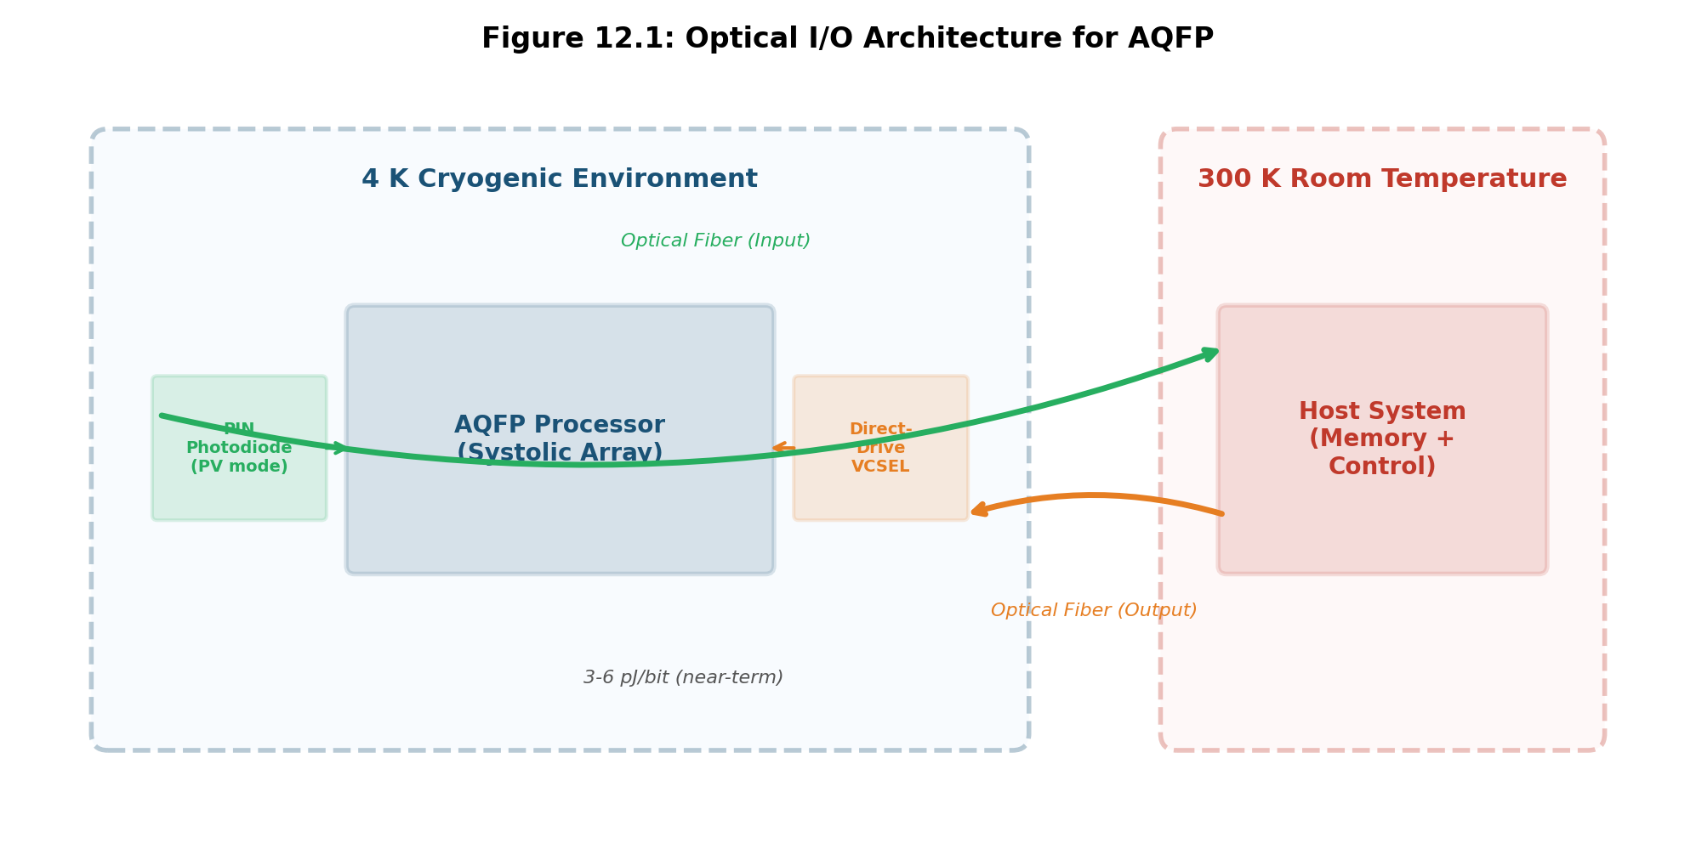
Figure 12.1: Optical I/O architecture showing PIN photodiode input and direct-drive VCSEL output paths between the 4K cryogenic and 300K room-temperature environments.

6.5 Performance Projections
Compute intensity and memory bandwidth analysis shows that for Llama 7B at FP4 precision, a KF25 vacuum flange port (the standard cryogenic I/O interface) achieves a compute-to-communication ratio R of approximately 9, which is sufficient to keep the systolic array fed at full throughput for the matrix multiplication kernels. Under these conditions, the projected inference throughput is approximately 2,340 tokens per second at roughly 5 W total system power (including cryocooler overhead), yielding an energy efficiency of approximately 470 tokens/sec/W. This represents roughly a 10x energy efficiency advantage over the NVIDIA B200 at comparable batch sizes, based on the technoeconomic model developed at Adiabatic Machines with an estimated 85% total cost of ownership (TCO) advantage.
These projections are based on measured AQFP gate energies and validated cell-level performance; they are not extrapolations from simulation alone. However, they do assume successful integration of the full systolic array, optical I/O, and cryogenic packaging, none of which have been demonstrated at scale for this specific architecture. The projections should be understood as design targets subject to the risks inherent in any deep-tech hardware development program.

Chapter 7: Cryogenic System Design

7.1 Cooling Systems
AQFP circuits operate at 4.2 K, the boiling point of liquid helium at atmospheric pressure. The practical cooling solution for a deployed system is a closed-cycle cryocooler, either Gifford-McMahon (GM) or pulse tube. Adiabatic Machines has experience with Sumitomo GM cryocoolers, which provide reliable cooling to 4 K with second-stage cooling power on the order of 1 W. For the target system, the total heat load budget at 4 K includes the chip power dissipation (milliwatts for the AQFP logic), wiring thermal conduction, optical fiber thermal load, and any residual radiation from the thermal shields.
The cooling overhead factor (the ratio of room-temperature electrical power consumed by the cryocooler to the heat removed at 4 K) is typically 300-1000x for small GM systems. This factor improves with scale: larger cryocoolers and multi-stage systems can achieve 200-300x, and liquid helium plants operate at even lower ratios. System-level energy efficiency calculations must always include this overhead.

7.2 Magnetic Shielding
Superconducting circuits are extremely sensitive to ambient magnetic fields. The Earth's field (~50 uT) is sufficient to cause widespread flux trapping and gate failure. Shielding is implemented in multiple layers: a room-temperature mu-metal shield (FINEMET or similar high-permeability alloy) reduces the field by a factor of 100-1000x; a superconducting lead foil shield at 4 K provides an additional shielding factor. The target residual field at the chip is below 1 uT during the cooldown through T_c.

7.3 Packaging
The chip is mounted in a cryogenic package that provides electrical connections (for DC bias, test points, and low-frequency control signals), optical connections (fiber arrays for data I/O), and thermal anchoring to the cryocooler cold stage. The package design must minimize thermal conduction from higher-temperature stages while providing sufficient I/O density. The KF25 vacuum flange is the standard interface for connecting the cryogenic insert to the vacuum system.

Chapter 8: Software and EDA Toolchain

8.1 Tool Ecosystem
The Adiabatic Machines EDA toolchain combines open-source and custom tools. The core tools are:
Tool | Function | Notes
Yosys | Logic synthesis (RTL to AOI) | Open source
Custom MAJ mapper | AOI to majority conversion | Internal tool
gdsfactory | Parametric cell layout generation | Python, open source
KLayout | Layout viewing, DRC, structural LVS | Open source, Python API
InductEx | Inductance and coupling extraction | 3D solver, licensed
JoSIM / JSIM | Circuit simulation | Open source / legacy
Custom placer/router | Row-based placement, channel routing | Internal tools
SuperFlow | RTL-to-GDS automation | Academic, reference implementation

8.2 EDA Workbench
The EDA workbench is a browser-based tool built with React, TypeScript, FastAPI, and D3.js. It provides a visual interface for the AQFP design flow with a plugin architecture organized around a Suite Map landing page. The workbench integrates cell layout viewing, simulation result inspection, and design rule checking into a unified environment. It uses KLayout as the primary layout editor, extended with Python plugins for AQFP-specific operations.
The workbench is designed to serve both human designers and coding agents. The API layer exposes all design operations as JSON-RPC endpoints, allowing automated design flows to be scripted in Python. For coding agents specifically, the key interfaces are: cell specification input (YAML format), layout generation trigger, extraction and LVS result retrieval, and simulation launch and result parsing.

8.3 Cell Library Generator
The cell library generator consumes a schematic specification in YAML format (derived from an optimized JSIM netlist) and produces a physical GDS layout. The specification includes junction critical currents, inductor values, coupling coefficient targets with tolerances, and port definitions. The generator uses gdsfactory's @gf.cell decorator for cached, parameterized cell creation, and follows a constraint-driven optimization loop:
The loop proceeds as follows. First, an initial layout is generated from transformer geometry templates (stacked spiral, interleaved, or overlay, depending on the coupling type). Second, InductEx extraction computes the actual inductances and coupling coefficients. Third, extracted values are compared against targets. Fourth, if any parameter is out of tolerance, the layout geometry is adjusted (trace length for inductance, overlap area or spacing for coupling). Fifth, this process repeats until convergence or a maximum iteration count is reached. Visual renders (PNG exports) are generated at regular intervals for inspection, either by a human designer or by an LLM supervisor in an automated flow.

8.4 Simulation and Verification Workflow
Simulation is performed with JoSIM (preferred, open source) or JSIM. The standard verification sequence is: first, simulate the cell at nominal process parameters with thermal noise disabled to verify basic functionality; second, re-simulate with thermal noise at 4.2 K to measure realistic excitation margins; third, sweep all five process corners (TT, FF, SS, FS, SF) to verify margin adequacy; fourth, if the cell is part of a larger circuit, perform a full-chip simulation with extracted parasitics. The margin threshold for sign-off is +/-20% at the TT corner with thermal noise enabled.

Chapter 9: Design Guidelines and Constraints

9.1 Critical Design Rules
This section summarizes the hard constraints that every AQFP design at Adiabatic Machines must satisfy. These rules are non-negotiable and must be checked at every stage of the design flow.
Constraint | Value / Rule | Consequence of Violation
Maximum wire length | 1 mm (3.9 mm with booster) | Signal attenuation, logic error
Minimum excitation margin | +/-20% at TT corner | Process yield loss
Moat placement | Cell boundaries only | Flux trapping, coupling disruption
Ground plane continuity | No breaks under transformers | Coupling coefficient error
Path balancing | All paths equal latency | Data misalignment, logic error
Buffer insertion | Every wire > 1 mm | Signal loss
Fanout handling | Branch cell for every FO > 1 | Signal degradation
Thermal noise verification | Simulate at 4.2 K | Overoptimistic margin estimate
Process corner coverage | All 5 corners | Yield risk
Inductance extraction | InductEx or FastHenry | Coupling parameter error

9.2 Performance Parameters
Parameter | Measured / Demonstrated | Source
Energy per JJ (measured) | 1.4 zJ (24 kBT) at 5 GHz | Takeuchi 2019 (8-bit adder)
Energy per gate (earlier) | ~10 zJ at 5 GHz | Takeuchi 2013 (single gate)
Gate latency (4-phase) | 50 ps/gate | Tutorial review (Takeuchi 2022)
Max demonstrated frequency | 2.5 GHz (large circuits) | Clock-distribution limited
Excitation margins (measured) | +/-19.4% at 4.2 K | Ayala 2020
Compact buffer area | 15 x 20 um | He 2020 (SFQ5ee)
Booster extended range | 3.9 mm | Mizushima 2023
Buffer reduction (retiming) | 14-37% | Ayala 2020

9.3 Naming and Terminology Conventions
For consistency across documentation, code, and communication, the following terminology conventions apply at Adiabatic Machines:
The device is referred to as "AQFP" (not QFP, SFQ, or RSFQ). The company abbreviation is "AM." The fabrication process is "SFQ5ee" (not SFQ5 or SFQ5-ee). The four subcells are "buffer/BUF," "inverter/INV," "constant/CONST," and "branch/BR." The coupling coefficients use underscored notation: k_in, k_out, k_x1, k_x2. Clock phases are numbered 0-3, and rows are numbered starting from 0. The pipeline threading mechanism is referred to as "pipeline threading" (not "multi-threading" or "interleaving," to avoid confusion with CPU threading concepts).

Chapter 10: References and Bibliography

10.1 Confidence Tiers
The AQFP literature is organized into confidence tiers based on the level of experimental validation. Tier 1 papers include direct energy measurement data and represent the highest confidence. Tier 2 papers demonstrate fabricated circuits without energy measurement. Tier 3 papers present simulation results correlated against previous experimental work. Tier 4 papers are purely theoretical or simulation-based. When citing performance claims, always reference the tier and note any discrepancies between simulation and measurement.

10.2 Tier 1: Experimental with Energy Measurement
Takeuchi 2019: "An adiabatic superconductor 8-bit adder with 24kBT energy dissipation per junction," Appl. Phys. Lett. 114, 042602 (2019). Key result: 1.4 zJ/JJ (= 24 kBT at 4.2 K) at 5 GHz, measured by direct calorimetry on an AIST 10 kA/cm^2 process. This is the only direct energy measurement of a multi-gate AQFP circuit and remains the primary experimental benchmark for AQFP switching energy.
Takeuchi 2013: "Measurement of 10 zJ energy dissipation of adiabatic quantum-flux-parametron logic using a superconducting resonator," Appl. Phys. Lett. 102, 052602 (2013). Key result: ~10 zJ per gate at 5 GHz via resonator-based measurement on AIST STP2 process. This was the first direct energy measurement of an AQFP gate.
Ayala 2021: "MANA: A monolithic adiabatic integration architecture microprocessor using 1.4-zJ/op unshunted superconductor Josephson junction devices," IEEE J. Solid-State Circuits 56(4), 1152-1165 (2021). Key result: first complete AQFP microprocessor (21,460 JJs, 4-bit, RISC/dataflow hybrid), operational at 100 kHz with a breakout execution-stage chip demonstrated at 2.5 GHz. The 1.4 zJ/JJ figure in the title and abstract is cited from the Takeuchi 2019 measurement, not an independent measurement performed on MANA itself. The paper's primary contribution is the system-level demonstration, not energy characterization.

10.3 Tier 2: Experimental Demonstration
Ayala 2020: Semi-custom design methodology with +/-30% excitation margins. Validated design flow and cell library on AIST 10 kA/cm^2.
He 2020: Compact cell design achieving 30% area reduction (15 x 20 um buffer) on MIT-LL SFQ5ee process.
Tanaka 2023: Full RTL-to-GDS flow with Synopsys integration, demonstrated on 1024-bit adders with >2M JJs (design only, not fabricated at that scale).

10.4 Tier 3-4: Simulation and Theory
Murai 2017: EDA tool development establishing the 1 mm wire length constraint and genetic algorithm placement.
Takeuchi 2015: Minimalist cell library (4-subcell architecture) with JSIM-validated margins.
Mizushima 2023: Booster cells extending interconnect range to 3.9 mm (simulation-based).
SuperFlow 2024: Fully-automated RTL-to-GDS flow with 12.8% wirelength improvement (benchmark validation, no fabrication).
Takeuchi 2022: Tutorial review providing comprehensive theoretical background.

10.5 Historical Foundations
Likharev 1977: First superconductor adiabatic device (parametric quantron). Theoretical foundation for reversible computing.
Goto 1987: Original QFP (Quantum Flux Parametron) invention. ERATO project demonstrating the adiabatic switching principle.

10.6 Key Discrepancies to Note
Several areas of the AQFP literature contain claims that are not fully supported by experimental evidence. Sub-kBT operation has been simulated but never measured. Operating frequencies above 5 GHz are theoretical projections, not demonstrated results. System-level energy efficiency varies 400-1000x depending on cooling overhead assumptions. Excitation margins at 0 K overpredict measured margins at 4.2 K by approximately 25%. Any design documentation or investor-facing material produced at Adiabatic Machines must accurately distinguish between measured results (Tier 1-2) and simulation/theoretical projections (Tier 3-4).

Appendix A: Quick Reference Card
This appendix provides a condensed reference for the most frequently needed parameters, suitable for printing or embedding in coding agent system prompts.

A.1 Physical Constants
Constant | Symbol | Value
Flux quantum | Phi_0 | 2.07 x 10^-15 Wb
Boltzmann constant | k_B | 1.38 x 10^-23 J/K
Landauer limit (4.2K) | kBT ln(2) | 0.04 zJ (4.0 x 10^-23 J)
Niobium T_c | T_c | 9.2 K

A.2 SFQ5ee Process Quick Reference
Parameter | Value
J_c | 10 kA/cm^2
Min feature | 250 nm
Min spacing | 250 nm
Via size | 250 x 250 nm
M5 Lsq | ~0.13 pH/sq
Stripline Lsq | ~0.26 pH/sq
JJ range | 0.5 - 2.0 um diameter
C_s | ~50 fF/um^2

A.3 Cell Library Quick Reference
Cell | JJs | k_in | k_out | k_x1/k_x2
Buffer | 2 | +0.3 | -0.3 | 0.3 / 0.3
Inverter | 2 | +0.3 | +0.3 | 0.3 / 0.3
Constant | 2 | n/a | -0.3 | 0.25 / 0.35
Branch | 4 | +0.3 | -0.3 x2 | 0.3 / 0.3

A.4 Design Constraint Quick Reference
Constraint | Value
Max wire length | 1 mm (3.9 mm with booster)
Min excitation margin | +/-20% at TT, 4.2 K
Moat placement | Cell boundaries only
Path balancing | All paths equal latency
Coupling tolerance | +/-0.02 on k values
Inductance tolerance | +/-5%
Pipeline threading | 4 interleaved streams
Gate latency (4-phase) | 50 ps/gate

