# Project Overview Document

## Project information

*Please provide important facts for your project, e.g. acronym, title, proposed period, principal investigator and contractor.*

|  |  |  |  |  |
| --- | --- | --- | --- | --- |
| Project |  | | | |
| Acronym | DESAM | | | |
| Title | Semantic Analysis of Bundestag Plenarsitzungen regarding Migration in Germany | | | |
| Period | Start: | 03.10.2023 | End: | 23.01.2024 |
| Principal investigator |  | | | |
| Contractor |  | | | |

## Document version

|  |  |  |  |  |  |
| --- | --- | --- | --- | --- | --- |
| Nr. | Date | Version | Altered chapters | Type of altering | Author |
| 1 | 30.10.2023 | 1.1 | all | Creation | Adian Dawuda |
| 2 | 05.11.2023 | 1.2 | all | Addition Content | Dawuda/Schachtschneider |
| 3 |  |  |  |  |  |
| 4 |  |  |  |  |  |
| 5 |  |  |  |  |  |

## Project Content and Project Goals

*Please provide an overview of your project with its main activities. Additionally give some information on the purpose, benefits and target groups as well as the proposed goals of your project. Please also provide explicit information on those aspects of the overall challenges, which you will not tackle with your project.*

|  |
| --- |
| Content & Goals |
| Project description *(~100-150 words)* |
| This Project aims to perform Semantic analysis of German Bundestag Plenarsitzungen in connection to Migration to and from places within Germany  Analysis of the protokolls. 20th Wahlperiode  Analysis of migration in connection with places within Germany (Possibly also countries or places outside of Germany). Possibly also include the connotation of the places.  Target audience  Workflow:  data is present as XML files which can be accessed through an API  geocodes/geonames: <https://www.geonames.org/>  LocateXT for finding place names and geocoding?  Python workflow for analysis and (partially for) visualization.  Visualization of the results:   * as a webmap * Also as network graphs. * Possibly also which words are used in combination with which places. |
| Project purpose, benefits and target group description *(~100 words)* |
| The main target group of this project are researchers or professionals in the field of politics, as the spatial aspect of the discourse on migration may be used to discover patterns and make decisions.  The benefits of this project include: - The creation of a spatial perspective on migration discourse - Supporting political decision making or planning - Transparent and well documented workflow providing results free of cost |
| Project objectives (please also include a listing of the sub-goals) *(~100 words)* |
|  |
| Non-Goals |
| * Analysis of places outside of Germany * Reasons for the migration * Differentiating between different types of migration (most likely not enough data for meaningful results) |

## Frame of the project

*Please provide a description of the existing situation. Therefore, please describe the actual state and the identified challenges. As a second part, please also provide the most important information with regard to the proposed project period and the most important dates (Kick-off, interim/mid-term report/presentation, final report, paper submission etc.)*

|  |
| --- |
| Context |
| Up-to-date status *(~50-100 words)* |
|  |
| Project setting *(~50 Wörter)* |
|  |

|  |  |  |  |  |  |
| --- | --- | --- | --- | --- | --- |
| Dates | | | | | |
| Time period | | | | | |
| Start: | | 03.10.2023 | | End | 23.01.2024 |
| Important Dates | | | | | |
| 1 | dd.mm.yyyy | | Beschreibung | | |
| 2 |  | |  | | |
| 3 |  | |  | | |

## Resources & Budget

*Please provide information on the project lead and the project team. Please include information on name, role and qualification. Additionally provide information about the planned resources with regard to personal costs and other costs,*

|  |
| --- |
| Project Team |
| Projekt Lead |
| Adian Dawuda |
| Project Team |
| Felix Schachtschneider |

|  |
| --- |
| Resources |
| Personal costs |
| 2 |
| Project costs |
| 0 |
| Other Costs |
| 0 |

## Project structure, description and risk matrix

*Please provide a description about your work plan (work breakdown structure) your work packages in tabular and graphical form.*

### Work packages overview:

|  |  |  |
| --- | --- | --- |
| WP | Name | Time Frame |
| 1 | Project Management | dd.mm.yyyy – dd.mm.yyyy |
| 2 | Literature review & Methodology |  |
| 3 | Data Acquisition & Pre-Processing |  |
| 4 | Data Processing & Analysis |  |
| 5 | Dissemination |  |
| 6 |  |  |
| 7 |  |  |

### Work Breakdown Structure (WBS)

*Create a work breakdown structure for your work packages including the important tasks* 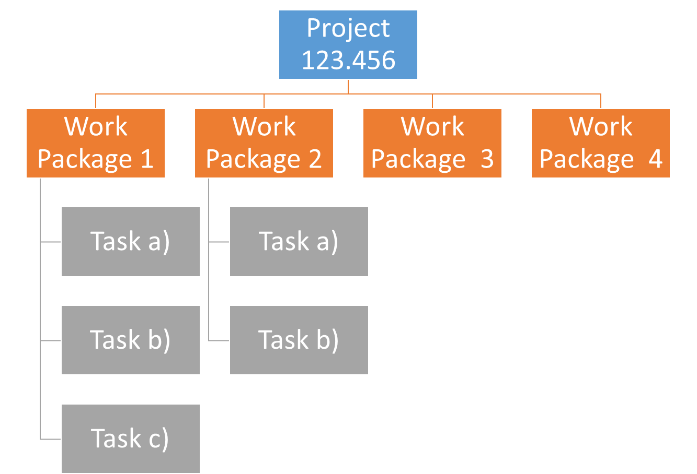

Figure 1 Work breakdown Structure

## Detailed work plan

*Please document the goals, content and expected results for each work package. Provide information on the planned approach and methods you want to apply as well as the expected results (including the planned milestones and deliverables). As a first work package please use ‘project management‘. (Add as many WP tables you need)*

|  |  |  |  |  |
| --- | --- | --- | --- | --- |
| WP 1 | Project management |  | | dd.mm.yyyy – dd.mm.yyyy |
| WP Lead | | | **WP team** | |
|  | | |  | |
| Objectives | | | | |
| The main objective is to ensure that the project is completed on time and to the required quality standards and that all project activities are completed successfully via GitLab. | | | | |
| Content & Tasks | | | | |
| 1.1. Establish project management procedures and documents  1.2. Monitor and regularly update progress, milestones, and deliverables | | | | |
| Expected results | | | | |
| A well-organized project management framework that supports the successful implementation of the project. | | | | |
| Milestones & Deliverables | | | | |
| M1: Project management tools created  D1: Project overview documents  D2: GitLab Wiki and repository entries | | | | |

|  |  |  |  |  |
| --- | --- | --- | --- | --- |
| WP 2 | Literature review & Methodology |  | | dd.mm.yyyy – dd.mm.yyyy |
| WP Lead | | | **WP team** | |
|  | | |  | |
| Objectives | | | | |
| The main objective is to find and catalogue relevant literature and gain a good understanding of the state of the art for this topic. Additionally identify the methodology to be used. | | | | |
| Content & Tasks | | | | |
| 2.1. State of the art literature review  2.2 Identify methodology | | | | |
| Expected results | | | | |
| Getting a good and deeply understanding of the state of the art and finding a suitable methodology. | | | | |
| Milestones & Deliverables | | | | |
| M1 Understanding of the project’s position among the state-of-the-art development  M2 Selected methodology approach | | | | |

|  |  |  |  |  |
| --- | --- | --- | --- | --- |
| WP 3 | Data Acquisition & Pre-Processing |  | | dd.mm.yyyy – dd.mm.yyyy |
| WP Lead | | | **WP team** | |
|  | | |  | |
| Objectives | | | | |
| The main objective is to collect all necessary data needed for the project and to preprocess it (e.g. Bundestags API, GeoNames). | | | | |
| Content & Tasks | | | | |
| 3.1 Collect and store data  3.2 Pre-process and clean data | | | | |
| Expected results | | | | |
| A data set that is collected, pre-processed, cleaned, and stored securely and accessibly.  An understanding of the quality and completeness of the data collected. | | | | |
| Milestones & Deliverables | | | | |
| D1: Data collected, pre-processed, cleaned, and stored.  D2: Working Database with the according data | | | | |
|  | | | | |

|  |  |  |  |  |
| --- | --- | --- | --- | --- |
| WP 4 | Data Processing & Analysis |  | | dd.mm.yyyy – dd.mm.yyyy |
| WP Lead | | | **WP team** | |
|  | | |  | |
| Objectives | | | | |
| The main objective is to analyse the data collected in WP 3. | | | | |
| Content & Tasks | | | | |
| 4.1 Set up computing environment  4.2 Develop a workflow for extracting semantic information  4.3 Test, review, and improve the workflow | | | | |
| Expected results | | | | |
| A | | | | |
| Milestones & Deliverables | | | | |
| M1: Workflow for extracting semantic information developed.  M2: Adequate computing environment selected  D1: | | | | |

|  |  |  |  |  |
| --- | --- | --- | --- | --- |
| WP 5 | Dissemination |  | | dd.mm.yyyy – dd.mm.yyyy |
| WP Lead | | | **WP team** | |
|  | | |  | |
| Objectives | | | | |
| Describing the project comprising Introduction, Methods, Results and Discussion parts. To create two presentations. To publish the code used for the analysis. | | | | |
| Content & Tasks | | | | |
| 5.1 Writing documentation (wiki)  5.2 Creating presentations  5.3 Publishing results | | | | |
| Expected results | | | | |
| A good documentation and awesome presentations with according results. | | | | |
| Milestones & Deliverables | | | | |
| M1:  D1: Documentation  D2: Presentation  D3: Used Code | | | | |

## Milestone plan

*Please provide a summary of the planned milestones and provide an according overview graphic.*

|  |  |  |
| --- | --- | --- |
|  | Name | Date Completion |
| M1 | Milestone description | dd.mm.yyyy |
|  |  |  |
|  |  |  |
|  |  |  |
|  |  |  |

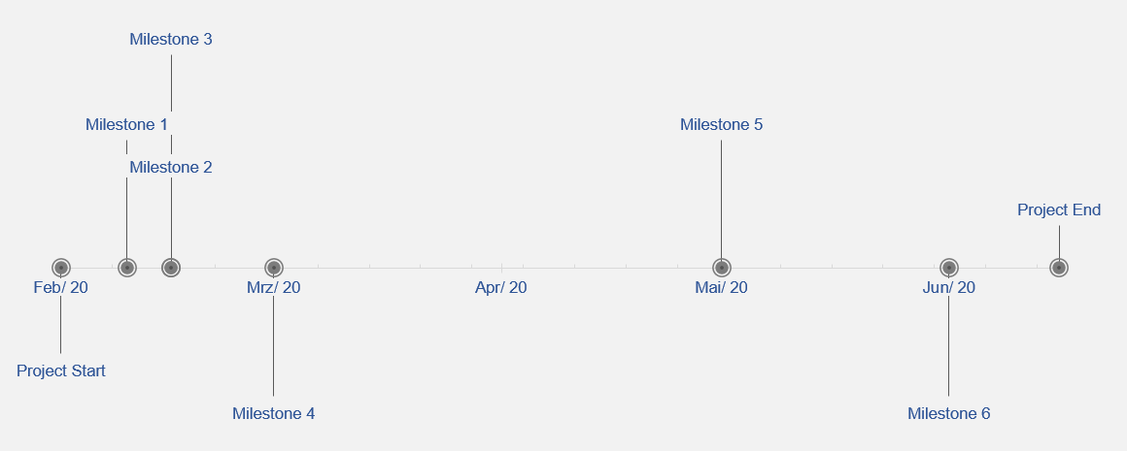

Figure 2 Milestones

## Gantt Chart

*Please provide an image of your Gantt Chart as overview graphics. Please attach the Gantt chart and it’s monthly updates in addition to this document.*

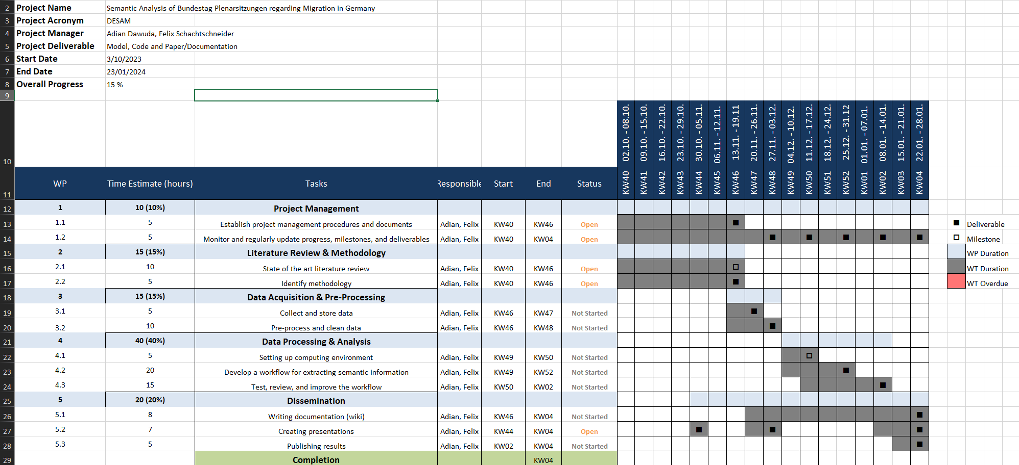

Figure 3 Gantt Chart

## Risk matrix

*In this table, please provide the important risk information. Please categorize the risks accordingly. ([L]ow, [ M ]edium, [****H****]igh], [C]leared)as well as your mitigation strategy. Please update this list accordingly during your project execution time frame.*

|  |  |  |  |  |
| --- | --- | --- | --- | --- |
|  | Risk | Mitigation Strategy | Type | Update |
| 1 | Risk 1 |  | L | dd.mm.yyyy |
| 2 | Risk 2 |  |  |  |
| 3 | Risk n |  |  |  |

## Additional comments

*Add additional comments if necessary.*

|  |
| --- |
| Comments |
|  |

## Approval

*Please provide further information if necessary.*

|  |  |  |  |
| --- | --- | --- | --- |
| Approval | | | |
| Approval: | Date: | | dd.mm.yyyy |
|  | |  | |
| Signature principal investigator | | Signature project lead/contractor | |

## Workload distribution

*Describe the team workload distribution in % per WP*

## Attachments

*Attachment 1: Gantt Chart (monthly updated).*