# Project Overview Document

## Project information

*Please provide important facts for your project, e.g. acronym, title, proposed period, principal investigator and contractor.*

|  |  |  |  |  |
| --- | --- | --- | --- | --- |
| Project |  | | | |
| Acronym | DMIG | | | |
| Title | Domestic Migration in Germany | | | |
| Period | Start: | 03.10.2023 | End: | 31.01.2024 |
| Principal investigator |  | | | |
| Contractor |  | | | |

## Document version

|  |  |  |  |  |  |
| --- | --- | --- | --- | --- | --- |
| Nr. | Date | Version | Altered chapters | Type of altering | Author |
| 1 | 30.10.2023 | 1.1 | all | Creation | Adian Dawuda |
| 2 | 05.11.2023 | 1.2 | all | Additions | Dawuda/Schachtschneider |
| 3 | 23.11.2023 | 1.3 | all | Changes/Additions | Dawuda/Schachtschneider |
| 4 |  |  |  |  |  |
| 5 |  |  |  |  |  |

## Project Content and Project Goals

*Please provide an overview of your project with its main activities. Additionally give some information on the purpose, benefits and target groups as well as the proposed goals of your project. Please also provide explicit information on those aspects of the overall challenges, which you will not tackle with your project.*

|  |
| --- |
| Content & Goals |
| Project description *(~100-150 words)* |
| This Project aims to build a spatial data infrastructure of yearly German domestic migration data. The migration data will be sourced from the German GENESIS (Gemeinsames Neues Statistisches Informations-System) online platform. The German State boundary geodata will be sourced separately and combined with the migration data in a PostGIS geodatabase. The process of downloading and preprocessing the aforementioned data will be highly automated with a Python script. Using Geoserver, WFS/WMS of the data will be created and incorporated into a dashboard. The dashboard will also include external services to aid in visualization (e.g., basemap) and will enable the interactive visualization of data from different years. In addition to the spatial visualization, data not depicted on the map will also be shown in panels of the dashboard. |
| Project purpose, benefits and target group description *(~100 words)* |
| The main target group of this project are researchers or professionals in the field of politics, as the spatial aspect of the discourse on migration may be used to discover patterns and make decisions.  The benefits of this project include:   * The creation of a spatial overview/perspective on migration discourse * Highly automated workflow, which requires little to no change for data from different years (future data in mind) * Supporting political decision making or planning * OGC web services can be incorporated into applications based on users needs * Dashboard well suited as a data source or for use in presentations * Transparent and well documented workflow providing results free of cost |
| Project objectives (please also include a listing of the sub-goals) *(~100 words)* |
| Project objectives include:   * Develop automated integration of necessary data into a PostGIS database * Develop a Python workflow to download domestic migration data and German state geodata (interaction with API if possible) * Develop a Python workflow to preprocess the downloaded data and import it into the database. * Optimized geodatabase in 3rd normal form * Data Published as OGC web services * Dashboard * Includes spatial data across all available years * Additional information and statistics |
| Non-Goals |
| * Analysis of migration at a district level * Reasons for the migration * Differentiating between different types of migration (most likely not enough data for meaningful results) |

## Frame of the project

*Please provide a description of the existing situation. Therefore, please describe the actual state and the identified challenges. As a second part, please also provide the most important information with regard to the proposed project period and the most important dates (Kick-off, interim/mid-term report/presentation, final report, paper submission etc.)*

|  |
| --- |
| Context |
| Up-to-date status *(~50-100 words)* |
| The overall project is currently in its early stages. The literature review phase is complete and the methodology is largely finalized. A source for the migration data has successfully been identified. Current work is ongoing to automate the data acquisition with the use of an API. The best source for the spatial data of German states is currently being searched for. |
| Project setting *(~50 Wörter)* |
| The project is being conducted during the winter semester of 2023/2024 in the *SDI Services Implementation* course in the M.Sc. Applied Geoinformatics curriculum. Over the course of the semester, a total of 200 hours is to be spent working on the project. This time is split up evenly among project members. |

|  |  |  |  |  |  |
| --- | --- | --- | --- | --- | --- |
| Dates | | | | | |
| Time period | | | | | |
| Start: | | 03.10.2023 | | End | 31.01.2024 |
| Important Dates | | | | | |
| 1 | 03.10.2023 | | Project start | | |
| 2 | 28.11.2023 | | Presentation: project idea and planned architecture | | |
| 3 | 24.12.2023 | | Automated data acquisition and preprocessing script complete | | |
| 4 | 23.01.2024 | | Presentation: Final architecture and project presentation | | |
| 5 | 28.01.2024 | | Data processing complete and dashboard complete | | |
| 6 | 31.01.2024 | | Dissemination complete and project end | | |

## Resources & Budget

*Please provide information on the project lead and the project team. Please include information on name, role and qualification. Additionally provide information about the planned resources with regard to personal costs and other costs,*

|  |
| --- |
| Project Team |
| Projekt Lead |
| Adian Dawuda |
| Project Team |
| Felix Schachtschneider |

|  |
| --- |
| Resources |
| Personal costs |
|  |
| Project costs |
|  |
| Other Costs |
|  |

## Project structure, description and risk matrix

*Please provide a description about your work plan (work breakdown structure) your work packages in tabular and graphical form.*

### Work packages overview:

|  |  |  |
| --- | --- | --- |
| WP | Name | Time Frame |
| 1 | Project Management | 03.10.2023 – 31.01.2024 |
| 2 | Literature review & Methodology | 03.10.2023 – 19.11.2023 |
| 3 | Data Acquisition & Pre-Processing | 20.11.2023 – 24.12.2023 |
| 4 | Data Processing & Analysis | 18.12.2023 – 28.01.2024 |
| 5 | Dissemination | 30.10.2023 – 31.01.2024 |

### Work Breakdown Structure (WBS)

*Create a work breakdown structure for your work packages including the important tasks* 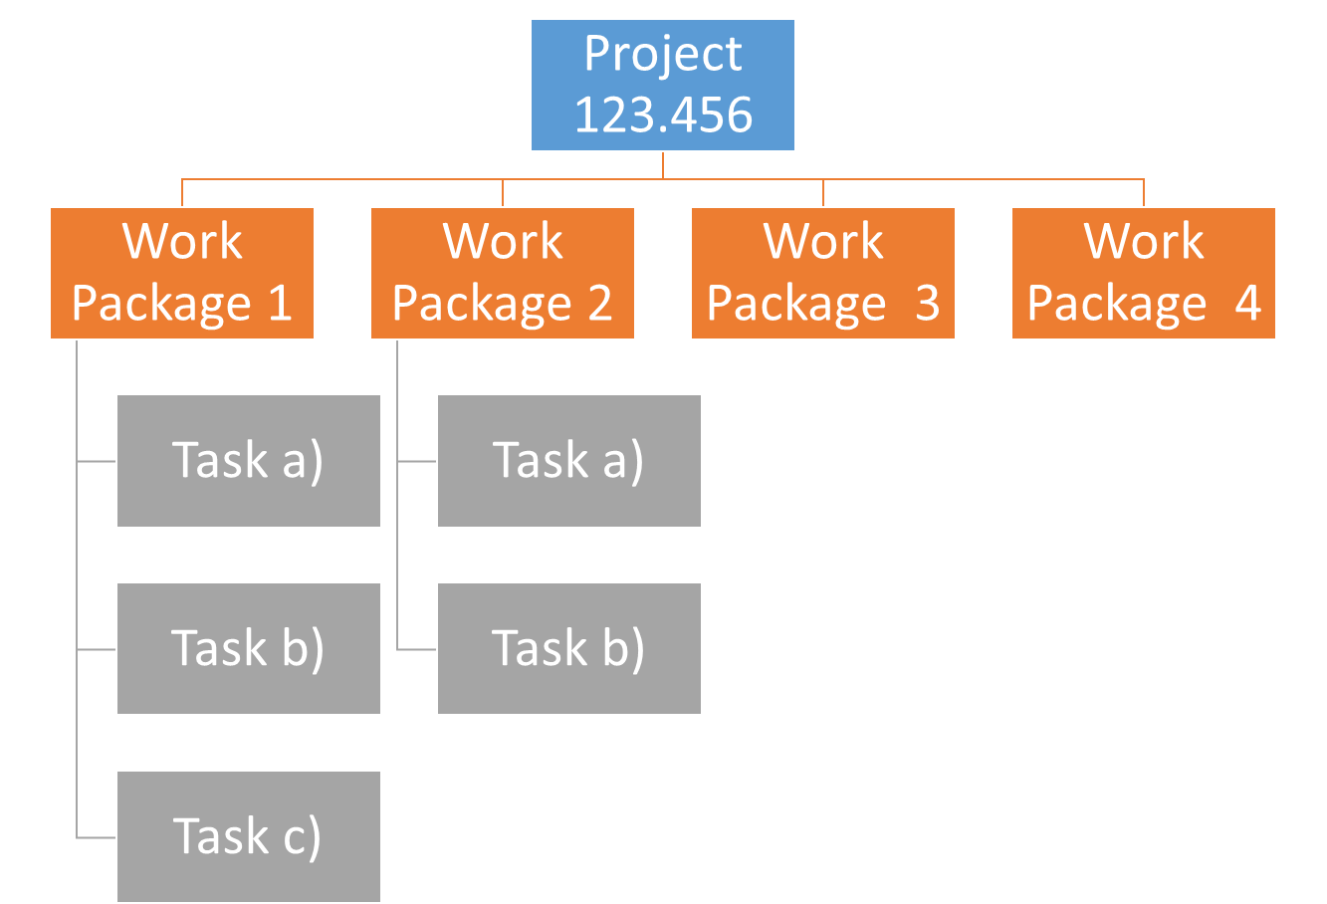

Figure 1 Work breakdown Structure

## Detailed work plan

*Please document the goals, content and expected results for each work package. Provide information on the planned approach and methods you want to apply as well as the expected results (including the planned milestones and deliverables). As a first work package please use ‘project management‘. (Add as many WP tables you need)*

|  |  |  |  |  |
| --- | --- | --- | --- | --- |
| WP 1 | Project management |  | | 03.10.2023 – 31.01.2024 |
| WP Lead | | | **WP team** | |
| Adian | | | Felix | |
| Objectives | | | | |
| To ensure that the project is completed on time and to the required quality standards.  The process is successfully documented via GitLab. | | | | |
| Content & Tasks | | | | |
| 1.1. Establish project management procedures and documents  1.2. Monitor and regularly update progress, milestones, and deliverables | | | | |
| Expected results | | | | |
| A well-organized project management framework that supports the successful implementation of the project. | | | | |
| Milestones & Deliverables | | | | |
| M1: Project management tools created  D1: Project overview documents  D2: GitLab Wiki and repository entries | | | | |

|  |  |  |  |  |
| --- | --- | --- | --- | --- |
| WP 2 | Literature review & Methodology |  | | 03.10.2023 – 19.11.2023 |
| WP Lead | | | **WP team** | |
| Felix | | | **Adian** | |
| Objectives | | | | |
| The main objective is to find and catalogue relevant literature/information and gain a good understanding of the state of the art for this topic. Additionally, to identify the methodology to be used. | | | | |
| Content & Tasks | | | | |
| 2.1. State of the art literature review  2.2 Identify methodology | | | | |
| Expected results | | | | |
| Getting a good and deeply understanding of the state of the art and finding a suitable methodology. | | | | |
| Milestones & Deliverables | | | | |
| M1 Understanding of the project’s position among the state-of-the-art development  M2 Selected methodology approach | | | | |

|  |  |  |  |  |
| --- | --- | --- | --- | --- |
| WP 3 | Data Acquisition & Pre-Processing |  | | 20.11.2023 – 24.12.2023 |
| WP Lead | | | **WP team** | |
| Adian | | | Felix | |
| Objectives | | | | |
| The main objective is to identify all necessary data and develop an automated download and preprocessing workflow using Python. | | | | |
| Content & Tasks | | | | |
| 3.1 Set up computing environment  3.2 Collect raw data  3.3 Preprocess data | | | | |
| Expected results | | | | |
| A data set that is that can be automatically collected and pre-processed.  An understanding of the quality and completeness of the data collected. | | | | |
| Milestones & Deliverables | | | | |
| M1: Functional computing environment  D1: Automated workflow to collect data  D2: Automated workflow to preprocess data D3: Preprocessed data | | | | |
|  | | | | |

|  |  |  |  |  |
| --- | --- | --- | --- | --- |
| WP 4 | Data Processing & Analysis |  | | 18.12.2023 – 28.01.2024 |
| WP Lead | | | **WP team** | |
| Felix | | | **Adian** | |
| Objectives | | | | |
| The main objective is to construct a spatial data infrastructure for the collected and preprocessed data. | | | | |
| Content & Tasks | | | | |
| 4.1 Insert data into PostGIS DB  4.2 Optimize PostGIS DB  4.3 Generate OGC services  4.4 Construct Dashboard | | | | |
| Expected results | | | | |
| A spatial data infrastructure comprising data storage in a PostGIS DB, web-service publishing, and integration into a dashboard. | | | | |
| Milestones & Deliverables | | | | |
| D1: Data in PostGIS DB  D2: Optimized and well-structured DB (3rd normal form)  D3: OGC web-services of the relevant data  D4: Visualization of the data in a dashboard | | | | |

|  |  |  |  |  |
| --- | --- | --- | --- | --- |
| WP 5 | Dissemination |  | | 30.10.2023 – 31.01.2024 |
| WP Lead | | | **WP team** | |
| Adian | | | Felix | |
| Objectives | | | | |
| Describing the project comprising Introduction, Methods, Results and Discussion parts.  To create two presentations.  To publish the code used for the analysis. | | | | |
| Content & Tasks | | | | |
| 5.1 Writing documentation (wiki)  5.2 Creating presentations  5.3 Publishing results | | | | |
| Expected results | | | | |
| A good documentation and awesome presentations with according results. | | | | |
| Milestones & Deliverables | | | | |
| D1: Documentation  D2: Presentation  D3: Used Code | | | | |

## Milestone plan

*Please provide a summary of the planned milestones and provide an according overview graphic.*

Note: End of Work Packages are counted as additional milestones in the table and image below.

|  |  |  |
| --- | --- | --- |
|  | Name | Date Completion |
|  | Project Start | 03.10.2023 |
| M1 | Understanding of the project’s position among the state-of-the-art development | 19.11.2023 |
| M2 | Selected methodology approach | 19.11.2023 |
| M3 | Functional computing environment | 03.12.2023 |
| M4 | Partially automated workflow and preprocessed data | 24.12.2023 |
| M5 | Spatial Data Infrastructure set up | 28.01.2024 |
| M6 | Completion of all tasks | 31.01.2024 |
|  | Project End | 31.01.2024 |

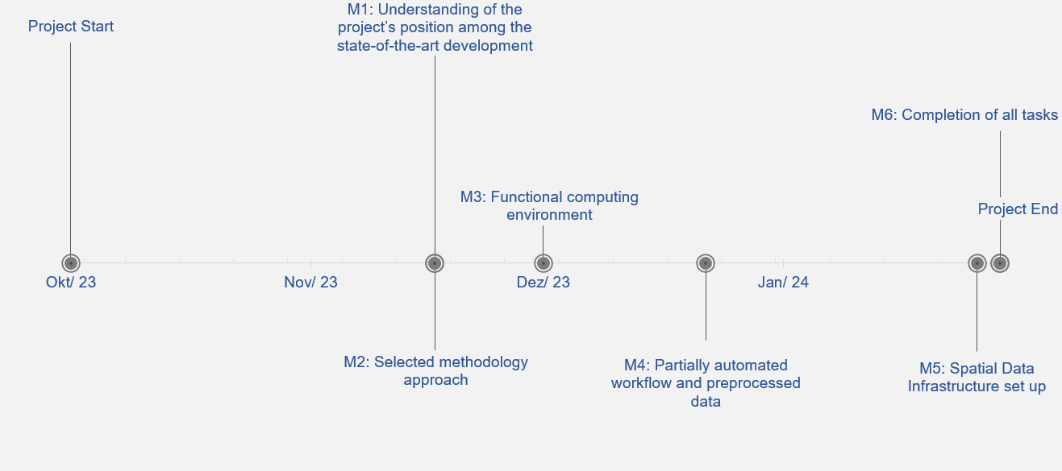

Figure 2 Milestones

## Gantt Chart

*Please provide an image of your Gantt Chart as overview graphics. Please attach the Gantt chart and it’s monthly updates in addition to this document.*

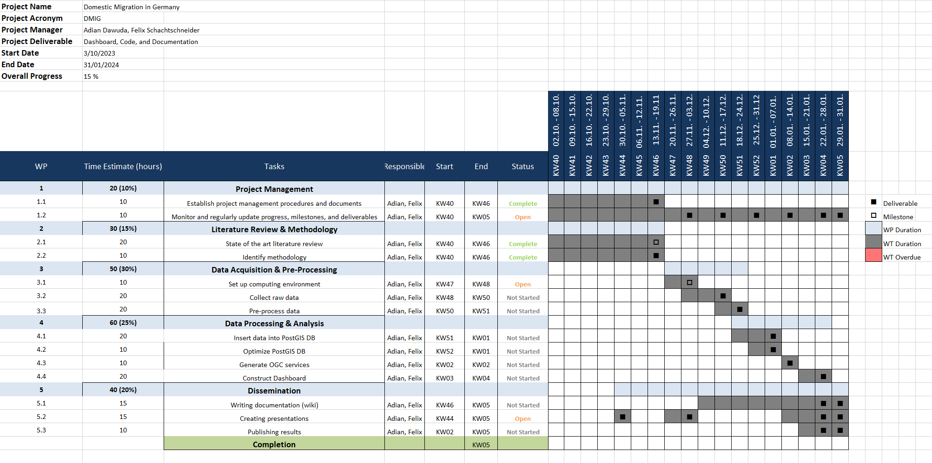

Figure 3 Gantt Chart

## Risk matrix

*In this table, please provide the important risk information. Please categorize the risks accordingly. ([L]ow, [ M ]edium, [****H****]igh], [C]leared)as well as your mitigation strategy. Please update this list accordingly during your project execution time frame.*

|  |  |  |  |  |
| --- | --- | --- | --- | --- |
|  | Risk | Mitigation Strategy | Type | Update |
| 1 | Risk 1 |  | L | dd.mm.yyyy |
| 2 | Risk 2 |  |  |  |
| 3 | Risk n |  |  |  |

## Additional comments

*Add additional comments if necessary.*

|  |
| --- |
| Comments |
|  |

## Approval

*Please provide further information if necessary.*

|  |  |  |  |
| --- | --- | --- | --- |
| Approval | | | |
| Approval: | Date: | | dd.mm.yyyy |
|  | |  | |
| Signature principal investigator | | Signature project lead/contractor | |

## Workload distribution

*Describe the team workload distribution in % per WP*

WP1: 50/50 WP2: 50/50

WP3: 50/50 WP4: 50/50

WP5: 50/50

## Attachments

*Attachment 1: Gantt Chart (monthly updated).*