19-11-25
REG NO: 43110033

CODE : INHERITANCE
package nov19_25;

public class Inheritance {
public static void main(String[] args) {

Son1 s1 = new Son1();
s1.bike(); // Son1 own method
s1.oldBike(); // Overridden method

Son2 s2 = new Son2();
s2.bike(); // Son2 own method
s2.oldBike(); // Overridden method
}
}

class GrandFather {
void oldBike() {
System.out.println("Royal Enfield 1983");
}
}

class Father extends GrandFather { // Single Inheritance
void oldBike() { // Method overriding
System.out.println("Royal Enfield 2002");
}
}

class Son1 extends Father { // Multilevel Inheritance
void bike() {
System.out.println("KTM 390");
}
}

class Son2 extends Father { // Hierarchical Inheritance
void bike() {
System.out.println("RC KTM 390");
}
}

OUTPUT:

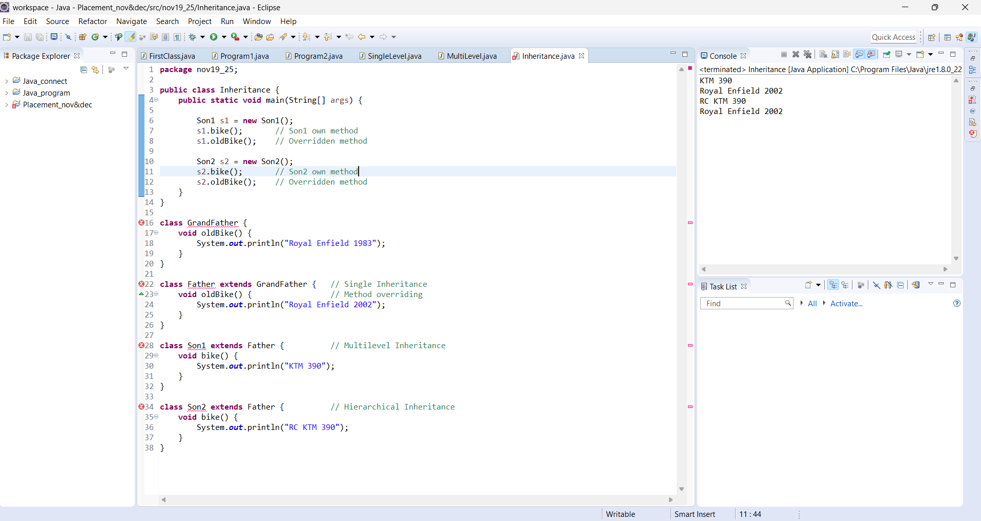

CODE:FINAL
package nov19_25;

public class Final {
public static void main(String[] args) {
Son5 s = new Son5();
s.bike(); // Son’s own method
s.Secbike(); // inherited final method from Father5
}
}

class Father5 {
// final method cannot be overridden
final void Secbike() {
System.out.println("BAJAJ NS 200 2019");
}
}

class Son5 extends Father5 {
void bike() {
System.out.println("KTM 390");
}
}
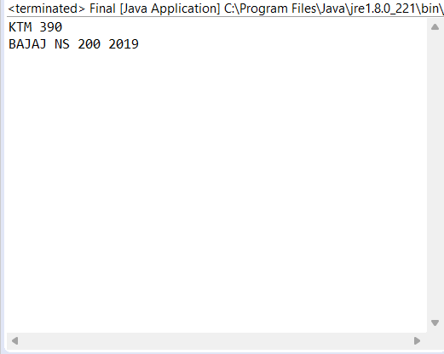

CODE:SUPER

package nov19_25;

public class Super {
public static void main(String[] args) {
Son6 s = new Son6();
s.car(); // Son6’s own method
s.oldCar(); // Son6’s overridden method + super call
}
}

class Father6 {
String car = "Toyota Corolla 2002";

void oldCar() {
System.out.println("Father6’s Car: " + car);
}
}

class Son6 extends Father6 {
String car = "BMW 2025";

void car() {
System.out.println("Son6’s Car: " + car);
}

@Override
void oldCar() {
System.out.println("Son6 also has: " + car);
super.oldCar(); // calls Father6’s version explicitly
}
}

OUTPUT:
