**CSE 423  
Moinul Hossain Bhuiyan  
ID: 20301002   
Lab Section: 01**

**BRAC UNIVERSITY**

Initializing from the Template

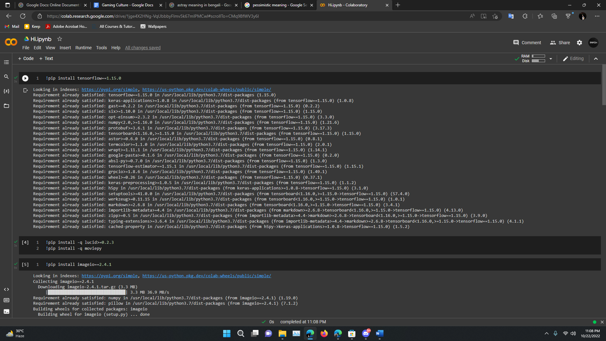

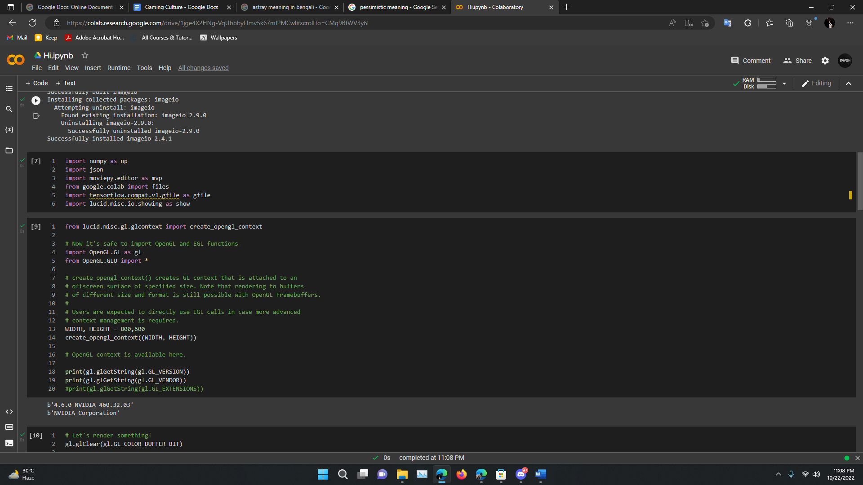

**TASK 01**

Driver Code:

# Let's render something!

gl.glClear(gl.GL_COLOR_BUFFER_BIT)

gl.glColor3f(0,1,1)   #openGL Color Codes

gl.glPointSize(5)

import random

def point(count):

 for i in range(0,count):

   start = random.uniform(0,1)

   end = random.uniform(0,1)

   gl.glBegin(gl.GL_POINTS)

   gl.glVertex2f(start,end)

   gl.glEnd()

point(50)

Printing Code:

img_buf = gl.glReadPixelsub(0, 0, WIDTH, HEIGHT, gl.GL_RGB, gl.GL_UNSIGNED_BYTE)

img = np.frombuffer(img_buf, np.uint8).reshape(HEIGHT, WIDTH, 3)[::-1]

show.image(img/255.0)

Screenshot:

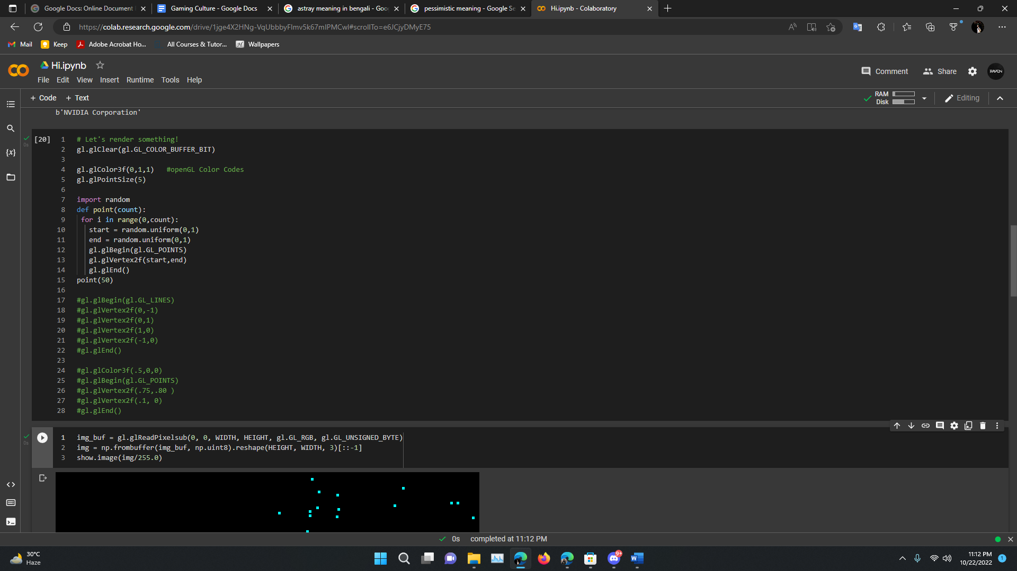

Output:

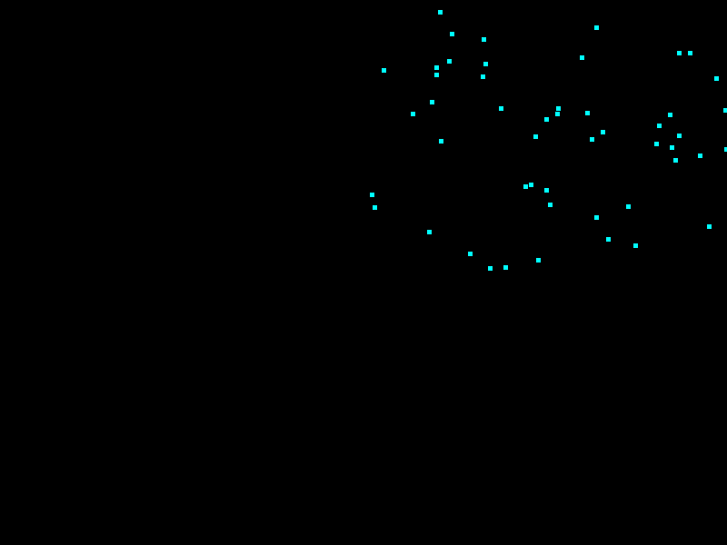

**Task 02**

Driver Code:

gl.glClear(gl.GL_COLOR_BUFFER_BIT)

gl.glColor3f(0.184314,0.184314,0.309804)

gl.glPointSize(5)

gl.glBegin(gl.GL_TRIANGLES)   # Treats each triplet of vertices as an independent triangle. Vertices 3n - 2, 3n - 1, and 3n define triangle n. N/3 triangles are drawn.

gl.glVertex2f(0.2,0.5)

gl.glVertex2f(0.5,0.5)

gl.glVertex2f(0.35,0.7)

gl.glEnd()

gl.glColor3f(0.184314,0.184314,0.309804)

gl.glBegin(gl.GL_LINES)

gl.glVertex2f(0.2,0.5)   #0.2 Refers to left straight lines position and 0.5 refers to the height of this line (upper corner)

gl.glVertex2f(0.2,0.1)  #0.2 refers to the left straight line (lower corner) amd 0.1 refers to this lines height (axis wise)

gl.glVertex2f(0.5,0.5)   #these refers to the right straight line

gl.glVertex2f(0.5,0.1)  #0.5 refers to the angle and 0.1 refers to the height of the right straight line

gl.glVertex2f(0.2,0.1)  #Fixing the Ground Line

gl.glVertex2f(0.5,0.1)  #Ground size 0.5 and angle 0.1

gl.glVertex2f(0.3,0.3)   #door left line

gl.glVertex2f(0.3,0.1)  #door left line

gl.glVertex2f(0.4,0.3)   #door right line

gl.glVertex2f(0.4,0.1)  #door right line

gl.glVertex2f(0.3,0.3)   #door upper line

gl.glVertex2f(0.4,0.3)   #door upper line

gl.glEnd()

#KNOB

gl.glColor3f(0.5,0,0)

gl.glBegin(gl.GL_POINTS)

gl.glVertex2f(0.38,0.2)

gl.glEnd()

#WIndows

gl.glColor3f(0.309804,0.184314,0.309804)

def wnd(x1,x2,x3,x4,y1,y2,y3,y4):     #For Windows

  gl.glBegin(gl.GL_LINES)

  gl.glVertex2f(x1,y1)

  gl.glVertex2f(x2,y2)

  gl.glVertex2f(x2,y2)

  gl.glVertex2f(x3,y3)

  gl.glVertex2f(x3,y3)

  gl.glVertex2f(x4,y4)

  gl.glVertex2f(x4,y4)

  gl.glVertex2f(x1,y1)

  gl.glEnd()

wnd(0.22,0.30,0.30,0.22,0.47,0.47,0.37,0.37)   # left square Window

wnd(0.40,0.478,0.478,0.40,0.47,0.47,0.37,0.37)   # right square window

Printing Code

img_buf = gl.glReadPixelsub(0, 0, WIDTH, HEIGHT, gl.GL_RGB, gl.GL_UNSIGNED_BYTE)

img = np.frombuffer(img_buf, np.uint8).reshape(HEIGHT, WIDTH, 3)[::-1]

show.image(img/255.0)

Screenshots:

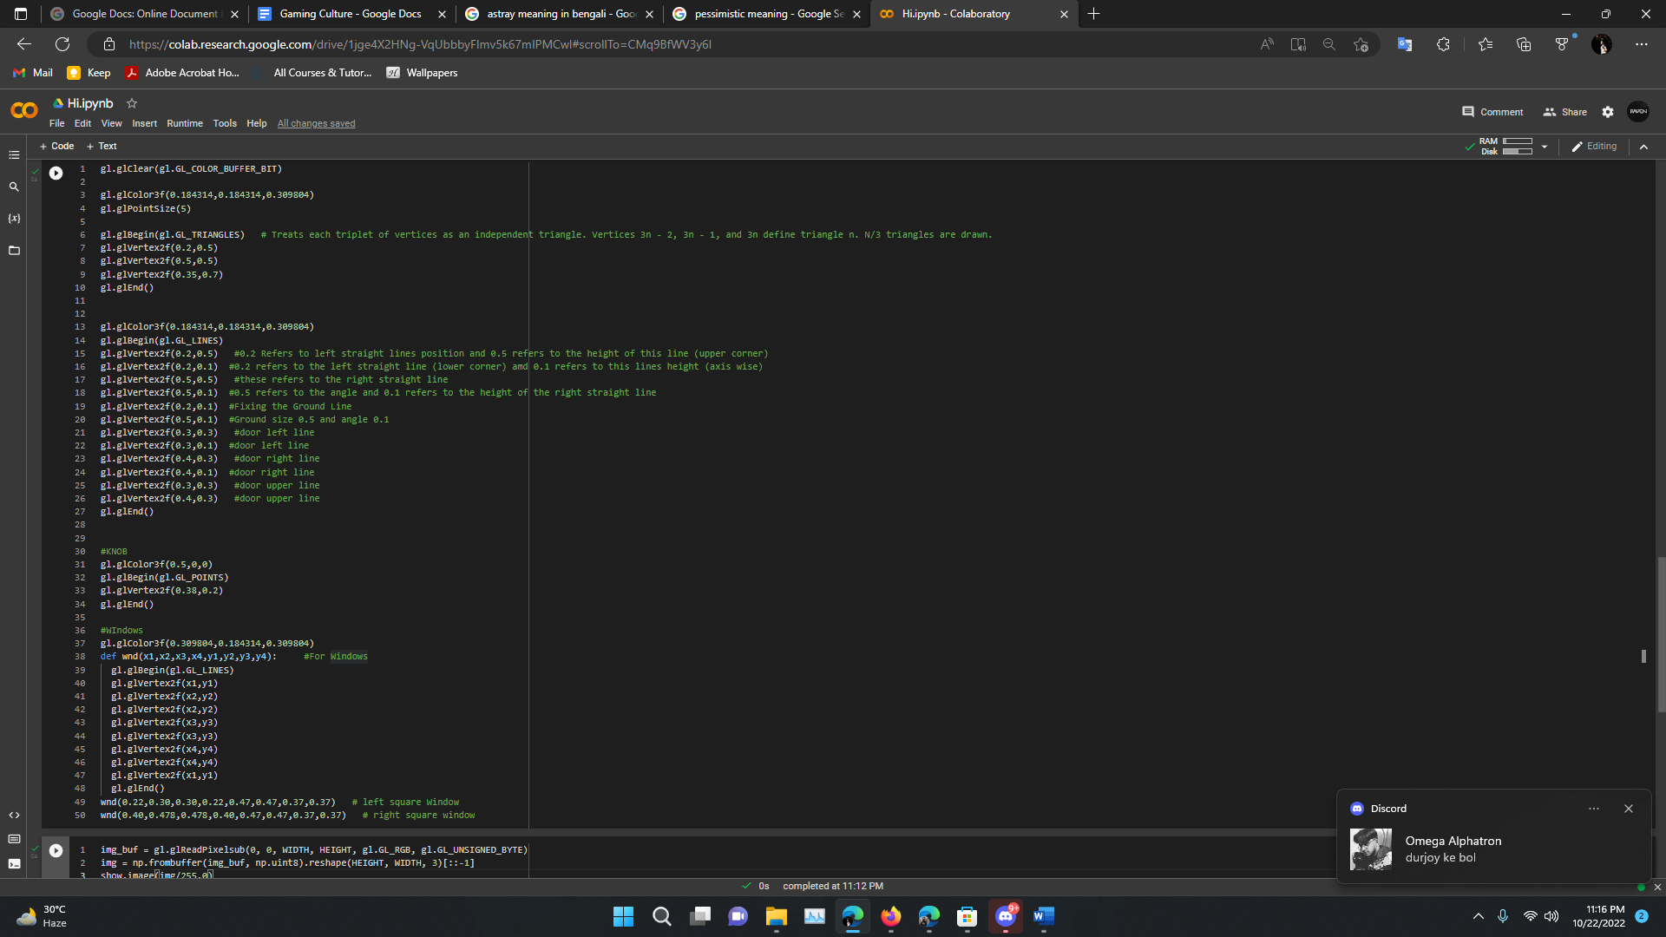

Output:

