CAPSTONE PROJECT REPORT
SAP MM Procure-to-Pay Analytics:
An End-to-End Python Simulation of the P2P Data Pipeline with Enterprise-Grade Analytical Reporting

Name: Adib Ahmed  Roll Number: 23052046  Course: SAP Data/Analytics Engineer | University: Kalinga Institute of Industrial Technology (KIIT)  Program / Branch: B.Tech Computer Science and Engineering
300  Purchase Orders | 592  Line Items | 85.6%  GR Completion Rate | 7.8 Days  Avg. Lead Time | 57.4%  On-Time GR Rate

1. Problem Statement

1.1 Complexity of the Procure-to-Pay Lifecycle
In SAP, the P2P process spans every touchpoint from procurement need identification to vendor payment clearance — involving Procurement, Stores, Logistics, and Finance. A Purchase Requisition triggers a Purchase Order (header in EKKO, line items in EKPO). The warehouse posts a Goods Receipt in MSEG (movement type 101), and Finance posts the vendor invoice via MIRO, generating an RBKP record. The delta between EKKO.BEDAT (PO date) and MSEG.BUDAT (GR posting date) is where the critical business intelligence lies.

1.2 Limitations of Standard SAP GUI Reporting
SAP's native ALV Grid and transactions like ME2N, MB51, and MIRO are transactional tools for record-level inspection, not analytics. They lack native charting, cannot cross-aggregate EKKO, MSEG, and RBKP without custom ABAP development, and cannot monitor SLA compliance at scale without production server contention. This project closes that gap with a Python-based simulation and analytics pipeline.

1.3 The Three-Way Match Challenge
The three-way match — verifying that EKKO/EKPO (PO), MSEG (GR), and RBKP (Invoice) agree on quantity and value — is the most critical P2P control point. A blocked invoice creates an open AP item requiring manual resolution. Simulating this logic, including POs without GRs and GRs without invoices, is a central design requirement.

2. Solution Architecture & Key Features
A self-contained Python pipeline that (1) simulates realistic SAP MM table data, (2) processes it through a join strategy replicating SAP's relational model, and (3) renders five executive-grade visualisations: spend by material, lead time distribution, procurement trends, vendor performance, and invoice processing health.

2.1 Automated KPI Calculation
- Total PO Value (EKPO.NETWR aggregate): Gross procurement commitment across all POs, regardless of fulfilment status.
- Invoiced Amount (RBKP.NETWR aggregate): Value formally invoiced and posted as Accounts Payable.
- Open AP Exposure: Delta between PO value and invoiced amount — Rs.1.20 Cr in the simulation.
- Average PO-to-GR Lead Time: (MSEG.BUDAT − EKKO.BEDAT) in calendar days. 7.8 days vs. a 7-day SLA.
- On-Time GR Rate: Percentage of GR postings with LEAD_TIME_DAYS ≤ 7. Simulated rate: 57.4%.

3. Data Architecture & Technical Stack

3.1 Technology Stack

Technology | Version / Library | Role in Pipeline
Python 3.11 | Core Language | Pipeline orchestration, logic, data types
pandas 2.x | Data Processing | DataFrame operations, merges, time arithmetic
NumPy | Numerical | Seeded random data generation with reproducibility
Matplotlib | Visualisation | Bar, histogram, dual-axis line, pie charts
GridSpec | Layout Engine | Multi-chart dashboard composition
FuncFormatter | Axis Formatting | Currency labels (Rs. with M/Cr suffixes)

3.2 SAP Table Mapping

Table | Business Entity | Primary Key | Key Fields Used
EKKO | Purchase Order Header — anchor of every P2P transaction. | EBELN | BEDAT (PO date), LIFNR (vendor), EKORG, NETWR (value), WAERS
EKPO | Purchase Order Item — 1:N child to EKKO. | EBELN + EBELP | MATNR, MATKL, MENGE (qty), NETPR (unit price), NETWR (item value)
MSEG | Material Document Segment — posted on GR against PO. | MBLNR + ZEILE | EBELN, EBELP, BUDAT (GR date), BWART (mvt 101), MENGE
RBKP | Invoice Receipt Header — MIRO accounting document. | BELNR + GJAHR | EBELN, BLDAT (invoice date), NETWR (invoiced amount), BSTAT

3.3 Vendor Master Reference

Vendor ID | Vendor Name | Material Category | Avg. Lead Time
V001 | Bharat Raw Materials Pvt. Ltd. | RM (Steel, Polymer) | 6.8 days
V002 | IndoSteel Traders | RM (Steel) | 8.2 days
V003 | Asian Polymers Ltd. | RM (Polymer) | 7.5 days
V004 | National Electrical Supplies | ELE (Motors) | 9.1 days
V005 | Prime Office Solutions | MRO, PKG | 6.3 days

3.4 Join Strategy — Simulating SAP’s Open Items Logic
Left joins preserve open POs and GR-done-but-not-invoiced orders that an inner join would silently discard — the most operationally critical records for a procurement controller.
# Step 1: Header + Items (inner join — PO must have at least one item)
df = ekko.merge(ekpo, on='EBELN', how='inner', suffixes=('_HDR', '_ITM'))

# Step 2: Attach Goods Receipt (left join — preserves open POs)
df = df.merge(mseg_key, on=['EBELN', 'EBELP'], how='left')

# Step 3: Attach Invoice (left join — preserves GR-done, not-invoiced POs)
df = df.merge(rbkp_key, on='EBELN', how='left')

3.5 Lead Time Computation
Lead time is computed as a vectorised pandas operation. The notna() flags convert left-join NaN patterns into boolean business indicators — replicating the logic of SAP's purchase order history table EKBE.
# EKKO.BEDAT = PO creation date | MSEG.BUDAT = GR posting date
df['LEAD_TIME_DAYS'] = (df['GR_DATE'] - df['BEDAT']).dt.days
df['IS_GR_POSTED'] = df['GR_DATE'].notna() # False = open PO
df['IS_INVOICED'] = df['INV_DATE'].notna() # False = GR done, invoice pending

4. Analytics Output & Dashboard

4.1 Dashboard Overview
Five visualisations on a dark-themed canvas (#0D1117), styled after SAP Analytics Cloud, Power BI, and Tableau, composed using Matplotlib's GridSpec engine.
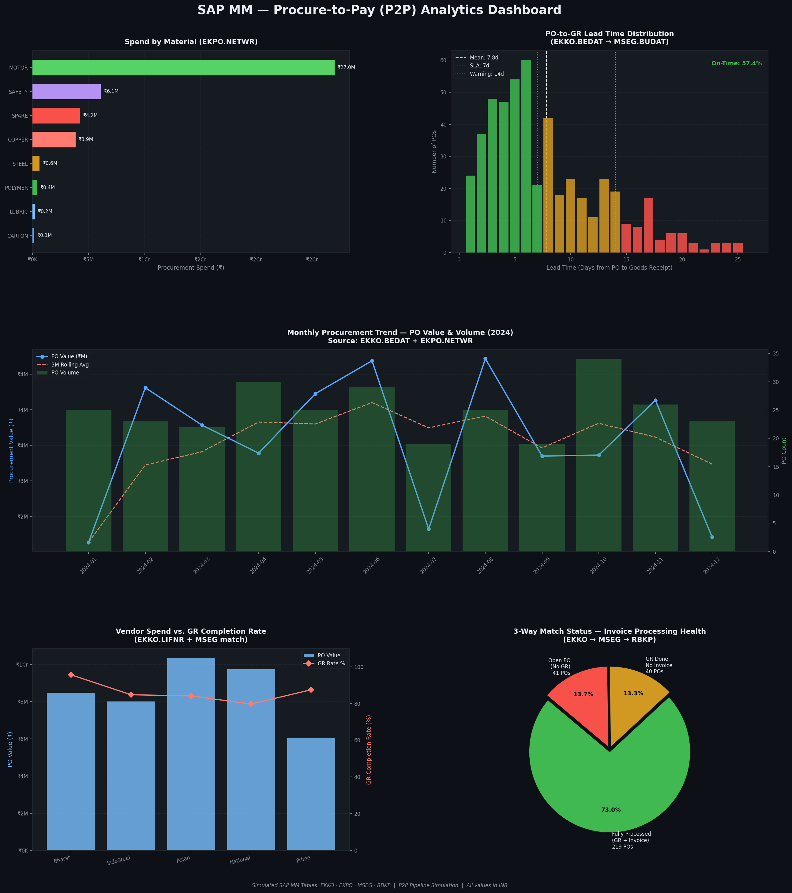

4.2 Chart-by-Chart Analysis
Chart 1 — Spend by Material (EKPO.NETWR). Groups EKPO by MATNR, summing NETWR. Equivalent to SAP transaction MC$G. Identifies spend concentration and intersecting lead-time risk per material.
Chart 2 — Lead Time Distribution (EKKO.BEDAT → MSEG.BUDAT). Histogram with SLA zones: green (≤7d), amber (8–14d), red (>14d). Mean at 7.8d; on-time rate 57.4% shown as an executive figure.
Chart 3 — Monthly Procurement Trend (Dual Axis). PO value (blue line) vs. order count (green bars) with a 3-month rolling average to surface AOV trends.
Chart 4 — Vendor Spend vs. GR Completion Rate. High-spend / low-GR vendors flagged for Source List (ME01) or Quota Arrangement (MEQ1) action.
Chart 5 — Three-Way Match Status. Pie chart: fully processed, GR-done-no-invoice (open AP), and open PO. Maps to SAP GR/IR clearing account reconciliation.

5. Unique Design Contributions

5.1 Relational Simulation Without a Live SAP Instance
The EKKO → EKPO → MSEG → RBKP 1-to-many hierarchy is built using NumPy's seeded generator (np.random.seed(42)) with realistic rates (87% GR, 82% invoice). Seeding guarantees identical results for any reviewer.

5.2 Authentic SAP MM Field Naming
Exact field names used throughout: EKKO.LIFNR, EKKO.BEDAT, MSEG.BUDAT, MSEG.BWART, RBKP.BLDAT, RBKP.BSTAT. An ABAP developer could adapt this logic directly into a CDS View or ABAP SELECT against a live system.

5.3 Five-Chart Dashboard
Vendor performance and three-way match health extend the baseline. Chart 5 maps directly to the mandatory SAP GR/IR reconciliation process — unique to P2P with no O2C equivalent.

6. Future Improvements & Enterprise Roadmap

6.1 Live SAP Data via PyRFC and OData
Replace data generation with PyRFC calls to RFC_READ_TABLE on EKKO, EKPO, MSEG, RBKP, or consume SAP S/4HANA's API_PURCHASEORDER_PROCESS_SRV OData service via Python requests with OAuth2.

6.2 Predictive Lead Time Forecasting
Train an XGBoost/LightGBM classifier on historical LEAD_TIME_DAYS to forecast SLA breach probability at PO creation time, using vendor, material, quantity, purchasing org, and plant as features.

6.3 SAP HANA Direct Connection
Use hdbcli to push join and aggregation logic to HANA Calculation Views. Combine with a Streamlit or Dash frontend for a self-refreshing, browser-accessible P2P dashboard with no SAP GUI dependency.

6.4 Accounts Payable Ageing
Simulate BSIK (open vendor items) and BSAK (cleared vendor items) to add AP ageing analytics — completing the financial close dimension of P2P and enabling working capital optimisation.

7. Conclusion
This project demonstrates that the analytical intent of enterprise SAP reporting is fully replicable in open-source Python. The four simulated tables — EKKO, EKPO, MSEG, and RBKP — encode the P2P cycle as a cascade of time-stamped, key-linked events. The inner/left join strategy ensures open items are never silently discarded. The 300-order, 592-item dataset with an 85.6% GR rate and 57.4% on-time delivery rate surfaces insights that, in a real enterprise, would trigger immediate vendor review and SLA renegotiation — all without SAP GUI access, ABAP development, or a BI licence.

